Supplementary Material

- Taxonomic Profiling

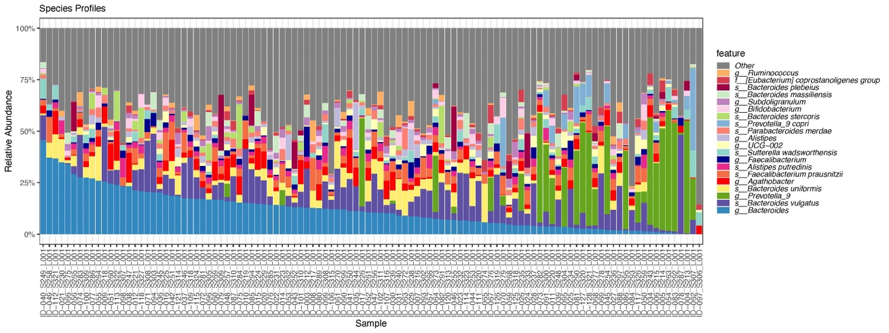
Figure S1. Relative Abundances of the top 20 most abundant species in the sample

- Alpha Diversity Multivariable ANOVA Results

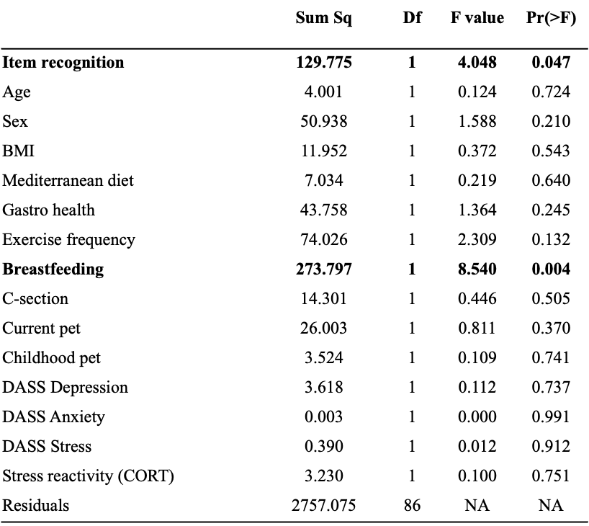
Table S1A. Multivariable ANOVA for Item Recognition on Inverse Simpson Diversity.

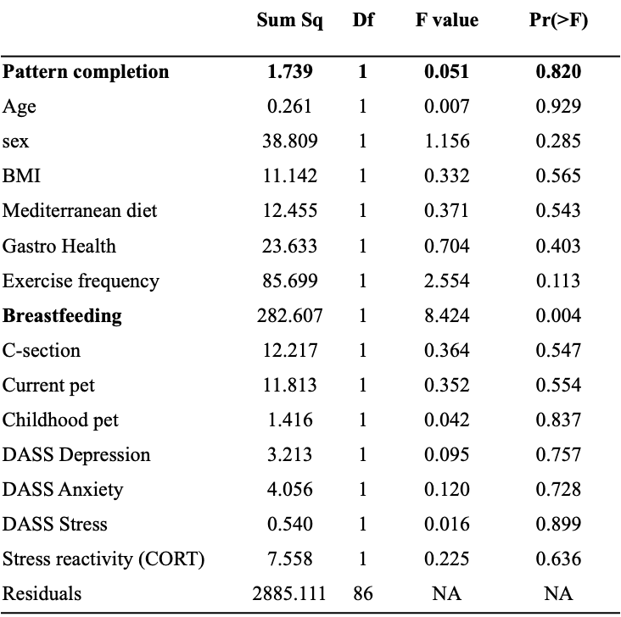
Table S1B. Multivariable ANOVA for Pattern Completion on Inverse Simpson Diversity.

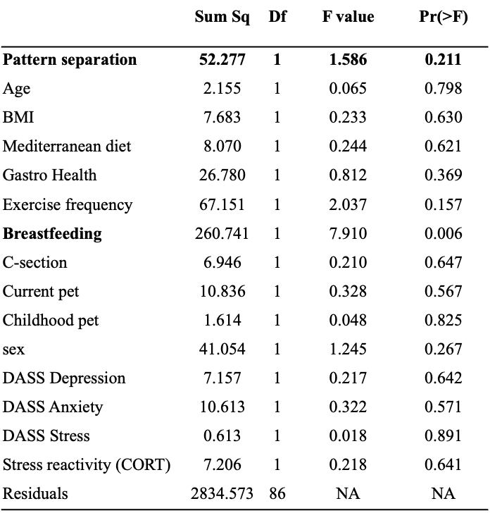
Table S1C. Multivariable ANOVA for Pattern Separation on Inverse Simpson Diversity.

 | Shannon | Shannon-rarefied | Observed-rarefied
item recognition | 0.07 | 0.07 | 0.09
breastfeeding | 0.01 | 0.01 | 0.02
pattern completion | 0.26 | 0.25 | 0.51
breastfeeding | 0.01 | 0.01 | 0.02
pattern separation | 0.81 | 0.84 | 0.32
breastfeeding | 0.01 | 0.01 | 0.02

Table S1D. Multivariable ANOVA for models. P-values are shown for Shannon diversity (unrarefied data) as well as Shannon and Observed in rarefied data.

- Multivariable PERMANOVA on Bray-Curtis Dissimilarity
 | Df | SumOfSqs | R2 | F | Pr(>F)
Item recognition | 1 | 0.395 | 0.017 | 1.866 | 0.037
age | 1 | 0.162 | 0.007 | 0.765 | 0.726
sex | 1 | 0.214 | 0.009 | 1.012 | 0.394
BMI | 1 | 0.184 | 0.008 | 0.869 | 0.607
Mediterranean diet | 1 | 0.315 | 0.014 | 1.489 | 0.115
Gastro health | 1 | 0.195 | 0.008 | 0.921 | 0.518
Exercise frequency | 1 | 0.241 | 0.010 | 1.140 | 0.285
Breastfeeding | 1 | 0.376 | 0.017 | 1.778 | 0.044
C-section | 1 | 0.181 | 0.008 | 0.855 | 0.613
Current pet | 1 | 0.152 | 0.006 | 0.719 | 0.782
Childhood pet | 1 | 0.456 | 0.020 | 2.154 | 0.015
DASS Depression | 1 | 0.327 | 0.014 | 1.547 | 0.086
DASS Anxiety | 1 | 0.167 | 0.007 | 0.790 | 0.649
DASS Stress | 1 | 0.197 | 0.008 | 0.931 | 0.475
Stress reactivity (CORT) | 1 | 0.165 | 0.007 | 0.779 | 0.712
Residual | 86 | 18.222 | 0.822 | NA | NA
Total | 101 | 22.146 | 1 | NA | NA
Table S2A. Multivariable PERMANOVA for Item recognition on Bray-Curtis dissimilarity at the species level, relative abundance with 999 permutations.

 | Df | SumOfSqs | R2 | F | Pr(>F)
Pattern Completion | 1 | 0.204 | 0.009 | 0.973 | 0.436
Age | 1 | 0.216 | 0.009 | 1.032 | 0.386
BMI | 1 | 0.186 | 0.008 | 0.889 | 0.580
Mediterranean diet | 1 | 0.326 | 0.015 | 1.558 | 0.108
Gastro Health | 1 | 0.227 | 0.010 | 1.085 | 0.322
Exercise frequency | 1 | 0.217 | 0.010 | 1.035 | 0.381
Creastfeeding | 1 | 0.359 | 0.016 | 1.716 | 0.066
C-section | 1 | 0.173 | 0.008 | 0.829 | 0.643
Current pet | 1 | 0.128 | 0.005 | 0.612 | 0.898
Childhood pet | 1 | 0.439 | 0.020 | 2.097 | 0.019
Sex | 1 | 0.203 | 0.009 | 0.968 | 0.436
DASS Depression | 1 | 0.327 | 0.015 | 1.559 | 0.090
DASS Anxiety | 1 | 0.204 | 0.009 | 0.976 | 0.431
DASS Stress | 1 | 0.191 | 0.008 | 0.911 | 0.503
Stress Reactivity (CORT) | 1 | 0.171 | 0.007 | 0.819 | 0.640
Residual | 86 | 18.033 | 0.831 | NA | NA
Total | 101 | 21.698 | 1 | NA | NA
Table S2B. Multivariable PERMANOVA for Pattern Completion on Bray-Curtis
Dissimilarity at genus level relative abundance with 999 permutations.

 |  | Df | SumOfSqs | R2 | F | Pr(>F)
Pattern separation |  | 1 | 0.205 | 0.009 | 0.982 | 0.411
Age |  | 1 | 0.222 | 0.010 | 1.060 | 0.346
sex |  | 1 | 0.202 | 0.009 | 0.966 | 0.434
BMI |  | 1 | 0.191 | 0.008 | 0.911 | 0.553
Mediterranean diet |  | 1 | 0.310 | 0.014 | 1.481 | 0.123
Gastro Health |  | 1 | 0.223 | 0.010 | 1.067 | 0.342
Exercise frequency |  | 1 | 0.214 | 0.009 | 1.023 | 0.401
breastfeeding |  | 1 | 0.357 | 0.016 | 1.704 | 0.066
C-section |  | 1 | 0.144 | 0.006 | 0.690 | 0.818
Current pet |  | 1 | 0.121 | 0.005 | 0.581 | 0.920
Childhood pet |  | 1 | 0.435 | 0.020 | 2.074 | 0.021
DASS Depression |  | 1 | 0.318 | 0.014 | 1.5174 | 0.097
DASS Anxiety |  | 1 | 0.216 | 0.009 | 1.034 | 0.366
DASS Stress |  | 1 | 0.190 | 0.008 | 0.908 | 0.506
Stress reactivity (CORT) |  | 1 | 0.172 | 0.007 | 0.820 | 0.641
Residual |  | 86 | 18.031 | 0.831 | NA | NA
Total |  | 101 | 21.698 | 1 | NA | NA
Table S2C. Multivariable PERMANOVA for pattern Separation on Bray-Curtis at genus level relative abundance with 999 permutations.

- Significant Single Taxa Associations for the Item Recognition Multivariable Model

feature | feature | coef | stderr | N | N.not.0 | pval | qval
s_Prevotella 9 copri | Item recognition | -1.321 | 0.336 | 108 | 21 | <0.001 | 0.177
f_Coriobacteriales incertae sedis | Sex | -1.563 | 0.389 | 108 | 29 | <0.001 | 0.177
o_DTU014 | Breastfeeding | -1.134 | 0.280 | 108 | 24 | <0.001 | 0.177
Table S3. Single feature significant associations were found with the multivariable model for item recognition (MaAsLin2, multivariable model).

- Differences in medians using Wilcoxon test. Median DASS Anxiety, DASS Depression, BMI, and Gastrointestinal symptoms between carriers and non-carriers of Prevotella copri.

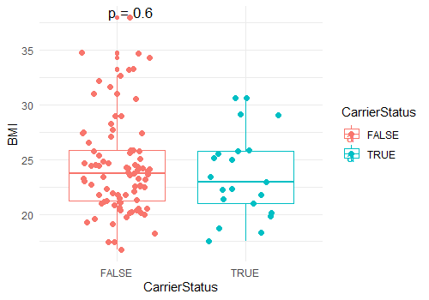 | 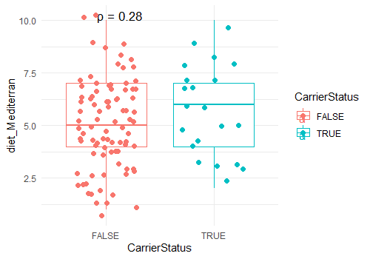
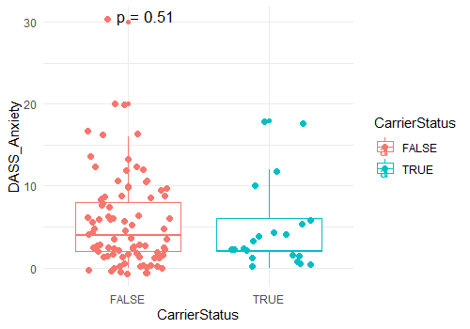 | 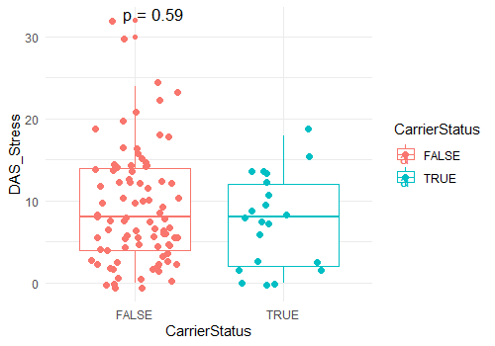
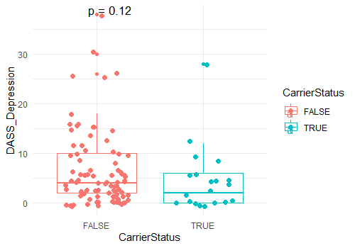 | 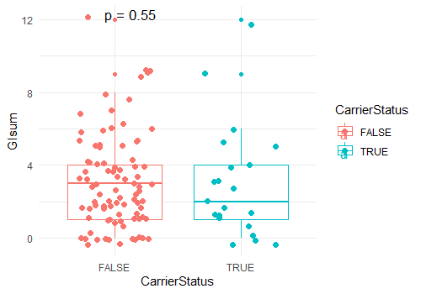
Figure S2. Median differences in health-related and psychological variables between P.copri carriers and non-carrier. Median DASS Anxiety, DASS Depression, BMI, and GISum (gastrointestinal symptoms) trended slightly higher in non-carriers, and Med diet score tended slightly higher in carriers, but there were no statistically significant differences in these variables between carriers and non-carriers.

- Exploratory analysis for Mediterranean diet.
feature | coef | stderr | N | N.not.0 | pval | qval
s__Dielma.fastidiosa | 0.171 | 0.049 | 108 | 20 | <0.001 | 0.164
g__Lachnospira | 0.457 | 0.142 | 108 | 46 | 0.001 | 0.183

Table S4. Single feature significant associations with the Mediterranean diet
(MaAsLin2, univariable model)

Although P. copri was not associated with the Mediterranean diet, caution is advised when using self-reported dietary questionnaires, as they can be subject to recall bias and memory inaccuracies. Nevertheless, the Mediterranean Diet Adherence Score (MEDAS) used in this study is a widely accepted and validated tool in nutritional epidemiology, providing a practical and reliable measure of dietary habits^{1–3}. Nevertheless, future studies could strengthen dietary assessments by incorporating objective biomarkers or detailed food frequency questionnaires (FFQs) to complement self-reported data.

- Stress reactivity protocol
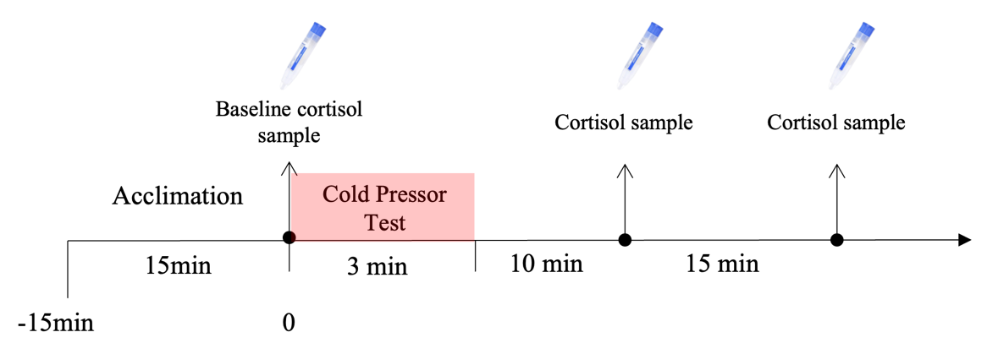
Figure S3. Cold Pressor Test protocol. The day after the Memory tasks, participants underwent The Cold Pressor Test (CPT)^{4,5}, which was used to provoke physical stress.
Participants were asked to submerge their non-dominant hand and arm into ice-cold water (0°C - 3°C). Saliva samples were collected to measure basal cortisol levels and cortisol response to the stressor. We collected one saliva sample before the CPT (baseline) and two samples at 10 and 25 minutes after the CPT. Right after the CPT, participants rated their level of unpleasantness on a scale from 1 to 10 (1 “not at all unpleasant” to 10 ”very much unpleasant”). On average, participants rated their experience as very unpleasant (average 8).

Figure S4. Distribution of stress reactivity measure by cortisol stressed-induce cortisol release. As an index of stress reactivity, we calculated the area under the curve between the three cortisol measures using the trapezoidal rule. AUC = 0.5 * 15 * (baseline cort + 2 * t10cort + t25cort). *AUC= area under the curve.

- Gastrointestinal Health Questionnaire

1. Have you been diagnosed with a functional gastrointestinal disorder (e.g., irritable
bowel syndrome, Crohn’s disease)? If so, please specify diagnosis and age of
diagnosis. -> Participants were discarded if they answered ‘Yes’ to this question.

2. Symptoms in the upper abdomen
A. In the last two months, how often did you have pain or an uncomfortable
feeling in the upper abdomen (above the belly button)? PLEASE TICK THE
CORRECT RESPONSE.
a. Never ___
b. 1 to 3 times per month ___
c. Once a week ___
d. Several times a week ___
e. Every day ___

B. Which of the following feelings did you have above the belly button? PLEASE
TICK THE CORRECT RESPONSE.
a. Pain ___
b. Nausea ___
c. Bloating ___
d. Feeling of fullness ___
e. Not being hungry after eating very little ___

3. Symptoms Lower abdomen
C. In the last two months, how often did you have pain or an uncomfortable
feeling in the lower abdomen (around or below the belly button)? PLEASE
TICK THE CORRECT RESPONSE.
a. Never ___
b. 1 to 3 times per month ___
c. Once a week ___
d. Several times a week ___
e. Every day ___

D. Which of the following feelings did you have below the belly button?
a. Pain ___
b. Nausea ___
c. Bloating ___
d. Feeling of fullness ___
e. Not being hungry after eating very little ___

4. In the last two months, how often did you have diarrhea? PLEASE TICK NEXT TO
THE CORRECT RESPONSE.
a. Never ___
a. 1 to 3 times per month ___
b. Once a week ___
c. Several times a week ___
d. Every day ___

5. In the last two months how often did you experience a feeling of bloating? PLEASE
TICK NEXT TO THE CORRECT RESPONSE.
a. Never ___
b. 1 to 3 times per month ___
c. Once a week ___
d. Several times a week ___
e. Every day ___

6. In the last two months, how often did you have constipation with compensatory
diarrhea? PLEASE TICK NEXT TO THE CORRECT RESPONSE.
a. Never ___
b. 1 to 3 times per month ___
c. Once a week ___
d. Several times a week ___
e. Every day ___

7. In the last two months, how often did you have constipation without
compensatory diarrhea? PLEASE TICK NEXT TO THE CORRECT RESPONSE.
a. Never ___
b. 1 to 3 times per month ___
c. Once a week ___
d. Several times a week ___
e. Every day ___
References
1. Schröder, H. et al. A Short Screener Is Valid for Assessing Mediterranean Diet Adherence among Older Spanish Men and Women. J. Nutr. 141, 1140–1145 (2011).
2. Martínez-González, M. A. et al. A 14-Item Mediterranean Diet Assessment Tool and Obesity Indexes among High-Risk Subjects: The PREDIMED Trial. PLOS ONE 7, e43134 (2012).
3. Hu, F. B. et al. Reproducibility and validity of dietary patterns assessed with a food-frequency questionnaire. Am. J. Clin. Nutr. 69, 243–249 (1999).
4. McRae Aimee L. et al. Stress reactivity: biological and subjective responses to the cold pressor and Trier Social stressors. Hum. Psychopharmacol. Clin. Exp. 21, 377–385 (2006).
5. Goldfarb, E. V., Mendelevich, Y. & Phelps, E. A. Acute Stress Time-dependently Modulates Multiple Memory Systems. J. Cogn. Neurosci. 29, 1877–1894 (2017).

