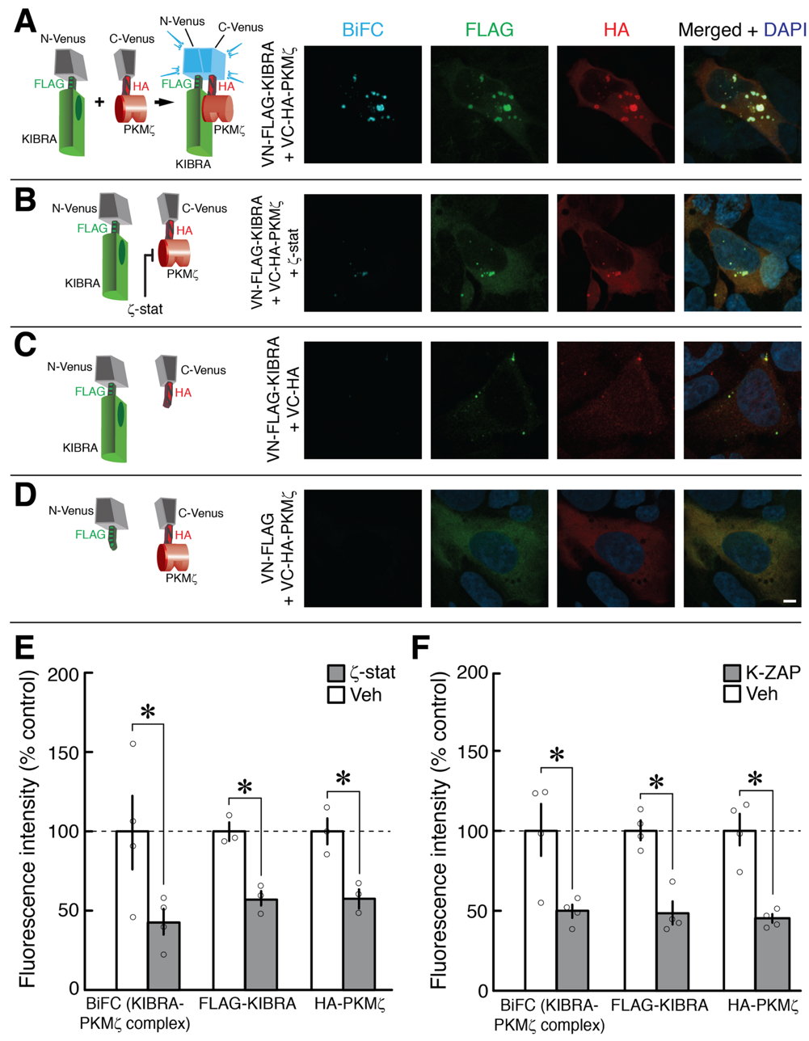

Supplementary Figure 1. KIBRA-PKMζ antagonists decrease KIBRA-PKMζ interaction and lower total KIBRA and PKMζ levels. (A-D) Left, schematics of Venus-fusion constructs used in BiFC experiments. Right, representative images of HEK293T cells 1 day after transfection. Left column, BiFC (cyan); middle columns, immunocytochemistry for FLAG-tagged KIBRA (green) and HA-tagged PKMζ (red); right column, merged images with nuclear stain DAPI (blue). (A) BiFC produced by co-transfection of N-terminal-Venus FLAG-tagged KIBRA and C-terminal-Venus HA-tagged PKMζ shows accumulation of intracellular aggregates of KIBRA-PKMζ complexes. (B) ζ-stat (10 μM) decreases BIFC as well as total levels of KIBRA and PKMζ. (C) Co-transfection of the N-terminal-Venus FLAG-tagged KIBRA and the C-terminal-Venus tagged with HA but without PKMζ shows minimal BiFC. (D) Co-transfection of C-terminal-Venus HA-tagged PKMζ and N-terminal-Venus tagged with FLAG but without KIBRA shows minimal BiFC. Scale bar, 5 µm. (E, F), means of total immunofluorescence intensities per field of BiFC, FLAG, and HA ± SEM show (E) ζ-stat and (F) K-ZAP (10 µM) decrease BiFC, total KIBRA, and total PKMζ immunofluorescence intensities (E: t₃ = 3.39, P = 0.04, d = 1.69; t₂ = 10.09, P = 0.010, d = 5.82; t₂ = 12.69, P = 0.006, d = 7.33; F: t₃ = 4.00, P = 0.03, d = 2.00; t₃ = 6.24, P = 0.008, d = 3.12; t₃ = 6.08, P = 0.009, d = 3.04, respectively). * denotes P < 0.05. Experiments described in Tsokas et al., Science Adv., 10, eadl0030 (2024).
Method: To measure fluorescence intensity of BiFC, FLAG-KIBRA, and HA-PKMζ, the images were converted to grayscale using ImageJ 1.52n. Individual cells were outlined using freehand or wand selection tools and added to the region of interest manager. Fluorescence intensity was extracted from each channel for individual cells using the Multi Measure algorithm.
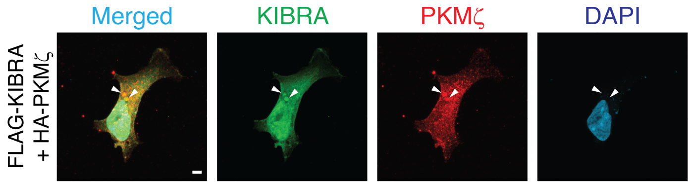

Supplementary Figure 2. Co-transfection of FLAG-tagged KIBRA and HA-tagged PKMζ without N-terminal or C-terminal Venus shows co-localization in aggregates. Transfections in HEK293T cells were performed as described in Tsokas et al., Science Adv., 10, eadl0030 (2024). Aggregates are shown at arrowheads. Scale bar, 5 µm.

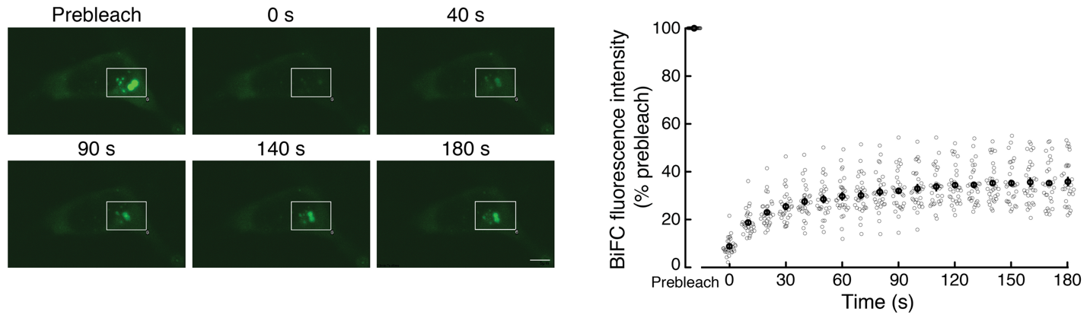

Supplementary Figure 3. Fluorescence recovery after photobleaching (FRAP) of BiFC shows aggregates contain a mobile pool of KIBRA-PKMζ complexes. The mobile fraction is detected by recovered fluorescence measured within a photobleached region of interest (white rectangle). Left, representative experiment, with postbleaching times denoted. Right, mean (black open circles) ± SEM; n = 30 (10 cells from each of 3 independent HEK293T cultures; individual experimental data shown in grey open circles). Compared to prebleach, the signal is significantly different using Bonferroni correction for multiple comparisons at the first time point postbleaching (prebleach vs. 0 s, paired t₂₉ = 136.60, P < 0.000001), and the signal at 180 s is significantly increased compared to the first postbleaching time point (0 s vs. 180 s, paired t₂₉ = 18.54, P < 0.000001).
Method: FRAP was performed using an Olympus FluoView FV1000 inverted confocal microscope equipped with a UPLSAPO 60X (NA 1.35) objective (Olympus, Tokyo, Japan) and a stage-top incubator. HEK293T cells were co-transfected with N-terminal-Venus FLAG-tagged KIBRA and C-terminal-Venus HA-tagged PKMζ, as previously described (Vogt-Eisele et al., J. Neurochem., 128:686 [2013]; Tsokas et al., Science Adv., 10, eadl0030 [2024]) and maintained at 37°C in a humidified atmosphere with 5% CO₂. A region of interest with KIBRA-PKMζ BiFC aggregates was photobleached using a 405-nm SIM Tornado laser (Olympus) at 60% power for 500 ms. Fluorescence recovery in the region of interest was monitored at 488 nm by acquiring images at time intervals denoted in the figure. Image acquisition was performed using Olympus FluoView software, and analysis was conducted with ImageJ software (NIH). Fluorescence intensity of the region of interest from each time interval was extracted using the Series Analysis Timelapse algorithm from Olympus FluoView software, and further analysis was conducted with ImageJ software (NIH). Fluorescence intensity of the photobleached area at each time point was background-corrected and expressed as the change in intensity relative to the prebleach intensity set at 100%. Because photobleaching includes areas outside the aggregates, the horizontal asymptote is likely an underestimate of the mobile fraction.

