Experimental Procedure
Monkeys were first trained on the match-to-sample task described in the manuscript using a set of four full color images (i.e. in the working memory condition). The memory delay for the task was titrated separately for each monkey until they achieved an accuracy between 45% and 70% correct. After any 120-trial session where accuracy was above 70% correct, 4 seconds were added to the memory delay. After sessions with accuracy below 45% correct, 2 seconds were subtracted from the memory delay. The delay was never decreased to less than 5 seconds.
After each monkey achieved an accuracy within the criterion range on two consecutive sessions of 120 trials, the metamemory choice stimuli to accept or decline trials were added. From that point on, each session of 120 trials consisted of 60 trials on which choice to take or decline the trial was presented before the test stimuli (the prospective condition), and 60 trials on which the metamemory choice was presented while the test stimuli were presented on screen but dimmed and not selectable (the concurrent condition). On 1/3 of all trials (20 in the prospective and 20 in the concurrent condition) the option to decline a trial was removed, so monkeys had to take the memory test to continue the task. These forced trials were the only ones used to titrate accuracy for each monkey from this point on, and accuracy was calculated across prospective and concurrent trials combined.
Once monkeys began testing with the metamemory choices, the number of touches required to complete the motor task after declining a trial was titrated for each monkey, to ensure they used both the accept and decline responses. After 120-trial sessions where a monkey rejected memory tests on more than 70% of trials, 4 touches were added to the criterion to complete the motor task. After sessions where a monkey rejected less than 35% of trials, 2 touches were subtracted from the touches required to complete the motor task, but the total number of touches required was never less than 2. Titrating memory delay to maintain the accuracy range described previously continued during this phase as well. After each monkey completed two consecutive sessions of 120 trials with both accuracy and decline rate in the criterion range, we continued testing each monkey until 30 sessions were completed with accuracy and decline range still within those ranges on average. These last 30 sessions were used to measure memory accuracy and metamemory benefit in the prospective and concurrent choice conditions. Memory delay and touches required to complete the motor task continued to be titrated based on accuracy and decline rate for each monkey over the course of the data collection phase using the same rules when monkeys completed a session outside of the criterion range, but the average across all 30 sessions had to be within the criterion range.
Consecutive trials were separated by an intertrial interval of 1 second after correct or declined trials, and a timeout after incorrect trials equal to half the duration of the memory delay for that monkey. Completing the motor task after a declined trial yielded one food pellet, while completing the memory test correctly yielded two food pellets. Incorrect trials, whether forced or accepted, were not rewarded.
This entire process was repeated with a large set of 12,000 images, including the titration of accuracy and decline rate, which was done separately for each monkey on each image set. Because memory accuracy on the familiarity task remains comparatively high even after longer memory delays, accuracy in the familiarity task was titrated by degrading the amount of information available in each image (Supp. Fig. 1). Thirty sessions of 120 trials were again collected after each monkey completed 2 consecutive sessions in which accuracy and decline rate were in the desired range.
Finally, to evaluate whether any differences between performance with the large set and small set of images were due to degradation of the large set of images, we repeated the entire process a third time using a small set of four images that were degraded using the same method as the large image set, and 30 sessions of 120 trials were once again collected.

Supp. Table 1: Results of the mixed effects logistic regression model. The model was fitted using the formula:
“Trial Outcome ~ Stimulus Set * Metamemory Choice * Choice Timing + (1 | Monkey)”

Random effect | Variance | Std.Dev.
Monkey (Intercept) | 0.028 | 0.168
Fixed effects | Estimate | SE | -95%CI |  | Z value | p-value
Fixed effects | Estimate | SE | LL | UL | Z value | p-value
(Intercept) | 0.567 | 0.077 | 0.416 | 0.718 | 7.407 | <.0001
Stimulus Set-LSD | 0.062 | 0.049 | -0.034 | 0.158 | 1.267 | 0.205
Stimulus Set-SSD | 0.019 | 0.049 | -0.077 | 0.115 | 0.398 | 0.691
Meta Choice-Accepted | 0.289 | 0.05 | 0.191 | 0.387 | 5.746 | <.0001
Timing-Concurrent | -0.08 | 0.048 | -0.174 | 0.014 | -1.648 | 0.099
Stimulus Set-LSD ×  Meta Choice- Accepted | 0.105 | 0.072 | -0.036 | 0.246 | 1.464 | 0.143
Stimulus Set-SSD ×  Meta Choice- Accepted | -0.015 | 0.071 | -0.154 | 0.124 | -0.214 | 0.831
Stimulus Set-LSD ×  Timing-Concurrent | 0.033 | 0.069 | -0.102 | 0.168 | 0.472 | 0.637
Stimulus Set-SSD ×  Timing-Concurrent | 0.03 | 0.069 | -0.105 | 0.165 | 0.442 | 0.658
Meta Choice- Accepted ×  Timing-Concurrent | 0.053 | 0.071 | -0.086 | 0.192 | 0.741 | 0.459
Stimulus Set-LSD ×  Meta Choice- Accepted ×  Timing-Concurrent | 0.222 | 0.103 | 0.020 | 0.424 | 2.161 | 0.031
Stimulus Set-SSD ×  Meta Choice- Accepted ×  Timing-Concurrent | 0.012 | 0.101 | -0.186 | 0.210 | 0.12 | 0.905
LSD: Large set of degraded images; SSD: Small set of degraded images
Supp. Fig. 1 Sample stimuli from the image degradation procedure used in the large set degraded and small set degraded conditions. Full color images were degraded using a filter in the image processing software Photoshop, and the process was repeated to degrade the images further for monkeys whose memory accuracy on the large set of degraded images was above 75% correct, until accuracy fell between 45% and 70% correct.

Supp. Fig. 2: Panel A: Mean prospective and concurrent metamemory benefits in tests with different stimulus sets plotted separately for each monkey as accuracy on accepted trials minus forced trials. Higher scores indicate better metamemory. This plot corresponds to the analysis by t-test described in the text. Panel B: The same accuracy data with forced and accepted trials plotted separately for each monkey separately. Panel B matches the generalized linear mixed model. Pro: Prospective metamemory choice, Con: Concurrent metamemory choice.
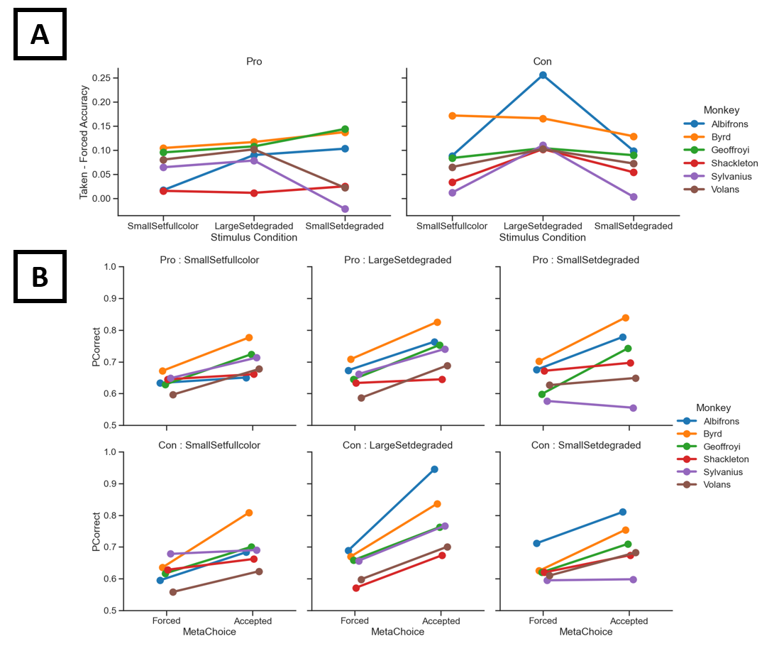

Supp. Fig. 3: Mean memory retention interval for each monkey under each set of conditions in the study. Retention interval was titrated for each monkey individually to match accuracy across tests with different image sets. Intervals were close to identical for each monkey between prospective and concurrent metamemory trials, which is critical to comparing these conditions. Retention intervals were markedly different between the different stimulus sets due to the accuracy titration procedures used to equate accuracy with different image sets. Pro: Prospective metamemory choice, Con: Concurrent metamemory choice.
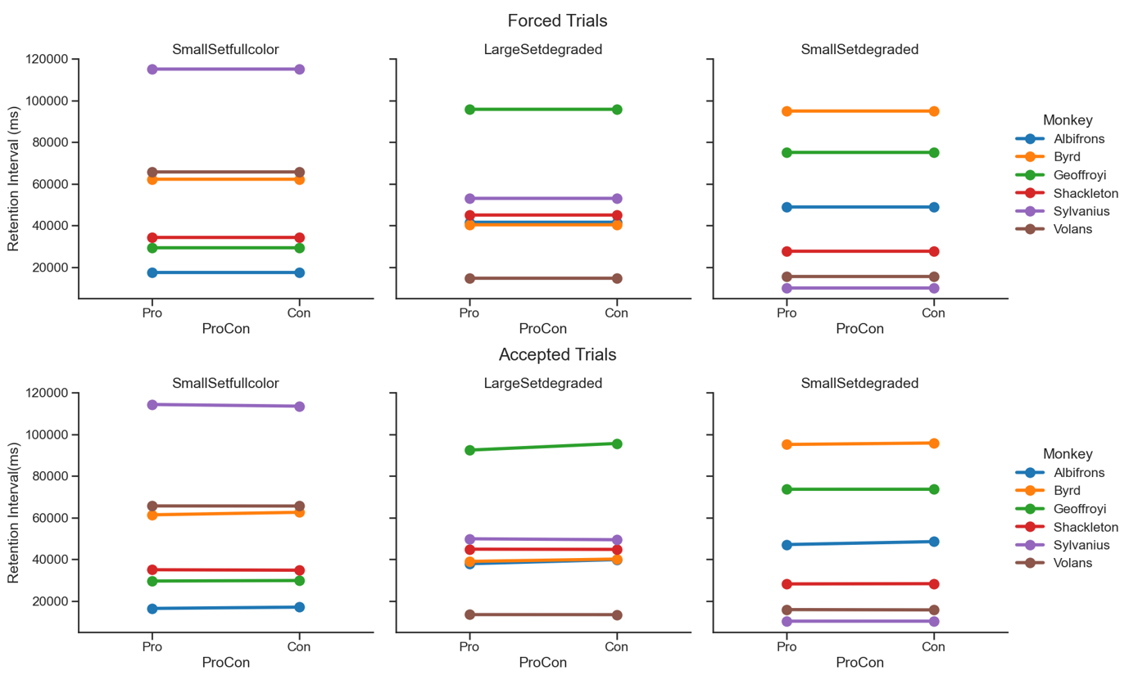

Supp. Fig. 4: Mean accuracy on forced trials across the last 30 testing sessions for each monkey in the study. Accuracy is plotted as a separate line for each monkey, and the dashed black lines refer to the target accuracy range (45-70%). Whenever a monkey completed a session outside of this range, their memory retention interval was modified to titrate their accuracy back into the target range. Pro: Prospective metamemory choice, Con: Concurrent metamemory choice.
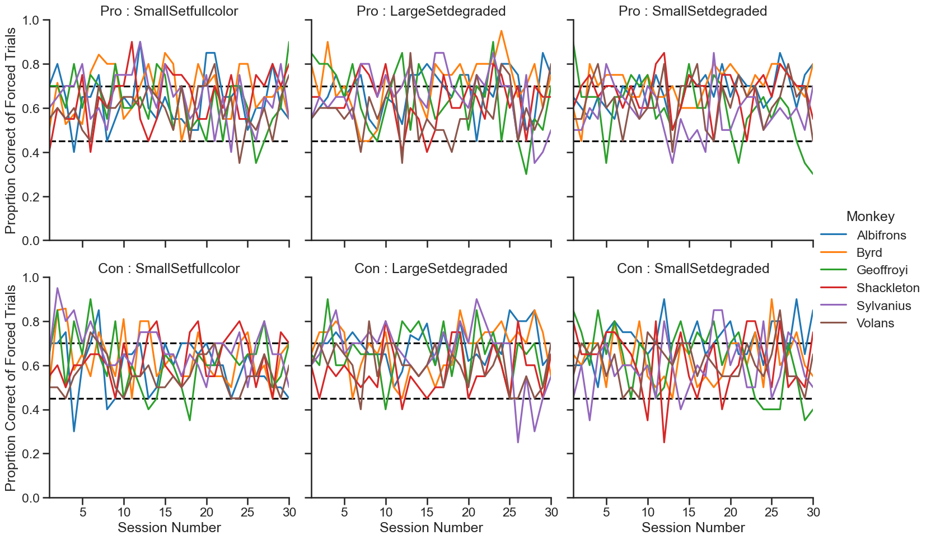

Initial statistical analysis
For our first analysis of metamemory, we performed a 3 (stimulus set: small full color, large degraded, small degraded) × 2 (metamemory choice timing: prospective, concurrent) within-subjects ANOVA on arcsine-transformed proportion of correct trials in each condition. Using this analysis, we found a significant main effect of the stimulus set (F(2,10)=4.344, p=.044, η²=.136), but not the timing of the metamemory choice (F(1,5)=2.522, p=.173, η²=.049), nor the interaction between the two factors (F(2,10)=2.341, p=.147, η²=.050). We report an analysis using mixed-effects logistic regression in the full manuscript (and Supp. Table 1), which models the probability of a given trial being correct on each condition by each monkey rather than a proportion from each monkey in each condition, thereby significantly increasing the statistical power of the analysis.

