Supplementary Figure 1. PNN counts. No sex differences were observed in the PL (A), the BLA (B), or the DH (C). Advanced age corresponded with reduced PNNs in the PL (D), but not BLA (E) or DH (F). Individual images are depicted as small dots, whereas averages per individual animal are depicted as larger dots. # p < 0.10.

Supplementary Figure 2. Levels of K48 presented as a proportion of DAPI present on the same section. No sex differences were observed in the PL (A), the BLA (B), or the DH (C). Advanced age did not correspond with differences in K48 in the PL (D), BLA (E), or DH (F). Individual images are depicted as small dots, whereas averages per individual animal are depicted as larger dots.

Supplementary Figure 3. Heatmaps depicting correlations between zif268 expression, PNN amount, and K48 polyubiquitin tagging in the PL (left), BLA (middle), and DH (right). * p < 0.05

Region | Sex | zif268 | WFA | K48
PL | M |  | 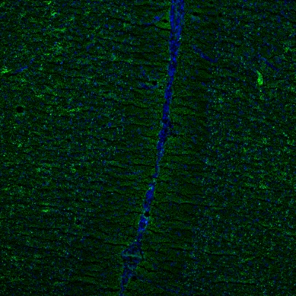
PL | F |  | 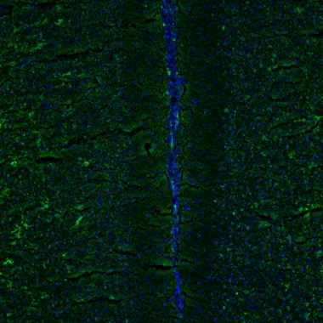
BLA | M |  | 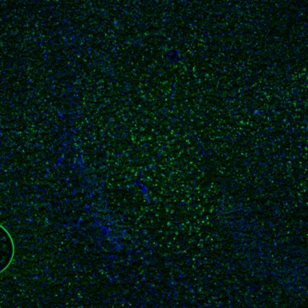
BLA | F |  | 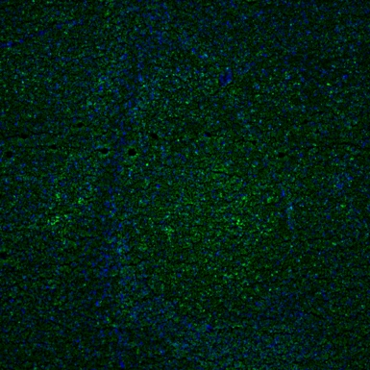
DH | M |  | 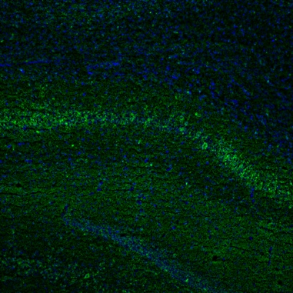
DH | F |  | 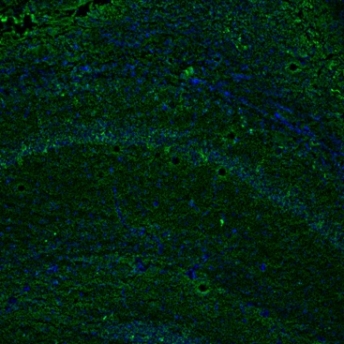
Supplementary Figure 4. Images showing staining in each region of interest for each stain for each sex. In each, the primary stain is green and the DAPI stain is blue. Zif268 and K48 were images at 20X and WFA was imaged at 10X.

We had three animals aged 670 where the median split was applied, we ran additional analyses without these animals included, both behaviorally and for all molecular analyses where age group was considered. These are below.
Age Group | Statistic | Acquisition |  |  | CS Test |  | Context Test
Age Group | Statistic | Pre | CS-US | Post | Pre | CS | Context Test
Aged | Mean | 16.9369 | 65.5522 | 49.2664 | 31.9650 | 63.3036 | 51.6509
Aged | N | 7 | 7 | 7 | 7 | 7 | 7
Aged | SD | 16.84876 | 20.77307 | 25.95927 | 23.90361 | 29.04620 | 31.50835
Advanced Age | Mean | 2.5167 | 56.4883 | 54.0288 | 12.2244 | 36.1847 | 46.1603
Advanced Age | N | 8 | 8 | 8 | 8 | 8 | 8
Advanced Age | SD | 2.23699 | 14.89182 | 21.46525 | 14.27378 | 27.96772 | 21.28263

Acquisition. A 2 (Group: Aged, Advanced Age) x 3 (Time Period: Pre, CS-US, Post) ANOVA conducted during the training phase found a main effect of time, F_{(2, 26)} = 101.27, MSE = 110.01, p < 0.001, h_{p}² = .89, no main effect of group, F < 1, and an interaction that did not meet criteria for significance, F_{(2, 26)} = 3.33, MSE = 110.01, p = 0.052, h_{p}² = .20.
CS Test. We conducted a 2 (Age: Aged, Advanced Age) x 2 (Time Period: Pre-CS, CS) to examine responding during the CS test based on age. This found main effects of time, F_{(1, 13)} = 12.67, MSE = 450.71, p = 0.003, h_{p}² = .49, and age, F_{(1, 13)} = 5.59, MSE = 733.29, p = 0.034, h_{p}² = .30, but no interaction, F < 1. As before, the animals in the advanced age group seemed to show overall lower levels of freezing compared to aged animals, while both groups showed an elevation in CS responding relative to the pre-CS period.
Context Test. A t-test found rats did not differ in freezing to the context based on age, t₍₁₃₎ = 0.40, p = 0.695.
Zif268. When comparing zif268 in the three ROIs using t-tests, we found that advanced age decreased zif268 expression in the PL (t₍₆₎ = 3.37, p = 0.015) but there were no group differences in either the BLA (t₍₉₎ = 0.57, p = 0.582) or DH (t₍₉₎ = 1.84, p = 0.099).
K48. As before, we found no differences in any region in K48 expression based on age (largest t = 1.00, p = 0.346).
PNNs. No differences were found in PNN amount in any ROI (largest t = 0.723, p = 0.488).

