Supplementary Information

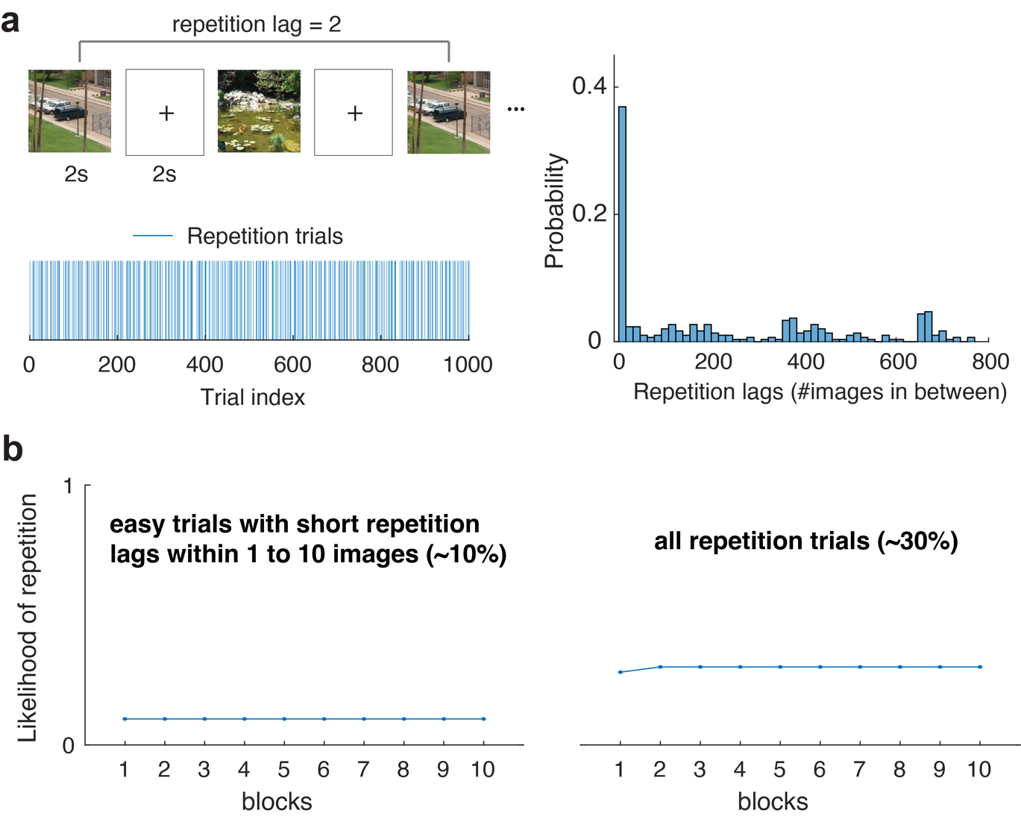
Figure S1. Design of the continuous recognition memory task. (a) Repetition schedule for the continuous recognition condition. Participants perform the continuous recognition memory task with 100 images per block across various experimental blocks (up to 10). For each block, 10% of trials contain an item that immediately repeats with a lag of 1-10 images from those within the same session. Additionally, 20% of trials contain an item that repeats from images previously shown before with a uniform lag distribution (see the right panel). In this context, the repetition lag refers to the number of images between two identical images since the first encounter of a repeated image. (b) In this design, the likelihood of repetition is uniform across experimental blocks at 30%, with 10% easy trials featuring a short repetition lag within 1 to 10 images. Therefore, this design should not artificially influence the response criterion, even if more repetitions were more likely toward the end of the experiment (Allen et al. 2022).

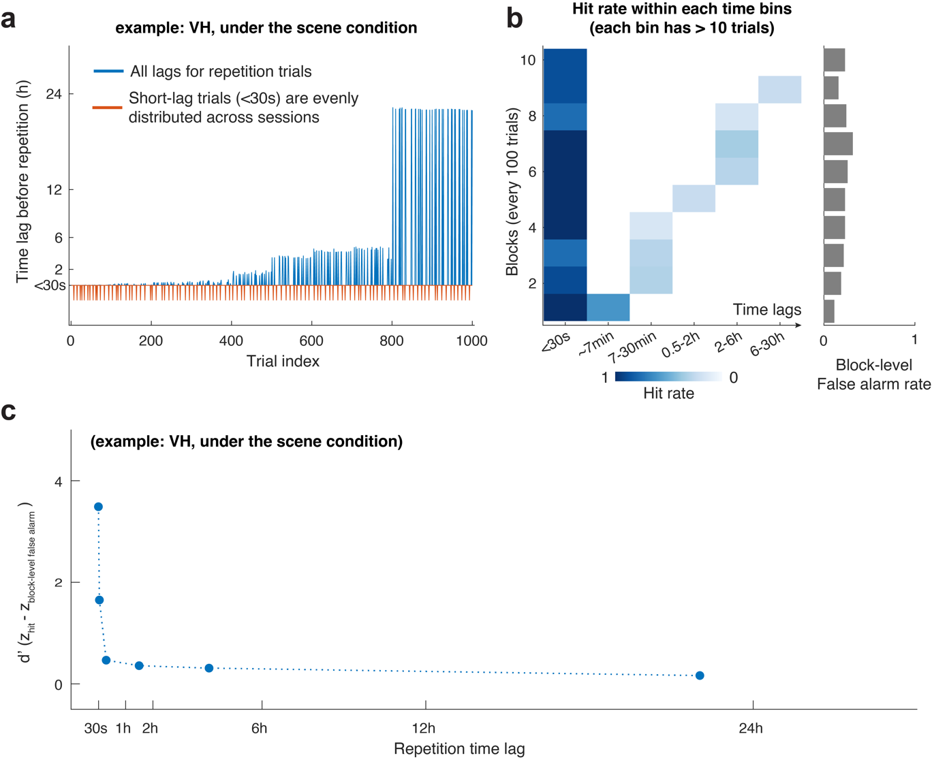
Figure S2. Analysis of the continuous recognition memory task. (a) Example repetition time lags observed from VH under the scene continuous recognition condition. Participants are allowed to take untimed rests between experimental blocks in this task, leading to naturally jittered repetition time lags for images across blocks. Additionally, our current design introduces a natural separation between immediate (repetition time lag < 30s, marked in red) and overnight test conditions (repetition time lag of approximately 24 hours, marked in blue) due to the variation in completion times across days. (b) Analyzing the continuous recognition task involves considering participants’ correct repetition detection (hit rate) for images tested at diﬀerent time bins of repetition duration, along with their tendency for false recognition (false alarm rate) within each experimental block during data collection. To ensure a reliable estimate of the time-dependent hit rate, we retained time bins with more than 10 trials identified as repetition trials. Importantly, because the likelihood of image repetition is strictly controlled at around 30% in each experimental block, participants’ tendency to report seeing a new item does not systematically vary across experimental sessions (see example data in the right panel). (c) Consequently, participants’ corrected recognition accuracy at each time bin can be quantified as the time-dependent hit rate minus the block-level false alarm rate. Using this metric, our data reveal the canonical forgetting curve often reported in the literature (Allen et al. 2022; Jenkins and Dallenbach 1924).

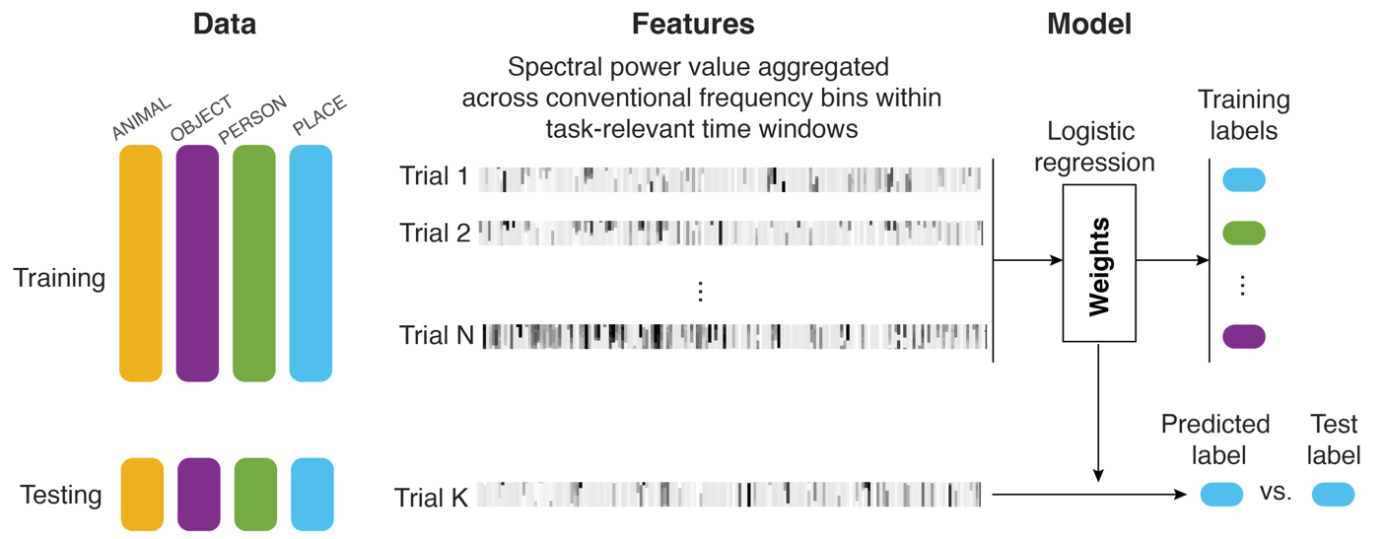

Figure S3. Building a logistic regression classifier. For each trial type (taxonomic categories: ANIMAL, OBJECT, PERSON, PLACE), we constructed and tested a classifier using spectral power values aggregated across conventional frequency bins (θ: 4-8Hz, α: 8-16Hz, β: 16-32Hz, γ: 32-70Hz, high-frequency broadband: 70-150Hz) from stimulus onset to the median reaction time (RT) as training and testing datasets. In each iteration, we employed the training data to build a classifier using a one-versus-all logistic regression model with regularization (Xie et al. 2024). Subsequently, we applied the training weights to the independent testing data to predict the label of the test stimulus. If this predicted label matched the test stimulus label, the classification was considered accurate; otherwise, it was considered inaccurate. We conducted this analysis using both individual time windows of the task (see Figures 2c and 2e) and aggregated data across all critical time windows from stimulus onset to the median reaction time (RT, 848 ms). In the former case, the features used in the classifier were the spectral power values at a single time window, with the feature length equivalent to the product of the number of frequency bins and the number of electrodes. In the latter case, the features used in the classifier were the spectral power values across time windows, with the feature length equivalent to the product of the number of frequency bins, the number of electrodes, and the number of time windows.

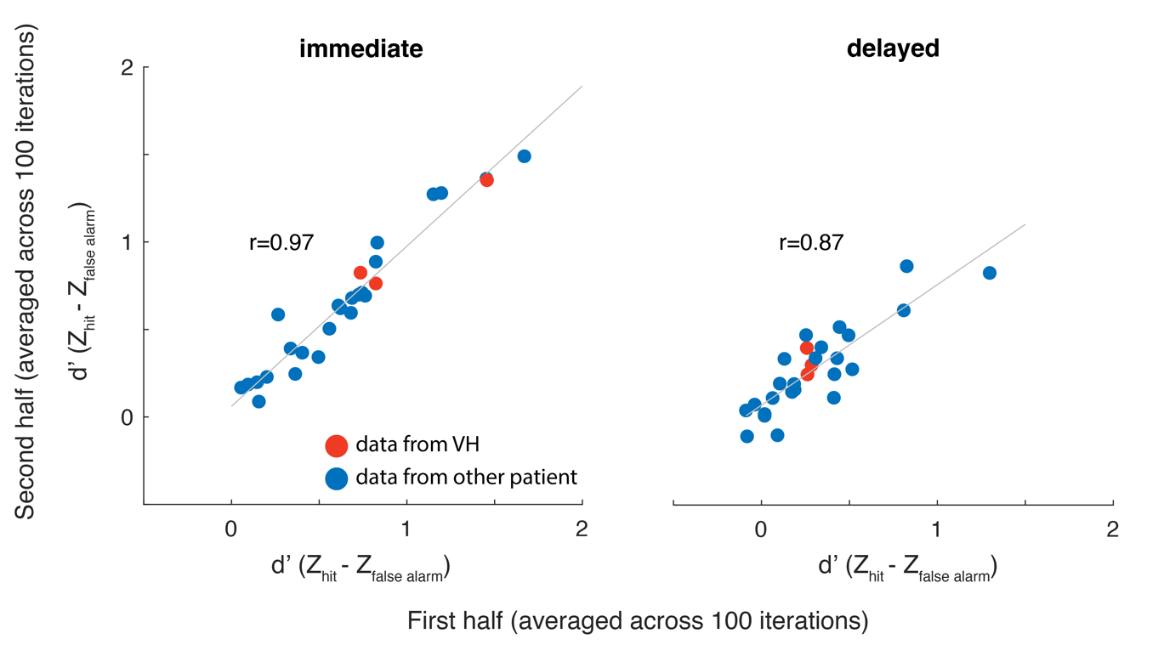
Figure S4. Reliability of immediate and delayed visual recognition memory task performance in the patient population. As participants completed a modest number of trials in the conventional recognition memory task for each stimulus condition outlined in Figure 3, questions remain regarding the extent to which the current measures reliably capture participants’ memory performance. To address this, we performed a split-half analysis by randomly dividing the data into halves (100 iterations) and calculating participants’ task performance in each half separately. We then averaged these resampled task performance estimates across iterations to obtain a robust measure of split-half correlation, gauging the within-subject reliability of the current recognition task performance (see Xie et al. 2020c for details). In the patient population, which includes VH (marked in red) and other neurological participants (marked in blue) who completed the immediate and delayed recognition memory tasks, task performance was highly reliable across random data halves, with an uncorrected correlation measure exceeding 0.80. Each data point represents data from one stimulus category for one participant. Immediate and delayed task performance were calculated separately.

Supplementary Table S1. Demographic information and clinical characteristics of the neurological cases

Study | SubID | Age | Gender | IQ | Ethnicity | Language Dominance | Handed-ness | Diagnosis | Is PPA intact
In all studies | VH | 36 | M | 103 | W | L | R | left temporal epilepsy | lesioned
Im. & delayed | C1 | 50 | F | NA | W | L | R | left temporal epilepsy | intact
Im. & delayed | C2 | 41 | F | 97 | AA | L | R | right temporal lobe epilepsy | intact
Im. & delayed | C3 | 37 | F | 72 | HS | L | R | right temporal lobe epilepsy | intact
Im. & delayed | C4 | 25 | M | 81 | AA | L | R | left frontal epilepsy | intact
Im. & delayed | C5 | 29 | F | 69 | W | L | R | bilateral parietal heterotopia | intact
Im. & delayed | C6 | 42 | F | 97 | W | L | R | left temporal epilepsy | intact
Im. & delayed | C7 | 40 | F | 64 | HS | L | R | left temporal and insular epilepsy | intact
Im. & delayed | C8 | 44 | F | 60 | AA | L | L | left temporal epilepsy | intact
Continuous | C9 | 37 | M | 81 | AS | L | R | left temporal lobe epilepsy | intact
Continuous | C10 | 34 | M | 107 | W | L | R | left frontal encephalomalacia | intact
Continuous | C11 | 53 | M | 84 | HS | L | R | right temporal lobe epilepsy | intact
Continuous | C12 | 46 | M | 79 | W | L | R | left posterior temporal epilepsy, low grade tumor | intact
Continuous | C13 | 41 | M | 76 | W | L | R | right peri-insular heterotopia | intact
Continuous | C14 | 22 | M | NA | AA | L | R | left temporal lobe epilepsy | intact
Continuous | C15 | 17 | F | NA | HS | L | L | right occipital epilepsy | intact
Continuous | C16 | 30 | M | 94 | W | L | L | bitemporal epilepsy | intact
Continuous | C17 | 32 | F | NA | AA | L | R | left temporal lobe epilepsy | intact
Continuous | C18 | 42 | M | 89 | AA | L | R | bitemporal epilepsy, right insular epilepsy | intact
Continuous | C19 | 41 | F | 97 | W | L | R | right temporal lobe ganglioglioma | intact
Continuous | C20 | 40 | M | 114 | W | L | L | right temporal lobe pleomorphic xanthoastrocytoma | intact

Note: W = White; AA = African American; HS = Hispanic; AS = Asian; L = Left; R = Right; Im. & delayed = Immediate & delayed recognition memory task; Continuous = Continuous recognition memory task.

