SUPPLEMENTAL MATERIALS

Early-life Adversity Recruitment and Scoring
All recruitment and ELA grouping procedures were preregistered (osf.io/d8cy2). Participants were coded as being exposed to ELA if they met the following criteria: 1) Scored greater than or equal to the validated cutoff scores (Bifulco et al., 2005) on any of the subscales on the CECA (Physical Abuse – caregiver 1: ≥ 1; Physical Abuse – caregiver 2: ≥ 1; Sexual Abuse Screen: ≥ 1). 2) Scored greater than or equal to the validated cutoff scores (Bernstein et al., 1997) on any of the subscales on the CTQ (Sexual Abuse: ≥ 9; Physical Abuse: ≥ 12). 3) Endorsed (i.e., answered "Yes") to any single relevant question on the JVQ-R2 (question numbers: 4-7, 9,10,14-16,19-23, 27-30, 32-34). Many participants met multiple ELA criteria (Fig. S1). A continuous measure of ELA severity was calculated by summing and standardizing the JVQ and adding it to a standardized combination of the three CTQ abuse sub-scales, similar to methods used in previous work (Lambert et al., 2017).

A pilot sample of N = 31 was collected to assess the level of ELA exposure in the online participant population. Seventy one percent of this sample (N = 22) were coded as being exposed to severe ELA according to our pre-registered criteria. Because this is commensurate with population-level studies of ELA exposure in U.S. adults (Green et al., 2010), we continued data collection. However, part way through data collection we modified our recruitment procedures due to unpredictably high levels of ELA exposure (at the time of procedure change, approximately 86% of possible participants met criteria for severe ELA exposure). This recruitment modification was formally amended in the preregistration.

FIGURE S1. ELA group inclusion criteria distribution across participants. Approximately half of the ELA group participants met group inclusion based on two or more criterion, with many reporting multiple types of adversity across multiple measures.
Psychopathology Questionnaires
After data collection for Sessions 1 and 2 was completed, but prior to data analysis, we added an exploratory session (i.e., not pre-registered) to collect psychopathology measures to test whether potential relationships between ELA and task behavior was related to current clinical outcomes. We also wanted to verify that our sample of ELA-exposed participants had expected increases in psychopathology, based on prior work showing this association (Green et al., 2010; Kessler et al., 2010; McLaughlin et al., 2010, 2012). N = 121 of our original participants completed a third online study session (71 women, 47 men, 3 other; N = 60 no-ELA, 61 ELA; ages 18-78, mean = 34.81). In Session 3, participants completed the Alcohol Use Disorders Identification Test (AUDIT), the Beck Depression Inventory (BDI-II), the Emotion Regulation Questionnaire (ERQ), the Coping Styles Questionnaire (CSQ), the Generalized Anxiety Disorder scale (GAD-7), the Rotter Locus of Control scale (LOC), the Life Orientation Test (LOT-R), the Patient Health Questionnaire (PHQ-9), the State-Trait Anxiety Inventory (STAI), and the Temporal Distance Questionnaire (TDQ). Participants also completed a pilot version of the McLaughlin Deprivation-Threat Scale, but this was not included in their ELA quantification and results are not reported here. The CSQ, ERQ and TDQ were used for a separate study and will not be reported here.
Participants in the ELA group had significantly more psychopathology-related outcomes compared to those in the no-ELA group. Specifically, the ELA group had increased levels of depression (BDI-II and PHQ-9) and anxiety (GAD-7 and STAI-S/STAI-T), more external locus of control (LOC), and were more pessimistic (LOT-R). There were no group differences on a measure of alcohol use disorders (AUDIT). See Table S1 for statistical details and Figure S2 for visualizations.
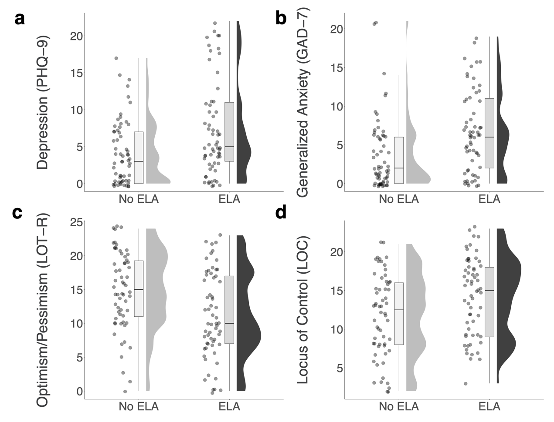
FIGURE S2. Participants with prior exposure to ELA differ from those without prior ELA exposure on multiple psychopathology measures. Shown here, participants in the ELA group have: a) increased levels of depression (PHQ-9), b) increased levels of anxiety (GAD-7), c) increased pessimism (LOT-R), and d) more external locus of control (LOC). (Note: Points that appear below 0 are due to jitter).

MEASURE | RESULTS
Beck Depression Inventory (BDI-II) | W = 1298, p = 0.005, CI = [-8.000, -1.000]
Patient Health Questionnaire (PHQ-9) | W = 1327, p = 0.009, CI = [-4.000, -0.000]
Generalized Anxiety Disorder scale (GAD-7) | W = 1190.5, p = 0.001, CI = [-4.999, -0.999]
State-Trait Anxiety Inventory - State (STAI-S) | W = 1392.5, p = 0.023, CI = [-11.000, -0.999]
State-Trait Anxiety Inventory - Trait (STAI-T) | t(119) = -2.620, p = 0.010, CI = [-10.667, -1.484]
Rotter Locus of Control scale (LOC) | W = 1365.5, p = 0.016, CI = [-4.000, -0.000]
Life Orientation Test (LOT-R) | t(119) = 3.291, p = 0.001, CI = [1.449, 5.825]
Alcohol Use Disorders Identification Test (AUDIT) | W = 1690, p = 0.461, CI = [-0.999, 0.000]
Table S1. Statistical details for group differences on psychopathology measures. Non-parametric t-tests (Mann-Whitney Wilcoxon sum rank test) were conducted in instances where variables were non-normal. All other tests were standard, two-sample t-tests.

Behavioral Task
To assess choice accuracy, we calculated the average proportion of trials that participants chose the greater value mine option. Participants were generally accurate and learned well in the task (mean choice accuracy = 0.73, SD = 0.11). Choice accuracy was not significantly different between ELA and no-ELA groups (p = 0.193), and there was no correlation between choice accuracy and ELA severity (p = 0.799).
Overall, participants believed that the hidden agent intervened more often than the ground truth (for a mean of 46.8% of trials compared to 30%; sd = 0.17). We speculate that the high rate of attribution to the hidden agent (low agency beliefs) might be contributing to our inability to confirm some of our hypotheses. Participants believed that the hidden agent was more likely to cause negative outcomes compared to positive outcomes, t(169) = 2.177, p = 0.030, d = 0.1669, 95% CI = [0.004, 0.086], indicative of a self-serving bias that we have seen in multiple previous samples using this task (Cohen et al., 2020; Dorfman et al., 2019, 2021).
In addition to our primary hypotheses, we also hypothesized that we might find differences in both relative agency beliefs and learning rates when looking at positive compared to negative outcomes, due to evidence that suggests that people learn about feedback differently depending on valence (Gershman, 2015; Lefebvre et al., 2017; Niv et al., 2012). Specifically, we expected that increased adversity severity would be associated with decreased subjective agency for positive outcomes (and/or increased agency for negative outcomes), in line with work on depressive realism (Alloy & Abramson, 1979). We instead found that participants with more severe adversity experiences were more likely to believe that they had agency over positive outcomes, r_{s}(168) = 0.156, p = 0.042. This association did not hold for negative outcomes, r_{s}(168) = 0.044 p = 0.571. One possible explanation for this finding is that an increased agency belief in positive outcomes in the benevolent condition could also be interpreted as a lower belief in the likelihood of a benevolent actor. Future work could investigate this by allowing for continuous subjective agency belief reporting by using a continuous scale as opposed to a binary “yes”/“no.”
Furthermore, we hypothesized that participants in the no-ELA group would have higher learning rates for positive compared to negative outcomes (i.e., more “optimistic” learning), while the ELA group would show a blunted relative difference in learning rates for positive and negative outcomes (i.e., more equal rates of learning). To address this question about valence-specific agency beliefs and learning, we calculated the average learning rates separately for each outcome type (positive and negative) and adversity group (ELA and no-ELA). While the ELA group did exhibit significant differences in learning rates between positive and negative outcomes, the directionality of the results are partially contrary to our hypothesis. Specifically, the ELA group showed significantly higher learning rates for negative compared to positive outcomes, t(84) = 3.29, p = 0.001, CI = [0.002, 0.010]. In addition, the no-ELA group also demonstrated significantly higher learning rates for negative compared to positive outcomes, although less robustly than the ELA group, t(84) = 2.30, p = 0.024, CI = [0.00, 0.01]. These results suggest that both groups display more “pessimistic” learning, updating more after negative outcomes.
We also looked at correlations between the continuous measure of ELA severity and average learning rates by outcome type. There was no relationship between ELA severity and mean learning rate for positive outcomes, r_{s}(168) = -0.04, p = 0.616, or mean learning rate for negative outcomes, r_{s}(168) = 0.00, p = 0.931.
Computational Model Fitting

The computational models were fitted using maximum a posteriori estimation with empirical priors based on previous research (Gershman, 2016). We computed a posterior over the underlying parameters and then input the expected values into a softmax function to model choice probabilities, with a response stochasticity (inverse temperature) parameter and a “stickiness” parameter to capture choice autocorrelation (Gershman et al., 2009).
We compared models using random-effects Bayesian model selection (Rigoux et al., 2014; Stephan et al., 2009). This procedure treats each participant as a random draw from a population-level distribution over models, which it estimates from the sample of model evidence values for each model. We approximated the log model evidence (LME) for each participant as LME = 0.5 * BIC, where BIC is the Bayesian information criterion based on maximum-likelihood estimation of the free parameters of the given model. For our comparison metric, we report the protected exceedance probability (PXP), the probability that a particular model is more frequent in the population than all other models under consideration, taking into account the possibility that some differences in model evidence are because of chance. Using this metric, higher PXP values indicate better model fit. See Table S2 for complete model comparison details.

MODEL | PXP | # SUBJS | FREE PARAMETERS
2-learning rate (pos & neg) | PXP = 0.26 | 72 | (4) positive learning rate, negative learning rate, stickiness, inverse temperature
6-learning rate (pos & neg in each task condition) | PXP < 0.001 | 0 | (8) 6 learning rates, stickiness, inverse temperature
Fixed Bayesian Model | PXP < 0.001 | 0 | (3) intervention probability, stickiness, inverse temperature
Empirical Bayesian Model w/task-relevant prior probability | PXP = 0.74 | 97 | (2) stickiness, inverse temperature
Empirical Bayesian Model w/subject-relevant prior probability | PXP < 0.001 | 0 | (3) subjective intervention probability, stickiness, inverse temperature
Adaptive Bayesian Model w/alpha & beta | PXP < 0.001 | 1 | (4) alpha, beta, stickiness, inverse temperature
Adaptive Bayesian Model | PXP < 0.001 | 0 | (2) stickiness, inverse temperature
TABLE S2. The Empirical Bayesian model with task-relevant prior probability fit participant behavior best.
We see expected learning rate patterns (Fig. S3), with people learning relatively more from positive compared to negative feedback in the adversarial condition, t(169) = -20.59, p < 0.0001, relatively more from negative compared to positive feedback in the benevolent condition, t(169) = 26.98, p < 0.0001, and relatively equal rates of learning in the random condition (Fig. S3). However, there is a trending negativity bias in the random condition, where participants learn slightly more from negative compared to positive outcomes, t(169) = 1.96, p = 0.052. Relatedly, learning rates from the winning model demonstrated that participants learned more from negative compared to positive feedback overall, t(169) = 3.95, p = 0.0001. This is contrary to what we have found in prior work using this task (Cohen et al., 2020; Dorfman et al., 2019, 2021) and contrary to participants’ subjective beliefs about agency (where they are more likely to believe they cause positive outcomes). This negative learning bias seems to be primarily driven by the fact that participants learn substantially more from negative outcomes in the benevolent (Tycoon) condition compared to positive outcomes in all conditions (see Fig. S3).
To confirm that the winning model can accurately capture participant behavior, we plotted the winning model’s choice probabilities together with the participants’ choice probabilities. We show that learning trajectories for the Empirical Bayesian Model fit participants’ choice behavior well (Fig. S4).

A signed-ranks test between the participants’ subjective beliefs about intervention and the model’s posterior over intervention showed a significant median point-biserial correlation (r_{pb} = 0.585, p < .0001). These results suggest that intervention judgments can be accurately predicted by the Empirical Bayesian model.

FIGURE S3. Average learning rate values from the Empirical Bayesian model show the expected pattern of learning asymmetries.

FIGURE S4. To visualize whether the winning model fits choice behavior well, we plotted the proportion of trials where participants made the optimal mine choice across trials, split by condition (solid line). Overlaid are the Empirical Bayesian model’s predicted choice probabilities for the optimal choice (dashed lines).

Even though the overall winning model was the Empirical Bayesian model, when we investigated individual model fits, we discovered that a large number of participants (N = 72, PXP = 0.26, Table S1) were better fit by the Two Learning Rate model. To better understand these model fit results, we performed exploratory analyses to assess what, if any, characteristics of the participants explained the divide in our distinct model groups. We had hypothesized that any learning and/or model differences would be explained by ELA group or ELA severity, but we did not find that this was the case. Instead, participants best fit by the Two Learning Rate model were less accurate, older, and had lower state anxiety as measured by the STAI-S. However, there was no significant association between choice accuracy and age, r(168) = 0.018, p = 0.18, and neither increasing the choice accuracy criterion (> 60%, N = 142), nor excluding age outliers (N = 162) changed the two winning models from being the Empirical Bayesian (PXP = 0.67; PXP = 0.87) and Two Learning Rate (PXP = 0.33; PXP = 0.13).

Interestingly, choice accuracy and subjective agency beliefs are significantly positively correlated, r(168) = 0.191, p = 0.013. This, together with the finding that participants in the Empirical Bayesian model have significantly higher accuracy, suggests that people with higher subjective self-agency are more apt to incorporate these beliefs into their learning.

