Supplemental materials for ‘Positive affect amplifies integration within episodic memories in the lab and the real world’

Julia G. Pratt
Stephanie E. Wemm
Bailey B. Harris
Yuye Huang
Rajita Sinha
Elizabeth V. Goldfarb

Supplementary Figures
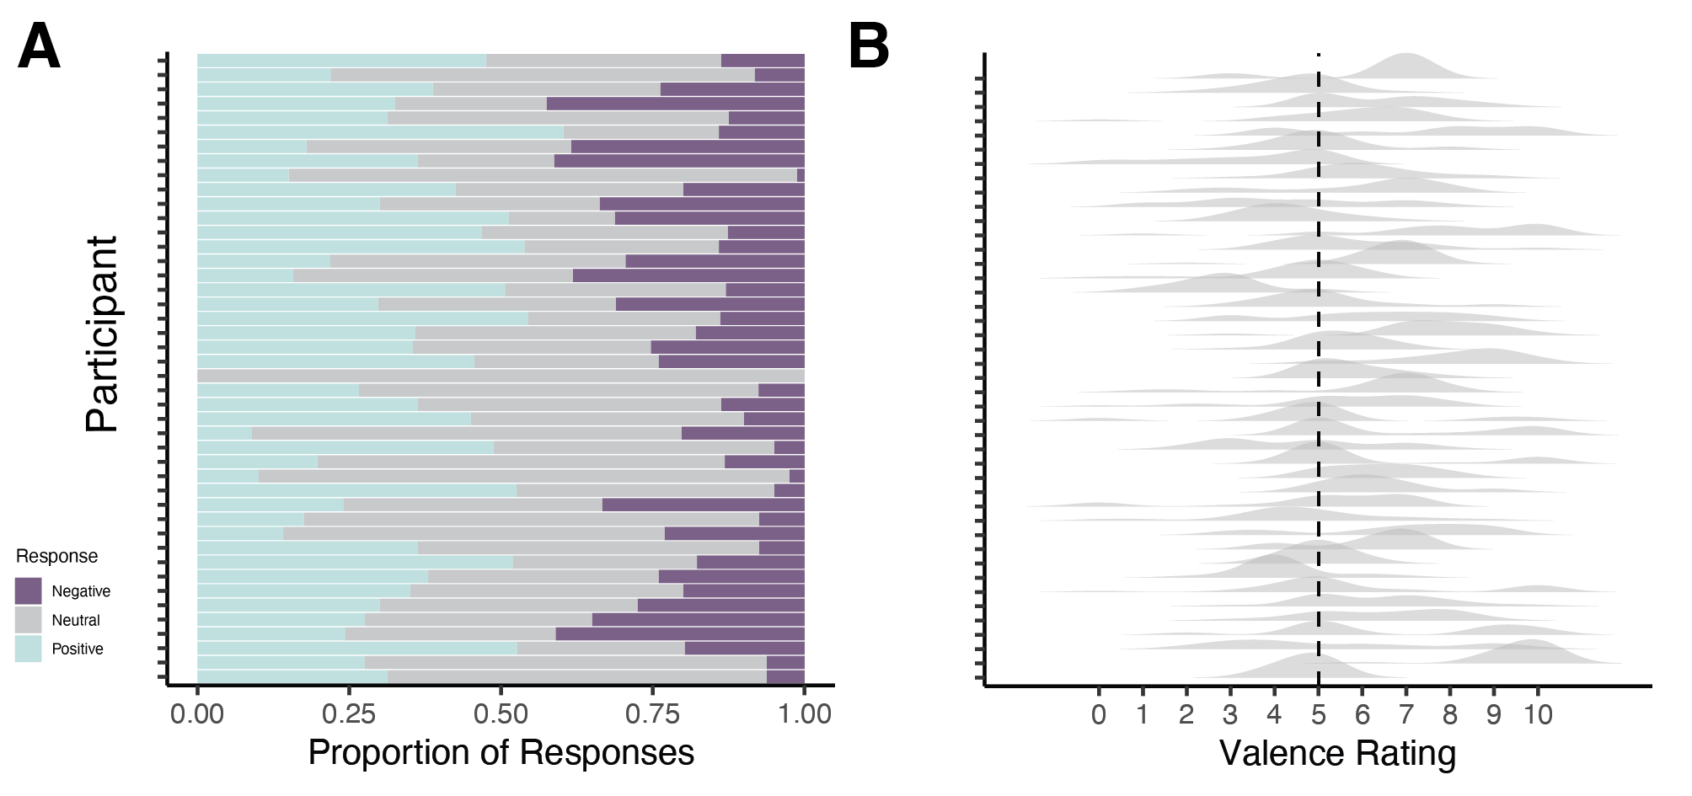Figure S1. Variance in valence assigned to different events across studies. (A) Experiment 1: Proportion of events given different valence ratings per participant. Note that participant with no variance in these responses (N = 1) was excluded from valence analyses. (B) Experiment 2: Distribution of events with different responses to question “Right now, how are you feeling?” (0 = very negative, 10 = very positive)

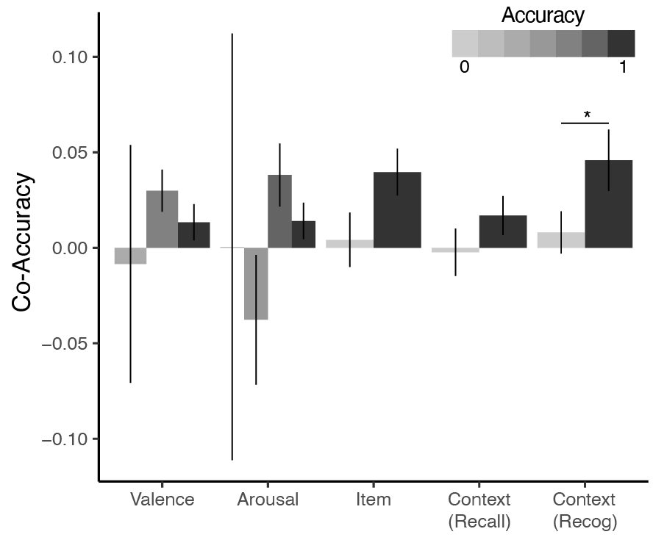
Figure S2. Relationship between co-accuracy and other measures of memory integration. We examined a standard assay of associative memory (context recognition, in which participants are cued with one feature and asked to select the paired feature). When we recomputed co-accuracy, omitting context recognition scores from this calculation, we found that trials for which participants had correct context recognition also had higher co-accuracy values ($F_{1,42}=4.51,p=.04,η_{p}^{2}=.06$). We repeated this process for accuracy on all other memory tests and did not find significant differences in co-accuracy. Error bars = +/- 1 SE. *p < .05

Supplementary Methods

Experiment 2 compensation
Participants were instructed about the compensation scheme at the beginning of the study. They would be compensated up to $76 based on the number of survey prompts completed. Although not the focus of the current study, compensation was also calculated based on the consistency of drinking reports between smartphone prompts and drinking behavior reported in weekly phone calls with the experimenter, yielding up to $14 additional compensation. Thus, participants could earn up to $90 for the two-week monitoring period.

