Supplemental information

Exploring Stress Hormone Effects on Memory Specificity and Strength in Mice using the Dual-Event Inhibitory Avoidance Task
Sevgi Bahtiyar, Kubra Gulmez Karaca, Marloes J.A.G. Henckens, Benno Roozendaal

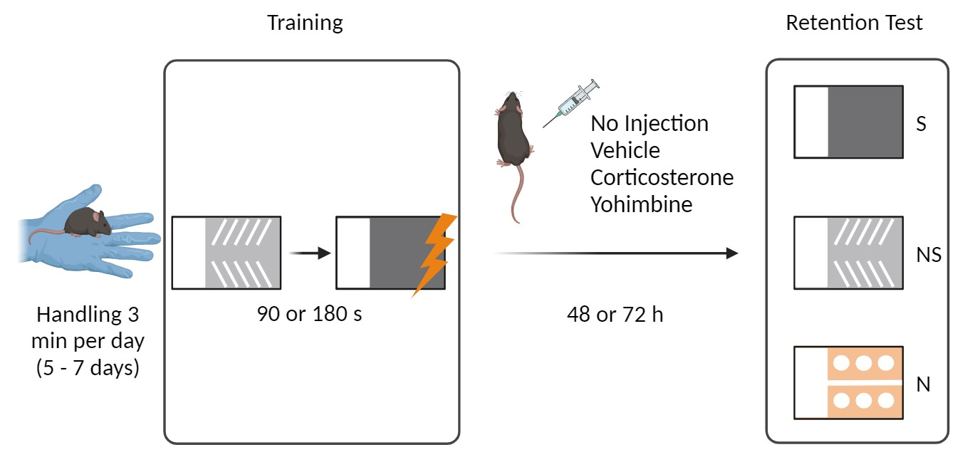
Supplemental Figure 1. Schematic overview of the general experimental design. Mice were initially handled 3 min per day for five to seven consecutive days. For training, mice were first trained in the Non-Shock Box (depicted in light grey) and after a short interval in the Shock Box (depicted in dark grey). A single inescapable footshock was given only after entering the dark compartment of the Shock box. Some mice received no injection and others received an intraperitoneal administration of vehicle, corticosterone or the noradrenergic stimulant yohimbine immediately after the training session. On the retention test, 48 or 72 h later, retention latencies were assessed, in a randomized order and without delay, in the two training contexts (i.e., Shock box and Non-Shock box) and in a Novel box the mice had not visited before. S, Shock box; NS, Non-Shock box; N, Novel box.

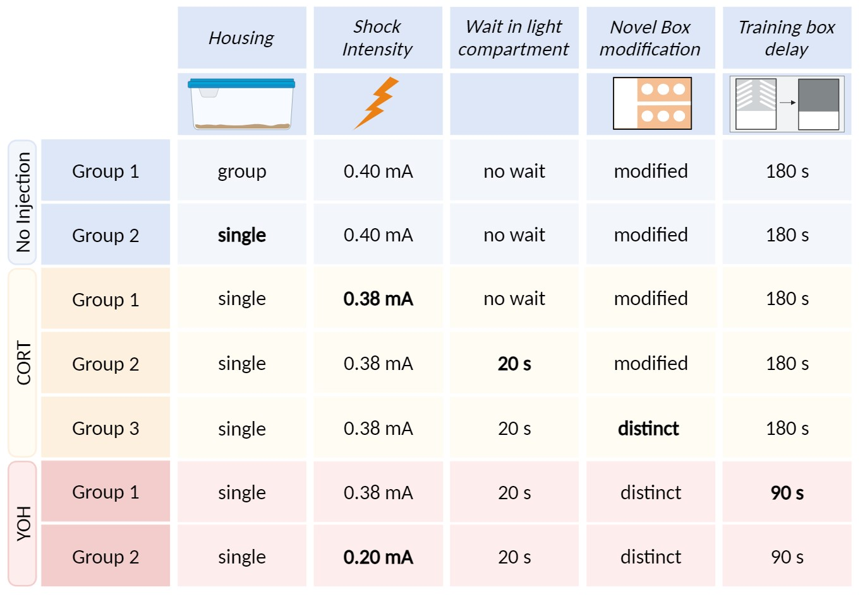
Supplemental Figure 2. Task parameters per experimental group. In total five parameters were changed over the course of the experiments (shown in bold): Housing conditions (group vs single housed), shock intensity, wait time in the starting compartment, extra Novel box modifications, and the interval between the two training events. All changes were implemented after obtaining the results of the previous experimental group. CORT, corticosterone; YOH, yohimbine.

Supplemental Table S1
Training and retention test latencies in seconds for animals shown in Figures 1, 2 and 4
Figure 1 | TRAINING |  | RETENTION TEST
 | Non-Shock mean ± s.e.m. | Shock  mean ± s.e.m. | Shock  mean ± s.e.m. | Non-Shock  mean ± s.e.m. | Novel  mean ± s.e.m.
(A) No Inj (n = 27)  (B) No Inj (n = 10) | 8.6 ± 2.6  7.1 ± 2.2 | 12.6 ± 1.8  8.8 ± 1.8 | 275.3 ± 47.5  316.1 ± 66.4 | 169.5 ± 43.1  44.2 ± 13.4 | 182.5 ± 48.8  53.9 ± 27.7
Figure 2A | TRAINING |  | RETENTION TEST
 | Non-Shock mean ± s.e.m. | Shock  mean ± s.e.m. | Shock  mean ± s.e.m. | Non-Shock  mean ± s.e.m. | Novel  mean ± s.e.m.
Vehicle (n = 16)  3 mg CORT (n = 11)  10 mg CORT (n = 15) | 7 ± 1.8  6.2 ± 1.4  5.1 ± 1.0 | 12.3 ± 2.2  14.5 ± 4.2  12.4 ± 2.5 | 90.3 ± 28.9  75.7 ± 20.0  80.6 ± 19.5 | 53.4 ± 17.7  57.6 ± 18.7  30.4 ± 7.4 | 57.3 ± 21.2  105.3 ± 40.7  71.2 ± 23.6
Figure 2B | TRAINING |  | RETENTION TEST
 | Non-Shock  mean ± s.e.m. | Shock  mean ± s.e.m. | Shock  mean ± s.e.m. | Non-Shock  mean ± s.e.m. | Novel  mean ± s.e.m.
Vehicle (n = 15)  1 mg CORT (n = 12)  3 mg CORT (n = 16)  10 mg CORT (n = 16) | 20.8 ± 2.4  26.4 ± 1.4  21.2 ± 2.5  19.7 ± 1.9 | 23.4 ± 2.3  29.0 ± 1.9  23.6 ± 2.4  25.6 ± 2.4 | 112.1 ± 23.9  111.3 ± 38.6  119.5 ± 49.1  122.6 ± 39.2 | 52.2 ± 14.5  61.8 ± 12.7  48.1 ± 10.4  74.2 ± 36.3 | 166.5 ± 58.9  146.6 ± 63.7  67.9 ± 36.5  171.2 ± 56.8
Figure 2C | TRAINING |  | RETENTION TEST
 | Non-Shock  mean ± s.e.m. | Shock  mean ± s.e.m. | Shock  mean ± s.e.m. | Non-Shock  mean ± s.e.m. | Novel  mean ± s.e.m.
Vehicle (n = 14)  3 mg CORT (n = 14)  10 mg CORT (n = 28) | 26.6 ± 1.0  25.8 ± 0.9  24.4 ± 0.8 | 26.6 ± 0.9  28.7 ± 1.2  29.8 ± 1.4 | 130.2 ± 41.3  168.9 ± 42.9  102.3 ± 23.0 | 77.0 ± 25.8  83.0 ± 20.9  67.8 ± 18.1 | 36.9 ± 17.4  57.6 ± 22.1  68.6 ± 33.5
Figure 4A | TRAINING |  | RETENTION TEST
 | Non-Shock  mean ± s.e.m. | Shock  mean ± s.e.m. | Shock  mean ± s.e.m. | Non-Shock  mean ± s.e.m. | Novel  mean ± s.e.m.
Vehicle (n = 17)  0.3 mg YOH (n = 16)  1 mg YOH (n = 18)  3 mg YOH (n = 19) | 6.1 ± 0.4  6.3 ± 0.8  8.1 ± 1.2  6.6 ± 0.7 | 7.3 ± 0.8  8.7 ± 1.3  10.1 ± 1.2  11.0 ± 1.6 | 123.9 ± 21.2  150.3 ± 37.7  162.5 ± 34.0  185.1 ± 27.4 | 59.8 ± 14.9  69.7 ± 19.0  78.7 ± 19.5  102.6 ± 16.2 | 35.9 ± 13.5  34.4 ± 16.9  72.5 ± 24.0  103.1 ± 37.9
Figure 4B | TRAINING |  | RETENTION TEST
 | Non-Shock  mean ± s.e.m. | Shock  mean ± s.e.m. | Shock  mean ± s.e.m. | Non-Shock  mean ± s.e.m. | Novel  mean ± s.e.m.
Vehicle (n = 14)  1 mg YOH (n = 15)  3 mg YOH (n = 17) | 32.3 ± 3.3  27.1 ± 1.2  29.8 ± 2.6 | 29.6 ± 1.0  30.3 ± 1.9  29.6 ± 1.3 | 213.2 ± 39.3  235.9 ± 33.2  228.9 ± 46.7 | 85.2 ± 21.6  104.0 ± 26.2  109.0 ± 19.2 | 92.4 ± 40.3  34.9 ± 5.1  39.1 ± 8.5
No inj, no injection; CORT, corticosterone; YOH, yohimbine

