Supplemental Material

Stress enhances memory for previously encoded events depending on stressor recall
Antonia Lilja MSc¹, Guillen Fernandez PhD², and Lars Schwabe PhD¹
¹Department of Cognitive Psychology, Institute of Psychology, Universität Hamburg, Von-Melle-Park 5, 20146 Hamburg, Germany
²Donders Institute for Brain, Cognition and Behaviour, Radboud University Medical Center, Kapittelweg 29, 6525 EN Nijmegen, The Netherlands

Supplemental Figure S1
Supplemental Table S1
Supplemental Table S2
Supplemental Table S3
Supplemental Table S4
Supplemental Table S5
Supplemental results

Supplemental Figure S1
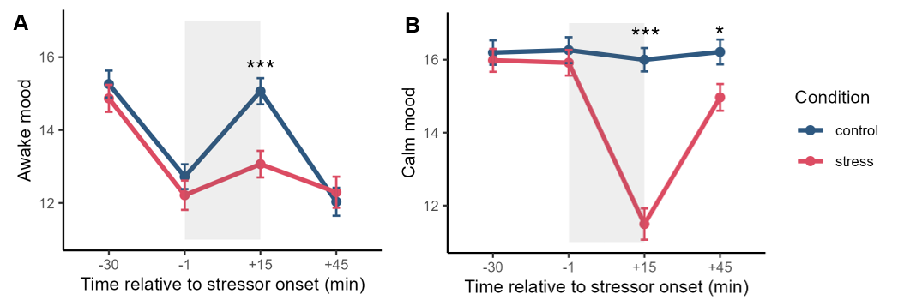
Supplemental Figure S1. After the treatment, stressed participants rated their mood as less awake (A) and less calm (B) than control participants. Error bars show SEM. (***) P < .001.

Supplemental Table S1. Baseline measurements of chronic stress, depressive and anxiety symptoms, sleep, state anxiety, autonomic activity, mood and salivary cortisol.
 | Day 1 |  | Day 2
 | Control | Stress | Control | Stress
Trait chronic stress (TICS) | 77.2 (29.1) | 76.9 (27.9)
Trait depression and anxiety (IDAS II) | 181.0 (39.6) | 175.0 (36.3)
Sleep quality | 75.8 (17.4) | 73.7 (15.6) | 70.2 (20.0) | 73.8 (17.6)
Sleep duration (h) | 7.5 (1.3) | 7.5 (1.1) | 7.3 (1.3) | 7.5 (1.3)
State anxiety (STAI-S) | 40.5 (6.3) | 40.8 (7.2) | 38.8 (6.5) | 41.8 (7.0)
Systolic blood pressure (mmHg) | 119.0 (14.7) | 118.0 (13.3) | 116.0 (13.5) | 118.0 (11.1)
Diastolic blood pressure (mmHg) | 83.7 (9.5) | 81.0 (7.8) | 79.7 (7.7) | 79.9 (7.2)
Pulse (BPM) | 84.1 (11.4) | 81.0 (14.9) | 87.7 (15.1) | 84.6 (14.9)
Mood (good) | 17.3 (2.3) | 17.5 (1.9) | 17.2 (2.4) | 17.0 (2.3)
Mood (awake) | 15.3 (2.9) | 14.9 (2.9) | 15.1 (2.9) | 14.7 (3.2)
Mood (calm) | 16.2 (2.6) | 16.0 (2.5) | 16.5 (2.4) | 15.7 (3.0)
Log cortisol (nmol/L) | 1.5 (0.5) | 1.5 (0.5) | 1.5 (0.5) | 1.4 (0.5)
Means and (SD) are shown.

Supplemental Table S2. Predicted probabilities of recognizing material that cues stressor relevant vs. irrelevant information.
 | Pre-treatment encoding |  | Post-treatment encoding
 | Control | Stress | Control | Stress
Stressor context | 0.439 (0.186) | 0.516 (0.191) | 0.426 (0.181) | 0.409 (0.178)
Lure context | 0.443 (0.185) | 0.500 (0.190) | 0.405 (0.179) | 0.405 (0.177)
Control context | 0.465 (0.188) | 0.517 (0.194) | 0.421 (0.180) | 0.419 (0.179)
Means and (SD) are shown.

Supplemental Table S3. Predicted probabilities of recognizing material that cues stressor relevant vs. irrelevant information depending on cortisol response.
 | Pre-treatment encoding |  |  | Post-treatment encoding
 | Control | High cortisol response (stress) | Low cortisol response (stress) | Control | High cortisol response (stress) | Low cortisol response (stress)
Stressor context | 0.427 (0.187) | 0.567 (0.218) | 0.472 (0.156) | 0.422 (0.183) | 0.439 (0.198) | 0.390 (0.148)
Lure context | 0.434 (0.187) | 0.545 (0.214) | 0.448 (0.159) | 0.397 (0.180) | 0.452 (0.200) | 0.368 (0.145)
Control context | 0.454 (0.190) | 0.566 (0.218) | 0.470 (0.162) | 0.414 (0.182) | 0.463 (0.203) | 0.377 (0.146)
Means and (SD) are shown.

Supplemental Table S4. Predicted probabilities of recalling material that cues stressor relevant vs. irrelevant information.
 | Pre-treatment encoding |  | Post-treatment encoding
 | Control | Stress | Control | Stress
Stressor context | 0.069 (0.034) | 0.086 (0.041) | 0.047 (0.019) | 0.058 (0.022)
Lure context | 0.069 (0.037) | 0.068 (0.038) | 0.057 (0.021) | 0.046 (0.017)
Control context | 0.083 (0.038) | 0.089 (0.043) | 0.060 (0.023) | 0.059 (0.023)
Means and (SD) are shown.

Supplemental Table S5. Predicted probabilities of recalling material that cues stressor relevant vs. irrelevant information depending on cortisol response.
 | Pre-treatment encoding |  |  | Post-treatment encoding
 | Control | High cortisol response (stress) | Low cortisol response (stress) | Control | High cortisol response (stress) | Low cortisol response (stress)
Stressor context | 0.065 (0.031) | 0.088 (0.051) | 0.086 (0.032) | 0.045 (0.017) | 0.060 (0.023) | 0.056 (0.021)
Lure context | 0.067 (0.036) | 0.077 (0.038) | 0.060 (0.031) | 0.061 (0.026) | 0.045 (0.016) | 0.047 (0.019)
Control context | 0.081 (0.037) | 0.103 (0.053) | 0.076 (0.034) | 0.058 (0.023) | 0.064 (0.024) | 0.056 (0.022)
Means and (SD) are shown.

Supplemental results
Response bias in memory for stressful episode. In order to control for response bias in the memory for the stressful episode, we computed d’ scores by subtracting the participant’s z-transformed false alarm rate from the z-transformed hit-rates for central and peripheral objects. We subsequently ran a mixed ANOVA with condition (stress vs. control) and object type (central vs. peripheral) as predictors. We found a near-significant condition x object type interaction (F (1, 118) = 3.63, p = .059, η² = .010) as well as a significant effect of object type (F (1, 118) = 224.97, p < .001, η² = .388). Pairwise comparisons showed improved memory for central objects in the stressed compared to control participants (t (118) = -2.122, p = .036). For peripheral objects there was no difference (t (118) = 0.231, p = .818). These findings show a slightly different pattern than what we saw for hit-rates. Specifically, for hit-rates, we did not find a significant difference between stressed and control participants for central objects.
We next ran a mixed ANOVA with salivary cortisol response (high vs. low vs. control) and object type (central vs. peripheral) as predictors. We found a main effect of object type (F (1, 109) = 200.94, p < .001, η² = .380) and an interaction of object type and responder (F (2, 109) = 3.54, p = .032, η² = .021). Tukey corrected post-hoc test showed no significant difference for central (all |t| < 2.262, all p > .065) or peripheral objects (all |t| < 0.891, all p > .647) depending on the cortisol response. These results reflect the same pattern as the hit-rates revealed.

Response bias in memory for events surrounding the stressful episode. Similarly, we computed d’ scores by subtracting the z-transformed false alarm rate from the hit-rates for images encoded before or after the treatment. We ran a mixed ANOVA with condition (stress vs. control) and phase (pre vs. post treatment) as predictors. We found a significant main effect of phase (F (1, 120) = 98.63, p < .001, η² = .029) and an interaction of condition and phase (F (1, 120) =19.03, p < .001, η² = .006). However, Tukey corrected post-hoc tests showed no significant differences between stressed and control participants in the pre-treatment encoding (t (120) = -1.677, p = .096) nor the post-treatment encoding phase (t (120) = -0.025, p = .980). These findings are in accordance with what we found with respect to analysis of hit-rates.
We next ran a mixed ANOVA with salivary cortisol response (high vs. low vs. control) and phase as predictors, and again found a significant main effect of phase (F (1, 111) = 105.85, p < .001, η² = .033) as well as an interaction of cortisol response and phase (F (2, 111) = 10.46, p < .001, η² = .007). The Tukey corrected pairwise comparisons showed a significantly higher d’ in stressed participants with a high cortisol response, compared to control participants, for information encoded before the stressor (t (111) = -2.568, p = .031). No other follow-up tests were significant (all |t| < 1.659, all p > .226). Also these findings agree with what we found for hit-rates.
We also ran linear regression models with pulse, systolic and diastolic blood pressure as predictors in order to assess how autonomic nervous system activity might contribute to response bias corrected recognition memory performance of material encoded before or after a stressor. The interactions of condition, phase and pulse or diastolic blood pressure were nonsignificant (both |β| < 0.058, both p > .113). The interaction of condition, phase and systolic blood pressure was significant (β = -0.082, p = .045). However, follow-up analyses showed no significant effects (all |β| < 0.151, all p > .999, Holm-Bonferroni corrected).
Next, we ran a linear regression model with condition, phase and centrality bias as predictors. The pattern of results was again the same, with a significant condition x phase x centrality bias interaction (β = -0.084, p = .049). However, follow-up simple slopes analyses showed no significant effects (all |β| < 0.374, all p > .131, Holm-Bonferroni corrected).
Finally, we ran a linear model with salivary cortisol response, phase, and centrality bias as predictors. Here, we found a significant interaction of low responder group, phase and centrality bias (β = -0.113, p = .040). Simple slopes analyses showed that high cortisol responders with a high centrality bias recalled more objects from the pre-encoding phase compared to controls (β = 0.548, p = .030, Holm-Bonferroni corrected). All other effects were nonsignificant (all |β| < 0.353, all p > .100, Holm-Bonferroni corrected). This mirrors the pattern of results we saw when analysing hit-rates.

