Supplementary material

Emotional intensity produces a linear relationship on conditioned learning but an inverted U-shaped effect on episodic memory

Lingwei Ouyang^{1, 2} & Joseph E. Dunsmoor^{1, 3}

¹Department of Psychiatry and Behavioral Sciences, University of Texas at Austin
²Department of Psychology, University of Texas at Austin
³Department of Neuroscience, University of Texas at Austin

Contacts: joseph.dunsmoor@austin.utexas.edu

Supplementary Text 1-2
Supplementary Table 1-19
Supplementary Figure 1-3

Supplementary Text 1. Manipulation check.
Post-shock ratings.
HI (7.48±0.207) group reported higher post-task shock intensity ratings than LI (1.15±0.07) group and NA (1.48±0.15) group. There was a main effect of intensity (F_{(2, 69)} = 530.8, P < 0.001, η²_{G} = 0.94). Planned comparison revealed no difference between LI and NA (t₍₆₉₎ = -1.56, P = 0.27, CI₉₅ = [-0.85, 0.18], d = -0.56). HI rated US as more intense than NA (t₍₆₉₎ = 27.71, P < 0.001, CI₉₅ = [5.48, 6.52], d = 6.75) and LI (t₍₆₉₎ = 28.97, P < 0.001, CI₉₅ = [5.81, 6.86], d = 8.51) See Supplementary Figure 1 for number of shocks estimated on day 1.
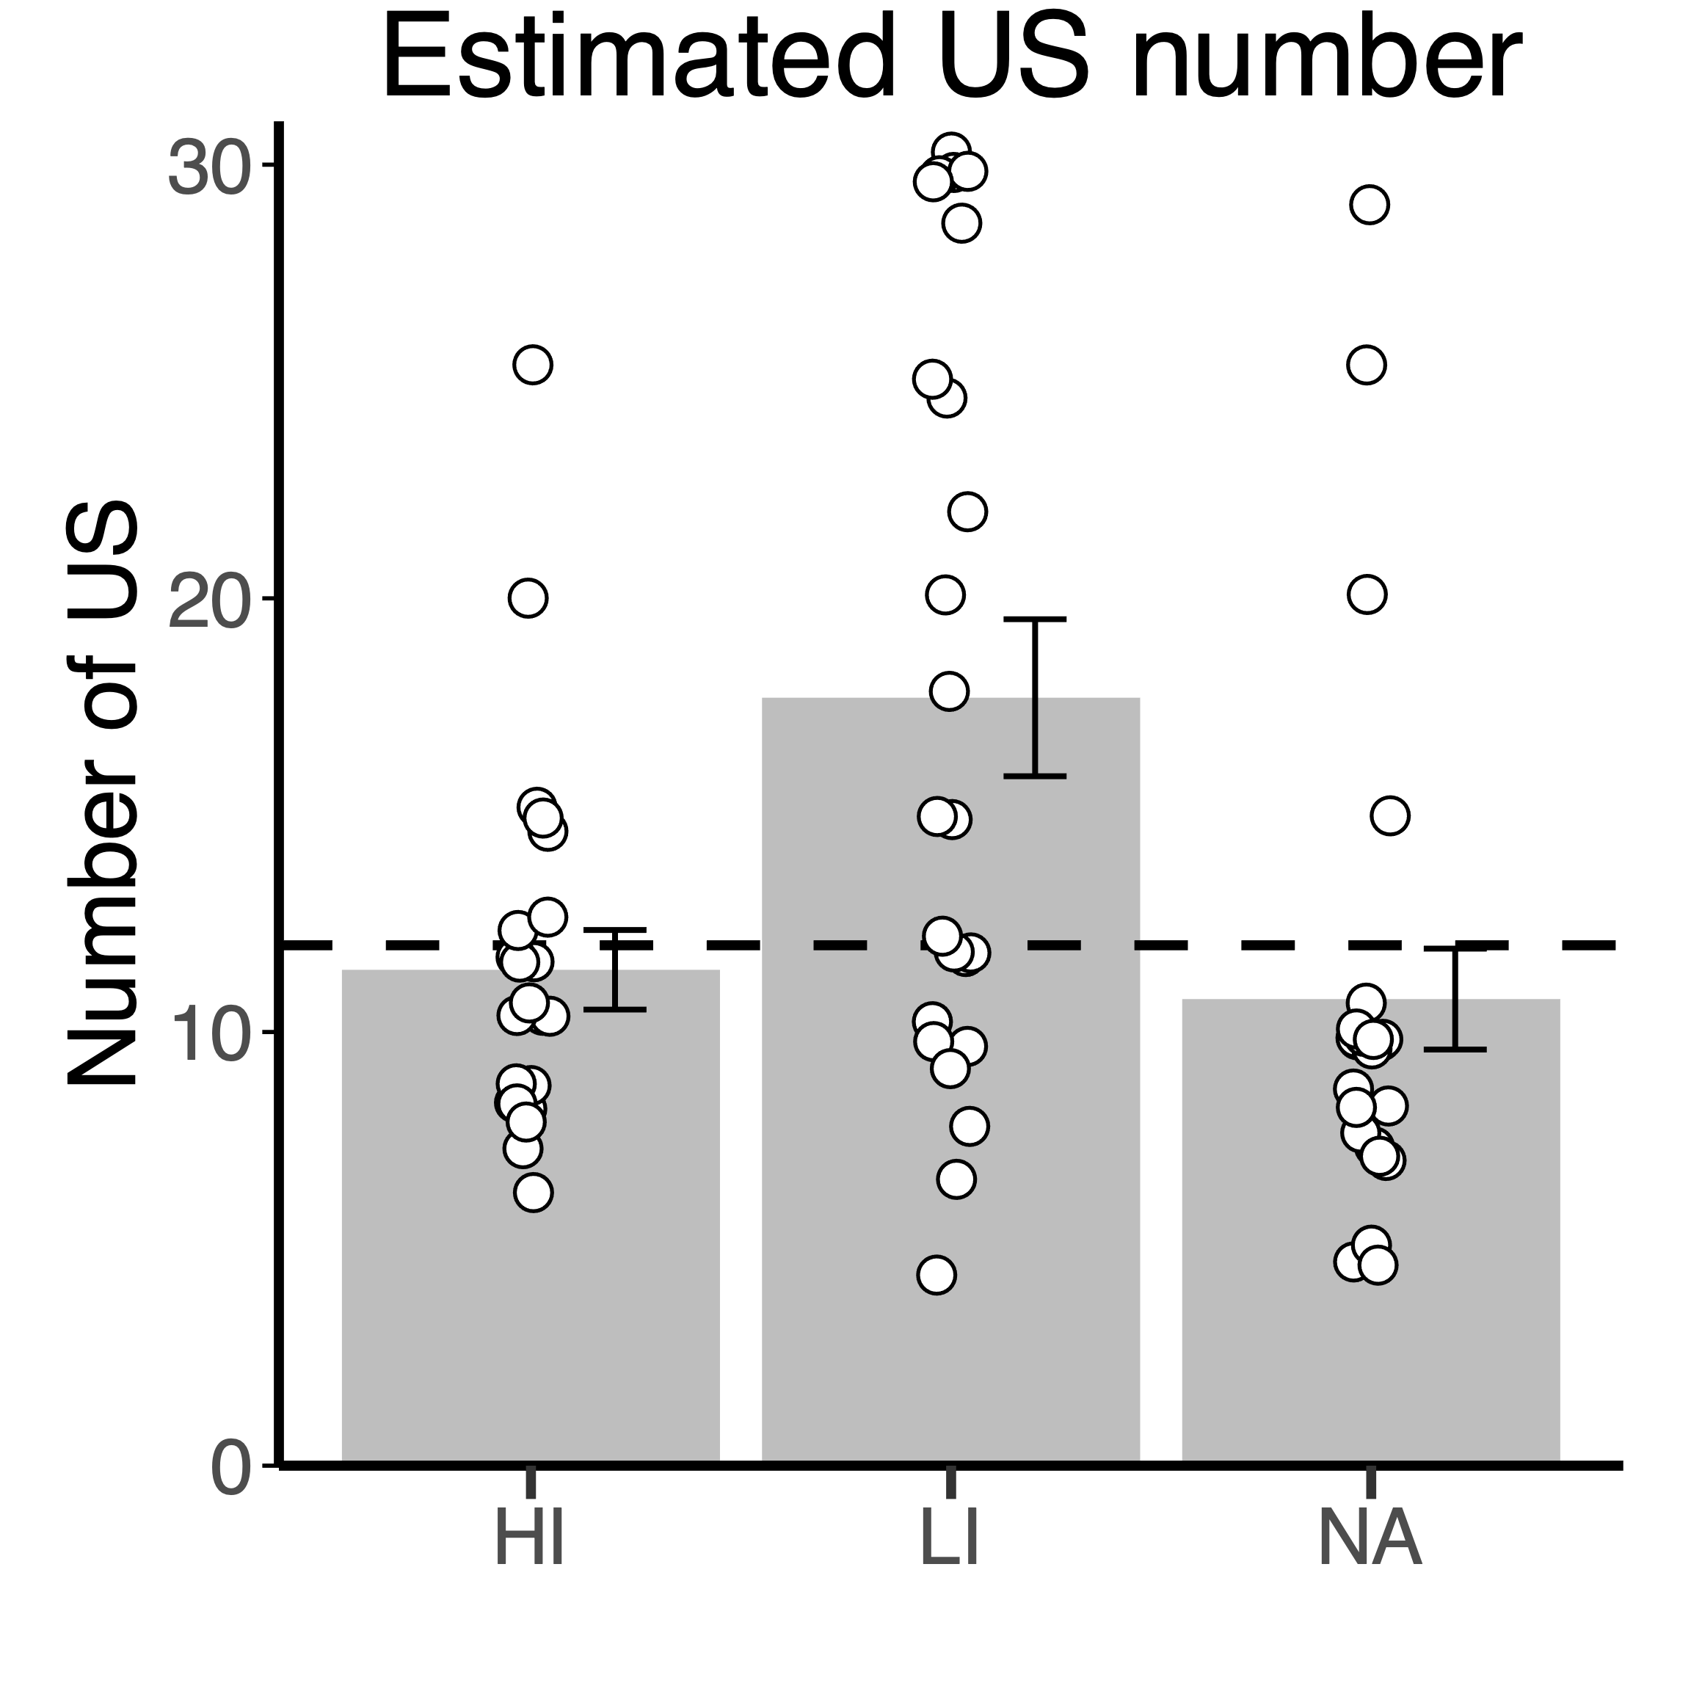
Affect.
Supplementary Figure 1. Post-task surveys on day 1 revealed LI estimated more US than HI and NA group. Bars and error bars denote mean and 95% standard error. Circles denote trial-averaged subject data. Dashed
line indicates the correct US number (n = 12).
All groups reported more negative than positive affect while waiting for the shock or NA: LI: neg: 13.1±0.63, pos: 7.67±0.52; HI: neg: 19.9±0.84, pos: 4.65±0.36; NA: pos: 13.5±0.8, neg: 7.4±0.32. ANOVA with affect as within-subject variable and intensity as between-subject variable showed an interaction between intensity and affect valence (F_{(2, 69)} = 26.18, P < 0.001, η²_{G} = 0.26). HI experienced more negative affect than NA (t₍₆₉₎ = 6.23, P < 0.001) and LI (t₍₆₉₎ = 5.92, P < 0.001), as well as less positive affect (NA: t₍₆₉₎ = -4.72, P < 0.001; LI: t₍₆₉₎ = -5.12, P < 0.001). There is no difference between LI and NA in either pos (t₍₆₉₎ = 0.46, P = 0.89) or neg (t₍₆₉₎ = -0.37, P = 0.93) affect. It is surprising that NA group also experienced more negative than positive affect. Post-survey descriptions suggested NA group felt “curious” and “anxious to know”, such negativity might be qualitatively different from shock-induced anxiety experienced in LI and HI groups.
US-related skin conductance response.
To check if three intensities were significantly different in arousal induction, we compared US-related response on the final SCR sample (after excluding non-responsive participants). US-related SCR showed a main effect of intensity (F_{(2, 65)} = 30.87, P < 0.001, η²_{G} = 0.48). Planned comparison significantly higher SCR in HI than LI (t₍₆₅₎ = 5.85, P < 0.001, CI₉₅ = [0.19, 0.45]) and NA (t₍₆₅₎ = 7.45, P < 0.001, CI₉₅ = [0.26, 0.51]). There is no difference between LI and NA (t₍₆₅₎ = 1.22, P < 0.001, CI₉₅ = [-0.06, 0.2]).
Skin conductance response results.
Supplementary Table 1. Differential SCR during conditioning (df = 65).
Intensity | Time | t | P | 95% CI | Cohen's d
Low | early | 3.92 | 2e-04 | 0.11 [0.05, 0.16]*** | 0.68
Low | late | 1.01 | 0.3164 | 0.04 [-0.03, 0.10] | 0.29
High | early | 5.14 | 0 | 0.13 [0.08, 0.18]*** | 0.71
High | late | 7.11 | 0 | 0.23 [0.17, 0.29]*** | 1.15
NA | early | 1.65 | 0.1028 | 0.04 [-0.01, 0.09] | 0.29
NA | late | -0.19 | 0.8493 | -0.01 [-0.07, 0.06] | -0.04

Supplementary Table 2. Differential SCR during extinction (df = 65).
Intensity | Time | t | P | 95% CI | Cohen's d
Low | early | 0.44 | 0.6597 | 0.01 [-0.04, 0.06] | 0.13
Low | late | -0.93 | 0.3553 | -0.03 [-0.10, 0.04] | -0.2
High | early | 5 | 0 | 0.12 [0.07, 0.17]*** | 0.67
High | late | 2.18 | 0.0329 | 0.07 [0.01, 0.13]* | 0.39
NA | early | 0.91 | 0.366 | 0.02 [-0.03, 0.07] | 0.15
NA | late | 0.99 | 0.3255 | 0.03 [-0.03, 0.09] | 0.18

Supplementary Table 3. Differential SCR during test (df = 63).
Intensity | Time | t | P | 95% CI | Cohen's d
Low | early | 0.53 | 0.5955 | 0.02 [-0.06, 0.11] | 0.11
Low | late | 0.76 | 0.4483 | 0.02 [-0.03, 0.07] | 0.12
High | early | 3.38 | 0.0012 | 0.13 [0.05, 0.20]** | 0.44
High | late | 2.66 | 0.0099 | 0.06 [0.01, 0.10]** | 0.3
NA | early | -1.27 | 0.2096 | -0.05 [-0.12, 0.03] | -0.3
NA | late | 0.27 | 0.7867 | 0.01 [-0.03, 0.05] | 0.04

Supplementary Table 4 ERI¹ [100 x mean (first 4 CS+ recovery test) – (mean [first 4 CS- recovery test])/ (max pair (CS+) - (CS-) acquisition].
Intensity | df | t | P | 95% CI | Cohen’s d
Low | 17 | 0.77 | 0.45 | 5.05 [-8.81, 18.91] | 0.18
High | 22 | 2.46 | 0.02 | 18.08 [2.82, 33.34]* | 0.51
NA | 21 | -1.89 | 0.073 | -6.88 [-14.46, 0.70] | -0.4

Supplementary Table 5 ERI¹ group comparison (df = 61).
Contrast | t | P | 95% CI | Cohen’s d
Low-High | -1.5 | 0.14 | -13.03 [-30.46, 4.39] | -0.41
Low-NA | 1.4 | 0.17 | 12.18 [-5.24, 29.61] | 0.52
High-NA | 3.09 | 0.003 | 25.22 [8.89, 41.54]** | 0.9

Supplementary Table 6 ERI² (df = 62) 100 × [(mean first 4 CS+ recovery) − (mean first 4 CS− recovery)]/max (CS+) acquisition).
Contrast | t | P | 95% CI | Cohen’s d
Low-High | -2.43 | 0.02 | -25.27 [-46.02, -4.52]* | -0.89
Low-NA | 0.54 | 0.59 | 5.55 [-15.01, 26.10] | 0.14
High-NA | 3.2 | 0.002 | 30.82 [11.58, 50.06]** | 0.85

Supplementary Table 7 ERI³ [mean (first 4 CS+ recovery) – mean (first 4 CS− recovery)] − [mean (last 4 CS+ extinction) – mean (last 4 CS− extinction)].
Intensity | df | t | P | 95% CI | Cohen’s d
Low | 17 | 0.92 | 0.372 | 0.06 [-0.07, 0.19] | 0.22
High | 22 | 1.28 | 0.213 | 0.06 [-0.04, 0.15] | 0.27
NA | 21 | -2.6 | 0.0168 | -0.09 [-0.15, -0.02]* | -0.55

Supplementary Table 8 ERI³ comparison
Contrast | t | P | 95% CI | Cohen’s d
Low-High | -0.01 | 0.99 | -0.00 [-0.13, 0.13] | 0
Low-NA | 2.27 | 0.03 | 0.15 [0.02, 0.28]* | 0.66
High-NA | 2.43 | 0.02 | 0.15 [0.03, 0.28]* | 0.76

Supplementary Table 9. (first CS recovery) – (last CS extinction) for CS+ and CS- (df = 64).
Contrast | CS type | t | P | 95% CI | Cohens’d
High-Low | CS- | 1.9 | 0.0615 | 0.29 [-0.01, 0.60] | 0.53
Low-NA |  | 0.51 | 0.6112 | 0.08 [-0.22, 0.38] | 0.16
High-NA |  | 2.62 | 0.011 | 0.37 [0.09, 0.65]* | 0.81
High-Low | CS+ | 2.31 | 0.0239 | 0.31 [0.04, 0.59]* | 0.69
Low-NA |  | 1.64 | 0.1054 | 0.22 [-0.05, 0.49] | 0.55
High-NA |  | 4.28 | 1e-04 | 0.53 [0.28, 0.78]*** | 1.2

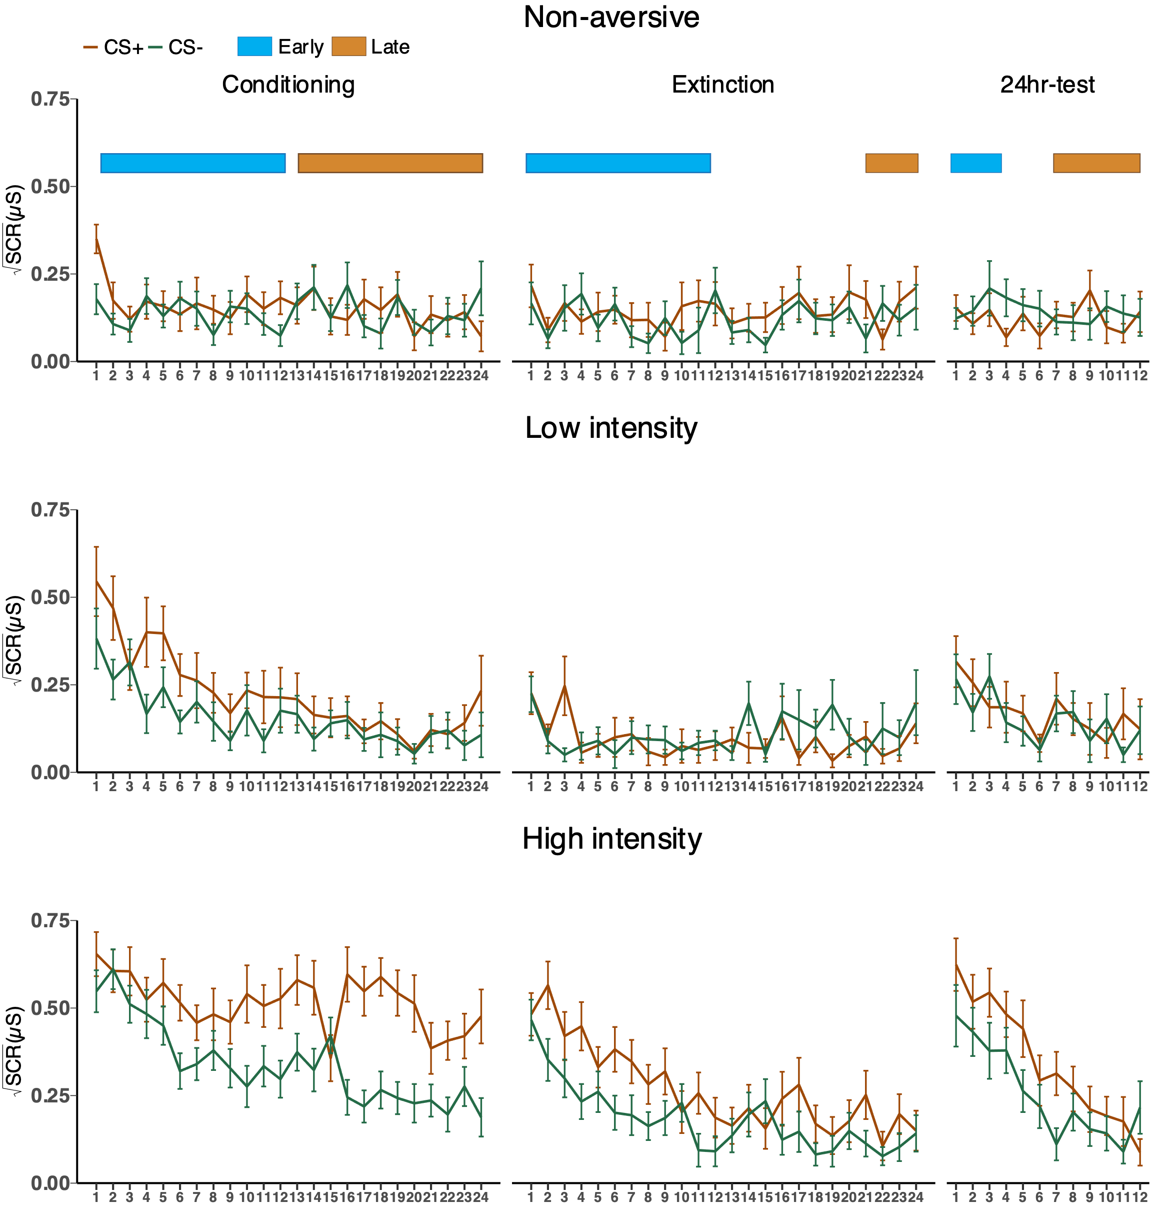
Supplementary Figure 2. Trial-by-trial SCR data. Lines depict trends of SCR. Points and error bars denote averaged participant data and standard error. Early and late phase of task was indicated by colored bars above the plots. Blue indicates early phase, and yellow indicates late phase.
US expectancy ratings.
Supplementary Table 10. Discriminatory expectancy CS+ - CS- (on logit scale).
Intensity | Early | Late
Conditioning
High | 2.45 [2.03, 2.90]* | 3.82 [3.17, 4.47]*
Low | 3.58 [3.04, 4.18]* | 11.88 [5.99, 22.42]*
NA | 2.80 [2.37, 3.27]* | 4.31 [3.64, 5.03]*
Extinction
High | 1.80 [1.31, 2.34]* | 1.06 [-0.06, 2.25]
Low | 3.15 [2.52, 3.86]* | 0.99 [-0.05, 2.11]
NA | 2.90 [2.30, 3.50]* | 2.81 [1.36, 4.70]*
Recovery test
High | 2.92 [1.98, 3.98]* | 6.51 [2.66, 11.99]*
Low | 4.97 [3.12, 7.82]* | 10.17 [2.89, 22.18]*
NA | 1.32 [0.55, 2.16]* | 1.94 [0.96, 2.97]*

Supplementary Table 11. Expectancy contrast of intensity on CS (on logit scale).
Contrast | CS type | Early | Late
Conditioning
High - Low | CS+ | -0.26 [-0.74, 0.23] | -0.20 [-0.69, 0.30]
High - NA |  | -0.17 [-0.67, 0.31] | -0.20 [-0.73, 0.27]
Low - NA |  | 0.08 [-0.41, 0.54] | -0.00 [-0.52, 0.46]
High - Low | CS- | 0.88 [0.16, 1.58]* | 7.85 [1.48, 18.08]*
High - NA |  | 0.18 [-0.48, 0.78] | 0.29 [-0.63, 1.25]
Low - NA |  | -0.71 [-1.42, 0.01] | -7.60 [-17.91, -1.41]*
Extinction
High - Low | CS+ | -0.42 [-1.11, 0.26] | -0.02 [-1.13, 1.02]
High - NA |  | -0.45 [-1.15, 0.21] | -0.29 [-1.30, 0.74]
Low - NA |  | -0.04 [-0.72, 0.62] | -0.27 [-1.29, 0.74]
High - Low | CS- | 0.94 [0.00, 1.88]* | -0.09 [-1.54, 1.33]
High - NA |  | 0.63 [-0.27, 1.52] | 1.45 [-0.35, 3.55]
Low - NA |  | -0.30 [-1.27, 0.74] | 1.55 [-0.29, 3.49]
Recovery test
High - Low | CS+ | 0.00 [-1.07, 0.92] | -0.39 [-1.42, 0.67]
High - NA |  | 0.64 [-0.41, 1.55] | -0.45 [-1.52, 0.50]
Low - NA |  | 0.64 [-0.37, 1.66] | -0.06 [-1.10, 0.94]
High - Low | CS- | 2.04 [-0.12, 4.92] | 3.13 [-6.04, 15.92]
High - NA |  | -0.98 [-2.27, 0.32] | -5.02 [-10.68, -1.03]*
Low - NA |  | -3.01 [-5.81, -0.79]* | -8.28 [-20.27, -0.73]*

Supplementary Table 12. Expectancy CS-intensity interaction (on logit scale).
Contrast | Early | Late
Conditioning
High - Low | -1.14 [-1.85, -0.43]* | -8.03 [-18.65, -2.06]*
High - NA | -0.35 [-1.00, 0.25] | -0.49 [-1.43, 0.45]
Low - NA | 0.78 [0.07, 1.50]* | 7.58 [1.39, 17.90]*
Extinction
Low - NA | -1.35 [-2.17, -0.51]* | 0.06 [-1.55, 1.65]
High - Low | -1.09 [-1.88, -0.30]* | -1.77 [-3.84, 0.19]
High - NA | 0.25 [-0.65, 1.18] | -1.83 [-3.90, 0.07]
Recovery test
High - Low | -2.03 [-5.02, 0.09] | -3.52 [-16.07, 5.84]
High - NA | 1.62 [0.37, 2.91]* | 4.60 [0.38, 10.01]*
Low - NA | 3.65 [1.35, 6.35]* | 8.23 [0.76, 20.30]*

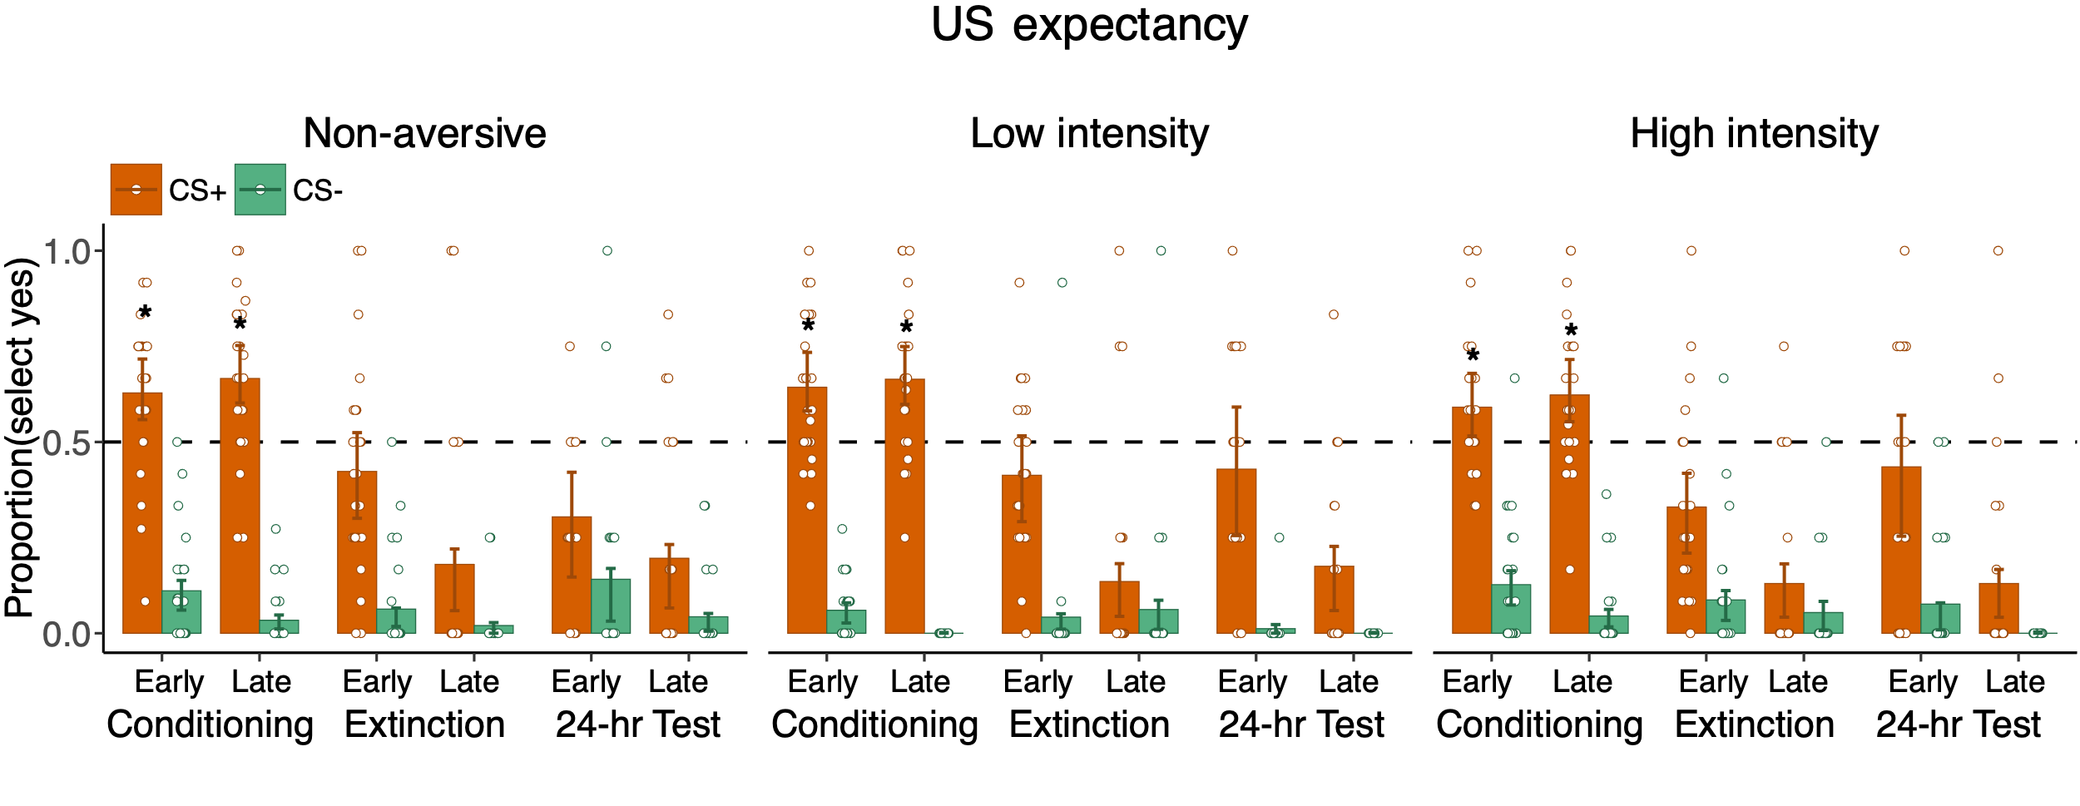
Recognition Memory.
Supplementary Figure 3. All groups showed recovery of US expectancy after 24 hours. Bars indicate mean proportion of selecting “yes”. Error bars denote the 95% MCMC highest posterior density interval (HDI) of probability and points denote trial-averaged data of individual participants. Dashed line indicates chance level (0.5). (*) Subjects consistently select “yes”.

Supplementary Table 13. The ratio of four responses (def old = “definitely old”, may old = “maybe old”, may new = “maybe new”, def new = “definitely new”, results presented as mean(standard error)).
Phase | Def old | May old | May new | Def new
Low intensity
Pre-Con | 0.59 (0.04) | 0.19 (0.02) | 0.17 (0.02) | 0.06 (0.01)
Conditioning | 0.56 (0.04) | 0.18 (0.02) | 0.16 (0.02) | 0.09 (0.02)
Extinction | 0.44 (0.04) | 0.19 (0.02) | 0.22 (0.03) | 0.15 (0.02)
Foil | 0.21 (0.02) | 0.31 (0.03) | 0.56 (0.04) | 0.63 (0.05)
High intensity
Pre-Con | 0.45 (0.02) | 0.23 (0.02) | 0.20 (0.02) | 0.12 (0.02)
Conditioning | 0.42 (0.03) | 0.22 (0.02) | 0.24 (0.02) | 0.12 (0.02)
Extinction | 0.36 (0.03) | 0.23 (0.02) | 0.25 (0.03) | 0.16 (0.02)
Foil | 0.18 (0.03) | 0.25 (0.02) | 0.61 (0.05) | 0.68 (0.05)
Non-aversive
Pre-Con | 0.42 (0.03) | 0.26 (0.02) | 0.20 (0.02) | 0.12 (0.02)
Conditioning | 0.43 (0.03) | 0.26 (0.02) | 0.19 (0.02) | 0.12 (0.02)
Extinction | 0.33 (0.03) | 0.27 (0.02) | 0.26 (0.02) | 0.15 (0.02)
Foil | 0.14 (0.03) | 0.31 (0.02) | 0.62 (0.04) | 0.64 (0.05)

Supplementary Table 14. Planned comparison between groups on CS type (df = 64).
Contrast | CS type | t | P | 95% CI | Cohen's d
Pre-Con
Low - High | CS+ | 2.99 | 0.0039 | 0.15 [0.05, 0.25]** | 0.82
Low - NA | CS+ | 2.8 | 0.0066 | 0.14 [0.04, 0.24]** | 0.75
High - NA | CS+ | -0.25 | 0.8044 | -0.01 [-0.11, 0.09] | -0.08
Low - High | CS- | 1.63 | 0.1068 | 0.08 [-0.02, 0.18] | 0.49
Low - NA | CS- | 2.37 | 0.0207 | 0.11 [0.02, 0.21]* | 0.62
High - NA | CS- | 0.69 | 0.4911 | 0.03 [-0.06, 0.13] | 0.22
Conditioning
Low - High | CS+ | 3.29 | 0.0016 | 0.18 [0.07, 0.28]** | 0.92
Low - NA | CS+ | 2.29 | 0.0252 | 0.12 [0.02, 0.22]* | 0.68
High - NA | CS+ | -1.06 | 0.2922 | -0.06 [-0.16, 0.05] | -0.3
Low - High | CS- | 1.53 | 0.1302 | 0.07 [-0.02, 0.15] | 0.43
Low - NA | CS- | 1.32 | 0.19 | 0.06 [-0.03, 0.14] | 0.37
High - NA | CS- | -0.24 | 0.8127 | -0.01 [-0.10, 0.08] | -0.07
Extinction
Low - High | CS+ | 1.96 | 0.054 | 0.10 [-0.00, 0.21] | 0.58
Low - NA | CS+ | 2.44 | 0.0175 | 0.12 [0.02, 0.23]* | 0.7
High - NA | CS+ | 0.43 | 0.6692 | 0.02 [-0.08, 0.12] | 0.12
Low - High | CS- | 0.59 | 0.5599 | 0.03 [-0.06, 0.12] | 0.15
Low - NA | CS- | 0.59 | 0.555 | 0.03 [-0.06, 0.11] | 0.15
High - NA | CS- | 0 | 0.9961 | -0.00 [-0.09, 0.09] | 0

Supplementary Table 15. High confidence false alarms (df = 69).
Intensity | t | P | 95% CI | Cohen’s d
High | 1.34 | 0.18 | 0.02 [-0.01, 0.05] | 0.2
Low | 0.88 | 0.38 | 0.01 [-0.02, 0.05] | 0.14
NA | 1.88 | 0.06 | 0.03 [-0.00, 0.06] | 0.26
Note: High confidence false alarms didn’t differ between CS+ and CS- within each group.

Supplementary Text 2. Selective enhancement with low confidence memory.
To make sure the result of no enhancement in HI doesn’t come from weakened confidence (such as low confidence hits is higher in CS+ than CS-), we also calculated corrected recognition by using low confidence memory hits and false alarm. There is main effect of Intensity (F_{(2, 69)} = 7.09, η²_{G} = 0.083, P = 0.002), CS type (F_{(1, 69)} = 9.39, P = 0.003, η²_{G} = 0.027) and three-way interaction between Intensity, Context and CS type (F_{(3.90, 134.41)} = 2.84, P = 0.028, η²_{G} = 0.016). No groups had retroactive enhancement of low confidence recognition (CS+ - CS- > 0).

Supplementary Table 16. Low-confidence selective enhancement (CS+ - CS).
Phase | t | P | 95% CI | Cohen’s d
Low intensity
Pre-Con | -1.16 | 0.252 | -0.04 [-0.10, 0.03] | -0.26
conditioning | -2.07 | 0.0421 | -0.07 [-0.14, -0.00]* | -0.51
extinction | -1.08 | 0.2828 | -0.03 [-0.09, 0.03] | -0.26
High intensity
Pre-Con | -0.93 | 0.3571 | -0.03 [-0.09, 0.03] | -0.26
conditioning | 0.58 | 0.5614 | 0.02 [-0.05, 0.09] | 0.16
extinction | -1.48 | 0.1424 | -0.05 [-0.11, 0.02] | -0.39
Non-aversive
Pre-Con | -1.51 | 0.1358 | -0.05 [-0.11, 0.02] | -0.34
conditioning | -3.5 | 8e-04 | -0.12 [-0.19, -0.05]*** | -1.14
extinction | -0.22 | 0.824 | -0.01 [-0.07, 0.05] | -0.06

Source memory.
Supplementary Table 17. Source memory summary (median [95% HDI], * reliably higher than 1/3).
CS type | Phase | Pre-Con | Conditioning | Extinction
High intensity
CS- | Pre-Con | 0.35 [0.31, 0.41] | 0.33 [0.27, 0.40] | 0.31 [0.25, 0.38]
 | Extinction | 0.32 [0.27, 0.37] | 0.29 [0.22, 0.35] | 0.39 [0.32, 0.47]
 | Conditioning | 0.33 [0.28, 0.39] | 0.28 [0.22, 0.35] | 0.38 [0.31, 0.46]
CS+ | Pre-Con | 0.31 [0.25, 0.35] | 0.44 [0.37, 0.51]* | 0.25 [0.19, 0.32]
 | Extinction | 0.26 [0.21, 0.31] | 0.44 [0.37, 0.52]* | 0.30 [0.23, 0.36]
 | Conditioning | 0.23 [0.18, 0.27] | 0.58 [0.50, 0.64]* | 0.20 [0.14, 0.25]
Low intensity
CS- | Pre-Con | 0.38 [0.33, 0.43] | 0.29 [0.23, 0.35] | 0.33 [0.27, 0.40]
 | Extinction | 0.33 [0.28, 0.38] | 0.25 [0.20, 0.31] | 0.42 [0.34, 0.49]*
 | Conditioning | 0.37 [0.31, 0.42] | 0.25 [0.19, 0.31] | 0.38 [0.32, 0.45]
CS+ | Pre-Con | 0.31 [0.26, 0.36] | 0.42 [0.36, 0.49]* | 0.26 [0.20, 0.32]
 | Extinction | 0.22 [0.18, 0.27] | 0.47 [0.40, 0.55]* | 0.30 [0.24, 0.38]
 | Conditioning | 0.24 [0.19, 0.29] | 0.55 [0.48, 0.62]* | 0.21 [0.16, 0.27]
Non-aversive
CS- | Pre-Con | 0.31 [0.26, 0.36] | 0.36 [0.30, 0.43] | 0.32 [0.26, 0.39]
 | Extinction | 0.25 [0.20, 0.29] | 0.36 [0.30, 0.43] | 0.39 [0.32, 0.46]
 | Conditioning | 0.24 [0.20, 0.29] | 0.39 [0.32, 0.46] | 0.37 [0.30, 0.44]
CS+ | Pre-Con | 0.29 [0.24, 0.34] | 0.44 [0.36, 0.50]* | 0.27 [0.21, 0.34]
 | Extinction | 0.23 [0.19, 0.27] | 0.46 [0.39, 0.54]* | 0.30 [0.24, 0.37]
 | Conditioning | 0.24 [0.19, 0.29] | 0.53 [0.46, 0.60]* | 0.23 [0.17, 0.28]
Note: There was no difference in fear context attribution (High-NA: 0.04 [-0.06, 0.14], Low-High: -0.03 [-0.13, 0.07], Low-NA: 0.01 [-0.09, 0.11]).

Supplementary Table 18. differential source memory- recognition association.
Intensity | Phase | t | P | 95% CI
Extinction source memory bias
High | Pre-Con | -1.61 | 0.1087 | -0.28 [-0.62, 0.06]
 | Conditioning | 0.06 | 0.9485 | 0.01 [-0.30, 0.32]
 | Extinction | 0.11 | 0.9119 | 0.02 [-0.32, 0.35]
Low | Pre-Con | -4.27 | 0 | -0.75 [-1.09, -0.40]***
 | Conditioning | -3.07 | 0.0025 | -0.45 [-0.73, -0.16]**
 | Extinction | -1.92 | 0.0564 | -0.32 [-0.66, 0.01]~
NA | Pre-Con | -1.81 | 0.0721 | -0.34 [-0.70, 0.03]
 | Conditioning | -2.12 | 0.0351 | -0.39 [-0.75, -0.03]*
 | Extinction | -0.78 | 0.4354 | -0.14 [-0.51, 0.22]
Conditioning source memory bias
High | Pre-Con | 2.67 | 0.0083 | 0.43 [0.11, 0.75]**
 | Conditioning | 1.89 | 0.0607 | 0.25 [-0.01, 0.51]
 | Extinction | 1.11 | 0.2672 | 0.16 [-0.12, 0.44]
Low | Pre-Con | 1.83 | 0.0681 | 0.40 [-0.03, 0.83]
 | Conditioning | 3.13 | 0.002 | 0.39 [0.15, 0.64]**
 | Extinction | 2.64 | 0.0089 | 0.45 [0.12, 0.79]**
NA | Pre-Con | 0.55 | 0.584 | 0.09 [-0.22, 0.40]
 | Conditioning | 3.44 | 7e-04 | 0.48 [0.20, 0.75]***
 | Extinction | 0.87 | 0.3831 | 0.13 [-0.16, 0.42]
(*) P < 0.05, (**) P < 0.01, (***) P < 0.001.(~) p = 0.0564.

Supplementary Table 19. The association coefficients from source memory and high confidence hits correlation, separated by phase during which the images were encoded.
CS type | Phase | Pre-Con | Conditioning | Extinction
Low intensity
CS+ | Pre-Con | 0.39 [-0.06, 0.83] | 1.19 [0.75, 1.62]* | 0.15 [-0.30, 0.62]
CS- |  | 0.38 [-0.05, 0.80] | 0.61 [0.16, 1.06]* | -0.46 [-0.91, -0.04]*
CS+ | Conditioning | 0.88 [0.41, 1.39]* | 1.63 [1.22, 2.06]* | 0.15 [-0.33, 0.66]
CS- |  | -0.49 [-0.90, -0.05]* | 0.01 [-0.46, 0.47] | -0.65 [-1.06, -0.22]*
CS+ | Extinction | -0.36 [-0.85, 0.15] | 0.86 [0.40, 1.29]* | -0.00 [-0.46, 0.47]
CS- |  | -1.06 [-1.54, -0.57]* | -0.29 [-0.80, 0.20] | -1.03 [-1.51, -0.59]*
High intensity
CS+ | Pre-Con | -0.17 [-0.64, 0.26] | 0.39 [-0.02, 0.82] | -1.04 [-1.53, -0.52]*
CS- |  | -0.16 [-0.62, 0.24] | 0.09 [-0.34, 0.52] | -0.88 [-1.35, -0.42]*
CS+ | Conditioning | -0.70 [-1.20, -0.20]* | 0.59 [0.21, 1.00]* | -0.24 [-0.75, 0.28]
CS- |  | -0.92 [-1.38, -0.46]* | -0.25 [-0.70, 0.23] | -1.29 [-1.74, -0.83]*
CS+ | Extinction | -0.63 [-1.14, -0.12]* | 0.25 [-0.19, 0.68] | -0.73 [-1.21, -0.24]*
CS- |  | -1.27 [-1.78, -0.77]* | -0.35 [-0.86, 0.13] | -1.49 [-1.98, -1.01]*
Non-aversive
CS+ | Pre-Con | -0.09 [-0.52, 0.34] | 0.17 [-0.23, 0.55] | -0.79 [-1.27, -0.36]*
CS- |  | -0.31 [-0.75, 0.10] | -0.26 [-0.68, 0.14] | -1.34 [-1.77, -0.85]*
CS+ | Conditioning | 0.25 [-0.20, 0.71] | 0.75 [0.34, 1.13]* | -0.65 [-1.12, -0.16]*
CS- |  | -1.10 [-1.63, -0.65]* | -0.46 [-0.86, -0.02]* | -1.33 [-1.79, -0.89]*
CS+ | Extinction | -0.43 [-0.91, 0.07] | 0.11 [-0.32, 0.54] | -1.38 [-1.90, -0.89]*
CS- |  | -0.98 [-1.50, -0.46]* | -1.01 [-1.47, -0.55]* | -1.71 [-2.21, -1.20]*

