Supplemental Material S01: Overview results mixed-effects regression models
Here, we report an overview over all major statistical results reported in the main text and the supplementary material. For details on how mixed-effects regression were performed, see the Methods section of the main text.
Model ID | DV | IV |  | b | SE | χ²(1) | p
1 | Response | Required action |  | 1.441 | 0.096 | 87.873 | < .001
1 | Response | Valence |  | 0.749 | 0.072 | 59.587 | < .001
1 | Response | Required action x cue valence |  | 0.019 | 0.060 | 0.093 | .760
2 | RT | Required action |  | -0.109 | 0.019 | 27.494 | < .001
2 | RT | Valence |  | -0.191 | 0.019 | 59.204 | < .001
2 | RT | Required action x cue valence |  | 0.031 | 0.015 | 4.384 | .036
3 | Accuracy | Congruency |  | 0.600 | 0.052 | 67.867 | < .001
3 | Accuracy | Stakes |  | -0.026 | 0.020 | 1.430 | .232
3 | Accuracy | Congruency x Stakes |  | -0.007 | 0.020 | 0.094 | .759
4 | RT | Congruency |  | -0.131 | 0.015 | 49.546 | < .001
4 | RT | Stakes |  | 0.072 | 0.010 | 33.702 | < .001
4 | RT | Congruency x Stakes |  | -0.019 | 0.010 | 3.856 | .049
Table S01. Overview of the results from all mixed-effects regression models reported the main text of the manuscript. Featuring data from N = 54 participants, trial with RTs < 0.300 sec. are excluded from RT analyses.

Supplemental Material S02: Overview results mixed-effects regression models on reaction times on all trials
Model ID | DV | IV |  | b | SE | χ²(1) | p
1 | RT | Required action |  | -0.103 | 0.019 | 23.936 | < .001
1 | RT | Valence |  | -0.183 | 0.019 | 53.550 | < .001
1 | RT | Required action x cue valence |  | -0.039 | 0.015 | 6.138 | .013
2 | RT | Congruency |  | -0.133 | 0.014 | 51.704 | < .001
2 | RT | Stakes |  | 0.070 | 0.011 | 31.210 | < .001
2 | RT | Congruency x Stakes |  | -0.019 | 0.010 | 3.982 | .046
Table S02. Overview of RT regression models from N = 54 participants when including all trials (also those with RTs < 0.3 sec.).

Supplemental Material S03: Overview results mixed-effects regression models including additional participant
Model ID | DV | IV |  | b | SE | χ²(1) | p
1 | Response | Required action |  | 1.417 | 0.098 | 86.250 | < .001
1 | Response | Valence |  | 0.736 | 0.071 | 59.174 | < .001
1 | Response | Required action x cue valence |  | 0.019 | 0.059 | 0.097 | .756
2 | RT | Required action |  | -0.105 | 0.018 | 26.984 | < .001
2 | RT | Valence |  | -0.189 | 0.018 | 60.877 | < .001
2 | RT | Required action x cue valence |  | -0.033 | 0.015 | 4.824 | .028
3 | Accuracy | Congruency |  | 0.591 | 0.052 | 67.189 | < .001
3 | Accuracy | Stakes |  | -0.025 | 0.019 | 1.365 | 0.243
3 | Accuracy | Congruency x Stakes |  | -0.009 | 0.020 | 0.169 | 0.681
4 | RT | Congruency |  | -0.130 | 0.014 | 50.997 | < .001
4 | RT | Stakes |  | 0.071 | 0.010 | 34.566 | < .001
4 | RT | Congruency x Stakes |  | -0.018 | 0.009 | 3.527 | .060
Table S03. Overview of all regression models when including data from all N = 55 participants (also the one participant excluded from analyses reported in the main text for not performing above chance level).

Supplemental Material S04: Overview response, accuracy, and RT means and standard deviations per condition
Responses
Req. Act. | Go | Go | NoGo | NoGo
Valence | Win | Avoid | Win | Avoid
Mean | 0.888 | 0.771 | 0.475 | 0.194
SD | 0.140 | 0.111 | 0.261 | 0.107
Table S04. Means and standard deviations of Go/NoGo responses across participants per required action x valence condition.

Responses
Req. Act. | Go | Go | Go | Go | NoGo | NoGo | NoGo | NoGo
Valence | Win | Win | Avoid | Avoid | Win | Win | Avoid | Avoid
Stakes | High | Low | High | Low | High | Low | High | Low
Mean | 0.883 | 0.893 | 0.767 | 0.774 | 0.477 | 0.474 | 0.200 | 0.187
SD | 0.151 | 0.138 | 0.125 | 0.114 | 0.253 | 0.276 | 0.116 | 0.109
Table S05. Means and standard deviations of Go/NoGo responses across participants per required action x valence x stakes condition.

Accuracy
Req. Act. | Go | Go | NoGo | NoGo
Valence | Win | Avoid | Win | Avoid
Mean | 0.888 | 0.771 | 0.525 | 0.806
SD | 0.140 | 0.111 | 0.261 | 0.107
Table S06. Means and standard deviations of accuracy across participants per required action x valence condition.

Accuracy
Req. Act. | Go | Go | Go | Go | NoGo | NoGo | NoGo | NoGo
Valence | Win | Win | Avoid | Avoid | Win | Win | Avoid | Avoid
Stakes | High | Low | High | Low | High | Low | High | Low
Mean | 0.883 | 0.893 | 0.767 | 0.774 | 0.523 | 0.526 | 0.800 | 0.813
SD | 0.151 | 0.138 | 0.125 | 0.114 | 0.253 | 0.276 | 0.116 | 0.109
Table S07. Means and standard deviations of accuracy across participants per required action x valence x stakes condition.

RTs
Req. Act. | Go | Go | NoGo | NoGo
Valence | Win | Avoid | Win | Avoid
Mean | 0.578 | 0.660 | 0.641 | 0.687
SD | 0.059 | 0.062 | 0.085 | 0.098
Table S08. Means and standard deviations of reaction times across participants per required action x valence condition.

RTs
Req. Act. | Go | Go | Go | Go | NoGo | NoGo | NoGo | NoGo
Valence | Win | Win | Avoid | Avoid | Win | Win | Avoid | Avoid
Stakes | High | Low | High | Low | High | Low | High | Low
Mean | 0.585 | 0.570 | 0.675 | 0.645 | 0.660 | 0.620 | 0.695 | 0.681
SD | 0.064 | 0.063 | 0.072 | 0.063 | 0.098 | 0.099 | 0.117 | 0.122
Table S09. Means and standard deviations of reaction times across participants per required action x valence x stakes condition.

Supplemental Material S05: Correlations with questionnaires
In line with the exploratory analysis plans in mentioned in our pre-registration, we extracted the per-participant coefficients (fixed plus random effects) for (a) the effect of cue valence on responses (Pavlovian bias), (b) the effect of stakes on accuracy, (c) the effect of valence on RTs (Pavlovian bias), and (d) the effect of stakes on RTs. We then computed correlations of these coefficients with forward memory span (Fitzpatrick et al. 2015), backwards memory span, the non-planning subscale of the Barratt Impulsiveness Scale (Patton et al. 1995), and the neuroticism subscale of the Big Five Aspects Scales (DeYoung et al. 2007). One might plausibly hypothesize that impulsivity is related to the Pavlovian bias since many impulsive behaviors can be conceptualized as automatic, cue-triggered behaviors. Hence, individuals high on impulsivity might show stronger Pavlovian biases in responses and reaction times. Furthermore, one might hypothesize that the phenomenon of choking under pressure arises from rumination and worrying, which is typically increased in individuals scoring high on neuroticism (DeCaro et al. 2011). Also, the effects of rumination on performance might be stronger in individuals with a low working memory score (Beilock and Carr 2005; DeCaro et al. 2011; Bijleveld and Veling 2014). Hence, individuals high on neuroticism and/or low on working memory span might show stronger effects of stakes on behavior.
See Figures S01 and S02 for scatterplots of all bivariate associations. None of the correlations were significant, providing no evidence for the strength of the Pavlovian bias or the effect of stakes on responses and RTs being related to either working memory span, impulsivity, or neuroticism.

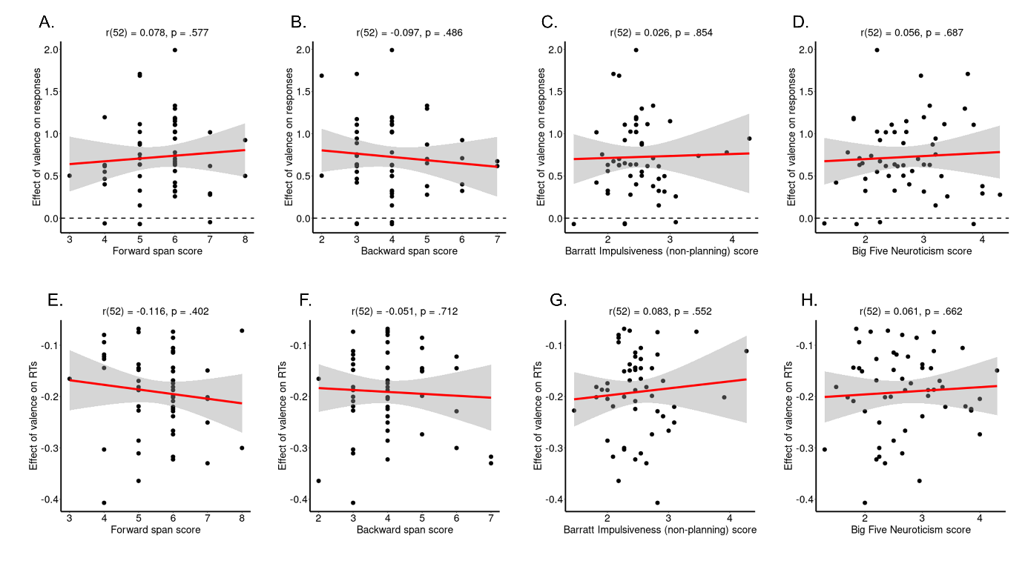
Figure S01. Association of memory performance, impulsivity, and neuroticism with the valence and stakes effects on responses. Correlations between the effect of valence on responses (A–D), reflecting Pavlovian biases, and the effect of stakes on accuracy (E–H) with (A/E) forward working memory span, (B/F) backwards working memory span, (C/G) impulsivity (Barratt Impulsiveness Scale, non-planning subscale) and (D/H) neuroticism. Black dots represent per-participant scores, the red line the best-fitting regression line, the grey shade the 95%-confidence interval. None of the displayed correlations is significant at α = .05.

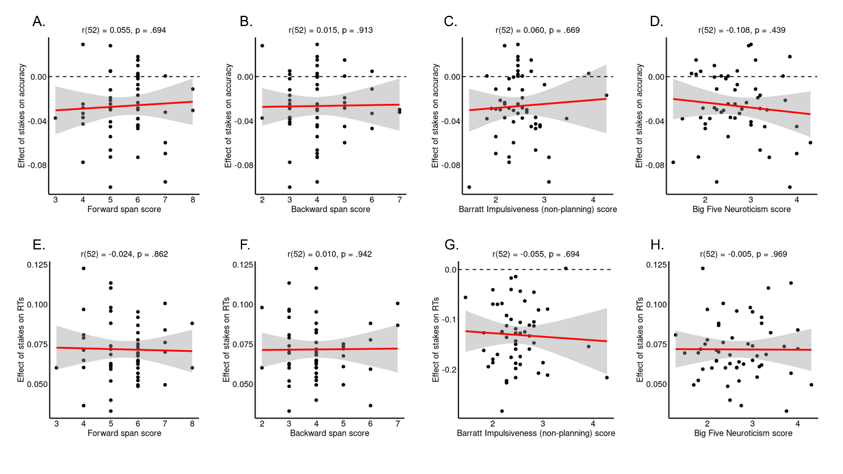
Figure S02. Association of memory performance, impulsivity, and neuroticism with the valence and stakes effects on RTs. Correlations between the effect of valence on RTs (A–D), reflecting Pavlovian biases, and the effect of stakes on RTs (E–H) with (A/E) forward working memory span, (B/F) backwards working memory span, (C/G) impulsivity (Barratt Impulsiveness Scale, non-planning subscale) and (D/H) neuroticism. Black dots represent per-participant scores, the red line the best-fitting regression line, the grey shade the 95%-confidence interval. None of the displayed correlations is significant at α = .05.

Supplemental Material S06: Effect of stakes on RTs over time
In the results in the main text, we report linear associations between time on task (cue repetition, trial number with blocks, trial number across blocks) and reaction time. All associations were non-significant. A more sensitive approach to detect possible non-linear changes over time are so called additive models, which model a time series as a mixture of smooth functions (i.e., thin plate regression splines) for each condition, and allow to test whether (a) a given time series is significantly different from a flat line, and (b) whether the time series of different conditions are significantly different from each other (Baayen et al. 2017; Wood 2017). A smooth function regularizes a raw times series and suppresses high-frequency (i.e., trial-by-trial) noise. Furthermore, it allows for non-zero auto-correlation between residuals, which are assumed to be zero in linear models.
In order to test whether the effect of task conditions of stakes on RTs changed over time, we fit three generalized additive mixed-effects models with the z-standardized trial-by-trial RT as dependent variable, modelled as an effect of cue repetition (1–20) with separate time series for (a) each cue condition (Go-to-Win, Go-to-Avoid, NoGo-to-Win, NoGo-to-Avoid), (b) for each stakes condition (high, low), or (c) the interaction between congruency (congruent, incongruent) and stakes (high, low). We modeled the time course of cue repetition as a factor smooth (which has a similar, but potentially non-linear effect as adding a random intercept and a random slope) for each participant for each block, allowing for the possibility that condition differences were different in different participants in different blocks (equivalent to a full random-effects structure). We used a scaled t-distribution instead of a Gaussian distribution for the RT variable as it led to lower AIC values. We also investigated whether fit further improved by adding an AR(1) auto-regressive model, which was not the case. For all fitted models, we visually checked that residuals were approximately normally distributed using quantile-quantile plots, and whether auto-correlation was near zero using auto-correlation plots (van Rij et al. 2019).
The model testing for differences between cue conditions suggested that RTs overall significantly decreased over time in all conditions (see Table S10; Fig. S03A). Further, RTs started to differ between cue conditions from repetition 1 or 2 onwards (see Table S11). Overall, RTs were faster for responses to Win than Avoid cues and faster for (correct) responses to Go cues than (incorrect) responses to NoGo cues. Overall, RT differences between conditions persisted throughout the block.
The model testing for differences between stakes levels suggested again that RTs overall significantly decreased over time in both conditions (Table S10; Fig. S03B). Furthermore, throughout the block, RTs were slower for responses on high-stakes trials than for responses on low-stakes trials (Table S11). This difference persisted throughout the block.
Finally, the model testing for differences between congruency conditions and stakes levels found again a significant decrease in RTs over time (Table S10; Fig. S03C). RTs were slower for responses to incongruent than to congruent cues, and slower on high-stakes trials than on low-stakes trials. Importantly, RTs were slower on high-stakes trials compared to low-stakes trials both for congruent and for incongruent cues, similarly, although this differences tended to be bigger for incongruent trials. These differences persisted throughout the task.
In sum, these results show that condition differences and differences between stakes in RTs emerge on the very first trials (cue repetitions) of a task and persist until the end of a block, with little change in these condition differences.
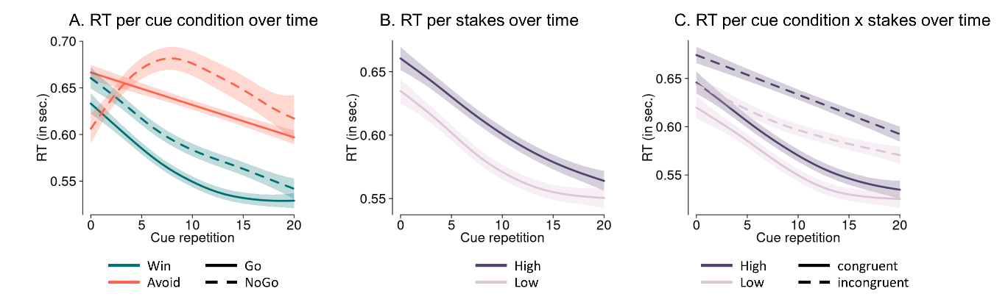
Figure S03. Time course of RTs over cue repetitions within a block as predicted by a generalized additive mixed-effects model, separated by conditions. Overall, RTs speed up over time. A. Differences between cue conditions as predicted by a mixed-effects additive model fitted to the data. RTs are significantly faster for responses to Win than responses to Avoid cues, and faster for (correct) responses to Go cues than (incorrect) responses to NoGo cues throughout a block. B. Differences between stakes levels. RTs are significantly slower on high-stakes trials compared to low-stakes trials throughout a block. C. Differences between stakes levels separately per condition. Both for congruent and incongruent cues, RTs on high-stakes trials are significantly slower than RTs on low-stakes trials. This difference tends to be larger for incongruent cues.

Model | Parametric coefficient  (Linear change within condition) | Smooth  (non-linear change within each condition)
Cue conditions:
Go-to-Win | t(3, 0.103) = 115.249, p < .001 | F(3.094, 3.788) = 27.370, p < .001
Go-to-Avoid | t(3, 0.103) = 22.778, p < .001 | F(1.000, 1.000) = 35.715, p < .001
NoGo-to-Win | t(3, 0.103) = 8.036, p < .001 | F(2.497, 3.061) = 26.894, p < .001
NoGo-to-Avoid | t(3, 0.103) = 12.887, p < .001 | F(2.963, 3.629) = 1.530, p = .107
Stakes:
High | t(3, 0.107) = 122.148, p < .001 | F(2.266, 2.746) = 35.926, p < .001
Low | t(3, 0.107) = -9.346, p < .001 | F(2.857, 3.478) = 24.505, p < .001
Congruency x Stakes:
Congruent /high | t(3, 0.104) = 108.940, p < .001 | F(2.426, 2.973) = 30.546, p < .001
Congruent/ low | t(3, 0.104) = -4.957, p < .001 | F(2.679, 3,284) = 22.242, p < .001
Incongruent/ high | t(3, 0.104) = 15.148, p < .001 | F(1.000, 1.000) = 44.597, p < .001
Incongruent/ low | t(3, 0.104) = 6.496, p < .001 | F(1.947, 2.381) = 15.505, p < .001
Table S10. Results from generalized additive mixed models (GAMMs) with separate smooths per condition. The parametric term reflects a linear change in time, while the smooth terms reflects any non-linear changes. Both add up to the total term.

Model | Parametric coefficient  (Intercept difference) | Smooth  (non-linear differences) | Windows of significant differences
Cue conditions:
G2W – G2A | t(3, 0.096) = 23.320, p < .001 | F(3.779, 4.618) = 5.052, p < .001 | 1 – 20
G2W – NG2W | t(3, 0.081) = 8.383, p < .001 | F(1.000, 1.000) = 0.606, p = .436 | 0 – 20
G2W – NG2A | t(3, 0.081) = 12.400, p < .001 | F(3.255, 3.933) = 14.710, p < .001 | 2 – 20
G2A – NG2W | t(3, 0.108) = -9.870, p < .001 | F(2.587, 3.168) = 5.080, p = .001 | 2 – 20
G2A – NG2A | t(3, 0.112) = 3.234, p = .001 | F(2.878, 3.476) = 7.412, p < .001 | 0 – 2, 5 – 16
NG2W – NG2A | t(3, 0.098) = 6.939, p < .001 | F(3.376, 4.042) = 11.760, p < .001 | 0 – 1, 3 – 20
Stakes:
High – Low | t(3, 0.107) = -9.317, p < .001 | F(1.424, 1.706) = 1.715, p = .278 | 0 – 20
Congruency x Stakes:
Cong/High – Cong/Low | t(3, 0.081) = -4.997, p < .001 | F(1.000, 1.000) = 0.039, p = .844 | 0 – 20
Incong/High – Incong/Low | t(3, 0.108) =-8.337, p < .001 | F(1.000, 1.000) = 0.369, p = .543 | 0 – 20
Cong/High – Incong/High | t(3, 0.999) = 15.430, p < .001 | F(1.711, 2.085) = 2.757, p = .061 | 0 – 20
Cong/Low – Incong/Low | t(3, 0.102) = 11.470, p < .001 | F(1.000, 1.000) = 5.196, p = .023 | 0 – 20
Table S11. Results from generalized additive mixed models (GAMMs) with difference smooths between two conditions. The parametric term reflects a linear difference between conditions, while the smooth terms reflects any non-linear difference. Both add up to the total term. The time window of significant condition differences is automatically returned by the model.

Supplemental Material S07: Reinforcement-learning drift diffusion models
 | M01 | M02 | M03 | M04 | M05 | M06 | M07 | M08 | M09 | M10 | M11 | M12
WAIC | 14501 | 9284 | 8011 | 7029 | 7023 | 6848 | 7082 | 6996 | 6821 | 7025 | 6843 | 6682
LOO-IC | 14365 | 8970 | 7611 | 6734 | 6656 | 6512 | 6722 | 6706 | 6420 | 6646 | 6494 | 6278
α | 2.011  [1.97, 2.02] | 1.377 [1.372, 1.404] | 1.466 [1.449, 1.482] | 1.442 [1.428, 1.456] |  | 1.409 [1.397, 1.421] | 1.430 [1.417, 1.444] | 1.444 [1.430, 1.457] |  |  | 1.408 [1.396, 1.421] | 1.379 [1.367, 1.390]
α_{Low} |  |  |  |  | 1.406 [1.393, 1.420] |  |  |  | 1.375 [1.361, 1.389] | 1.410 [1.397, 1.424]
α_{High} |  |  |  |  | 1.479 [1.466, 1.492] |  |  |  | 1.429 [1.414, 1.444] | 1.475 [1.462, 1.488]
τ | 0.128 [0.119, 0.136] | 0.234 [0.226, 0.241] | 0.228 [0.220, 0.236] | 0.232 [0.224, 0.239] | 0.233 [0.226, 0.240] |  | 0.234 [0.227, 0.241] | 0.231 [0.224, 0.239] |  | 0.233 [0.225, 0.240]
τ_{Low} |  |  |  |  |  | 0.237 [0.230, 0.245] |  |  | 0.243 [0.236, 0.250] |  | 0.238 [0.231, 0.245] | 0.244 [0.237, 0.251]
τ_{High} |  |  |  |  |  | 0.249 [0.242, 0.256] |  |  | 0.247 [0.240, 0.254] |  | 0.249 [0.241, 0.256]
τ_{High/Cong} |  |  |  |  |  |  |  |  |  |  |  | 0.266 [0.260, 0.273]
τ_{High/Incong} |  |  |  |  |  |  |  |  |  |  |  | 0.264 [0.256, 0.271]
β | 0.061 [0.058, 0.063] | 0.259 [0.251, 0.267] |  | 0.251 [0.244, 0.258] | 0.250 [0.243, 0.257] | 0.264 [0.257, 0.270] |  | 0.249 [0.243, 0.256] | 0.266 [0.259, 0.273] | 0.250 [0.243, 0.256] | 0.264 [0.257, 0.271] | 0.277 [0.270, 0.284]
β_{Win} |  |  | 0.318 [0.308, 0.328]
β_{Avoid} |  |  | 0.167 [0.161, 0.172]
β_{Low} |  |  |  |  |  |  | 0.268 [0.262, 0.274]
β_{High} |  |  |  |  |  |  | 0.247 [0.241, 0.253]
δ_{Int} | 3.617 [3.558, 3.675] | 1.358 [1.310, 1.407] | 1.542 [1.483, 1.602]
δ_{Win} |  |  |  | 2.086 [2.018, 2.152] | 2.100 [2.032, 2.167] | 2.037 [1.890, 2.105] | 2.041 [1.971, 2.112] | 2.159 [2.091, 2.228] | 2.026 [1.957, 2.094] | 2.130 [2.061, 2.199] | 2.074 [2.005, 2.142] | 1.981 [1.910, 2.053]
δ_{Avoid} |  |  |  | 0.796 [0.757, 0.834] | 0.803 [0.765, 0.841] | 0.736 [0.698, 0.774] | 0.763 [0.726, 0.799] | 0.867 [0.827, 0.908] | 0.727 [0.691, 0.764] | 0.831 [0.791, 0.871] | 0.774 [0.736, 0.813] | 0.684 [0.645, 0.723]
δ_{Slope} |  | 6.823 [6.354, 7.267] | 6.283 [5.872, 6.681] | 6.093 [5.718, 6.446] | 6.149 [5.773, 6.508] | 6.191 [5.810, 6.550] | 6.102 [5.734, 6.458] | 6.109 [5.741, 6.464] | 6.218 [5.834, 6.590] | 6.151 [5.777, 6.510] | 6.219 [5.834, 6.586] | 6.273 [5.896, 6.633]
δ_{High} |  |  |  |  |  |  |  | -0.128  [-0.148,  -0.108] |  | -0.054  [-0.076,  -0.033] | -0.075  [-0.096,  -0.054]
ε |  | 0.100 [0.088, 0.110] | 0.102 [0.092, 0.112] | 0.121 [0.110, 0.131] | 0.121 [0.109, 0.131] | 0.120 [0.108, 0.130] | 0.120 [0.109, 0.130] | 0.122 [0.110, 0.132] | 0.120 [0.109, 0.130] | 0.121 [0.109, 0.131] | 0.120 [0.109, 0.131] | 0.119 [0.108, 0.129]
Table S12. Mean [25th percentile, 75th percentile] of the posterior densities of group-level parameters. α = decision threshold, τ = non-decision time, β = starting point bias, δ = drift rate, ε = learning rate. WAIC and LOO-IC are reported as measures of model fit, with smaller values indicating a better fit.

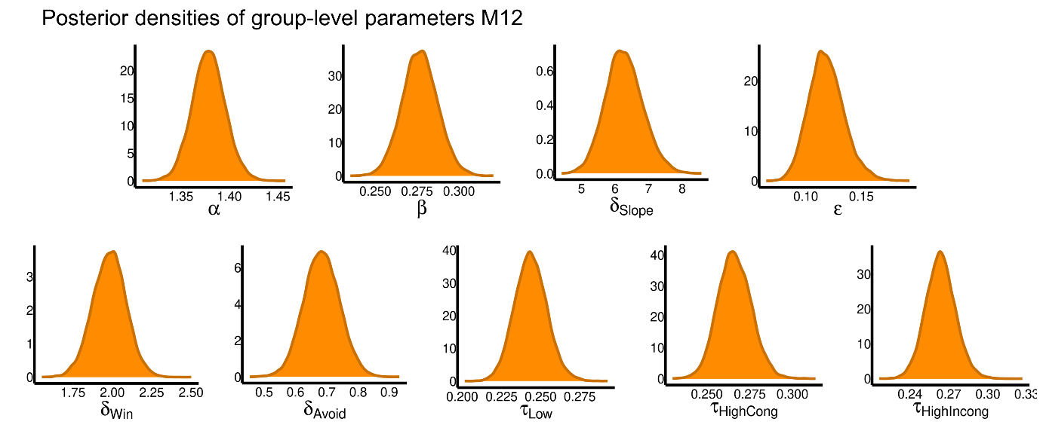
Figure S04. Posterior densities of the group-level parameters of the winning model M12. α = decision threshold, τ = non-decision time, β = starting point bias, δ = drift rate, ε = learning rate.

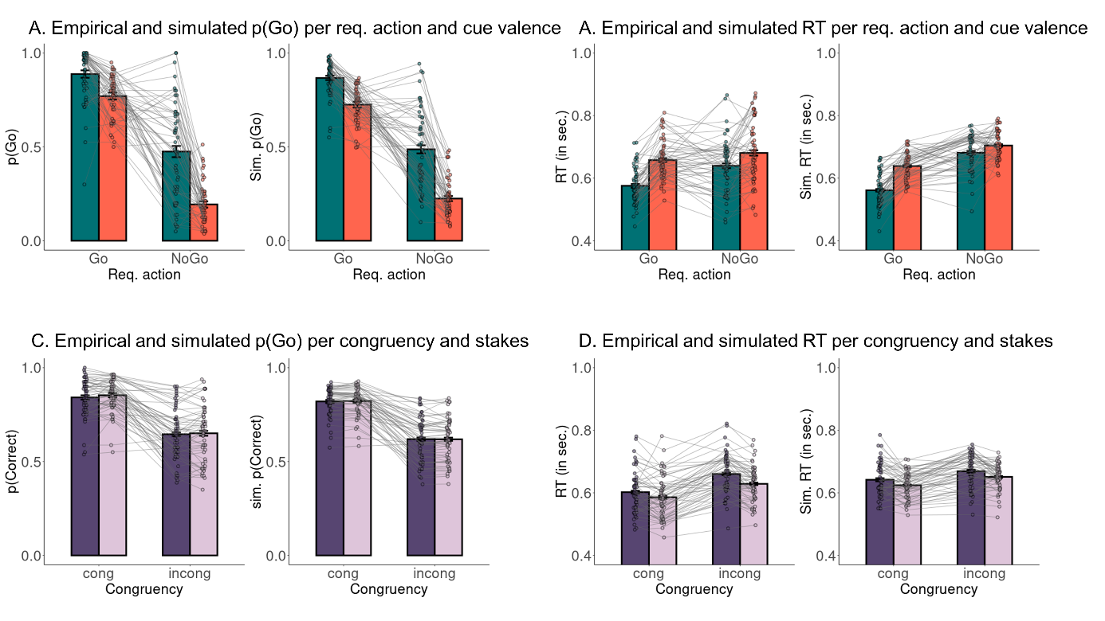
Figure S05. Posterior predictive checks for data simulated from the winning model M12. A. Both in empirical data (left panel) and data simulated from the winning model M12 (right panel), (simulated) participants performed more Go responses to Go than NoGo cues (learning) and more Go responses to Win than Avoid cues (Pavlovian bias). Simulated data matched the empirical data pattern. B. Both in empirical and simulated data, (simulated) participants showed faster responses to Go than NoGo cues and to Win than Avoid cues. Simulated data matched the empirical data pattern. C. Both in empirical and simulated data, (simulated) participants performed more accurately for congruent than incongruent cues, with no difference between high and low stakes. D. Both in empirical and simulated data, (simulated) participants performed faster for congruent than incongruent cues and under low compared to high stakes. In empirical participants, the stakes effect was stronger for incongruent than congruent cues, but this difference was somewhat underestimated by the winning model M12.

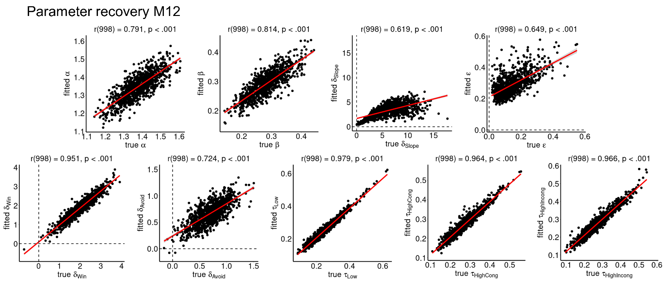
Figure S06. Parameter recovery results for the winning model M12. The correlation between generative and fitted parameters is overall very high. Recovery is overall very high. It is least optimal (but still strongly significant) for δ_{Slope} and ε, which trade off against each other (see Fig. 4D main text). α = decision threshold, τ = non-decision time, β = starting point bias, δ = drift rate, ε = learning rate.

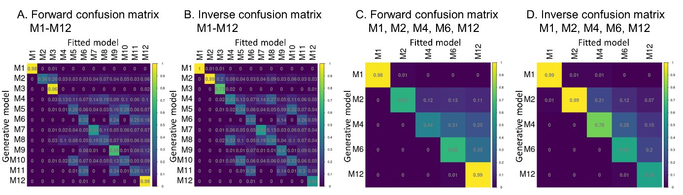
Figure S07. Forward and inverse confusion matrices from model recovery of all models and of nested sub-versions of the winning model M12. A. The forward confusion matrix displays the conditional probabilities that model Y is the best fitting model (columns) if model X (rows) is the underlying generative model used to simulate a given data set (identical to Fig. 4E main text). Rows sum to 100%. On-diagonal probabilities indicate the probability of reidentifying the generative model. All on-diagonal probabilities are significantly above chance (range 0.13–0.98; 95th percentile of permutation null distribution: p = 0.10). Especially recovery for M12 is exceptionally high (98%). B. The inverse confusion matrix displays the conditional probabilities that model X is the generative model (rows) if model Y (rows) is the best fitting model for a given data set. Columns sum to 100%. On-diagonal probabilities indicate the probability of reidentifying the generative model. All on-diagonal probabilities are significantly above chance (range 0.30–1.00; 95th percentile of permutation null distribution: p = 0.10). C. Forward confusion matrix only for the five models that are nested sub-versions of M12 (i.e., M1, M2, M4, M6, M12). Recovery is overall much higher (range 0.44–0.99; 95th percentile of permutation null distribution: p = 0.22). D. Inverse confusion matrix only for the five models that are nested sub-versions of M12. Recovery is overall much higher (range 0.58–0.99; 95th percentile of permutation null distribution: p = 0.22).

Supplementary References
Baayen H, Vasishth S, Kliegl R, Bates D. 2017. The cave of shadows: Addressing the human factor with generalized additive mixed models. Journal of Memory and Language 94: 206–234.
Beilock SL, Carr TH. 2005. When high-powered people fail: Working memory and “choking under pressure” in math. Psychological Science 16: 101–105.
Bijleveld E, Veling H. 2014. Separating chokers from nonchokers: Predicting real-life tennis performance under pressure from behavioral tasks that tap into working memory functioning. Journal of Sport and Exercise Psychology 36: 347–356.
DeCaro MS, Thomas RD, Albert NB, Beilock SL. 2011. Choking under pressure: Multiple routes to skill failure. Journal of Experimental Psychology: General 140: 390–406.
DeYoung CG, Quilty LC, Peterson JB. 2007. Between facets and domains: 10 aspects of the Big Five. Journal of Personality and Social Psychology 93: 880–896.
Fitzpatrick AL, Rapp SR, Luchsinger J, Hill-Briggs F, Alonso A, Gottesman R, Lee H, Carnethon M, Liu K, Williams K, et al. 2015. Sociodemographic correlates of cognition in the Multi-Ethnic Study of Atherosclerosis (MESA). The American Journal of Geriatric Psychiatry 23: 684–697.
Patton JH, Stanford MS, Barratt ES. 1995. Factor structure of the Barratt Impulsiveness Scale. Journal of Clinical Psychology 51: 768–774.
van Rij J, Hendriks P, van Rijn H, Baayen RH, Wood SN. 2019. Analyzing the time course of pupillometric data. Trends in Hearing 23: 2331216519832483.
Wood SN. 2017. Generalized additive models: An introduction with R. Chapman & Hall/CRC, Boca Raton, FL http://doi.wiley.com/10.1111/j.1541-0420.2007.00905_3.x.

