Supplementary Information

Network motifs exhibiting a differential response to spaced and massed inputs
Ashley Sreejan, Priyanka Saxena, and Chetan Gadgil

Table of contents
1. Existing studies 2
2. Formulation of ODE-based motif models 3
2.1. Autoregulation 3
2.2. Positive Feedback Loops 5
2.3. Negative Feedback Loops 6
2.4. Coherent Feedforward Loops (OR logic) 7
2.5. Coherent Feedforward Loops (AND logic) 8
2.6. Incoherent Feedforward Loops 8
2.7. Activation Cascades 9
2.8. Inhibition Cascades 9
3. Non-dimensionalization of ODE-based models 10
4. Constraints for the filtration of parameter sets 11
5. Parameter values for Figures 1B and 1C 13
6. Effect of minimum RER threshold on the results 14
7. Effect of response element definition on the results 15
8. Conversion cascades 16
9. Representative simulation results for PFBLv6, CFFLv1-OR and ACv3 mechanisms 17
10. Individual pathways in the Zhang et al. model show spacing effect 20
11. Effect of Hill coefficient on the results 22
12. Effect of minimum significant response threshold on the results 23
13. References 24

Existing studies
The following table summarizes some existing studies on the spacing effect and differential response to spaced and massed stimuli.
Reference | T/E# | System | Stimulus Protocol | Motifs* | Response Measure
Kogan et al. 1997 | E | CREB mutant mice | Water maze and contextual conditioning tasks with 1 hr intervals for spaced training | --- | Amount of food eaten 24 hr after training.
Mauelshagen et al. 1998 | E | Aplysia SN/MN neurons | Spaced: $5×5$ min 50μM 5-HT with an ISI of 15 min. Massed: $1×25$ min 50 µM 5-HT. | --- | Excitatory postsynaptic potential (EPSP)
Scharf et al. 2002 | E | Mouse hippocampal slices | 100 Hz tetraburst stimulation. Massed 20 s inter-burst interval. Spaced 5 min IBI. 1.5 mA foot shock for 2 s. Spaced: 1 hr inter-shock-interval. Massed: 3.5 min ISI. | --- | fEPSP measurements. Freezing behavior measurement for 5 min, 24 hr after training.
Fuhrmann et al. 2002 | T+E | Neocortical depressing synapses | Neuronal firing rates with variable frequency | --- | Information in bits and encoded per unit time
Woo et al. 2003 | E | R(AB) transgenic mice hippocampal neurons | Four 100 Hz bursts of 1 s duration. Spaced stimulation using a 5 min interval and massed with 3 and 20 s intervals. | --- | fEPSP for 2 hr after electrical stimulation
Ajay and Bhalla 2004 | T+E | Hippocampal CA1 neurons | Repeated 100 Hz, 1 s tetani with ITI 10, 20, 60, 300, 600, and 1800 s. Ca²⁺ influx and Glu activation as a square 5 µM pulse for 1 s duration | FFLs and FBLs | fEPSP was recorded for 45 min after the last tetanic stimuli. ERKII, CaMKII experimentally recorded 600 s after the last tetanus. ERKII, CaMKII, PKC, PKA time-course from the model.
Farah et al. 2009, 2015 | T+E | Aplysia SN neurons | Spaced: $5×5$ min10 µM 5-HT at 20 min intervals. Massed: Continuous 90 min application of 5-HT | FBL | PKC Apl II translocation
Kim et al. 2010 | T+E | Mouse hippocampal slices | Four 100 Hz bursts of 1 s duration. Spaced stimulation using a 5 min interval and massed with 3 s interval. | PFBL | (1) Cumulative activity of PKA for 50 mins (2) fEPSP experimentally (3) PKA activity at 5 min after last tetanus
Naqib et al. 2011 | T+E | Aplysia SN neurons | Spaced: $5×5$ min 10 µM 5-HT, with an ISI of 20 min. Massed: $1×90$ min 10 µM 5-HT | FBL | PKC Apl II translocation
Zhang et al. 2012 | T+E | Aplysia SN neurons (PKA and ERK Cascades) | Optimization using non-uniform ISI between 5 pulses of 5-HT (ISI = 5n min) | FFL | Peak concentration of a hypothetical ‘LTF inducer molecule’
Liu et al. 2013 | T+E | Aplysia SN-MN neurons (PKA, ERK Cascades, and reduced CBP activity using siRNA knockdown) | Optimized rescue protocol using non-uniform ISI between 5 pulses of 5-HT (ISI 5n min) | FFL | Peak concentration of C/EBP
Philips et al. 2013 | E | Aplysia and Aplysia SN neurons | Two shocks separated by 15, 45, and 60 min | --- | Tail withdrawal response. MAPK, CREB, C/EBP levels
Table S1. Some existing studies on the spacing effect and differential response to spaced and massed stimulus. ISI, IBI, and ITI denote inter-stimulus, inter-burst, and inter-tetanic intervals. (P)FBL and FFL represent (positive) feedback and feedforward loops, respectively. # Theoretical (T) or Experimental (E) study. * An underlying network architecture observable or discussed explicitly in the study.

Formulation of ODE-based motif models
The set of ordinary differential equations (ODEs) describing the forty-one motif models (see Figure S1) are given in the following sections. All kinetic parameters are denoted by $k$ and $K$, while lowercase $x$, $y$, $z$, $a$, and $b$ denote the concentration of each species in the model. The zero-order formation rate constant of each species is indicated by $k_{b}$ and the first-order degradation rate constant by $k_{d}$. For instance, $k_{bx}$ and $k_{dx}$ represent the formation and degradation rate constants of species X. In each model, $S\left(t\right)$ represents the stimulus (input) strength, which assumes a value of 1 or 0, corresponding to the on and off states of the square wave input. The regulatory interactions (catalytic activations and inhibitions) were modeled using Hill functions as follows.
$$F_{A}\left(x,K\right)=\frac{x^{n}}{K^{n}+x^{n}} \text{and} F_{I}\left(x,K\right)=\frac{K^{n}}{K^{n}+x^{n}}$$
Here $x$ denotes the concentration of activator/inhibitor, and $n$ represents the Hill coefficient. For simplicity, the Hill coefficients were assumed to be equal for all regulatory interactions in each model.

Autoregulation
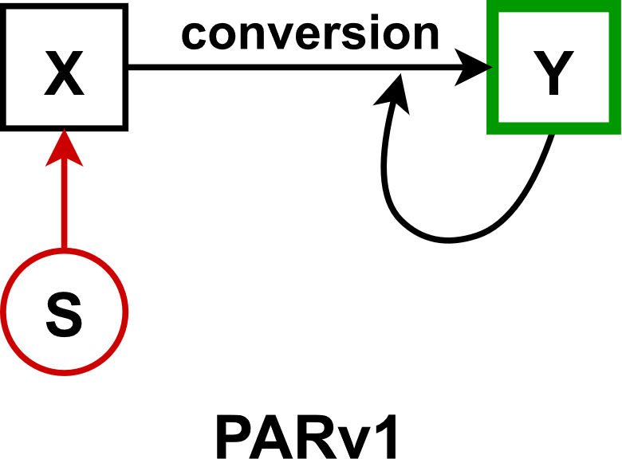 | $$\dot{x}=k_{bx}+k_{sx}⋅S\left(t\right)-k_{xy}⋅x-k_{yxy}⋅x⋅F_{A}\left(y,K_{yxy}\right)-k_{dx}⋅x \\ \dot{y}=k_{xy}⋅x+k_{yxy}⋅x⋅F_{A}\left(y,K_{yxy}\right)-k_{dy}⋅y$$
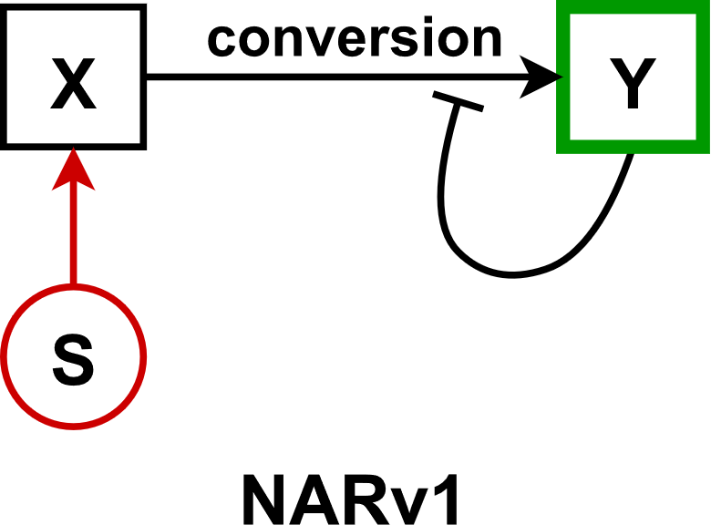 | $$\dot{x}=k_{bx}+k_{sx}⋅S\left(t\right)-k_{xy}⋅x-k_{yxy}⋅x⋅F_{I}\left(y,K_{yxy}\right)-k_{dx}⋅x \\ \dot{y}=k_{xy}⋅x+k_{yxy}⋅x⋅F_{I}\left(y,K_{yxy}\right)-k_{dy}⋅y$$
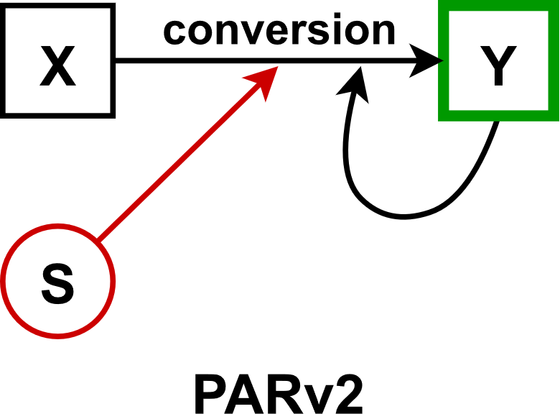 | $$\dot{x}=k_{bx}-k_{xsy}⋅x⋅S\left(t\right)-k_{yxy}⋅x⋅F_{A}\left(y,K_{yxy}\right)-k_{dx}⋅x \\ \dot{y}=k_{xsy}⋅x⋅S\left(t\right)+k_{yxy}⋅x⋅F_{A}\left(y,K_{yxy}\right)-k_{dy}⋅y$$
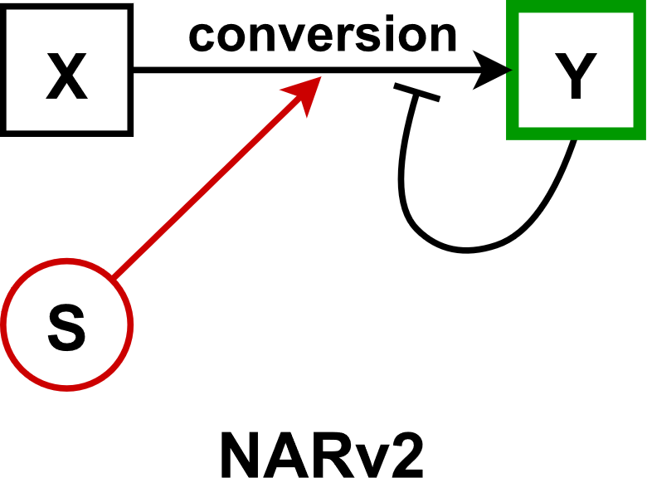 | $$\dot{x}=k_{bx}-k_{xsy}⋅x⋅S\left(t\right)-k_{yxy}⋅x⋅F_{I}\left(y,K_{yxy}\right)-k_{dx}⋅x \\ \dot{y}=k_{xsy}⋅x⋅S\left(t\right)+k_{yxy}⋅x⋅F_{I}\left(y,K_{yxy}\right)-k_{dy}⋅y$$
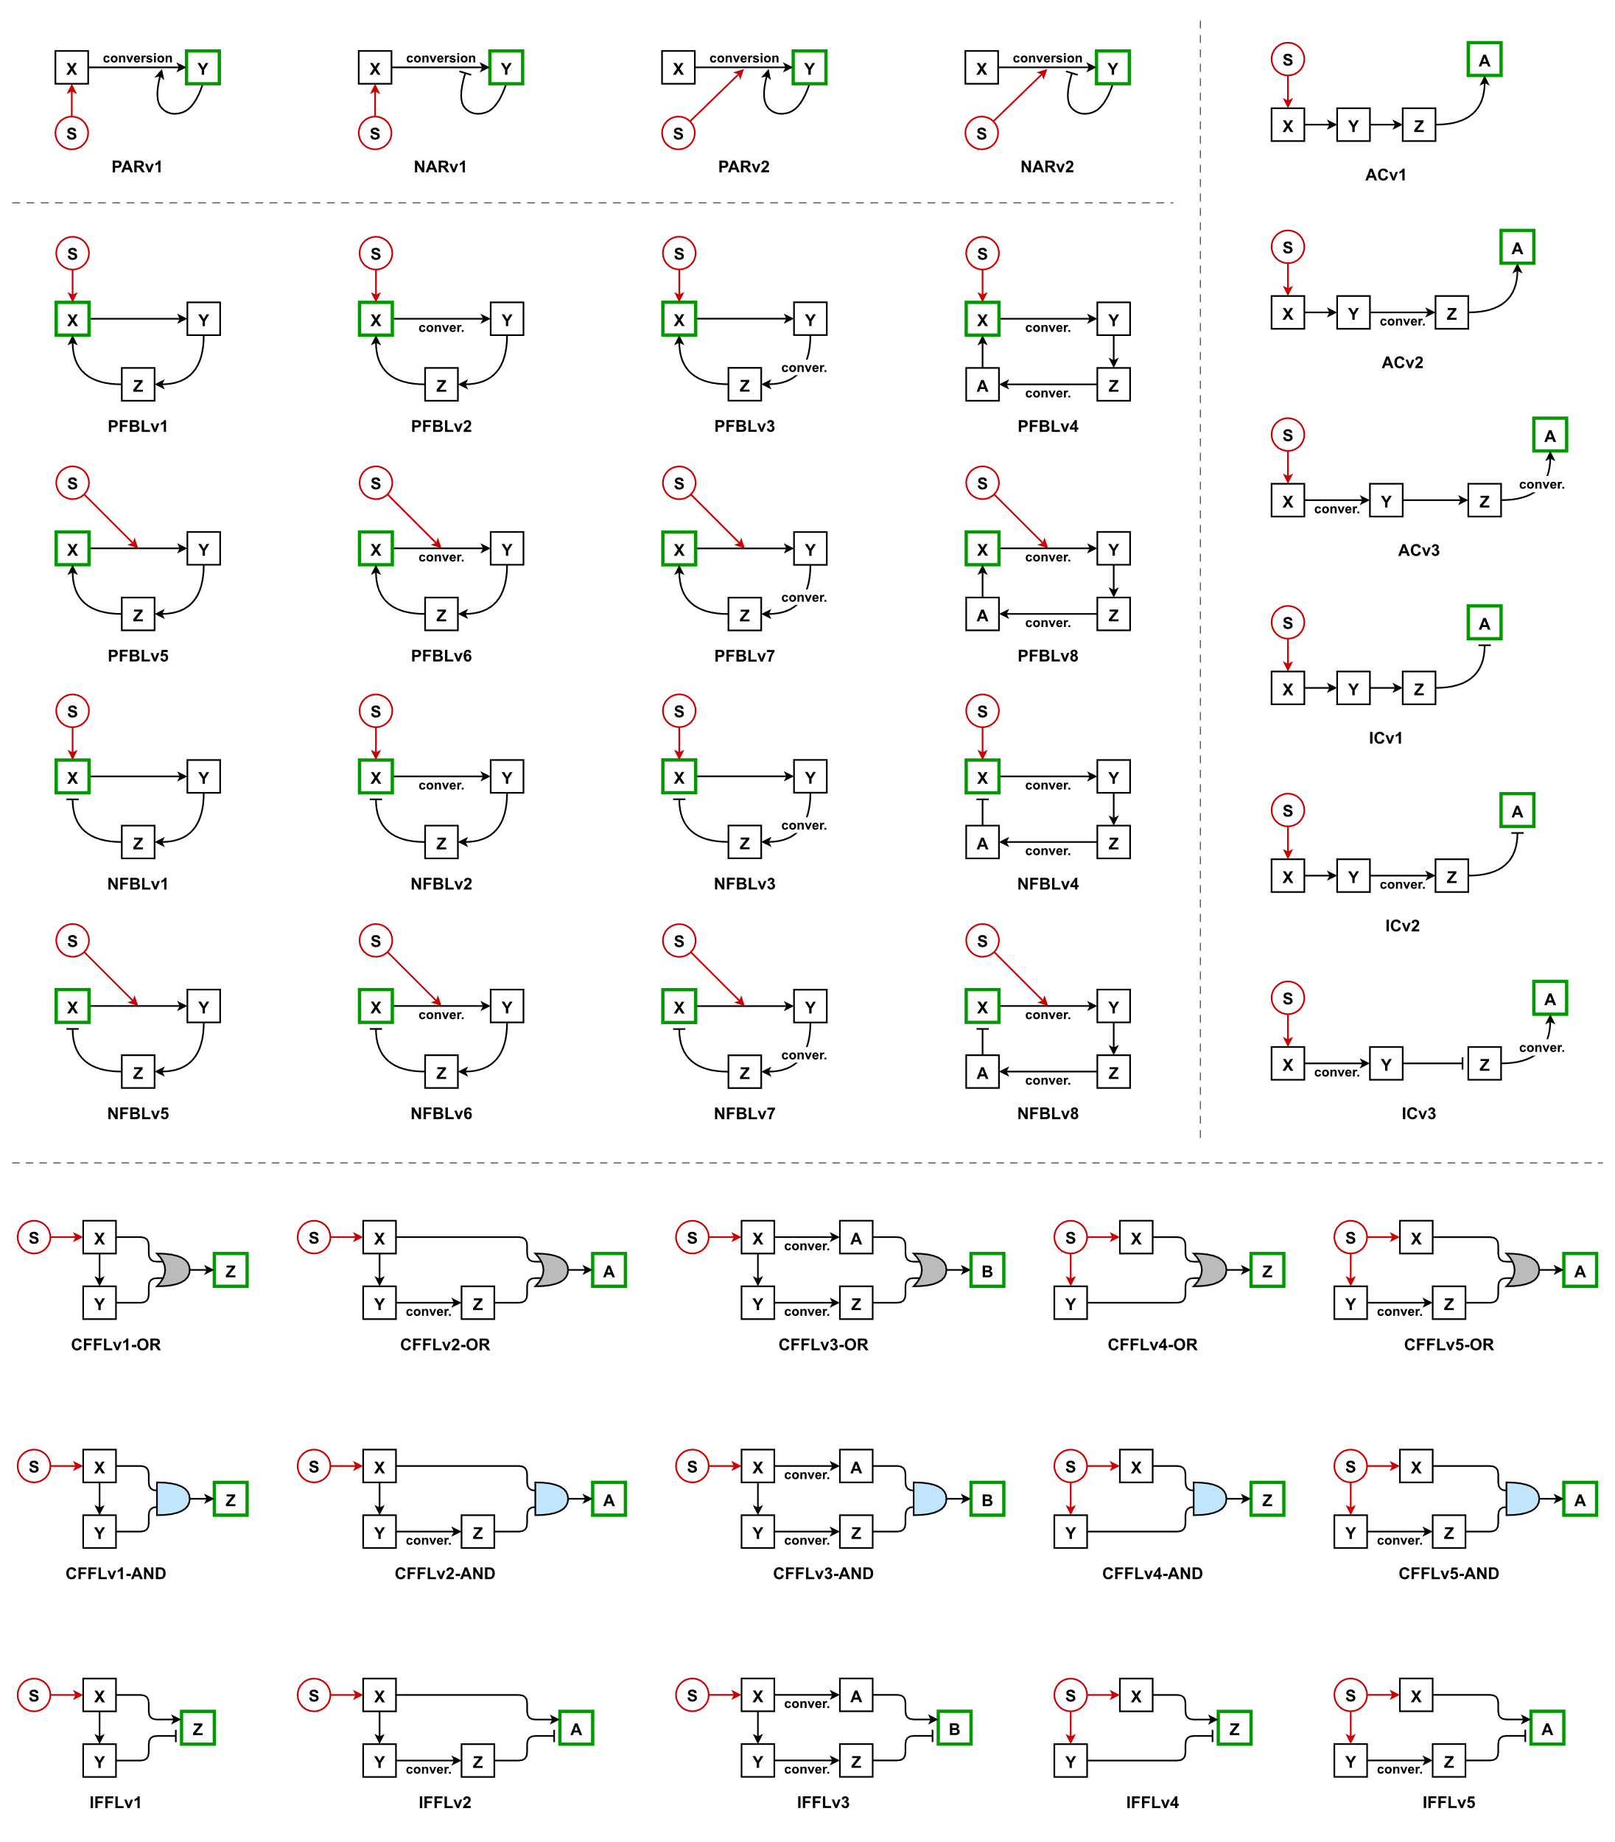
Figure S1. Details of the forty-one motif models examined in this study: Signal element S is highlighted in red, and the response element in green. X, Y, Z, A, and B denote the biomolecular species in each model. Catalytic activation and inhibition reactions are indicated by normal and blunt arrows, respectively. The coherent feedforward loop is categorized into two classes corresponding to OR and AND Boolean logics.

Positive Feedback Loops
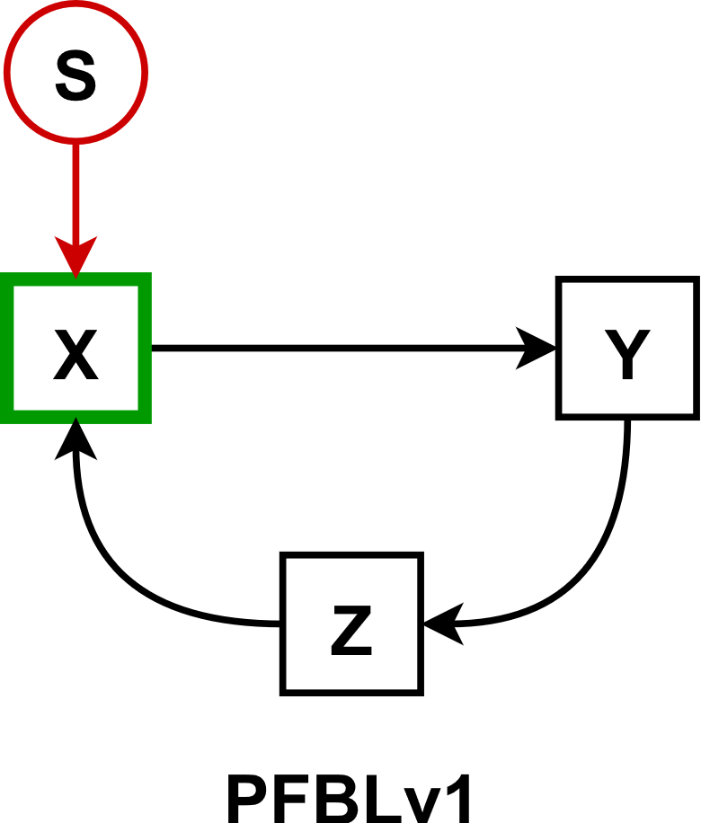 | $$\dot{x}=k_{bx}+k_{sx}⋅S\left(t\right)+k_{zx}⋅F_{A}\left(z,K_{zx}\right)-k_{dx}⋅x \\ \dot{y}=k_{by}+k_{xy}⋅F_{A}\left(x,K_{xy}\right)-k_{dy}⋅y \\ \dot{z}=k_{bz}+k_{yz}⋅F_{A}\left(y,K_{yz}\right)-k_{dz}⋅z$$
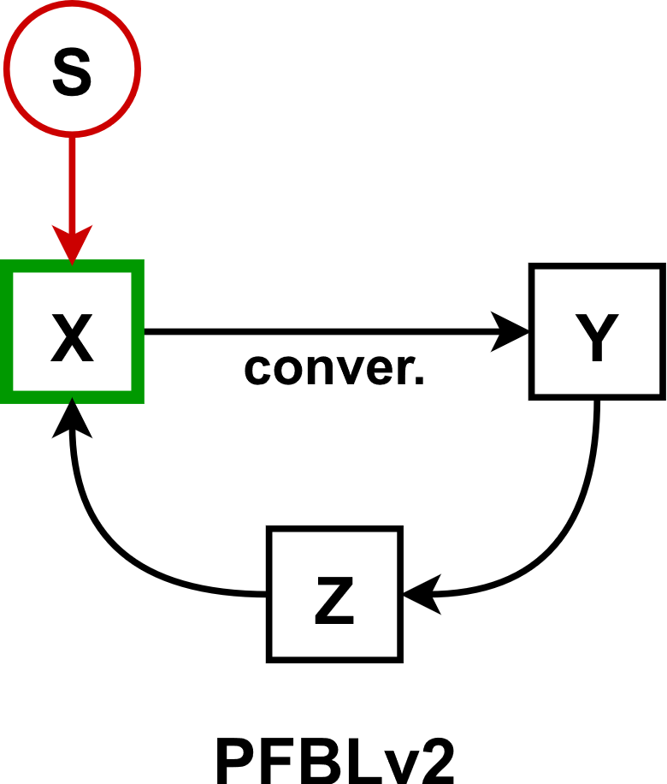 | $$\dot{x}=k_{bx}+k_{sx}⋅S\left(t\right)+k_{zx}⋅F_{A}\left(z,K_{zx}\right)-k_{xy}⋅x-k_{dx}⋅x \\ \dot{y}=k_{xy}⋅x-k_{dy}⋅y \\ \dot{z}=k_{bz}+k_{yz}⋅F_{A}\left(y,K_{yz}\right)-k_{dz}⋅z$$
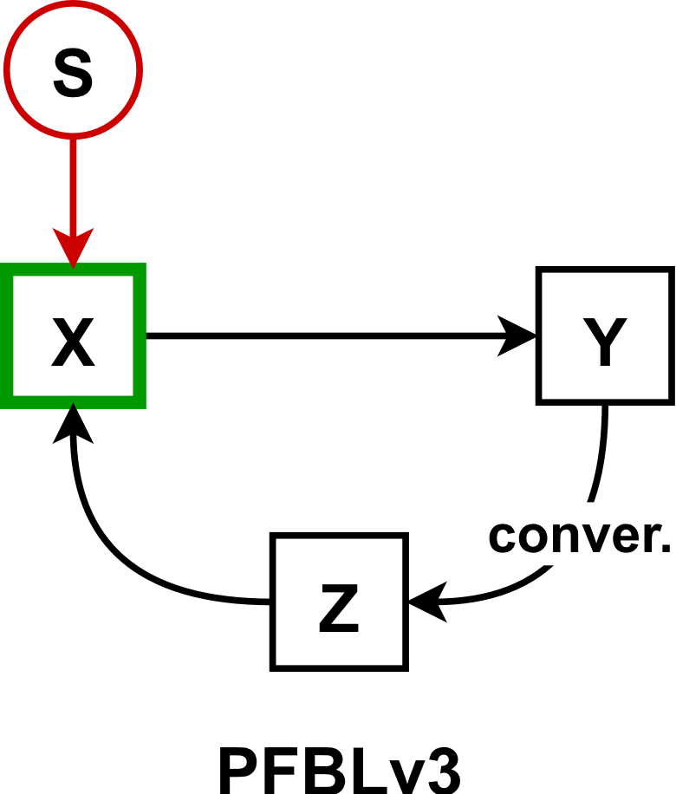 | $$\dot{x}=k_{bx}+k_{sx}⋅S\left(t\right)+k_{zx}⋅F_{A}\left(z,K_{zx}\right)-k_{dx}⋅x \\ \dot{y}=k_{by}+k_{xy}⋅F_{A}\left(x,K_{xy}\right)-k_{yz}⋅y-k_{dy}⋅y \\ \dot{z}=k_{yz}⋅y-k_{dz}⋅z$$
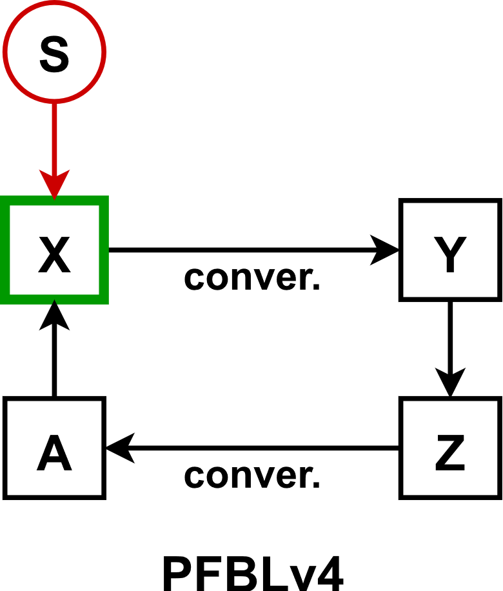 | $$\dot{x}=k_{bx}+k_{sx}⋅S\left(t\right)+k_{ax}⋅F_{A}\left(a,K_{ax}\right)-k_{xy}⋅x-k_{dx}⋅x \\ \dot{y}=k_{xy}⋅x-k_{dy}⋅y \\ \dot{z}=k_{bz}+k_{yz}⋅F_{A}\left(y,K_{yz}\right)-k_{za}⋅z-k_{dz}⋅z \\ \dot{a}=k_{za}⋅z-k_{da}⋅a$$
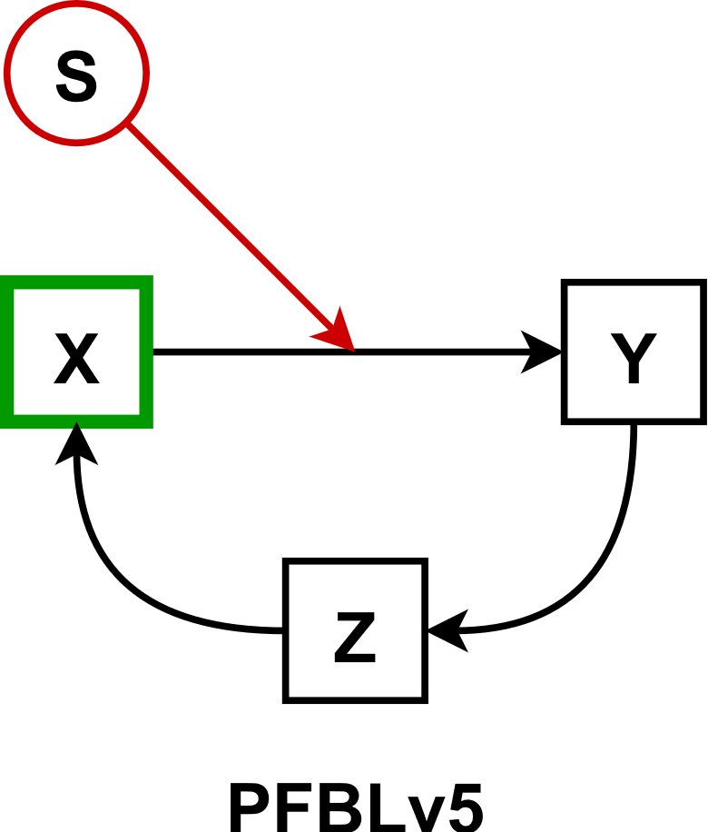 | $$\dot{x}=k_{bx}+k_{zx}⋅F_{A}\left(z,K_{zx}\right)-k_{dx}⋅x \\ \dot{y}=k_{by}+k_{xsy}⋅S\left(t\right)⋅F_{A}\left(x,K_{xy}\right)-k_{dy}⋅y \\ \dot{z}=k_{bz}+k_{yz}⋅F_{A}\left(y,K_{yz}\right)-k_{dz}⋅z$$
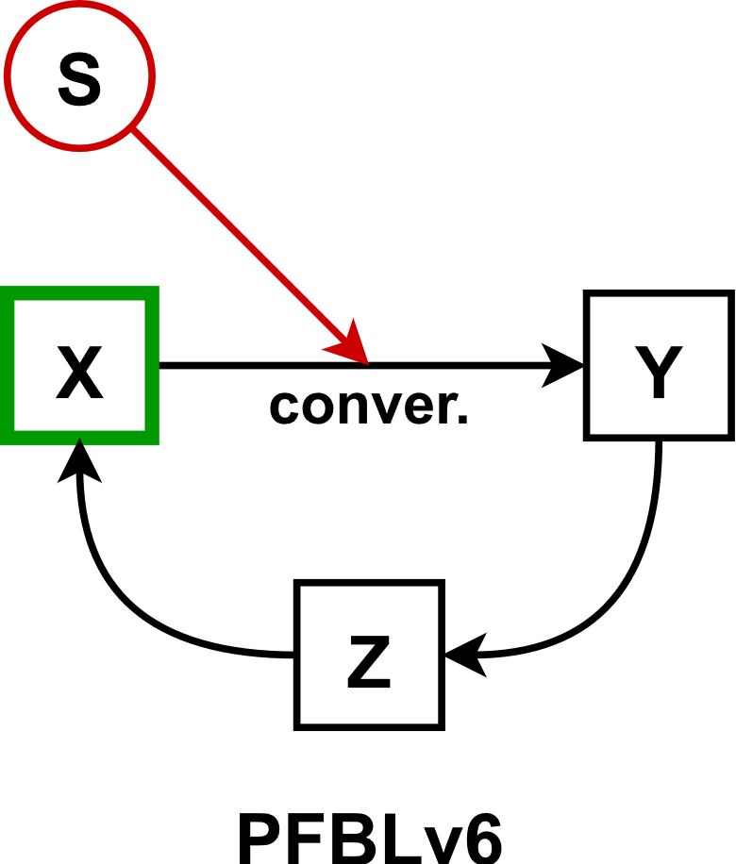 | $$\dot{x}=k_{bx}+k_{zx}⋅F_{A}\left(z,K_{zx}\right)-k_{xsy}⋅x⋅S-k_{dx}⋅x \\ \dot{y}=k_{xsy}⋅x⋅S\left(t\right)-k_{dy}⋅y \\ \dot{z}=k_{bz}+k_{yz}⋅F_{A}\left(y,K_{yz}\right)-k_{dz}⋅z$$
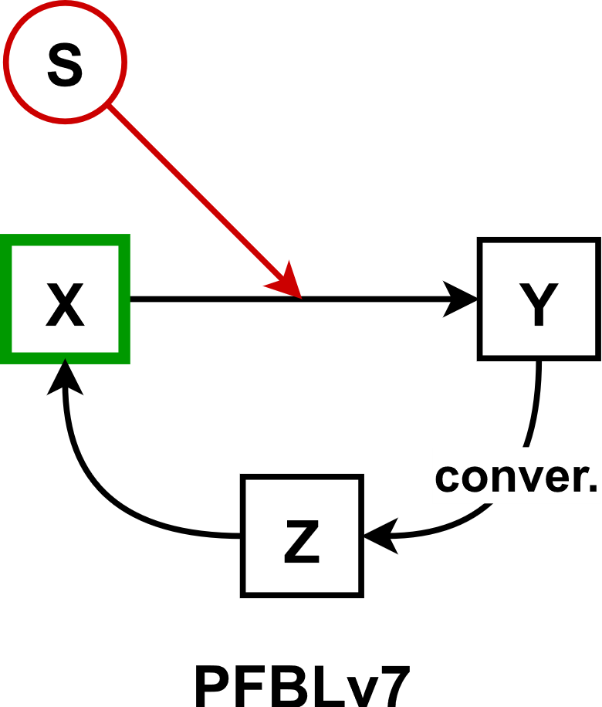 | $$\dot{x}=k_{bx}+k_{zx}⋅F_{A}\left(z,K_{zx}\right)-k_{dx}⋅x \\ \dot{y}=k_{by}+k_{xsy}⋅S\left(t\right)⋅F_{A}\left(x,K_{xy}\right)-k_{yz}⋅y-k_{dy}⋅y \\ \dot{z}=k_{yz}⋅y-k_{dz}⋅z$$
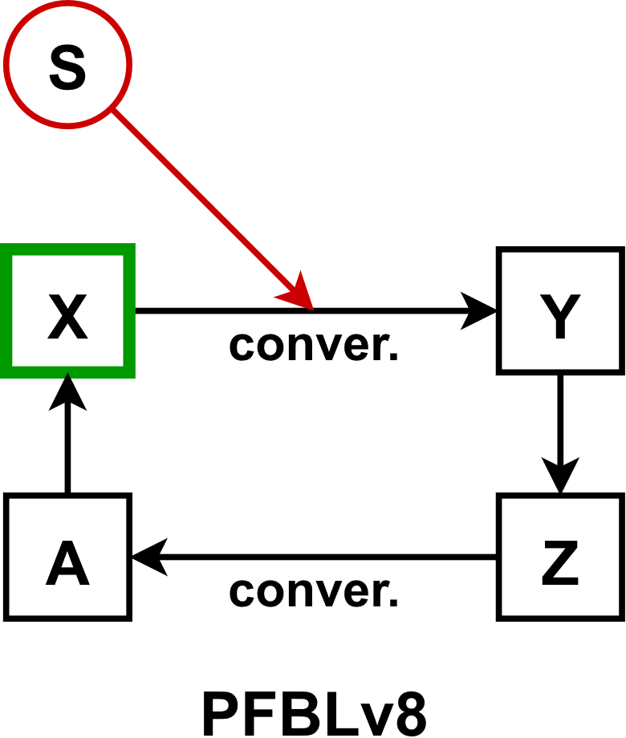 | $$\dot{x}=k_{bx}+k_{ax}⋅F_{A}\left(a,K_{ax}\right)-k_{xsy}⋅x⋅S-k_{dx}⋅x \\ \dot{y}=k_{xsy}⋅x⋅S\left(t\right)-k_{dy}⋅y \\ \dot{z}=k_{bz}+k_{yz}⋅F_{A}\left(y,K_{yz}\right)-k_{za}⋅z-k_{dz}⋅z \\ \dot{a}=k_{za}⋅z-k_{da}⋅a$$

Negative Feedback Loops
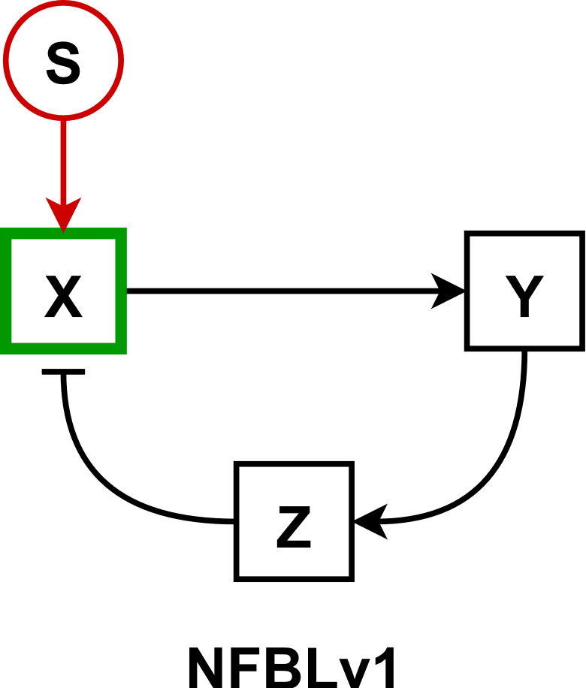 | $$\dot{x}=k_{bx}+k_{sx}⋅S\left(t\right)+k_{zx}⋅F_{I}\left(z,K_{zx}\right)-k_{dx}⋅x \\ \dot{y}=k_{by}+k_{xy}⋅F_{A}\left(x,K_{xy}\right)-k_{dy}⋅y \\ \dot{z}=k_{bz}+k_{yz}⋅F_{A}\left(y,K_{yz}\right)-k_{dz}⋅z$$
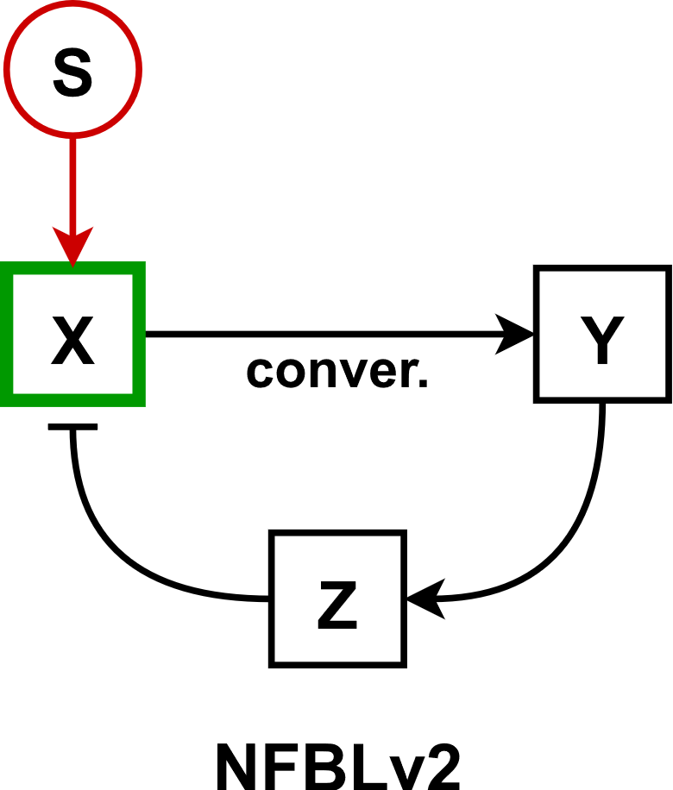 | $$\dot{x}=k_{bx}+k_{sx}⋅S\left(t\right)+k_{zx}⋅F_{I}\left(z,K_{zx}\right)-k_{xy}⋅x-k_{dx}⋅x \\ \dot{y}=k_{xy}⋅x-k_{dy}⋅y \\ \dot{z}=k_{bz}+k_{yz}⋅F_{A}\left(y,K_{yz}\right)-k_{dz}⋅z$$
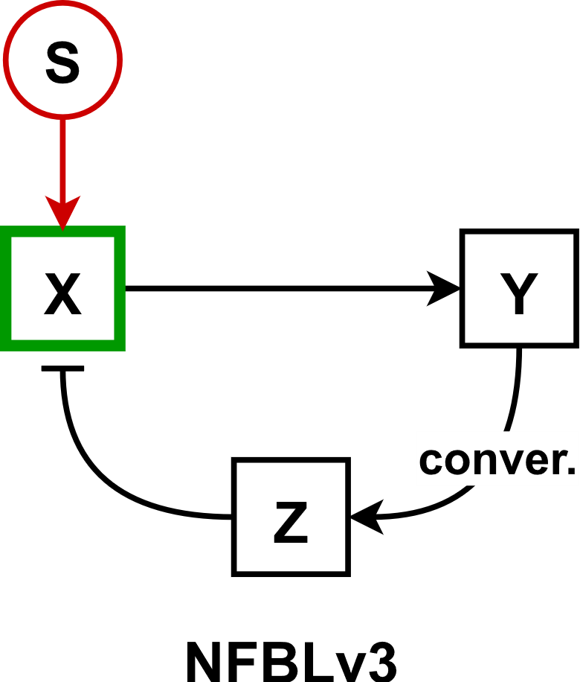 | $$\dot{x}=k_{bx}+k_{sx}⋅S\left(t\right)+k_{zx}⋅F_{I}\left(z,K_{zx}\right)-k_{dx}⋅x \\ \dot{y}=k_{by}+k_{xy}⋅F_{A}\left(x,K_{xy}\right)-k_{yz}⋅y-k_{dy}⋅y \\ \dot{z}=k_{yz}⋅y-k_{dz}⋅z$$
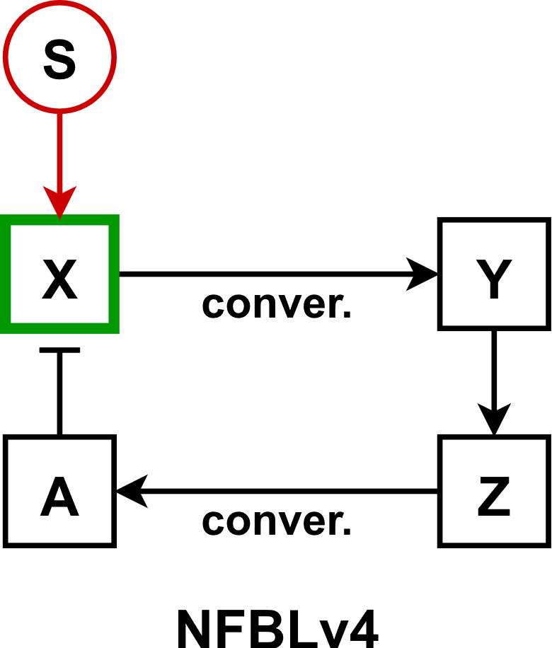 | $$\dot{x}=k_{bx}+k_{sx}⋅S\left(t\right)+k_{ax}⋅F_{I}\left(a,K_{ax}\right)-k_{xy}⋅x-k_{dx}⋅x \\ \dot{y}=k_{xy}⋅x-k_{dy}⋅y \\ \dot{z}=k_{bz}+k_{yz}⋅F_{A}\left(y,K_{yz}\right)-k_{za}⋅z-k_{dz}⋅z \\ \dot{a}=k_{za}⋅z-k_{da}⋅a$$
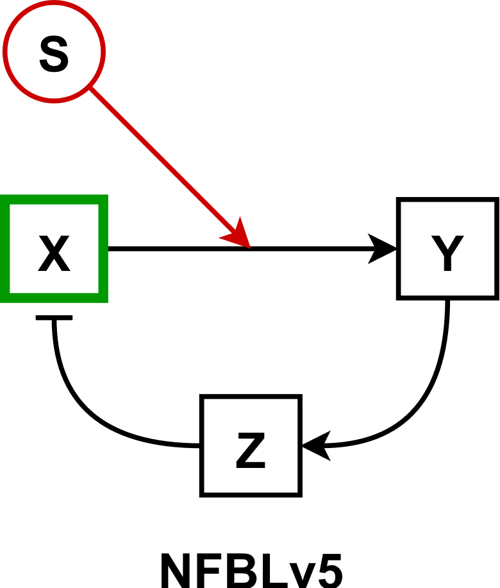 | $$\dot{x}=k_{bx}+k_{zx}⋅F_{I}\left(z,K_{zx}\right)-k_{dx}⋅x \\ \dot{y}=k_{by}+k_{xsy}⋅S\left(t\right)⋅F_{A}\left(x,K_{xy}\right)-k_{dy}⋅y \\ \dot{z}=k_{bz}+k_{yz}⋅F_{A}\left(y,K_{yz}\right)-k_{dz}⋅z$$
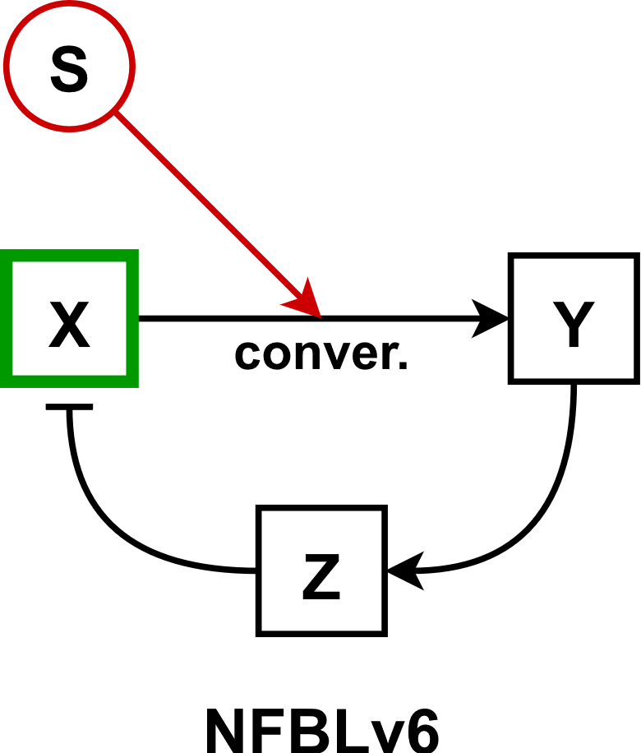 | $$\dot{x}=k_{bx}+k_{zx}⋅F_{I}\left(z,K_{zx}\right)-k_{xsy}⋅x⋅S\left(t\right)-k_{dx}⋅x \\ \dot{y}=k_{xsy}⋅x⋅S\left(t\right)-k_{dy}⋅y \\ \dot{z}=k_{bz}+k_{yz}⋅F_{A}\left(y,K_{yz}\right)-k_{dz}⋅z$$
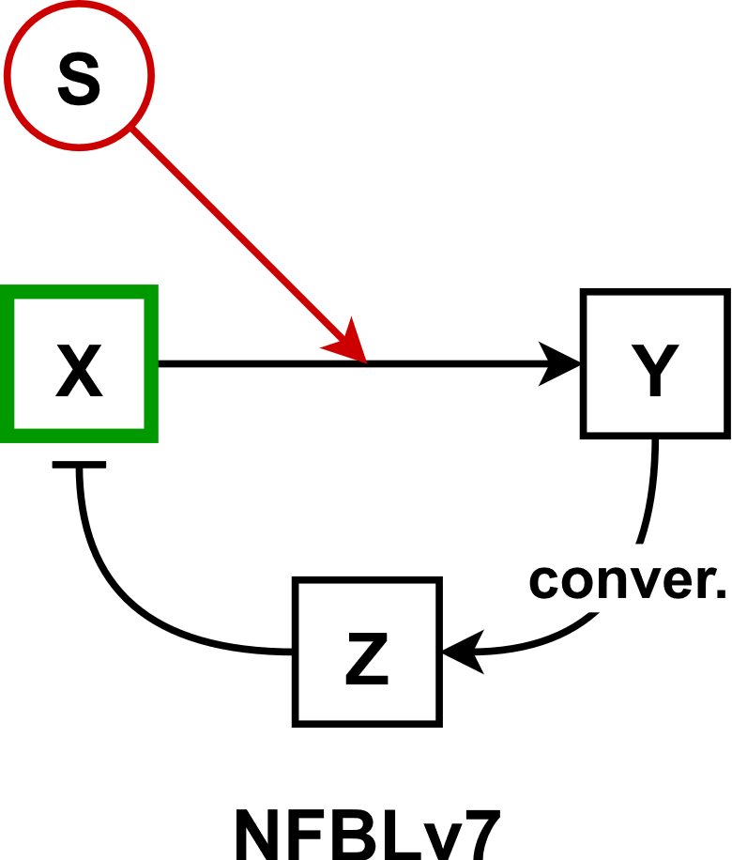 | $$\dot{x}=k_{bx}+k_{zx}⋅F_{I}\left(z,K_{zx}\right)-k_{dx}⋅x \\ \dot{y}=k_{by}+k_{xsy}⋅S\left(t\right)⋅F_{A}\left(x,K_{xy}\right)-k_{yz}⋅y-k_{dy}⋅y \\ \dot{z}=k_{yz}⋅y-k_{dz}⋅z$$
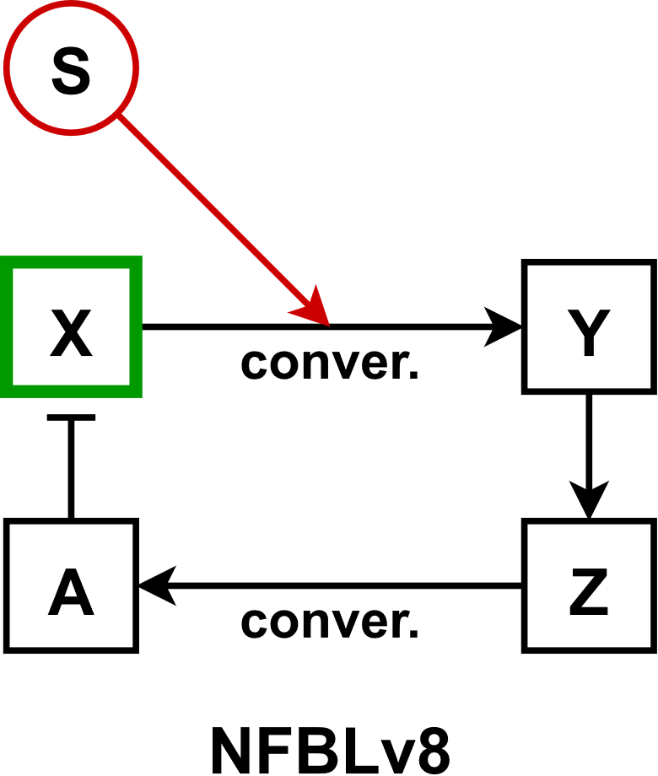 | $$\dot{x}=k_{bx}+k_{ax}⋅F_{I}\left(a,K_{ax}\right)-k_{xsy}⋅x⋅S\left(t\right)-k_{dx}⋅x \\ \dot{y}=k_{xsy}⋅x⋅S\left(t\right)-k_{dy}⋅y \\ \dot{z}=k_{bz}+k_{yz}⋅F_{A}\left(y,K_{yz}\right)-k_{za}⋅z-k_{dz}⋅z \\ \dot{a}=k_{za}⋅z-k_{da}⋅a$$

Coherent Feedforward Loops (OR logic)
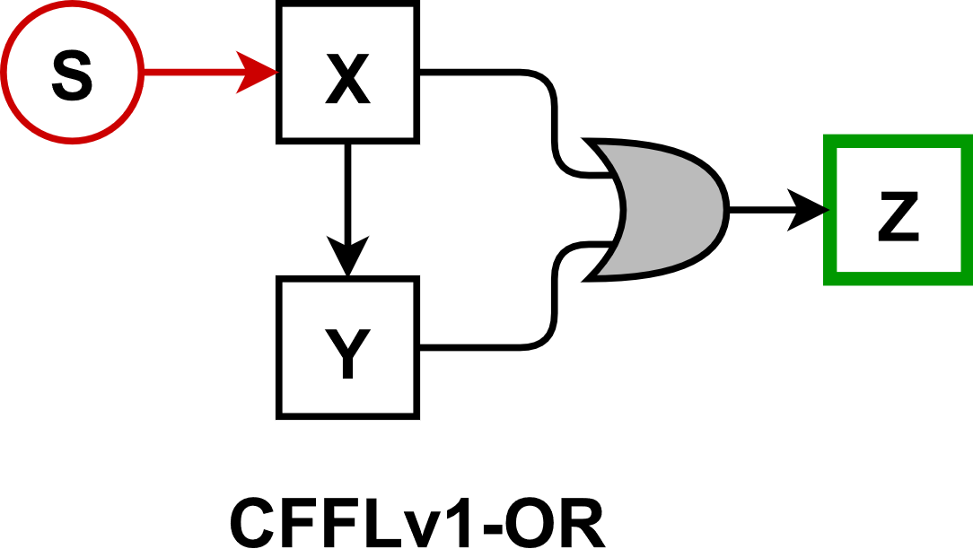 | $$\dot{x}=k_{bx}+k_{sx}⋅S\left(t\right)-k_{dx}⋅x \\ \dot{y}=k_{by}+k_{xy}⋅F_{A}\left(x,K_{xy}\right)-k_{dy}⋅y \\ \dot{z}=k_{bz}+k_{xyz}⋅F_{A}\left(x+y,K_{xyz}\right)-k_{dz}⋅z$$
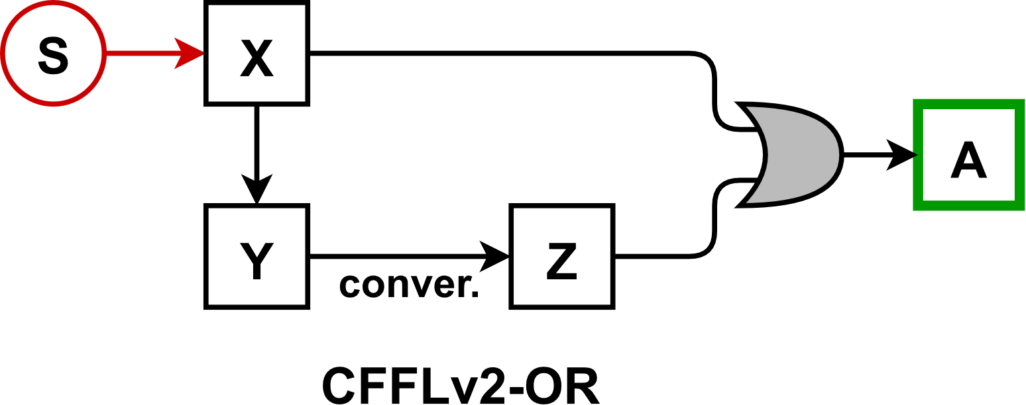 | $$\dot{x}=k_{bx}+k_{sx}⋅S\left(t\right)-k_{dx}⋅x \\ \dot{y}=k_{by}+k_{xy}⋅F_{A}\left(x,K_{xy}\right)-k_{yz}⋅y-k_{dy}⋅y \\ \dot{z}=k_{yz}⋅y-k_{dz}⋅z \\ \dot{a}=k_{ba}+k_{xza}⋅F_{A}\left(x+z,K_{xza}\right)-k_{da}⋅a$$
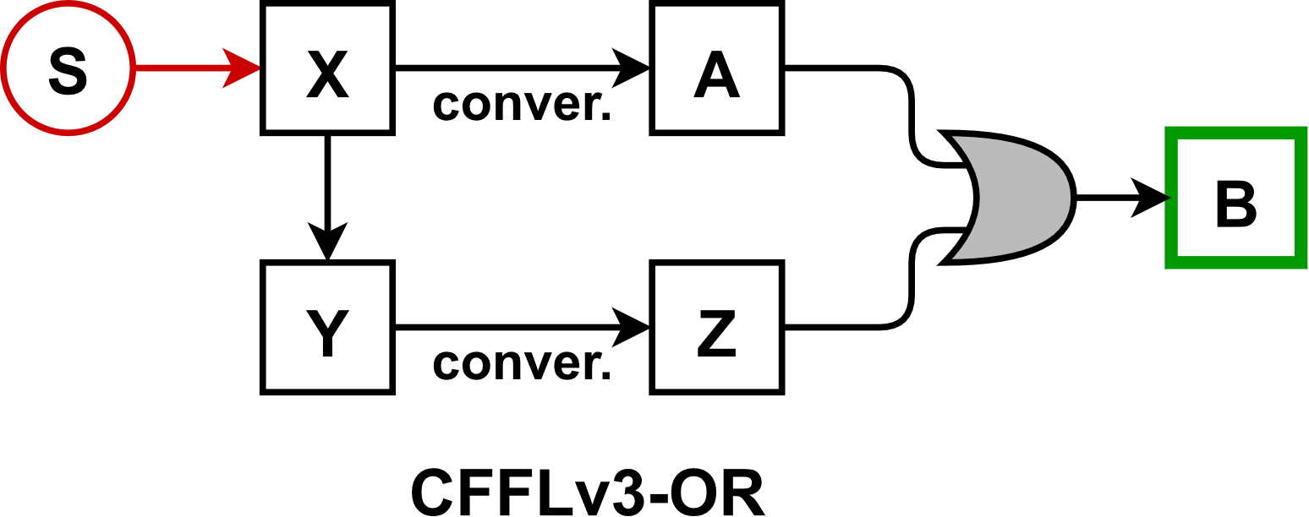 | $$\dot{x}=k_{bx}+k_{sx}⋅S\left(t\right)-k_{xa}⋅x-k_{dx}⋅x \\ \dot{y}=k_{by}+k_{xy}⋅F_{A}\left(x,K_{xy}\right)-k_{yz}⋅y-k_{dy}⋅y \\ \dot{z}=k_{yz}⋅y-k_{dz}⋅z \\ \dot{a}=k_{xa}⋅x-k_{da}⋅a \\ \dot{b}=k_{bb}+k_{zab}⋅F_{A}\left(z+a,K_{zab}\right)-k_{db}⋅b$$
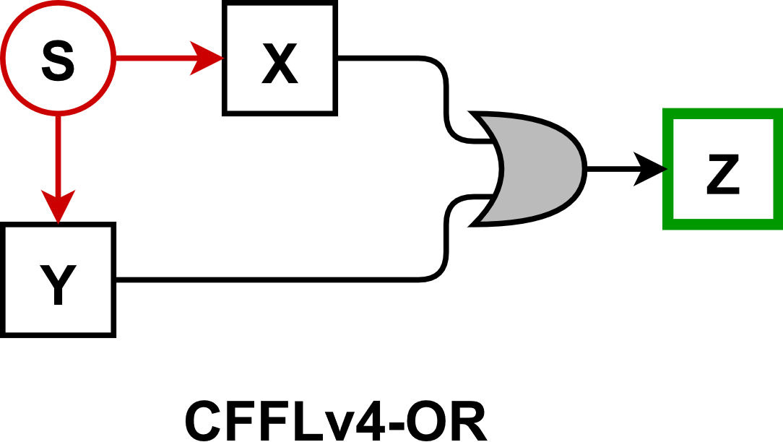 | $$\dot{x}=k_{bx}+k_{sx}⋅S\left(t\right)-k_{dx}⋅x \\ \dot{y}=k_{by}+k_{sy}⋅S\left(t\right)-k_{dy}⋅y \\ \dot{z}=k_{bz}+k_{xyz}⋅F_{A}\left(x+y,K_{xyz}\right)-k_{dz}⋅z$$
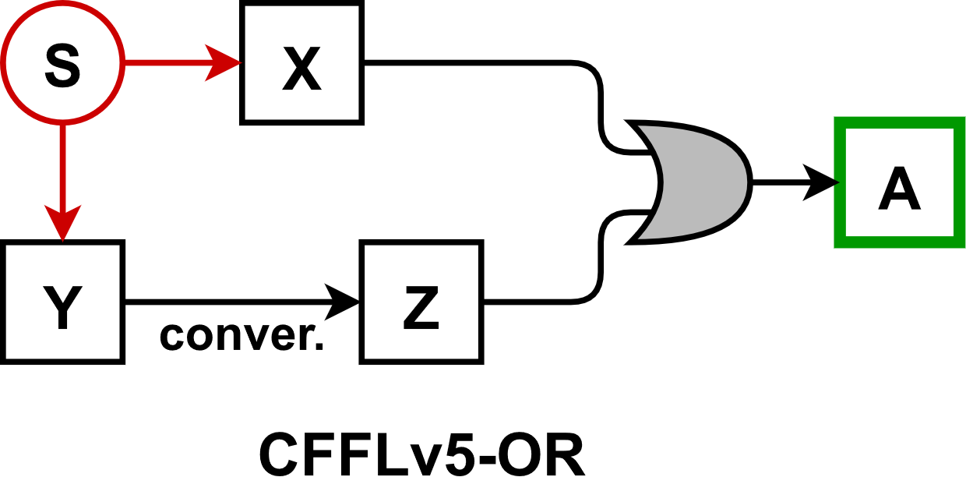 | $$\dot{x}=k_{bx}+k_{sx}⋅S\left(t\right)-k_{dx}⋅x \\ \dot{y}=k_{by}+k_{sy}⋅S\left(t\right)-k_{yz}⋅y-k_{dy}⋅y \\ \dot{z}=k_{yz}⋅y-k_{dz}⋅z \\ \dot{a}=k_{ba}+k_{xza}⋅F_{A}\left(x+z,K_{xza}\right)-k_{da}⋅a$$

Coherent Feedforward Loops (AND logic)
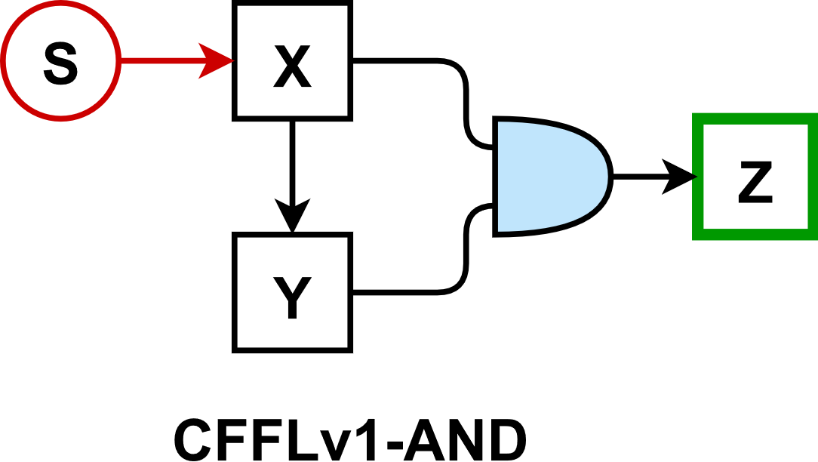 | $$\dot{x}=k_{bx}+k_{sx}⋅S\left(t\right)-k_{dx}⋅x \\ \dot{y}=k_{by}+k_{xy}⋅F_{A}\left(x,K_{xy}\right)-k_{dy}⋅y \\ \dot{z}=k_{bz}+k_{xyz}⋅F_{A}\left(x,K_{xz}\right)⋅F_{A}\left(y,K_{yz}\right)-k_{dz}⋅z$$
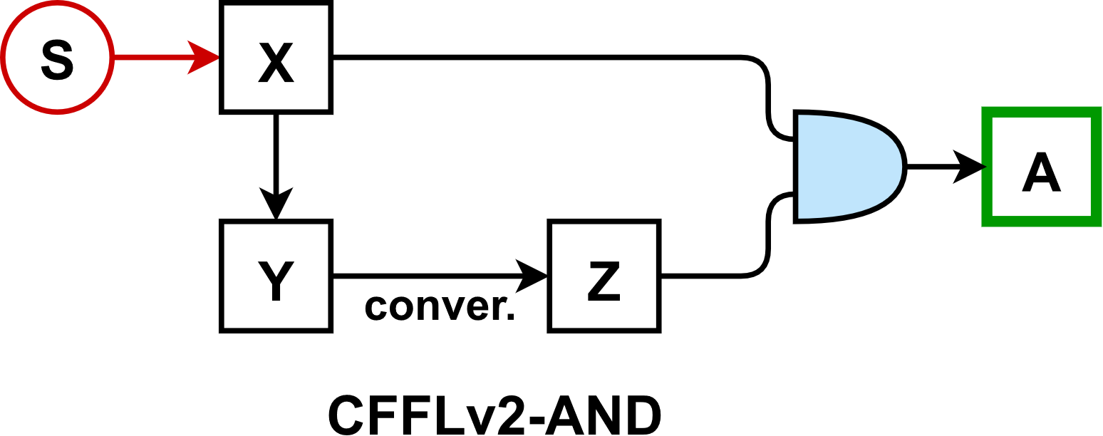 | $$\dot{x}=k_{bx}+k_{sx}⋅S\left(t\right)-k_{dx}⋅x \\ \dot{y}=k_{by}+k_{xy}⋅F_{A}\left(x,K_{xy}\right)-k_{yz}⋅y-k_{dy}⋅y \\ \dot{z}=k_{yz}⋅y-k_{dz}⋅z \\ \dot{a}=k_{ba}+k_{xza}⋅F_{A}\left(x,K_{xa}\right)⋅F_{A}\left(z,K_{za}\right)-k_{da}⋅a$$
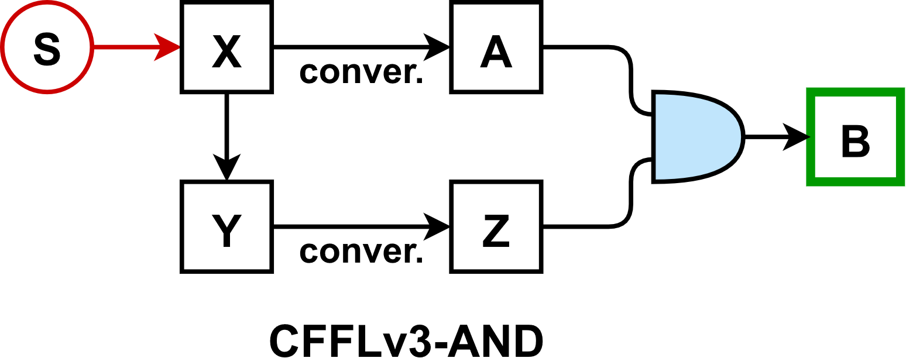 | $$\dot{x}=k_{bx}+k_{sx}⋅S\left(t\right)-k_{xa}⋅x-k_{dx}⋅x \\ \dot{y}=k_{by}+k_{xy}⋅F_{A}\left(x,K_{xy}\right)-k_{yz}⋅y-k_{dy}⋅y \\ \dot{z}=k_{yz}⋅y-k_{dz}⋅z \\ \dot{a}=k_{xa}⋅x-k_{da}⋅a \\ \dot{b}=k_{bb}+k_{zab}⋅F_{A}\left(z,K_{zb}\right)⋅F_{A}\left(a,K_{ab}\right)-k_{db}⋅b$$
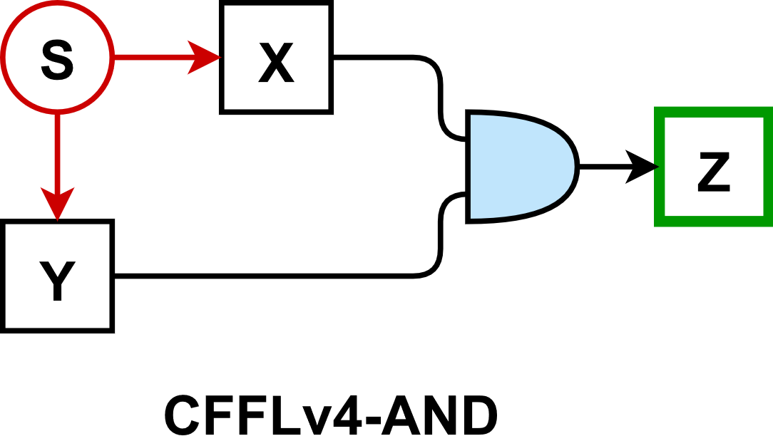 | $$\dot{x}=k_{bx}+k_{sx}⋅S\left(t\right)-k_{dx}⋅x \\ \dot{y}=k_{by}+k_{sy}⋅S\left(t\right)-k_{dy}⋅y \\ \dot{z}=k_{bz}+k_{xyz}⋅F_{A}\left(x,K_{xz}\right)⋅F_{A}\left(y,K_{yz}\right)-k_{dz}⋅z$$
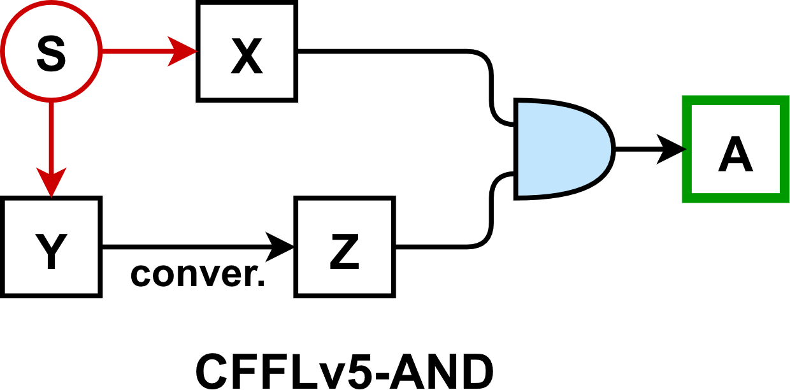 | $$\dot{x}=k_{bx}+k_{sx}⋅S\left(t\right)-k_{dx}⋅x \\ \dot{y}=k_{by}+k_{sy}⋅S\left(t\right)-k_{yz}⋅y-k_{dy}⋅y \\ \dot{z}=k_{yz}⋅y-k_{dz}⋅z \\ \dot{a}=k_{ba}+k_{xza}⋅F_{A}\left(x,K_{xa}\right)⋅F_{A}\left(z,K_{za}\right)-k_{da}⋅a$$

Incoherent Feedforward Loops
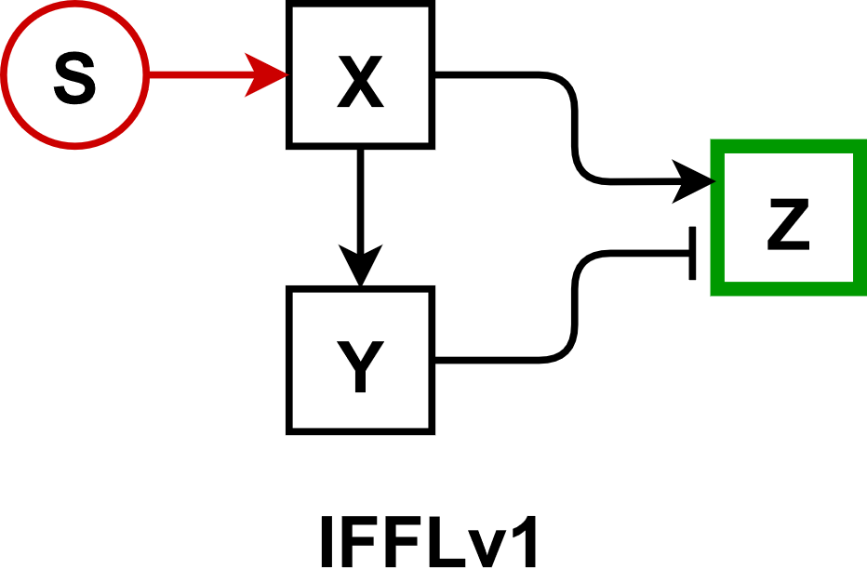 | $$\dot{x}=k_{bx}+k_{sx}⋅S\left(t\right)-k_{dx}⋅x \\ \dot{y}=k_{by}+k_{xy}⋅F_{A}\left(x,K_{xy}\right)-k_{dy}⋅y \\ \dot{z}=k_{bz}+k_{xz}⋅F_{A}\left(x,K_{xz}\right)+k_{yz}⋅F_{I}\left(y,K_{yz}\right)-k_{dz}⋅z$$
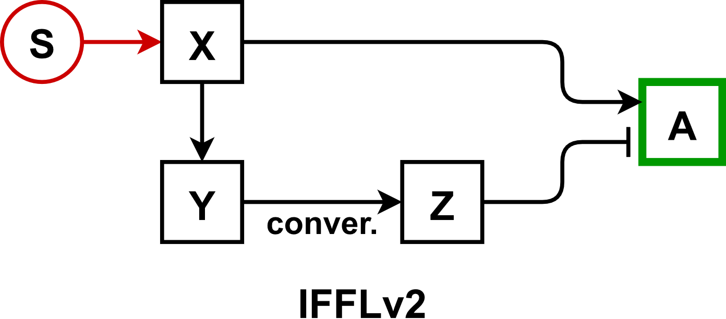 | $$\dot{x}=k_{bx}+k_{sx}⋅S\left(t\right)-k_{dx}⋅x \\ \dot{y}=k_{by}+k_{xy}⋅F_{A}\left(x,K_{xy}\right)-k_{yz}⋅y-k_{dy}⋅y \\ \dot{z}=k_{yz}⋅y-k_{dz}⋅z \\ \dot{a}=k_{ba}+k_{xa}⋅F_{A}\left(x,K_{xa}\right)+k_{za}⋅F_{I}\left(z,K_{za}\right)-k_{da}⋅a$$
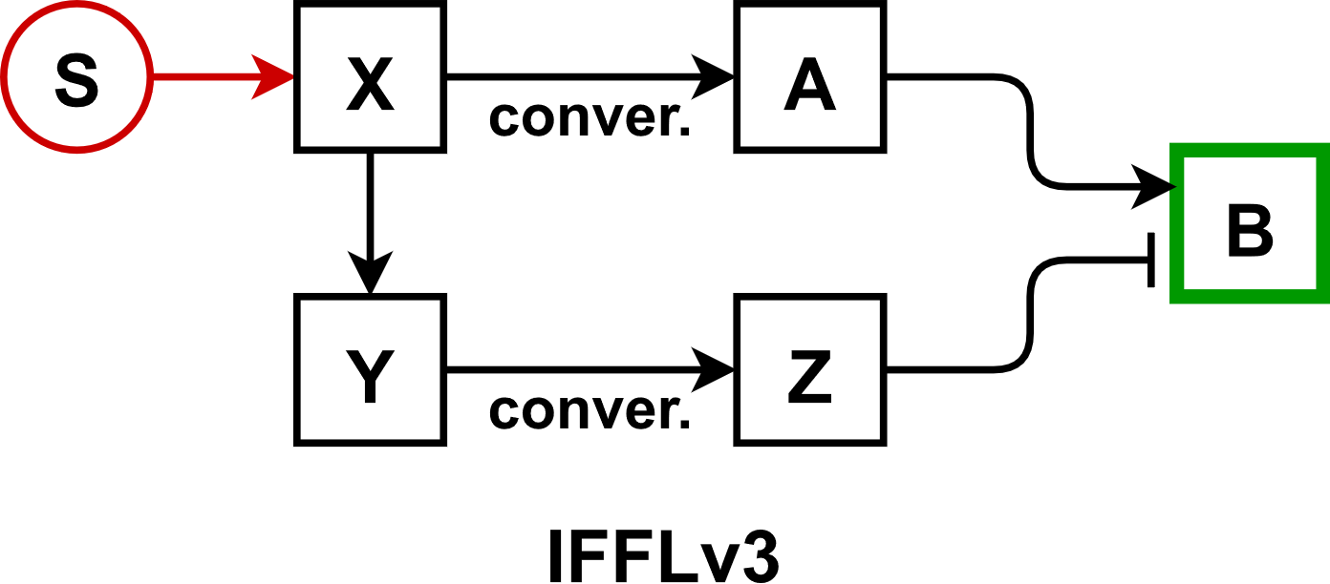 | $$\dot{x}=k_{bx}+k_{sx}⋅S\left(t\right)-k_{xa}⋅x-k_{dx}⋅x \\ \dot{y}=k_{by}+k_{xy}⋅F_{A}\left(x,K_{xy}\right)-k_{yz}⋅y-k_{dy}⋅y \\ \dot{z}=k_{yz}⋅y-k_{dz}⋅z \\ \dot{a}=k_{xa}⋅x-k_{da}⋅a \\ \dot{b}=k_{bb}+k_{ab}⋅F_{A}\left(a,K_{ab}\right)+k_{zb}⋅F_{I}\left(z,K_{zb}\right)-k_{db}⋅b$$
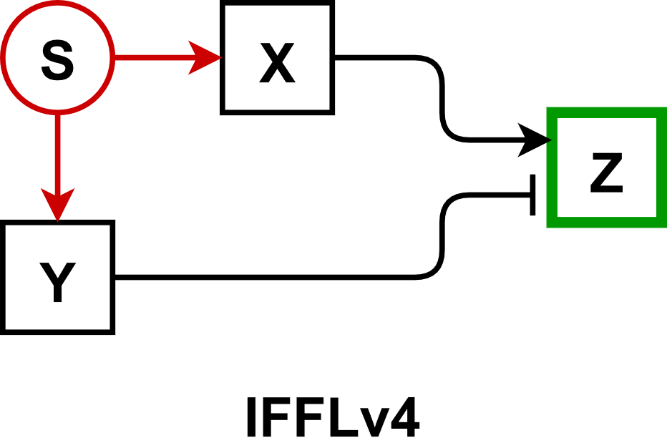 | $$\dot{x}=k_{bx}+k_{sx}⋅S\left(t\right)-k_{dx}⋅x \\ \dot{y}=k_{by}+k_{sy}⋅S\left(t\right)-k_{dy}⋅y \\ \dot{z}=k_{bz}+k_{xz}⋅F_{A}\left(x,K_{xz}\right)+k_{yz}⋅F_{I}\left(y,K_{yz}\right)-k_{dz}⋅z$$
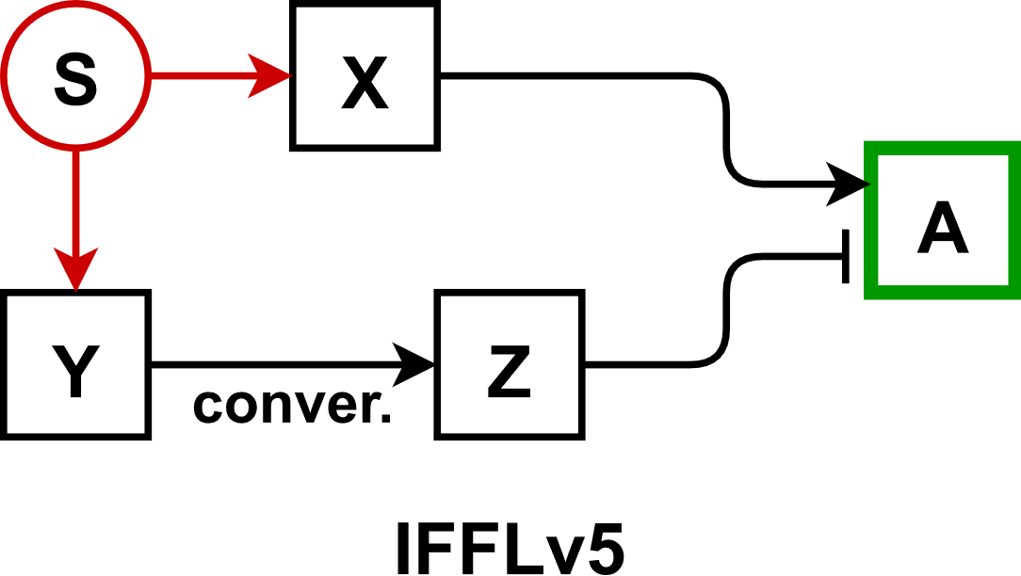 | $$\dot{x}=k_{bx}+k_{sx}⋅S\left(t\right)-k_{dx}⋅x \\ \dot{y}=k_{by}+k_{sy}⋅S\left(t\right)-k_{yz}⋅y-k_{dy}⋅y \\ \dot{z}=k_{yz}⋅y-k_{dz}⋅z \\ \dot{a}=k_{ba}+k_{xa}⋅F_{A}\left(x,K_{xa}\right)+k_{za}⋅F_{I}\left(z,K_{za}\right)-k_{da}⋅a$$

Activation Cascades
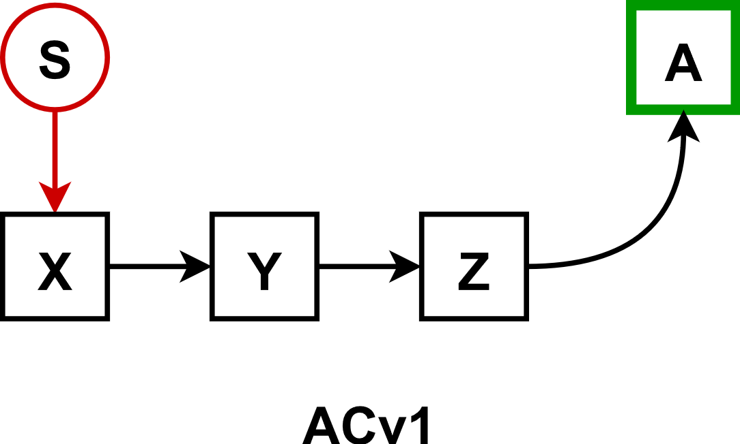 | $$\dot{x}=k_{bx}+k_{sx}⋅S\left(t\right)-k_{dx}⋅x \\ \dot{y}=k_{by}+k_{xy}⋅F_{A}\left(x,K_{xy}\right)-k_{dy}⋅y \\ \dot{z}=k_{bz}+k_{yz}⋅F_{A}\left(y,K_{yz}\right)-k_{dz}⋅z \\ \dot{a}=k_{ba}+k_{za}⋅F_{A}\left(z,K_{za}\right)-k_{da}⋅a$$
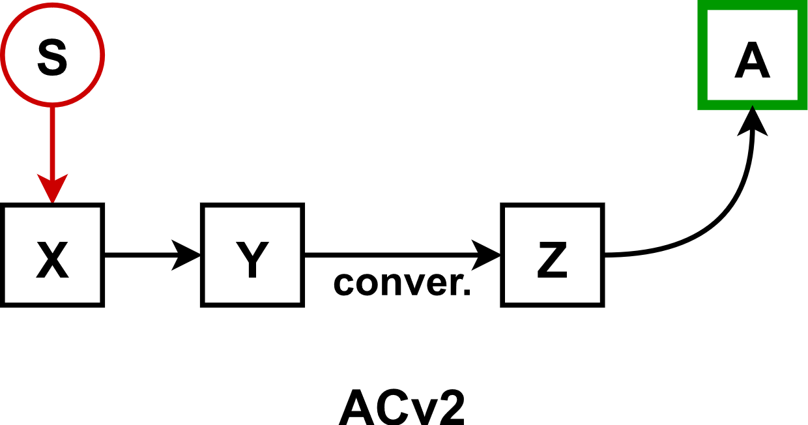 | $$\dot{x}=k_{bx}+k_{sx}⋅S\left(t\right)-k_{dx}⋅x \\ \dot{y}=k_{by}+k_{xy}⋅F_{A}\left(x,K_{xy}\right)-k_{yz}⋅y-k_{dy}⋅y \\ \dot{z}=k_{yz}⋅y-k_{dz}⋅z \\ \dot{a}=k_{ba}+k_{za}⋅F_{A}\left(z,K_{za}\right)-k_{da}⋅a$$
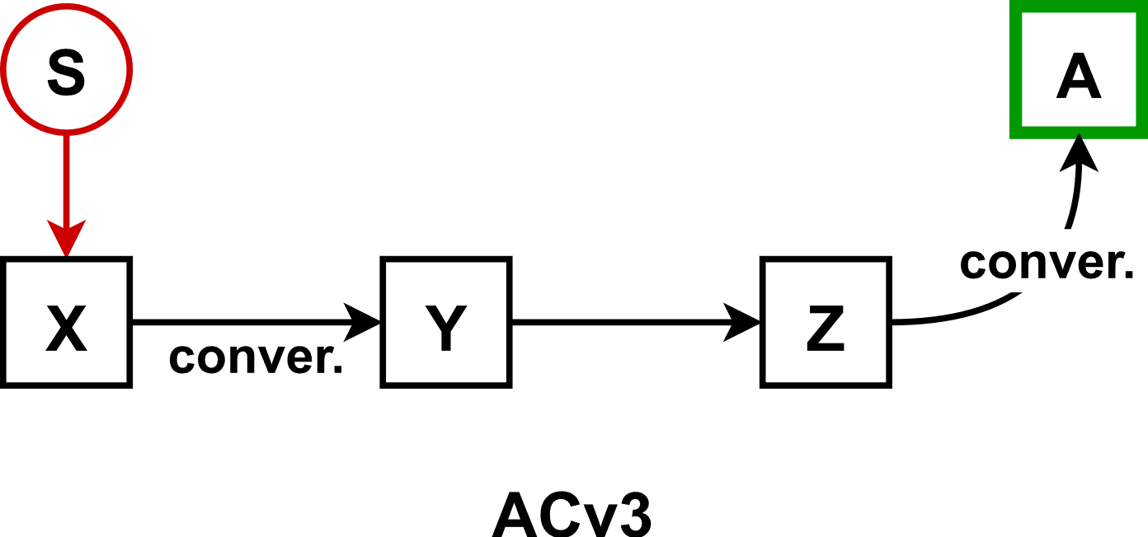 | $$\dot{x}=k_{bx}+k_{sx}⋅S\left(t\right)-k_{xy}⋅x-k_{dx}⋅x \\ \dot{y}=k_{xy}⋅x-k_{dy}⋅y \\ \dot{z}=k_{bz}+k_{yz}⋅F_{A}\left(y,K_{yz}\right)-k_{za}⋅z-k_{dz}⋅z \\ \dot{a}=k_{za}⋅z-k_{da}⋅a$$

Inhibition Cascades
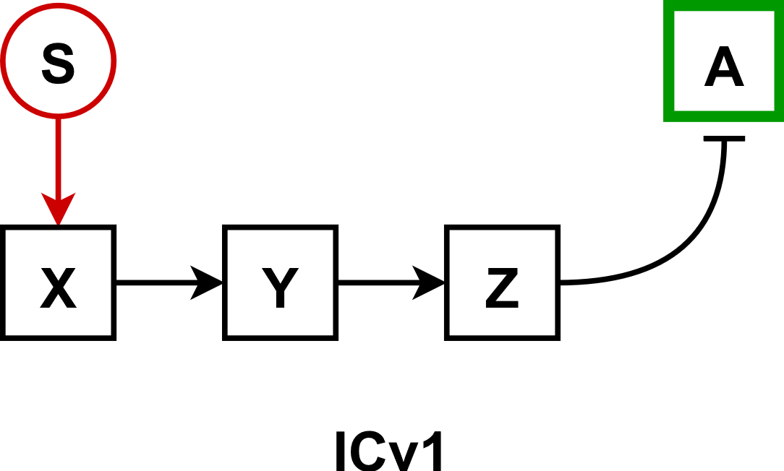 | $$\dot{x}=k_{bx}+k_{sx}⋅S\left(t\right)-k_{dx}⋅x \\ \dot{y}=k_{by}+k_{xy}⋅F_{A}\left(x,K_{xy}\right)-k_{dy}⋅y \\ \dot{z}=k_{bz}+k_{yz}⋅F_{A}\left(y,K_{yz}\right)-k_{dz}⋅z \\ \dot{a}=k_{ba}+k_{za}⋅F_{I}\left(z,K_{za}\right)-k_{da}⋅a$$
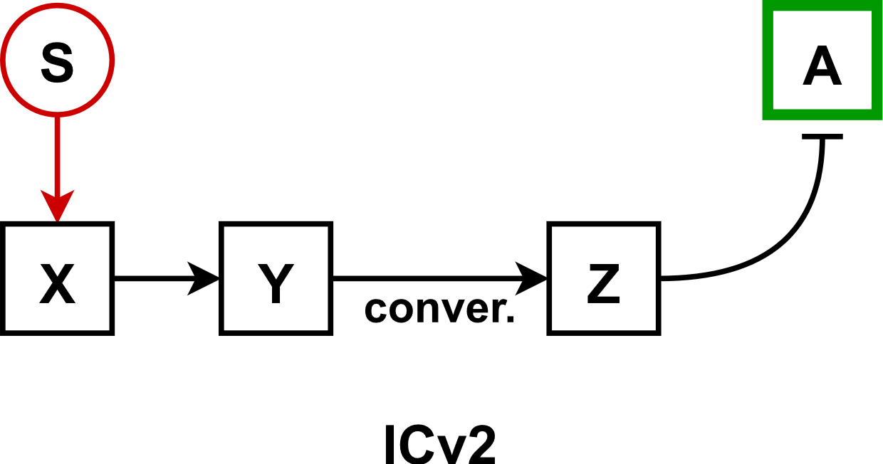 | $$\dot{x}=k_{bx}+k_{sx}⋅S\left(t\right)-k_{dx}⋅x \\ \dot{y}=k_{by}+k_{xy}⋅F_{A}\left(x,K_{xy}\right)-k_{yz}⋅y-k_{dy}⋅y \\ \dot{z}=k_{yz}⋅y-k_{dz}⋅z \\ \dot{a}=k_{ba}+k_{za}⋅F_{I}\left(z,K_{za}\right)-k_{da}⋅a$$
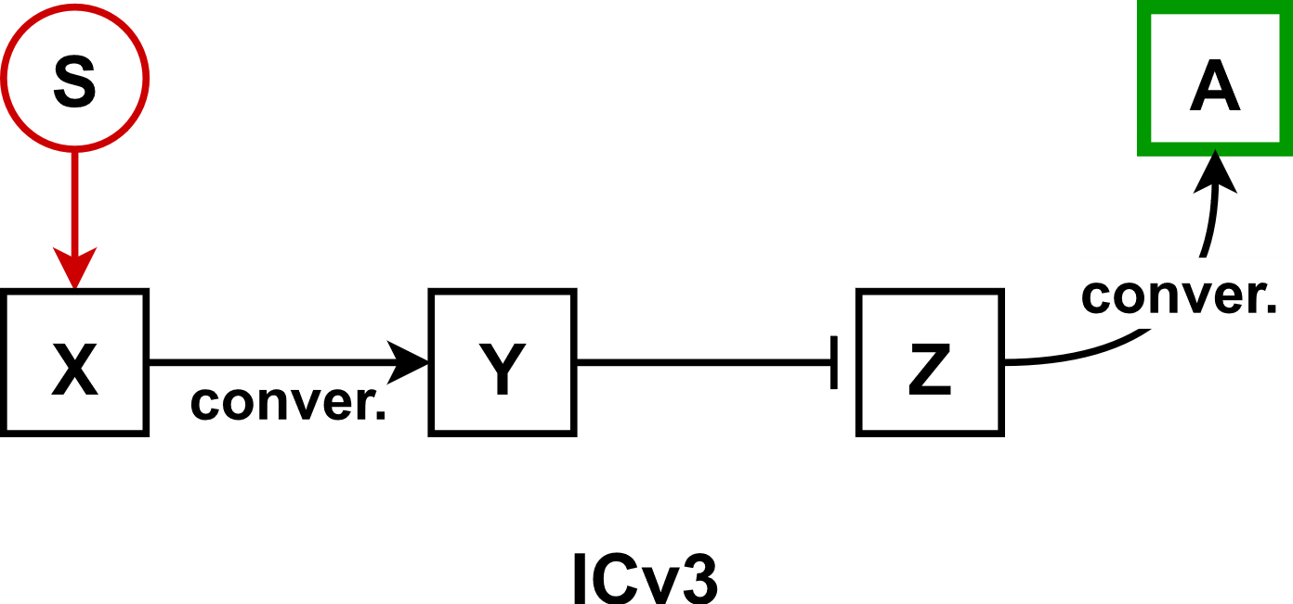 | $$\dot{x}=k_{bx}+k_{sx}⋅S\left(t\right)-k_{xy}⋅x-k_{dx}⋅x \\ \dot{y}=k_{xy}⋅x-k_{dy}⋅y \\ \dot{z}=k_{bz}+k_{yz}⋅F_{I}\left(y,K_{yz}\right)-k_{za}⋅z-k_{dz}⋅z \\ \dot{a}=k_{za}⋅z-k_{da}⋅a$$

Non-dimensionalization of ODE-based models
Further reduction of the kinetic models was carried out by rescaling time using the degradation rate constant of the response element. Additionally, the concentration of each species was rescaled using the (rescaled) zero-order formation rate constant of the response element. For the cases where the response element was formed through a conversion reaction from a precursor form (such as in PARv2), the rescaling was carried out using the zero-order formation rate constant of the precursor element. The resulting sets of non-dimensionalized equations were employed for conducting numerical simulations.
For instance, the nondimensionalization of the PARv2 model results in the following set of equations, where each term is dimensionless.
$$\frac{dα}{dτ}=1-k_{xsy}^{'}⋅α⋅S\left(t\right)-k_{yxy}^{'}⋅α⋅\frac{β^{n}}{{\left(K_{yxy}^{'}\right)}^{n}+β^{n}}-k_{dx}^{'}⋅α \\ \frac{dβ}{dτ}=k_{xsy}^{'}⋅α⋅S\left(t\right)+k_{yxy}^{'}⋅α⋅\frac{β^{n}}{{\left(K_{yxy}^{'}\right)}^{n}+β^{n}}-β$$
Here, $α=x/\left(k_{bx}/k_{dy}\right)$ and $β=y/\left(k_{bx}/k_{dy}\right)$ denote the rescaled X and Y concentrations, and $τ=k_{dy}⋅t$ represents the rescaled time variable. The dimensionless kinetic parameters are defined as follows.
$$k_{dx}^{'}=k_{dx}/k_{dy}$$ | $$k_{xsy}^{'}=k_{xsy}/k_{dy}$$ | $$K_{yxy}^{'}=K_{yxy}/\left(k_{bx}/k_{dy}\right)$$ | $$k_{yxy}^{'}=k_{yxy}/k_{dy}$$
For the numerical simulations, similar sets of non-dimensionalized equations were derived for each model by simply setting the formation and degradation rate constants of the response element to 1. After non-dimensionalization, the Latin hypercube (LH) method was employed to sample values for the rescaled parameters. In the PARv2 model, for example, $k_{bx}$ and $k_{dy}$ were set to 1, while the rescaled kinetic constants, $k_{dx}^{'}$, $k_{xsy}^{'}$, $k_{yxy}^{'}$ and $K_{yxy}^{'}$, were sampled using the LH method, generating 50,000 distinct parameter sets.

Constraints for the filtration of parameter sets
We assumed that the following constraints define the characteristics of the relative enhancement in response (RER) curve that represents a successful replication of the spacing effect.
- Minimum significant response threshold: Since RER was computed as the fractional deviation from the massed response, we set a minimum significant massed response threshold at ${10}^{-4}$ dimensionless unit (d.u.). Any massed response value below this threshold was deemed insignificant, and the parameter sets that produced such values were excluded from further analysis. This threshold serves to limit the upper bound of RER values since RER becomes undefined as $R_{massed}$ approaches zero (Eq. 1).
- Inverted U-shape: An RER curve that successfully describes the spacing effect was assumed to have an inverted U-shape as a function of ISI. Hence, to eliminate parameter sets that lead to oscillations or multiple local peaks in RER values, we defined that the normalized RER (and equivalently RER) should monotonically increase until its maximum, followed by a monotonic decrease. This ensures the existence of a single peak, as illustrated in Figure S2.
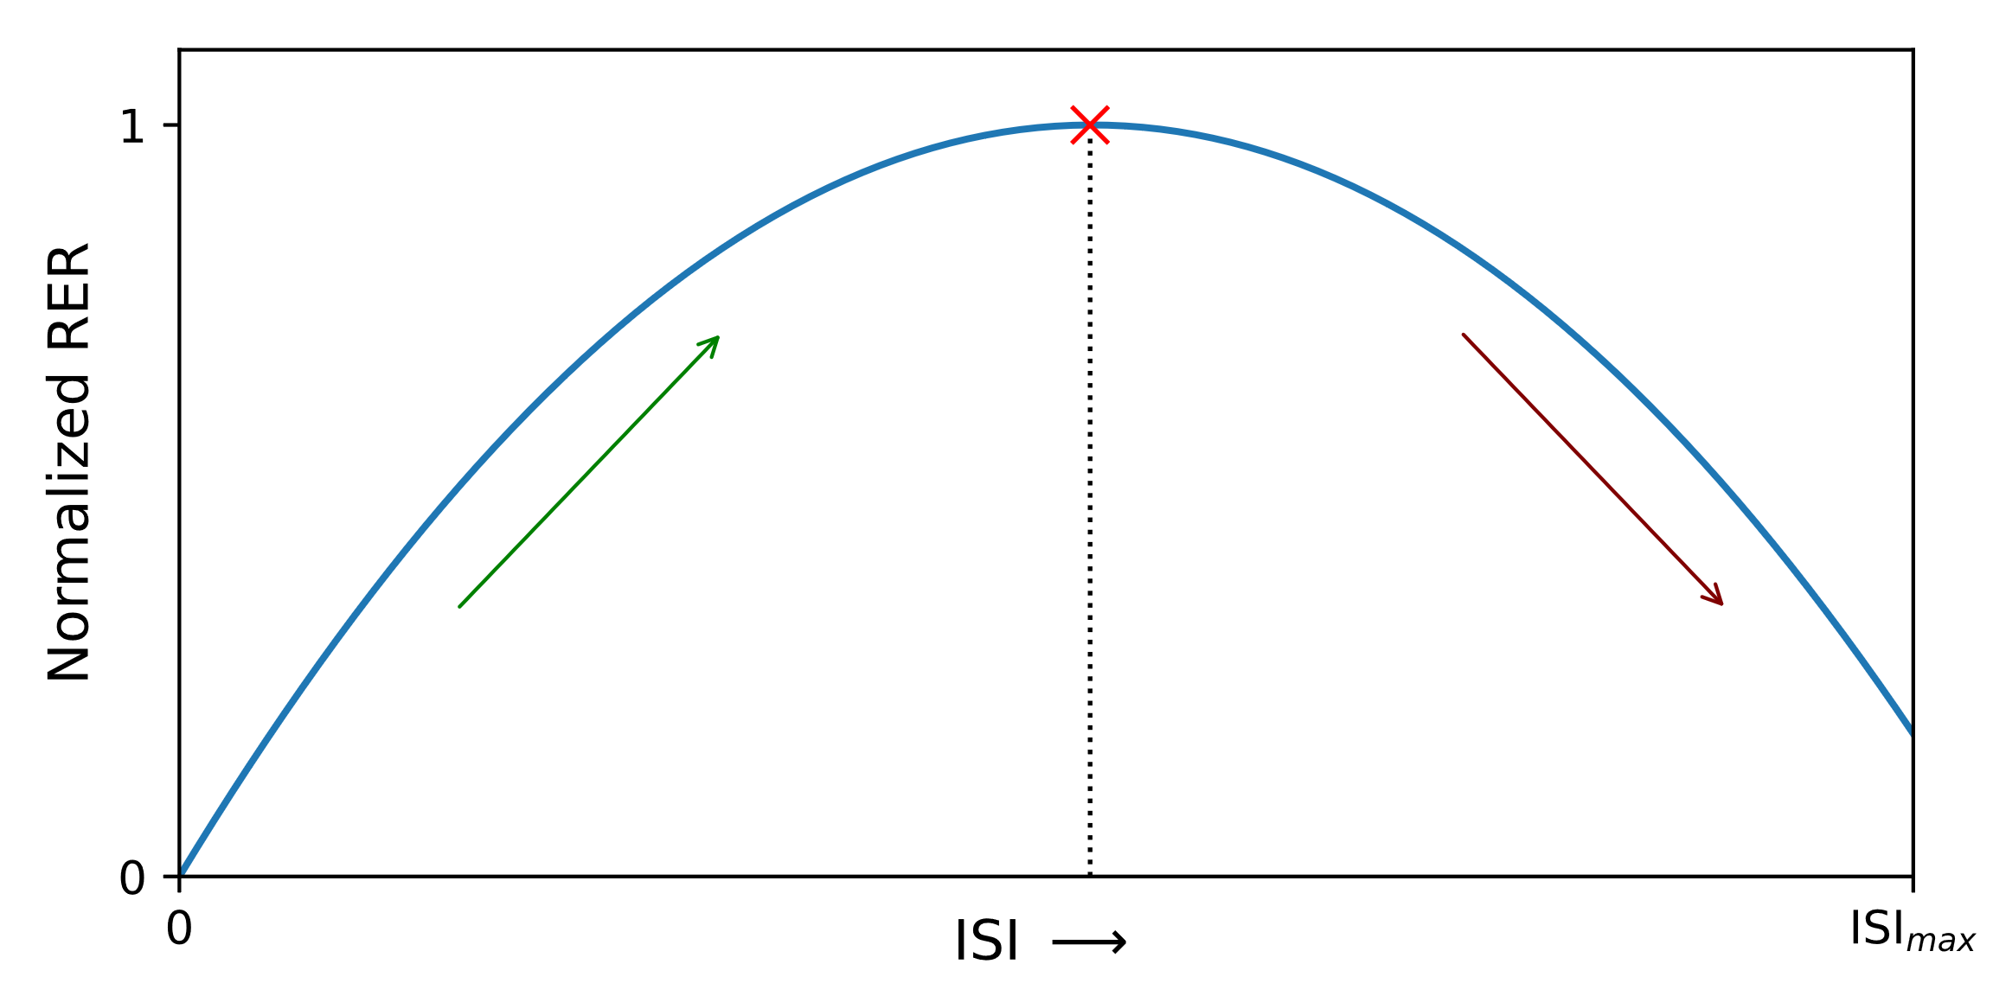 | Figure S2. RER curves that replicate the spacing effect are assumed to have an inverted U-shape, characterized by a monotonic increase until its maximum, followed by a monotonic decrease.
- Position of the optimum ISI: Constraints were set on the position of the maximum RER value to disregard parameter sets that produced maximum RER values near the edges of the ISI range, as shown in Figure S3A. An optimal ISI close to zero suggests that the optimal spaced training protocol resembles massed training. On the other hand, optimal ISI close to maximum ISI may be attributed to the proximity of the last spaced training pulse to test time (when measured at $t_{f}$). Hence, only the cases where the optimum ISI occurred between 5 and 45 d.u. (within an 80% subinterval of the ISI range of 0 to 50 d.u.) were considered as successful recreations of the spacing effect (Figure S3B).
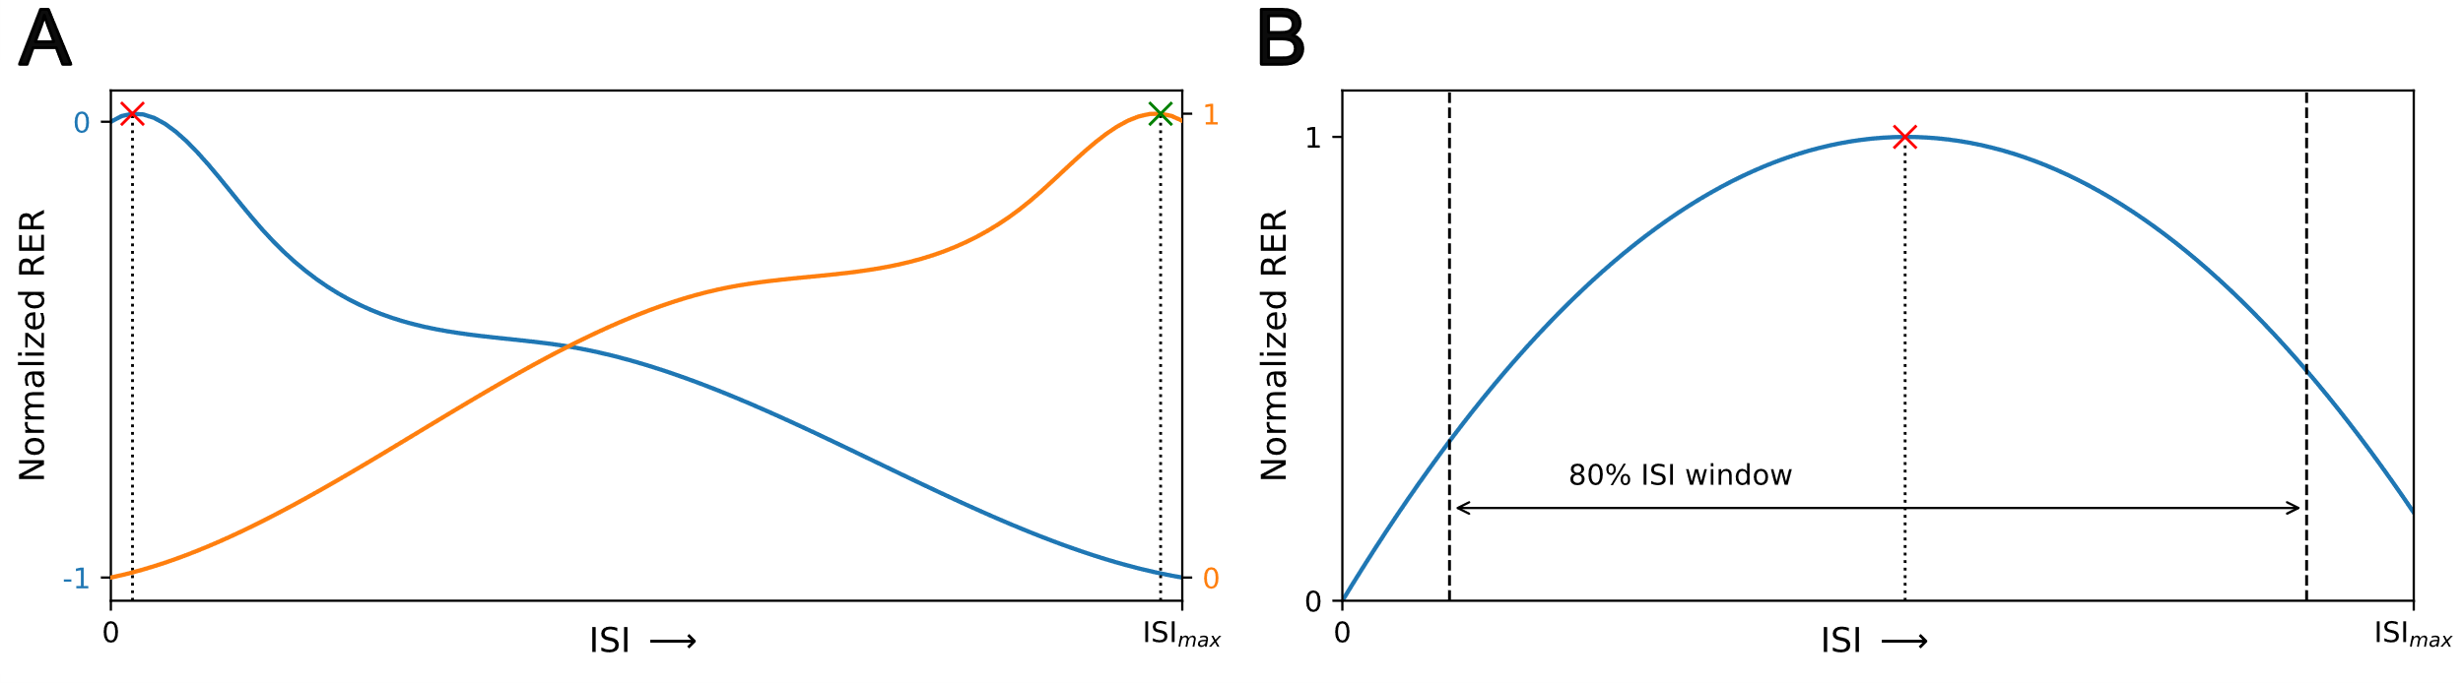
Figure S3. (A) Parameter sets that yielded RER curves with the maximum RER near the boundaries of the ISI range were omitted from the analysis. (B) Only the parameter sets that produced an optimum ISI within a range of 80% of maximum ISI were considered as suitable for replicating the spacing effect.
The following three constraints were employed to eliminate parameter sets that resulted in RER curves showing either very low (Figure S4 and Figure S5) or very high (Figure S6) sensitivity to the changes in ISI. The combination of these conditions ensures the selection of parameter sets that produce a gradual increase and decrease in RER as a function of ISI.
- The difference between the maximum normalized RER (NRER) value and the NRER value at $ISI_{max}$ was used as a measure to filter out parameter sets for which the decrease in RER is insignificant after attaining the maximum (as shown in Figure S4A). Parameter sets that produced such instances were removed since they do not allow a clear definition of the optimum ISI. For the purpose of numerical simulations, this minimum threshold was assumed to be 0.05 (5%). That is, $\left|\max\left(NRER\right)-NRER\left(ISI_{max}\right)\right|>0.05$.
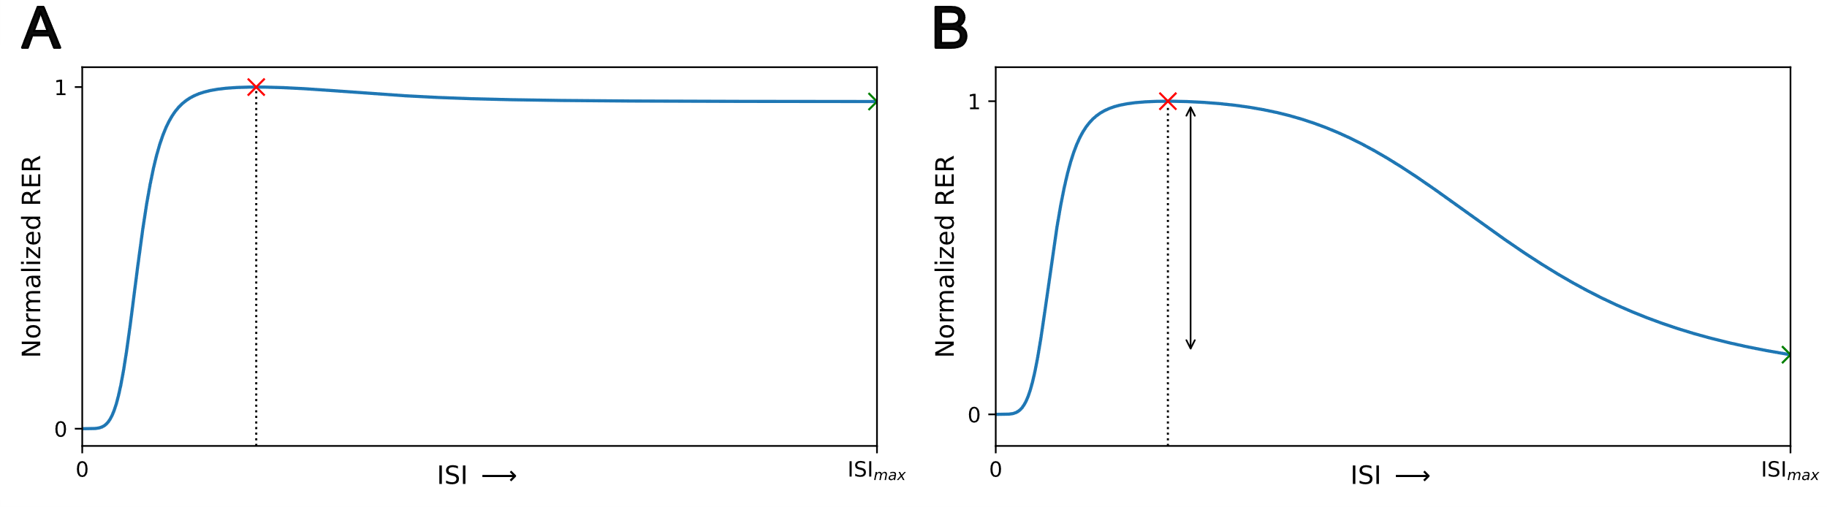
Figure S4. The difference between the maximum RER value and the RER value at maximum ISI (${ISI}_{max}$) was used as a measure to ensure that the RER does not remain near its maximum for ISI values longer than the optimum. (A) and (B) illustrate two representative normalized RER (NRER) curves where $\left|\max\left(NRER\right)-NRER\left(ISI_{max}\right)\right|$ equals 0.03 ($<0.05$) and 0.80 ($>0.05$), respectively.
- In order to remove parameter sets that produce RER curves that plateau around the optimal ISI, a requirement was enforced where the standard deviation of 5% normalized RER values around its maximum must exceed ${10}^{-4}$ (Figure S5). This guarantees a more limited range for the optimum ISI and a narrower width for the RER peak.
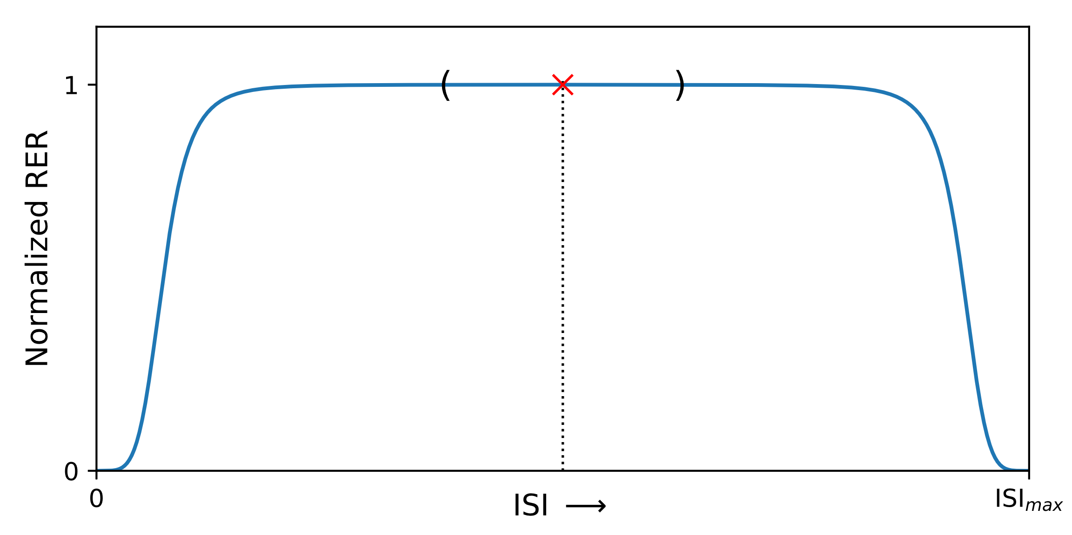 | Figure S5. Parameter sets that produce RER curves that plateau around the optimal ISI were disregarded as they presented a wide range for optimum ISI. The standard deviation of 5% normalized RER values around the peak was used to determine the RER curve’s flatness around the maximum.
- Large fluctuations in normalized RER relative to small changes in ISI denote an increased degree of sensitivity. In order to eliminate such occurrences, we filtered out parameter sets that exhibited pronounced variability in RER as a function of ISI. A parameter set was deemed suitable only if the difference between any two consecutive normalized RER values did not exceed a threshold of 0.10 (Figure S6).
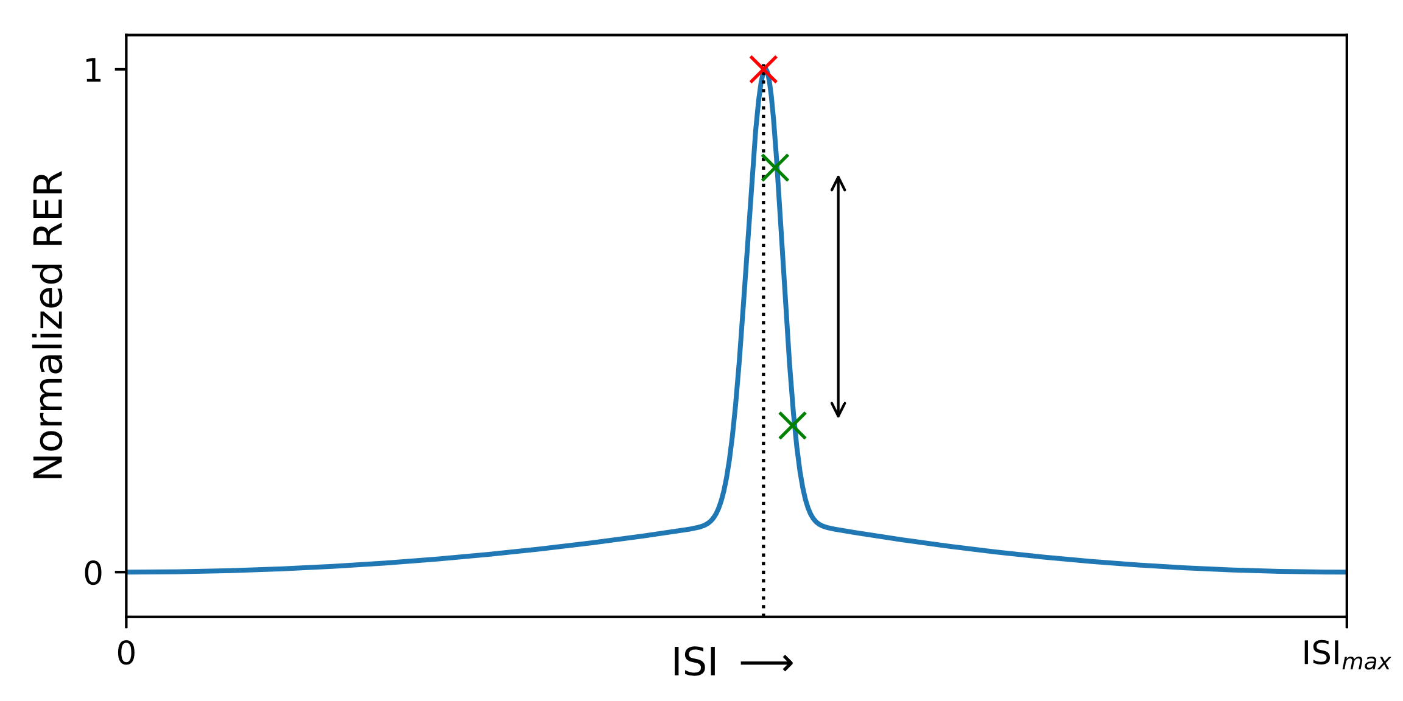 | Figure S6. The difference between consecutive RER values was used to filter out parameter sets where the RER curve exhibited high sensitivity to change in ISI.
Filtration of parameter sets that did not produce the spacing effect was carried out in three iterations for different ISI values between 0.1 d.u. and 50 d.u. In the first iteration, parameter sets that produce monotonic RER curves (not having a maximum or minimum) and those not satisfying constraint C1 while computing RER for 10 equidistant ISI values between 5 and 50 d.u. were filtered out. The second filtration was performed using constraints C1, C3, and C4 for RER values computed at 50 equidistant ISI values (between 1 d.u. and 50 d.u.). The last filtration was performed by applying all constraints, and the RER values were computed for 500 equidistant ISI values between 0.1 d.u. and 50 d.u. Constraint C6 was applied for these 500 RER values calculated between 0.1 d.u. and 50 d.u. Note that the constraints C2 and C6 were not used in the first two filtration steps. For each parameter set and motif model, these computations are repeated for all combinations of response measures, input pulses, and time of response measurement.
Furthermore, a minimum RER cutoff threshold of 10% was employed to identify parameter sets that exhibited a significant enhancement in response following spaced stimulation. Any parameter set that gave an inverted U-shaped RER curve with a maximal RER value below 10% at the optimal ISI was disregarded and excluded from the data presented in Figures 3, 4, and 5.

Parameter values for Figures 1B and 1C
The following table summarizes the model and stimulus parameter values used for generating the results depicted in Figures 1B and 1C. Figure 1B was generated using parameter set p1 listed below with an optimal ISI of 8.1 d.u. corresponding to the $R_{tot}^{f}$ metric.
(Rescaled) Parameter | Parameter set
(Rescaled) Parameter | p1 | p2 | p3 | p4 | p5 | p6
$$Δ$$ | $$2.329×{10}^{1}$$ | $$1.194×{10}^{1}$$ | $$1.063×{10}^{1}$$ | $$6.933$$ | $$5.454$$ | $$6.858×{10}^{1}$$
$$k_{by}^{'}$$ | $$4.413×{10}^{-1}$$ | $$1.057×{10}^{-2}$$ | $$1.912×{10}^{-2}$$ | $$1.319$$ | $$3.404×{10}^{-3}$$ | $$8.558×{10}^{-3}$$
$$k_{xyz}^{'}$$ | $$8.892×{10}^{1}$$ | $$1.149×{10}^{1}$$ | $$1.271×{10}^{2}$$ | $$6.778×{10}^{2}$$ | $$4.187$$ | $$1.957$$
$$k_{sy}^{'}$$ | $$1.216×{10}^{1}$$ | $$5.627$$ | $$3.010×{10}^{2}$$ | $$9.738×{10}^{-1}$$ | $$1.803×{10}^{2}$$ | $$2.828×{10}^{1}$$
$$k_{dx}^{'}$$ | $$1.238×{10}^{2}$$ | $$5.110×{10}^{-1}$$ | $$5.643$$ | $$4.004×{10}^{-2}$$ | $$2.123×{10}^{2}$$ | $$3.477×{10}^{2}$$
$$k_{dy}^{'}$$ | $$8.005×{10}^{-2}$$ | $$1.737×{10}^{-2}$$ | $$4.144×{10}^{-2}$$ | $$1.743×{10}^{2}$$ | $$6.671×{10}^{-2}$$ | $$2.409×{10}^{-2}$$
$$k_{bx}^{'}$$ | $$1.287$$ | $$2.000×{10}^{-1}$$ | $$8.856×{10}^{1}$$ | $$3.095×{10}^{-2}$$ | $$3.264×{10}^{2}$$ | $$2.158×{10}^{-1}$$
$$K_{xyz}^{'}$$ | $$3.763×{10}^{1}$$ | $$2.741×{10}^{1}$$ | $$5.844×{10}^{2}$$ | $$2.726$$ | $$7.844×{10}^{1}$$ | $$1.762×{10}^{2}$$
$$k_{sx}^{'}$$ | $$3.728×{10}^{-2}$$ | $$2.782×{10}^{2}$$ | $$1.472$$ | $$3.708$$ | $$2.637$$ | $$2.961×{10}^{2}$$
Table S2. Parameter values used for generating Figures 1B and 1C. All kinetic constants and stimulus duration values ($Δ$ for the DC protocol) are represented in dimensionless units. The CFFLv4-OR model was non-dimensionalized by setting $k_{bz}=k_{dz}=1$.

Effect of minimum RER threshold on the results
We increased the minimum RER threshold to 100%, ensuring that the parameter sets that generated an inverted U-shaped RER curve also resulted in at least twice the magnitude of spaced response compared to the corresponding massed response. The results are presented in Figure S7.
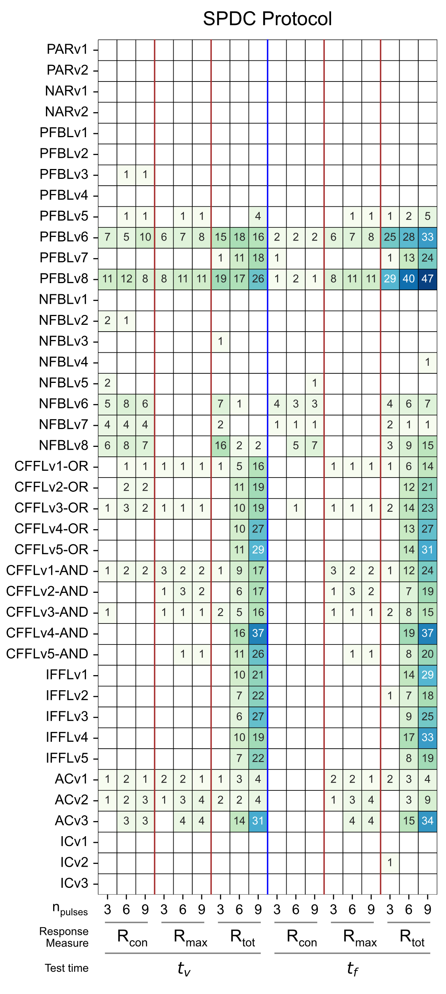 | 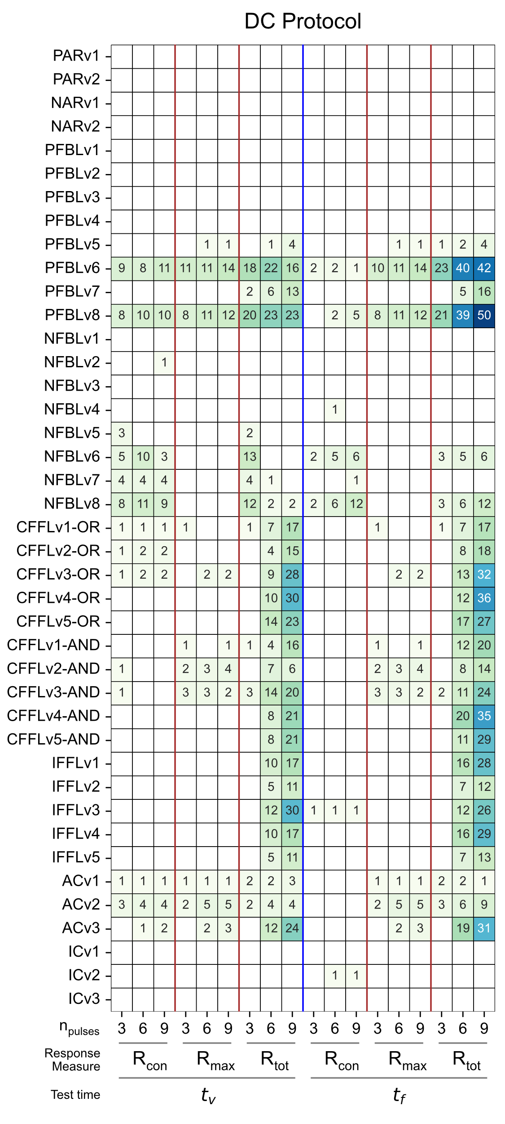
Figure S7. Summary of simulation results for SPDC and DC protocols with a 100% minimum RER threshold. The figure describes the number of parameter sets that replicate the spacing effect for each motif model.
As observable from Figure S7, PFBLv6 and v8 replicate the spacing effect characteristics across all response metrics. Simultaneously, they exhibit a response increase by a factor of two following spaced training when compared to the corresponding massed training.

Effect of response element definition on the results
As each element in the feedback loop can potentially act as the response to stimulation, each positive feedback loop was analyzed, assigning the role response element to different components in the model. A summary of simulation results for different combinations of positive feedback models and response elements is presented in Figure S8.
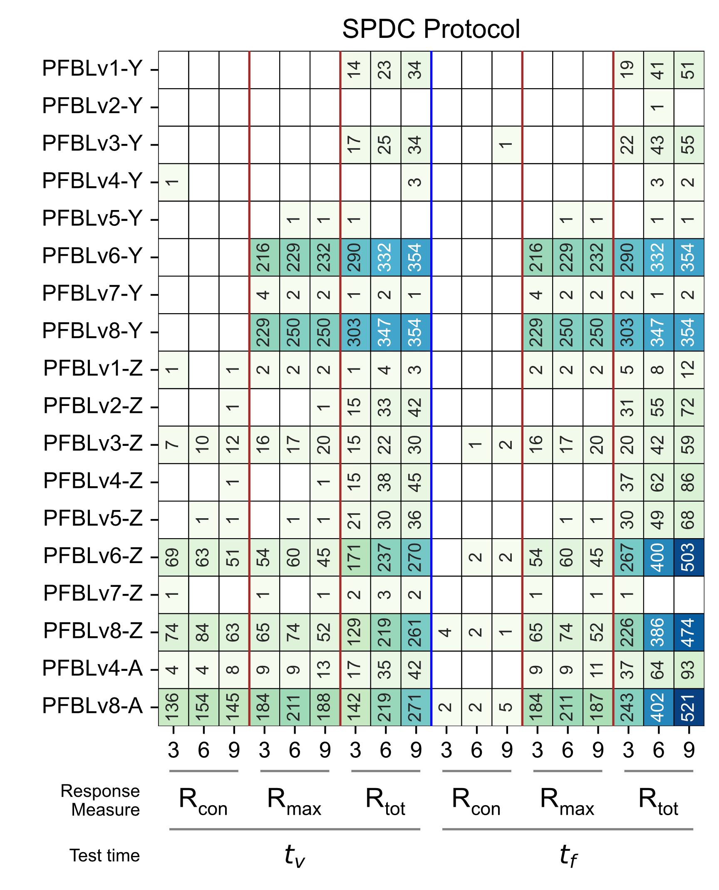 | 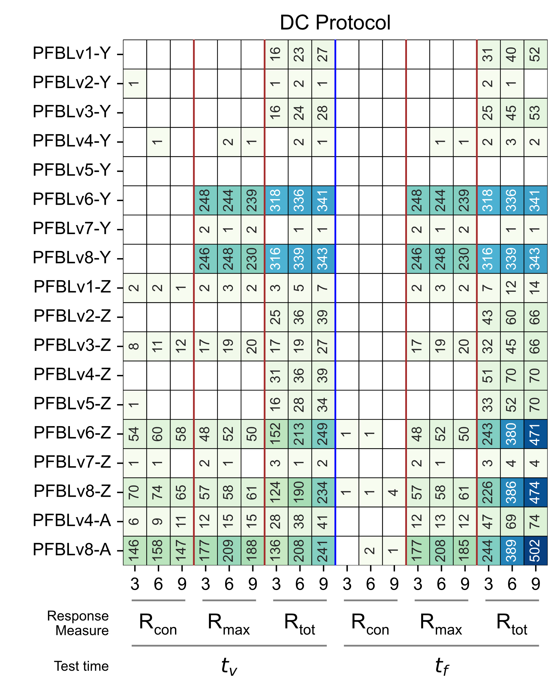
Figure S8. Summary of simulation results for PFBLs with components Y, Z and A assigned as response elements. The figure describes the number of parameter sets that replicate the spacing effect with a minimum RER of 10%.

Conversion cascades
The following two kinetic models of sequential conversion reactions involving 4 and 5 components were analyzed to determine if the presence of conversion reactions is sufficient to generate inverted U-shaped response curves.
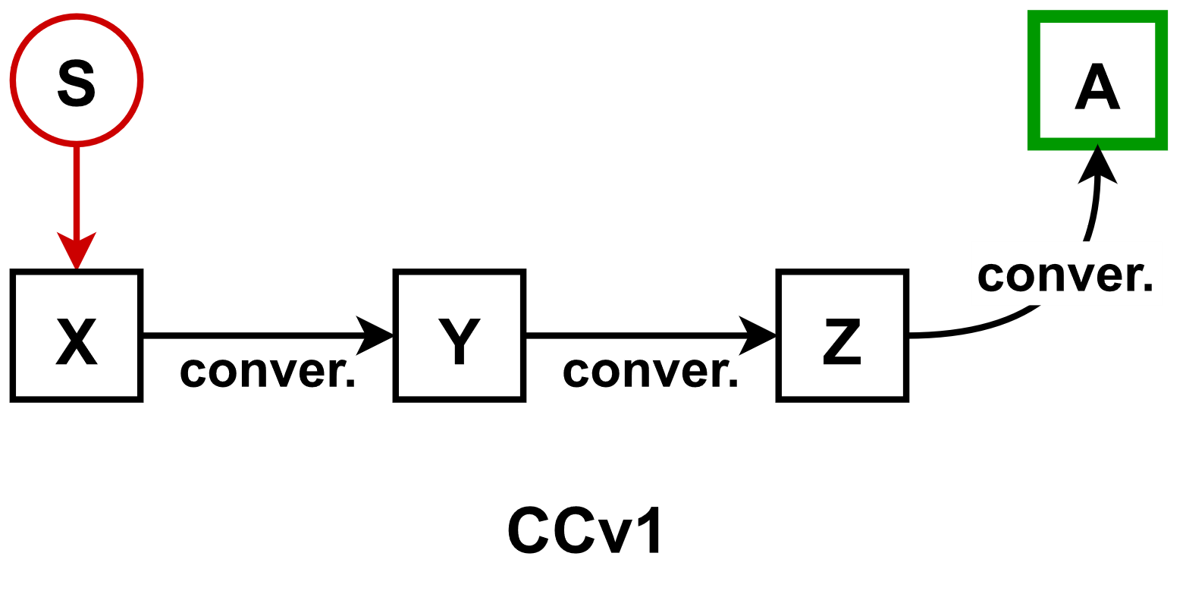 | 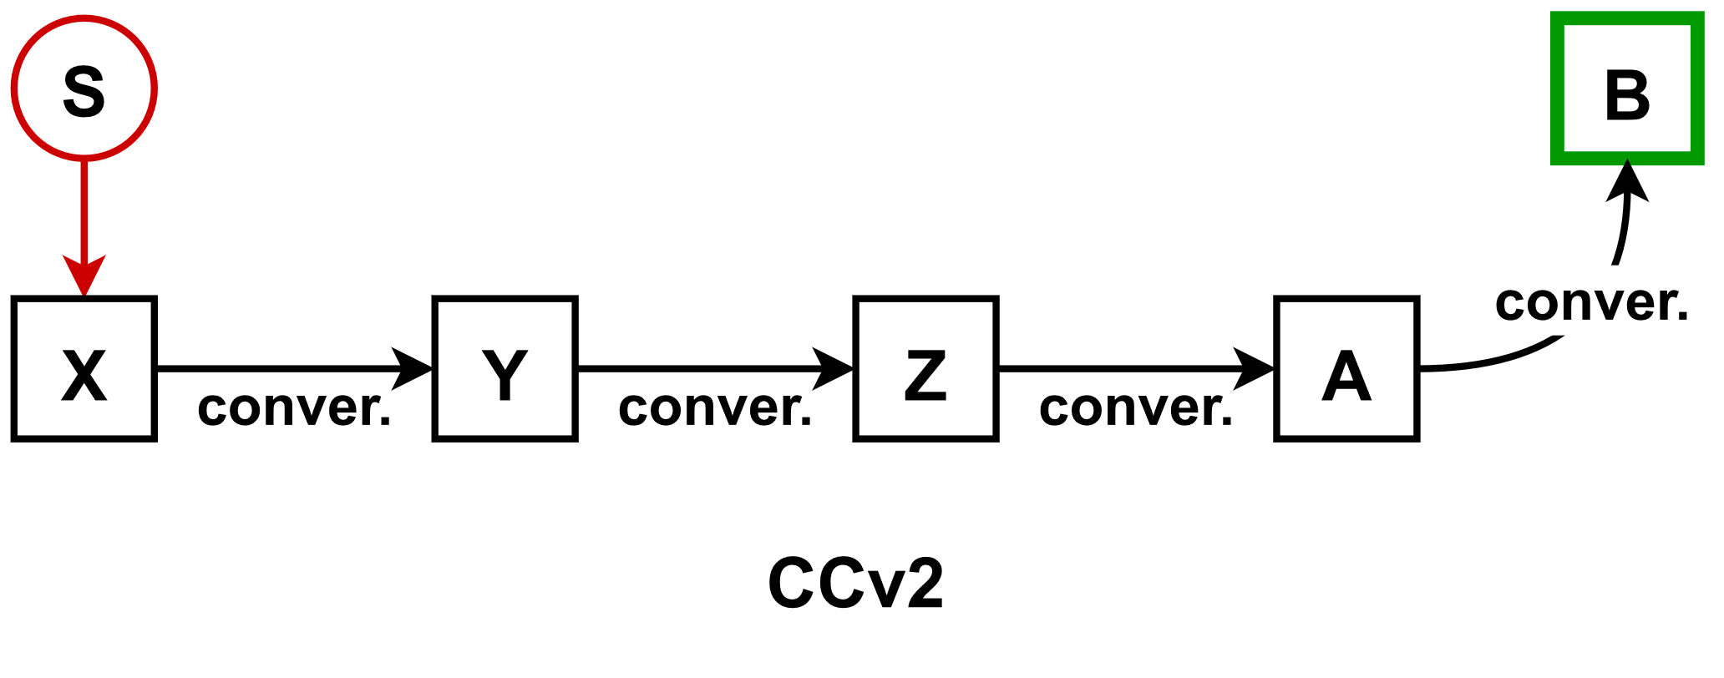
$$\dot{x}=k_{bx}+k_{sx}⋅S-k_{xy}⋅x-k_{dx}⋅x \\ \dot{y}=k_{xy}⋅x-k_{yz}⋅y-k_{dy}⋅y \\ \dot{z}=k_{yz}⋅y-k_{za}⋅z-k_{dz}⋅z \\ \dot{a}=k_{za}⋅z-k_{da}⋅a$$ | $$\dot{x}=k_{bx}+k_{sx}⋅S-k_{xy}⋅x-k_{dx}⋅x \\ \dot{y}=k_{xy}⋅x-k_{yz}⋅y-k_{dy}⋅y \\ \dot{z}=k_{yz}⋅y-k_{za}⋅z-k_{dz}⋅z \\ \dot{a}=k_{za}⋅z-k_{ab}⋅a-k_{da}⋅a \\ \dot{b}=k_{ab}⋅a-k_{db}⋅b$$
Results of numerical simulations using the two stimulation protocols and the parameter filtration are presented in Figure S9. For almost all cases, simple cascades of sequential conversion did not produce an inverted U-shaped curve as defined by the constraints presented previously. The only instances in which these models generated such a curve were in combination with response measurement at $t_{v}$.
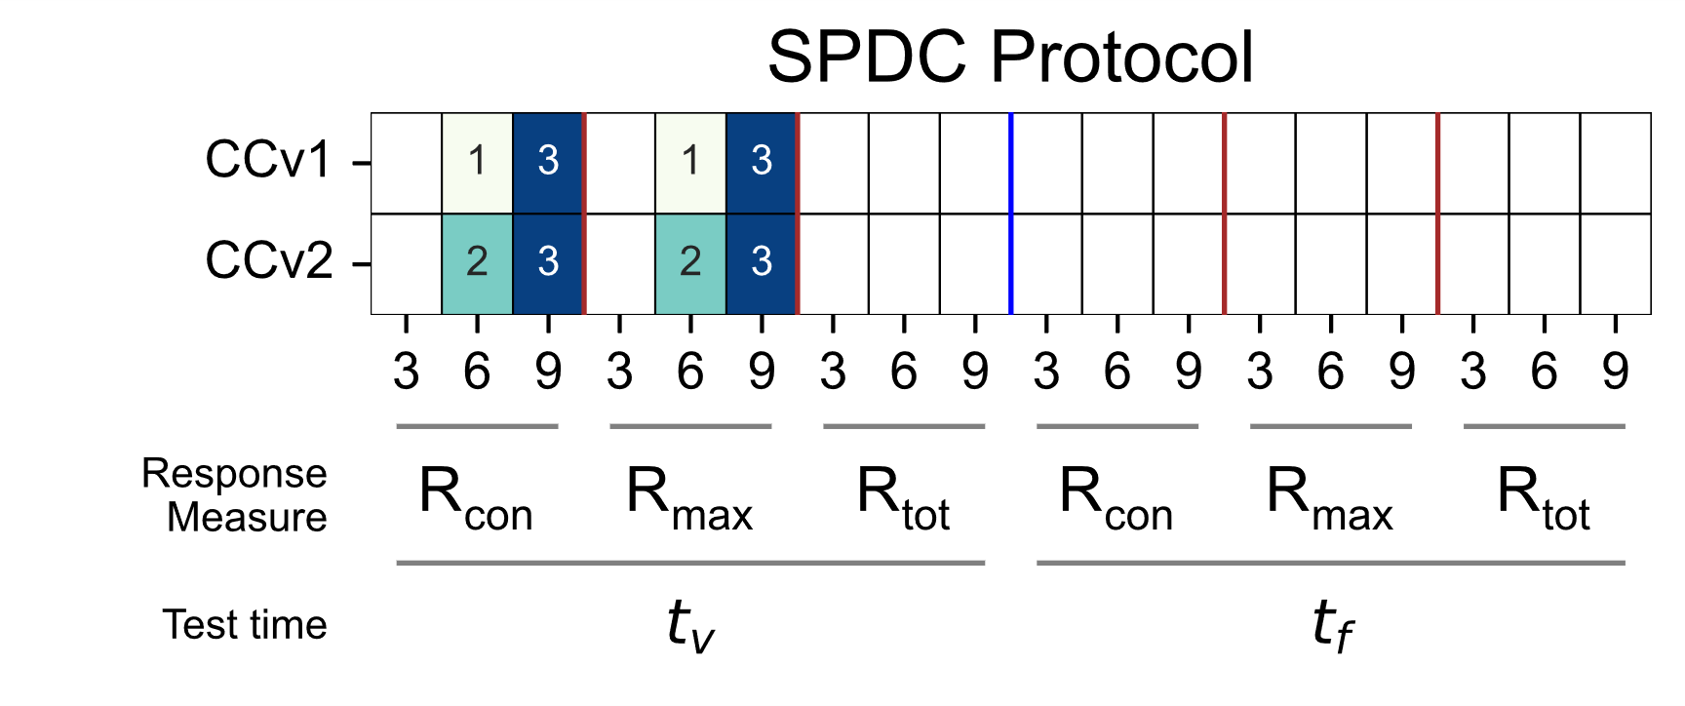 | 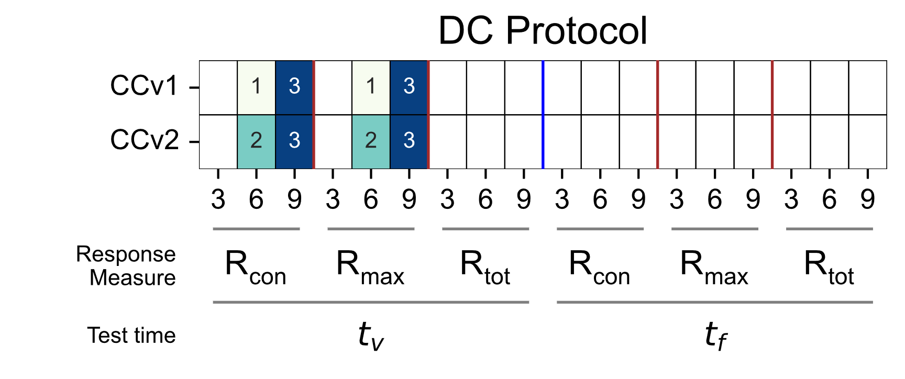
Figure S9. Summary of simulation results for conversion cascades describing the number of parameter sets that replicate the spacing effect with a minimum RER of 10%.

Representative simulation results for PFBLv6, CFFLv1-OR and ACv3 mechanisms
The subsequent figures provide a visual representation of how alterations in the inter-stimulus interval influence the concentration of the response element across three distinct motifs and can generate an inverted U-shaped response. The three figures depicted below correspond to three parameter sets identified as capable of showing the spacing effect across all three response measures.

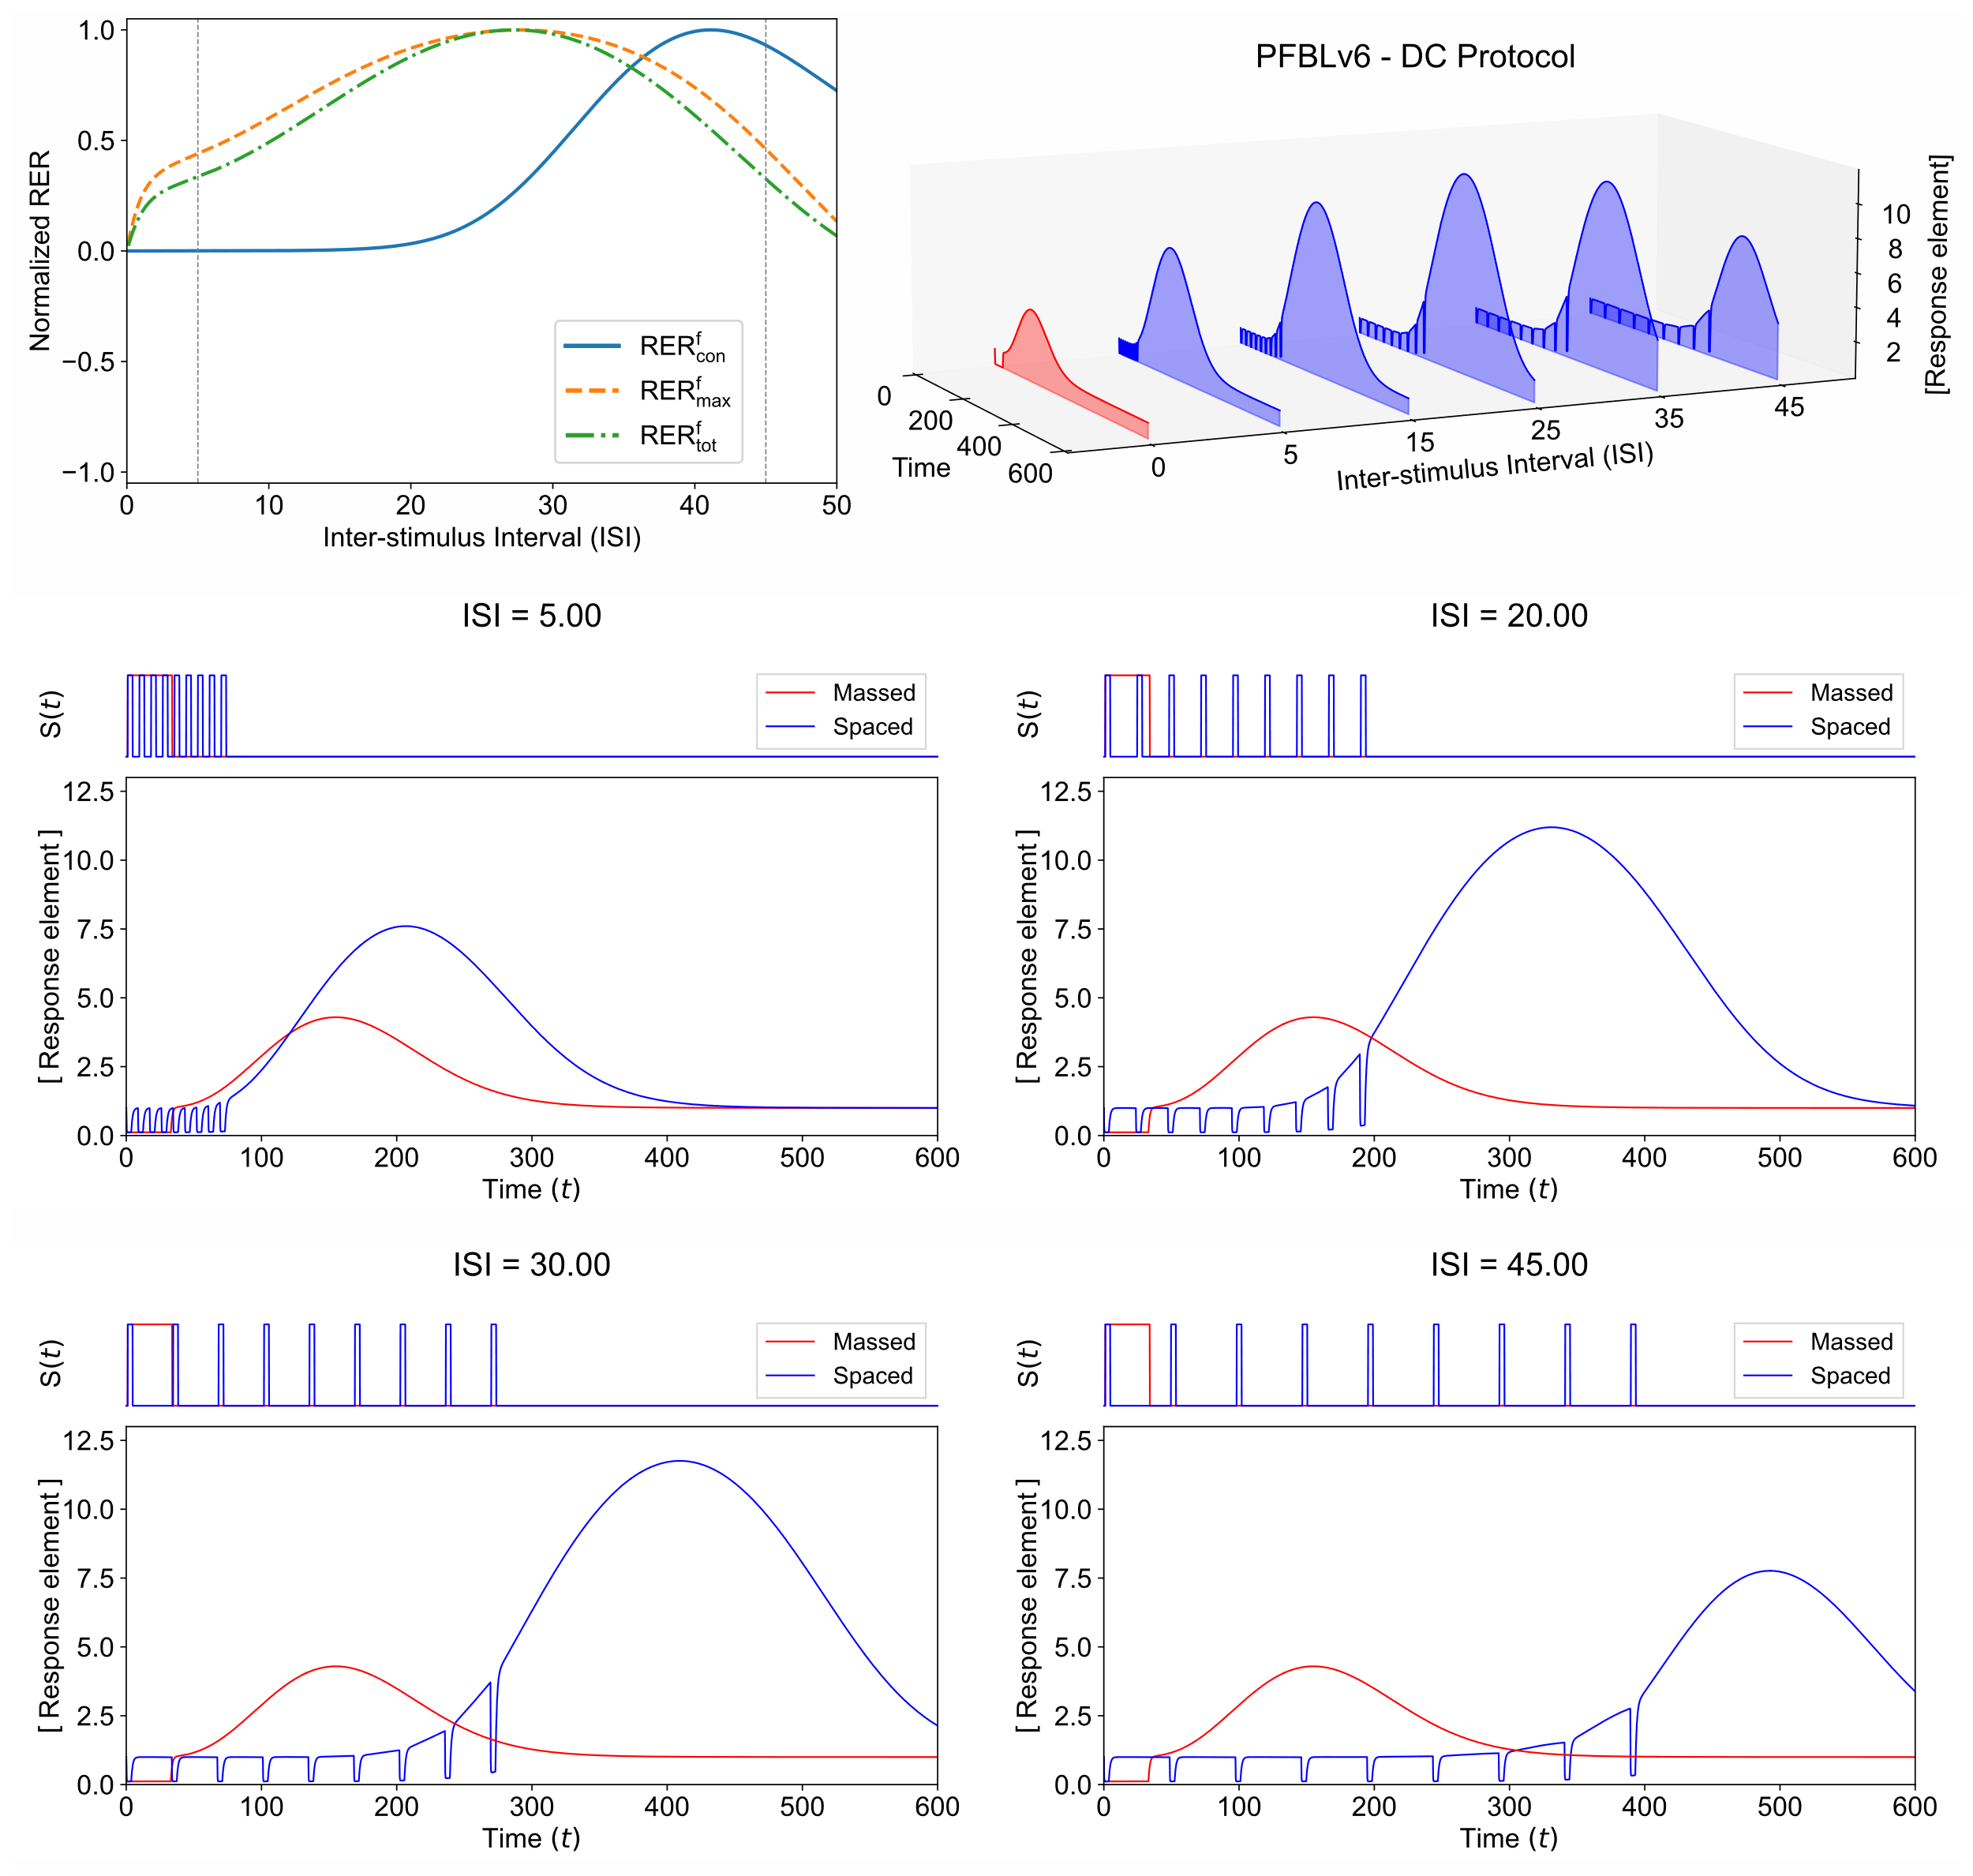
Figure S10. Representative simulation results for PFBLv6 following massed and spaced training using 9 input pulses for a single parameter set. Top-left: Normalized RER values, computed using Eq. (2) at $t_{f}$, show an inverted U-shape, indicating the existence of optimal ISI. The parameter set chosen here exhibits the spacing effect for all three response measures, as indicated by the inverted U-shaped $RER_{con}$, $RER_{max}$, and $RER_{tot}$ curves. Top-right: Response element’s time series following massed (red) and spaced (blue) stimulation with different ISI. Middle and bottom row: Each subfigure depicts the response element’s time series following massed (red) and spaced (blue) training using 9 input pulses for inter-stimulus values of 5, 20, 30, and 45 d.u. Each subfigure is generated using the same parameter set that was identified as capable of generating the spacing effect in combination with the $R_{con}$, $R_{max}$, and $R_{tot}$ measures. The values of the corresponding dimensionless model parameters are $k_{zx}^{'}=1.993×{10}^{2}$, $k_{bz}^{'}=1.930×{10}^{-3}$, $k_{dy}^{'}=3.348×{10}^{-3}$, $K_{ZX}^{'}=2.199$, $K_{YZ}^{'}=1.627×{10}^{1}$, $k_{yz}^{'}=1.645×{10}^{-2}$, $k_{dz}^{'}=1.354×{10}^{-2}$, $k_{xsy}^{'}=7.701$, and $Δ=3.296×{10}^{1}$. Non-dimensionalization of the PFBLv6 model was carried out by setting $k_{bx}$ and $k_{dx}$ equal to 1, as X was designated as the response element.

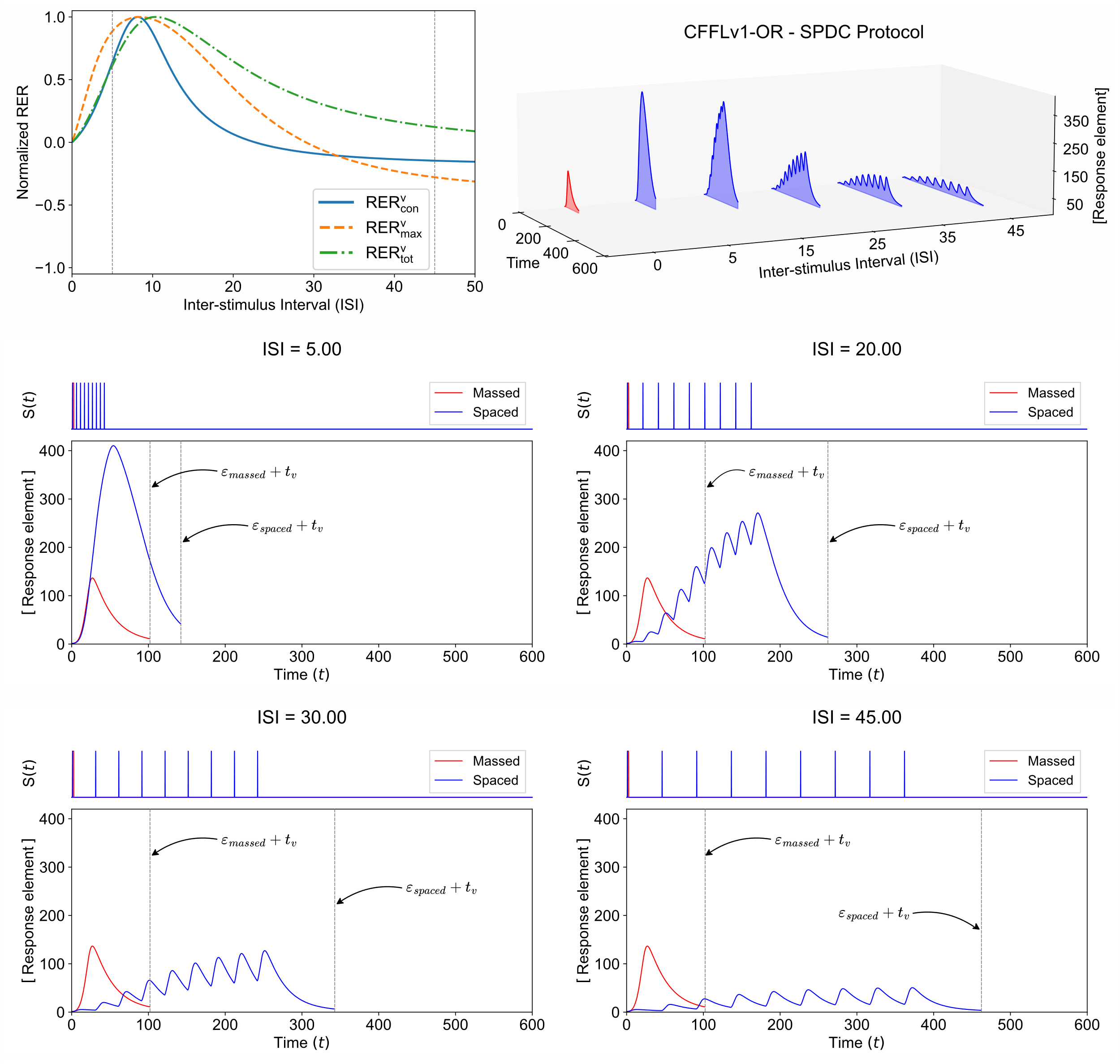
Figure S11. Representative simulation results for CFFLv1-OR following massed and spaced training using 9 input pulses for a single parameter set. Top-left: Normalized RER values, computed using Eq. (2) at $t_{v}$, show an inverted U-shape, indicating the existence of optimal ISI. The parameter set chosen here exhibits the spacing effect for all three response measures. Top-right: Response element’s time series (till response measurement) following massed (red) and spaced (blue) stimulation with different ISI. Middle and bottom row: Each subfigure depicts the response element’s time series following massed (red) and spaced (blue) training using 9 input pulses for inter-stimulus values of 5, 20, 30, and 45 d.u. Each subfigure is generated using the same parameter set that was identified as capable of generating the spacing effect in combination with the $R_{con}$, $R_{max}$, and $R_{tot}$ measures. The values of the corresponding dimensionless parameters are $k_{by}^{'}=1.160$, $k_{xyz}^{'}=4.910×{10}^{2}$, $k_{dx}^{'}=1.338×{10}^{-1}$, $k_{xy}^{'}=1.444×{10}^{1}$, $k_{dy}^{'}=1.243×{10}^{-2}$, $k_{bx}^{'}=3.817×{10}^{-3}$, $K_{XY}^{'}=1.226×{10}^{-1}$, $K_{XYZ}^{'}=4.524×{10}^{2}$, $k_{sx}^{'}=1.194$, and $δ=1.826×{10}^{-1}$. The CFFLv1-OR model was non-dimensionalized by setting $k_{bz}$ and $k_{dz}$ equal to 1.

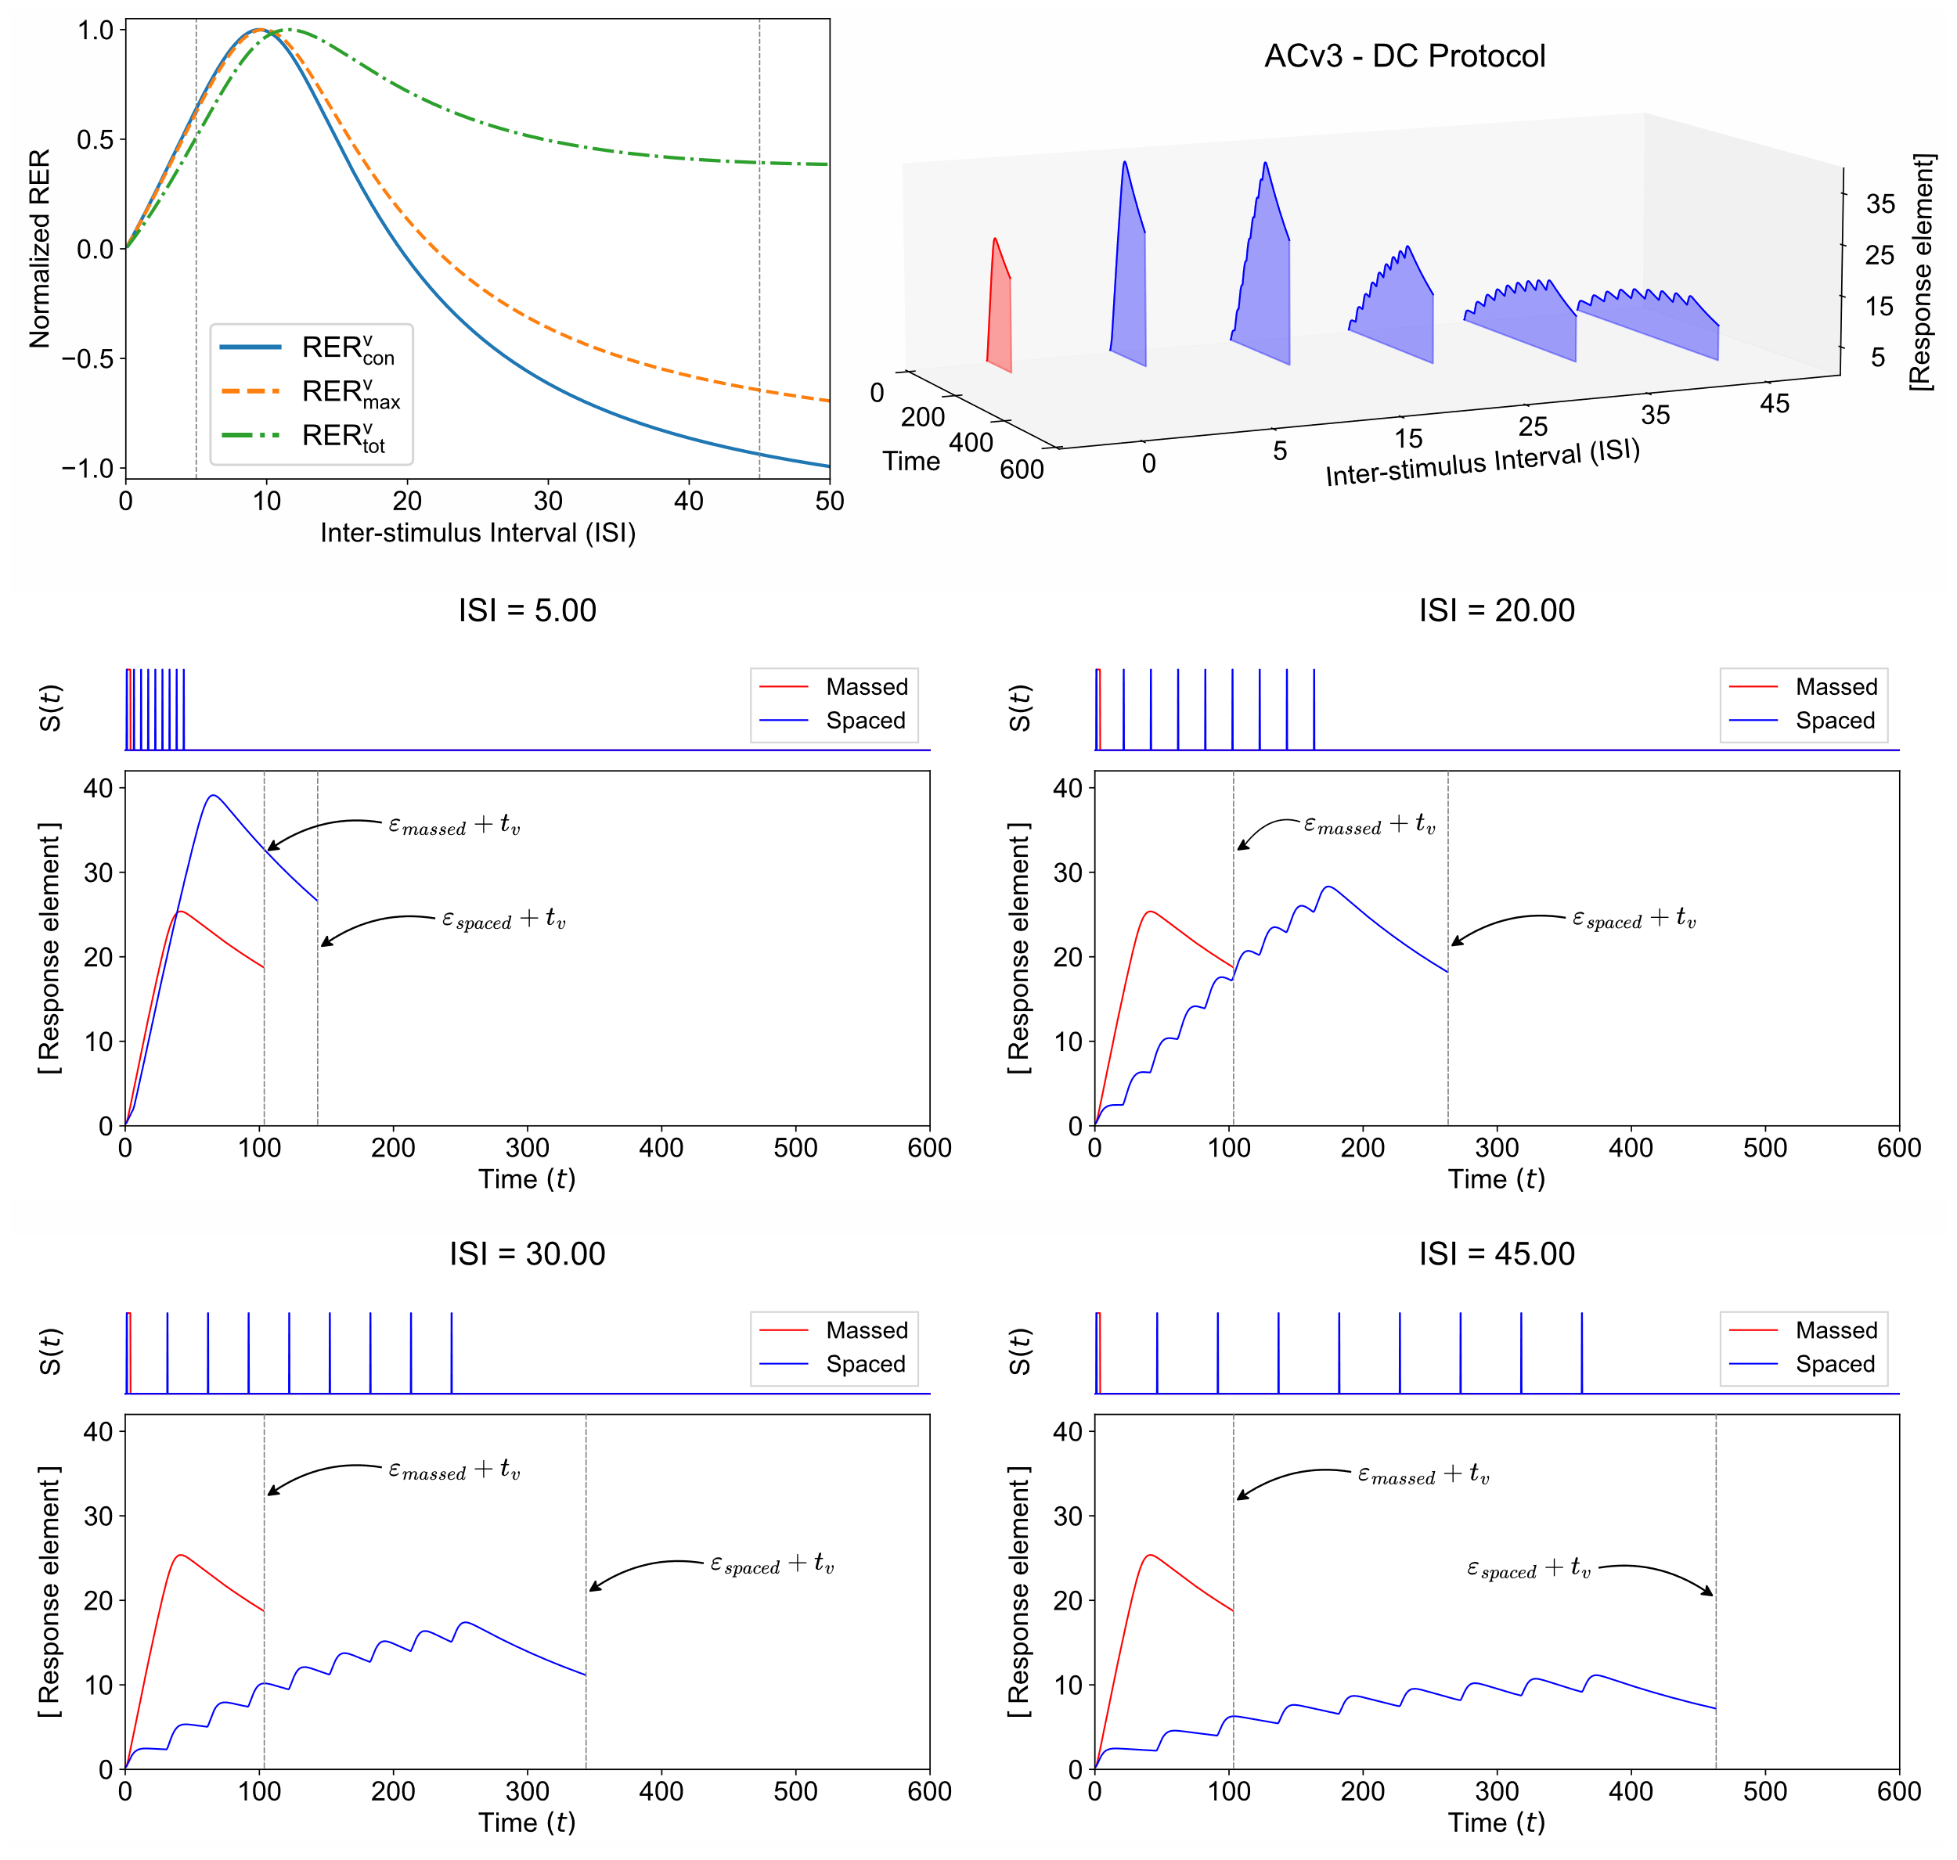
Figure S12. Representative simulation results for ACv3 following massed and spaced stimulation using 9 input pulses for a single parameter set. Top-left: Normalized RER values, computed using Eq. (2) at $t_{v}$, show an inverted U-shape, indicating the existence of optimal ISI. The parameter set chosen here exhibits the spacing effect for the three response measures. Top-right: Response element’s time series (till response measurement) following massed (red) and spaced (blue) stimulation with different ISI. Middle and bottom row: Each subfigure depicts the response element’s time series following massed (red) and spaced (blue) training using 9 input pulses for inter-stimulus values of 5, 20, 30, and 45 d.u. Each subfigure is generated using the same parameter set that was identified as capable of generating the spacing effect in combination with the $R_{con}$, $R_{max}$, and $R_{tot}$ measures. The values of the corresponding dimensionless parameters are $k_{dx}^{'}=6.963×{10}^{-3}$, $k_{xy}^{'}=1.004×{10}^{2}$, $k_{dy}^{'}=6.788×{10}^{-2}$, $k_{bx}^{'}=5.126×{10}^{-2}$, $K_{YZ}^{'}=1.102×{10}^{2}$, $k_{yz}^{'}=5.919×{10}^{2}$, $k_{dz}^{'}=3.859×{10}^{-3}$, $k_{sx}^{'}=3.885×{10}^{2}$, $k_{za}^{'}=1.379×{10}^{-3}$, and $Δ=2.824$. Non-dimensionalization of the ACv3 model was carried out by setting both $k_{ba}$ and $k_{da}$ equal to 1.

Individual pathways in the Zhang et al. model show spacing effect
A model for enhanced learning protocols proposed by Zhang et al. involves the interaction between protein kinase A (PKA) and extracellular signal-regulated kinase (ERK) pathways connected via a feedforward architecture (Zhang et al. 2012). Since it was observed that simple linear activation cascades are sufficient to generate the spacing effect, individual pathways leading to the response in the Zhang et al. model may be sufficient to produce the spacing effect in the form of an inverted U-shaped curve. Hence, we formulated and analyzed the two pathways leading to the response in the Zhang et al. model individually (Figure S13). Zhang et al. utilized the peak level of the product of PKA and ERK activation to compare the response to stimulation protocols. As achieving this for a single pathway is not feasible, we modeled the response using two approaches: (i) utilizing PKA-C/ERK-PP as the response element and (ii) incorporating a hypothetical inducer as the response component in the model, with its formation activated by the presence of PKA-C/ERK-PP. The subsequent figure provides an overview of the PKA and ERK activation pathway models.
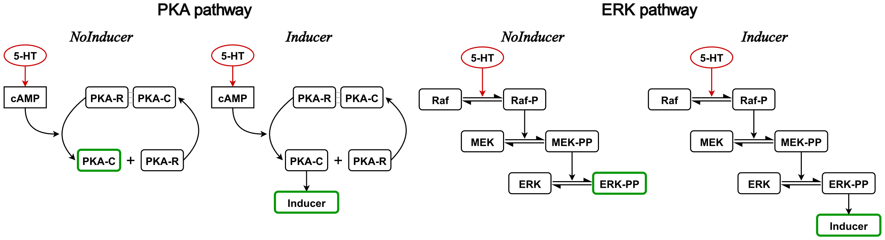
Figure S13. Simplified ERK and PKA activation pathway models based on the Zhang et al. (2012) model for spacing effect. In the first model, the catalytic PKA-C was designated as the response element (NoInducer). The second model incorporates a hypothetical inducer as the response component, with its formation activated by PKA-C (Inducer). Similarly, the Raf-MEK-ERK pathway was modeled in two ways based on the presence of an Inducer element. In each model, 5-HT (serotonin), as a function of time, acts as a proxy for the stimulation protocol, and the response element is highlighted in green.
In the PKA activation pathway, 5-HT acts as the signal that activates cyclic adenosine monophosphate (cAMP), which in turn results in the dissociation of the inactive PKA-RC complex, yielding catalytic PKA-C form. The system of ODEs for the two models is given by:
$$\frac{d\left[cAMP\right]}{dt} = \frac{λ⋅\left[5\text{-}HT\right]}{K_{5\text{-}HT}+\left[5\text{-}HT\right]}-k_{b,cAMP}⋅\left[cAMP\right] \\ \frac{d\left[PKA\text{-}RC\right]}{dt} = k_{b, PKA}⋅\left[PKA\text{-}C\right]⋅\left[PKA\text{-}R\right]-k_{f, PKA}⋅\left[PKA\text{-}RC\right]⋅{\left[cAMP\right]}^{2} \\ \frac{d\left[PKA\text{-}R\right]}{dt} = -\frac{d\left[PKA\text{-}RC\right]}{dt} \\ \frac{d\left[PKA\text{-}C\right]}{dt} = \frac{d\left[PKA\text{-}R\right]}{dt} \\ \frac{d\left[Inducer\right]}{dt} = k_{f,Inducer}⋅\left[PKA\text{-}C\right]-k_{b, Inducer}⋅\left[Inducer\right] (\text{only f}\text{or the }\text{Inducer}\text{ model})$$
The differential equations for the ERK pathway were written similarly, closely following the Zhang et al. model. The four models were numerically simulated using the SPDC and DC protocols following the same methodology applied to the motif models. All models underwent two sets of simulations: the first using randomly generated kinetic parameter values ranging from ${10}^{-3}$ to ${10}^{3}$ (denoted as Random), while the second employed parameter values sourced from the literature. Since certain kinetic constants employed in this study were absent in the original model ($k_{b, Inducer}$ for instance), these values were sampled from the same range while keeping other known parameters constant (hence denoted as SemiRandom). The Latin Hypercube method was employed for all parameter sampling in logarithmic space, and 5000 distinct parameter sets were generated for the numerical simulation of each model. As values of several kinetic constants are known in this context, neither model was non-dimensionalized for numerical analysis. The amount of 5-HT during the on-state of the stimulation protocol was assumed to be 50 $μ$M, and the initial amount of PKA-RC complex to be 1 $μ$M. The Raf, MEK, and ERK concentrations were set to 0.5 $μ$M, as used by Zhang et al. in their simulations. The results of the simulations are presented in Figure S14.
Utilizing PKA-C as the response element with known kinetic parameter values (NoInducer-SemiRandom in Figure S14A) did not yield any parameter sets that produced the spacing effect as defined by the constraints. In contrast, introducing a hypothetical inducer component as the response element identified several parameter sets capable of generating the spacing effect. Surprisingly, even with the SemiRandom approach, where most parameter values are fixed at their known values, the Inducer model consistently exhibited the spacing effect across all three measures. Inverted U-shaped curves were observed for $R_{con}$ and $R_{max}$ measures relative to the administration of the last input pulse ($t_{v}$), and $R_{max}$ and $R_{tot}$ measures when the response was measured at $t_{f}$. In both scenarios, the Inducer model proved suitable when combined with the $R_{max}$ measure, aligning with the methodology of Zhang et al. Thus, similar to sequential activation cascades, a single pathway leading to the response in feedforward loops was found adequate to generate the characteristics of the spacing effect.
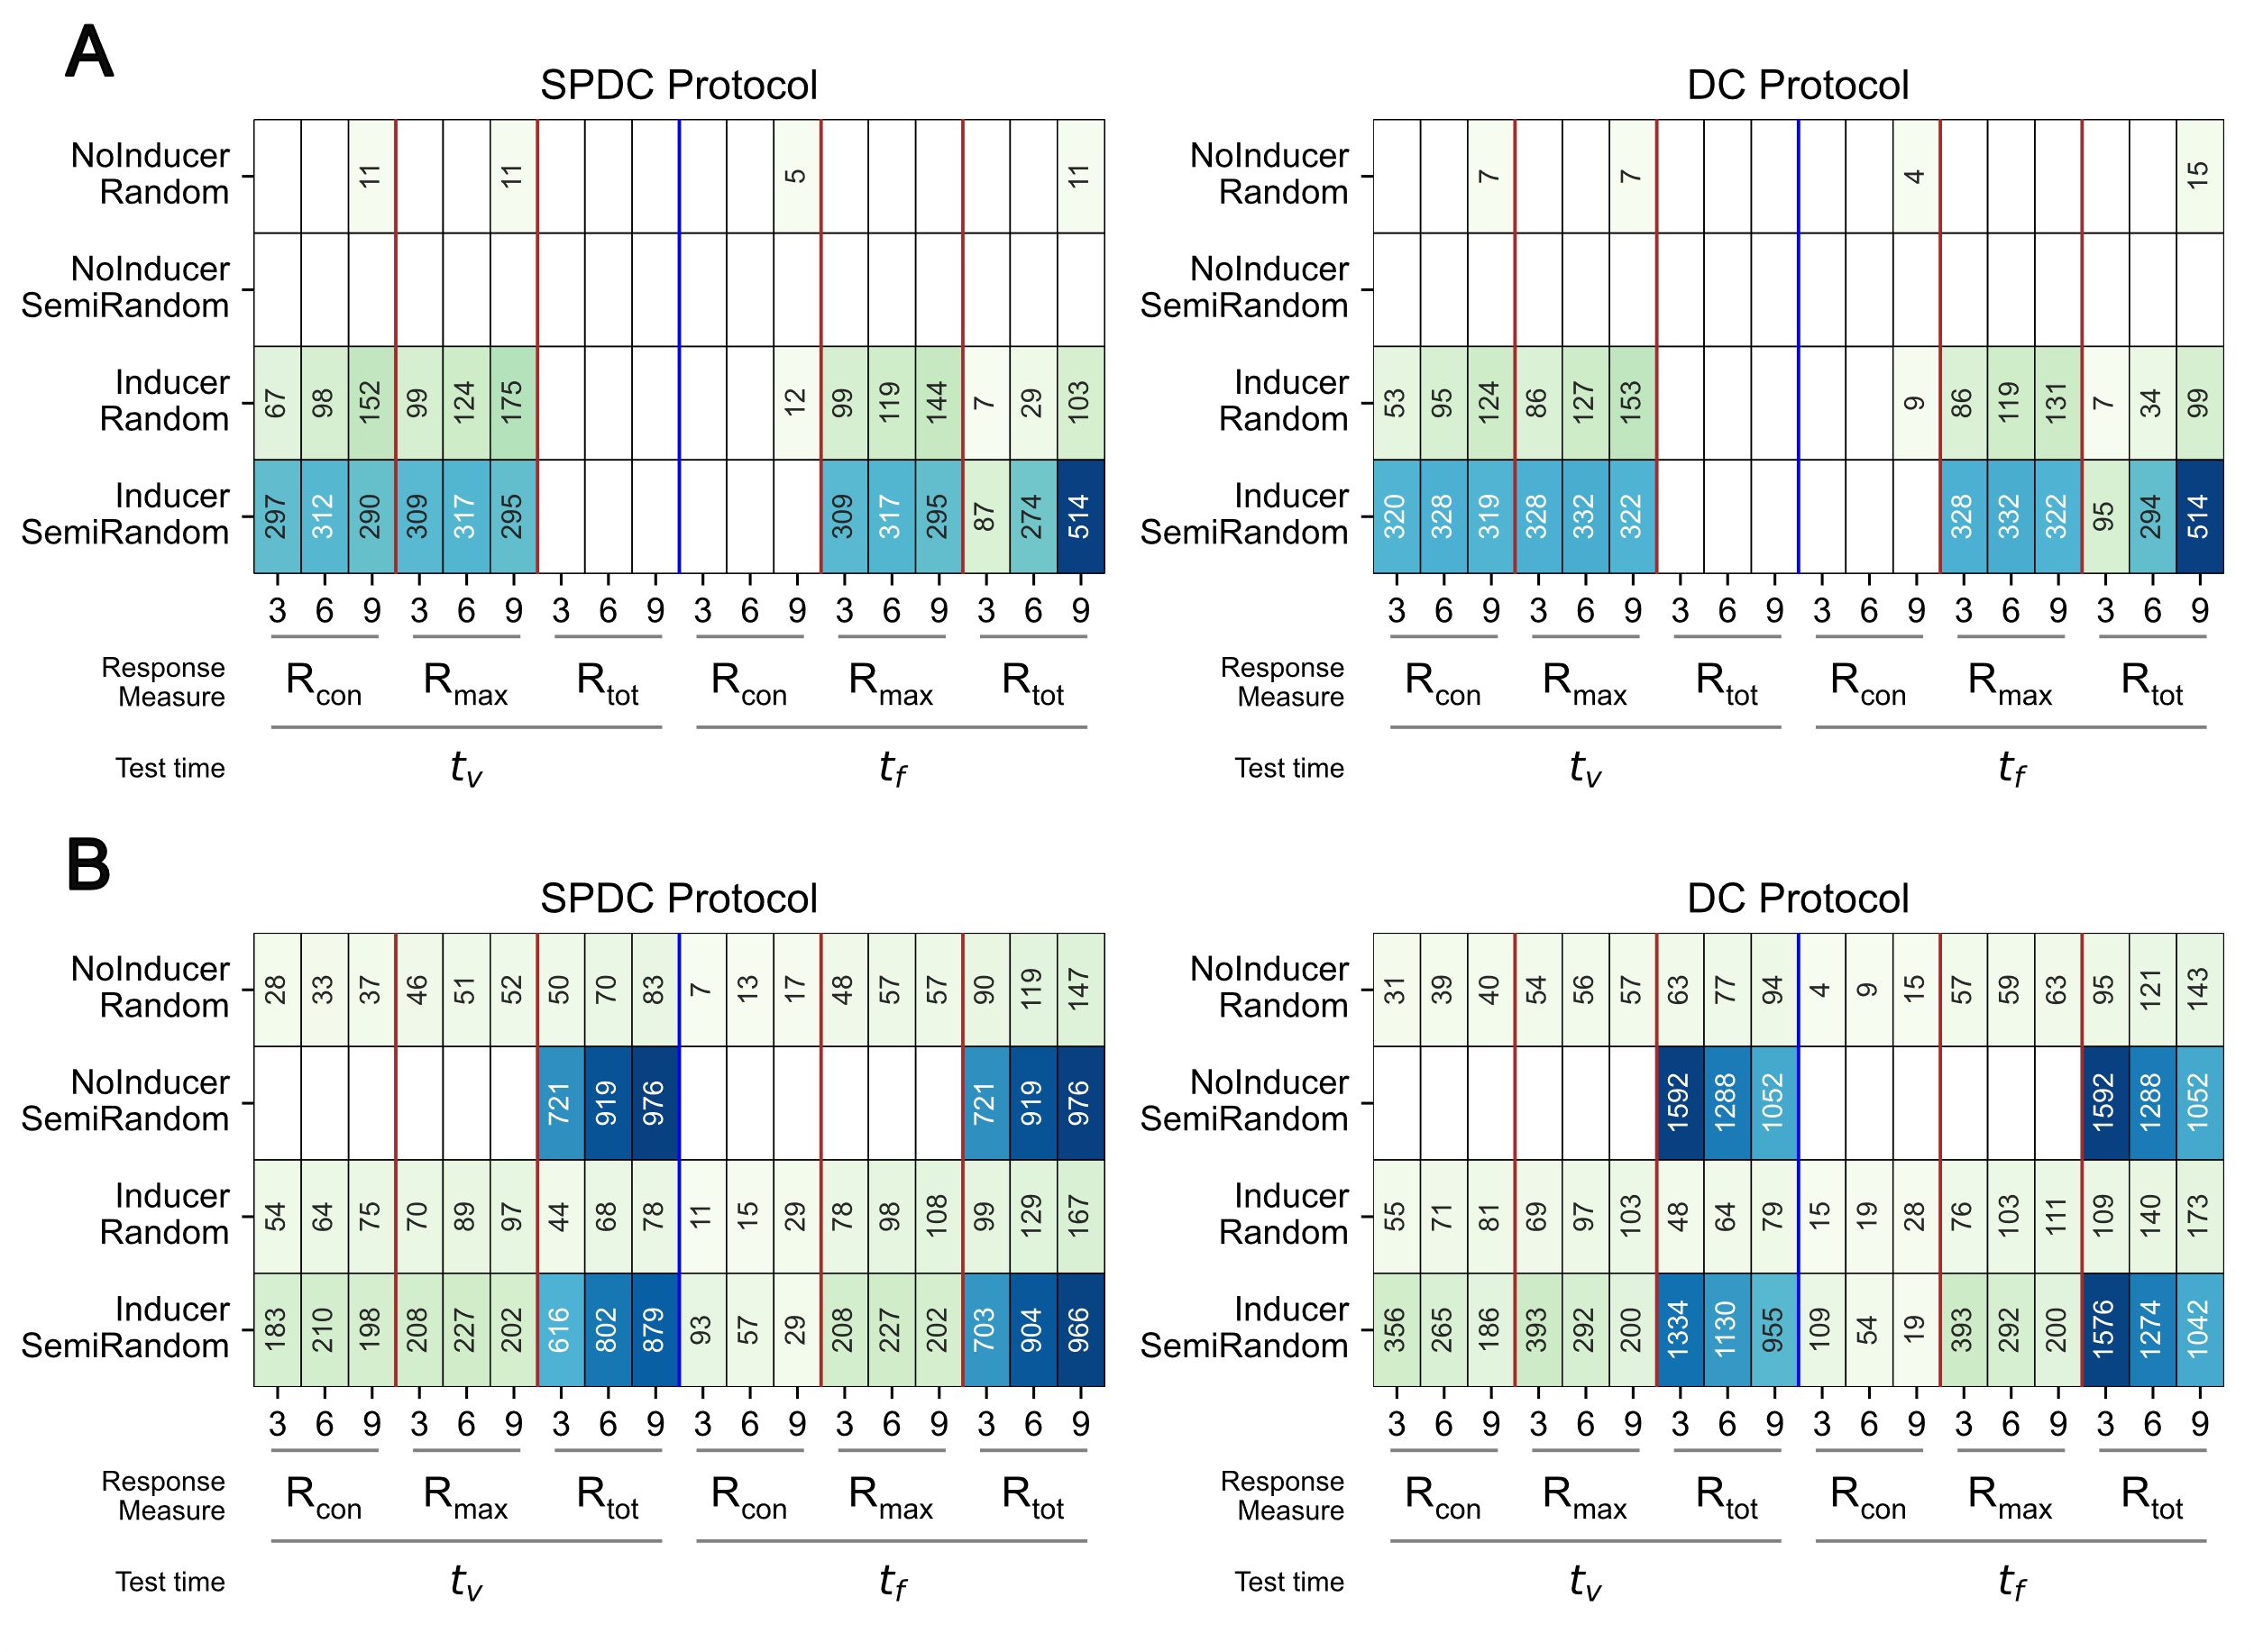
Figure S14. Simulation results for the (A) PKA activation models and (B) Raf-MEK-ERK models described in Figure S13. Each cell represents the number of parameter sets (out of 5000), showing the spacing effect defined by the constraints outlined. The minimum RER cutoff was set as 10%.
In the Zhang et al. model, the response was quantified as a product of PKA and ERK concentrations. Hence, in the absence of one kinase, the response diminishes immediately. In our single-pathway model, the variable inducer, when incorporated, appears to behave similarly to the product of PKA and ERK activities in the original model. The presence of PKA initiates the formation of the inducer at a notably higher rate than its degradation in the Inducer model. As the PKA signal decreases, the relative degradation rate rises, leading to a decline in response. Analysis of the second pathway (Raf-MEK-ERK activation without delay) in the feedforward architecture also revealed the capability of generating an inverted U-shaped response as a function of increasing stimulus intervals (Figure S14B). Each pathway leading to the response can elicit the spacing effect-like response individually. However, it is crucial to note that the results presented here only reveal the capacity of individual pathways in feedforward architectures to exhibit the spacing effect in the form of an inverted U-shaped curve. They do not imply redundancy of the other pathway.

Effect of Hill coefficient on the results
All results presented previously are based on motif dynamics employing a Hill coefficient value of 5. However, repeating the analysis outlined in this study for smaller values of the Hill coefficient produced no apparent qualitative changes in the results portrayed in Figure 3. A representative simulation result for one such analysis (with Hill coefficient $n=2$) is presented in Figure S15.
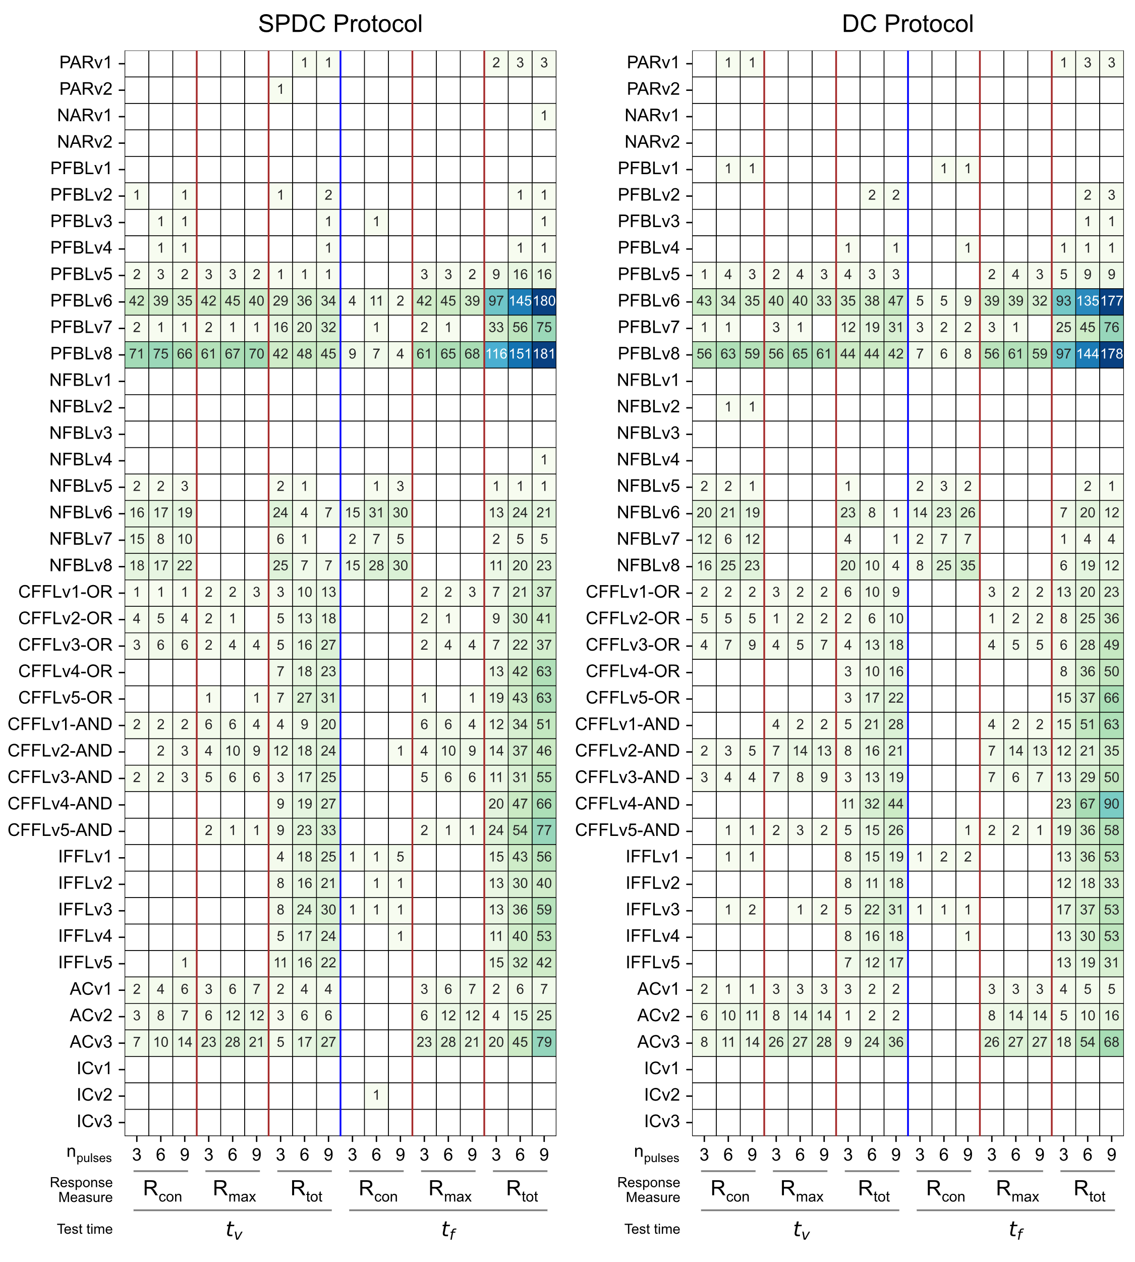
Figure S15. Summary of simulation results for a Hill coefficient value of 2. Each cell describes the number of parameter sets that replicate the spacing effect with a minimum RER of 10%.

Effect of minimum significant response threshold on the results
The constraints described for filtering parameter sets utilize specific thresholds for the values of massed response, RER, and normalized RER. To evaluate the robustness of the results to changes in these thresholds, we systematically varied each threshold. For instance, the minimum significant massed response value that corresponds to constraint C1 was increased to $1$ d.u. from ${10}^{-4}$ d.u. The simulation results corresponding to a massed response cutoff of 1 d.u. are summarized in the following figure.
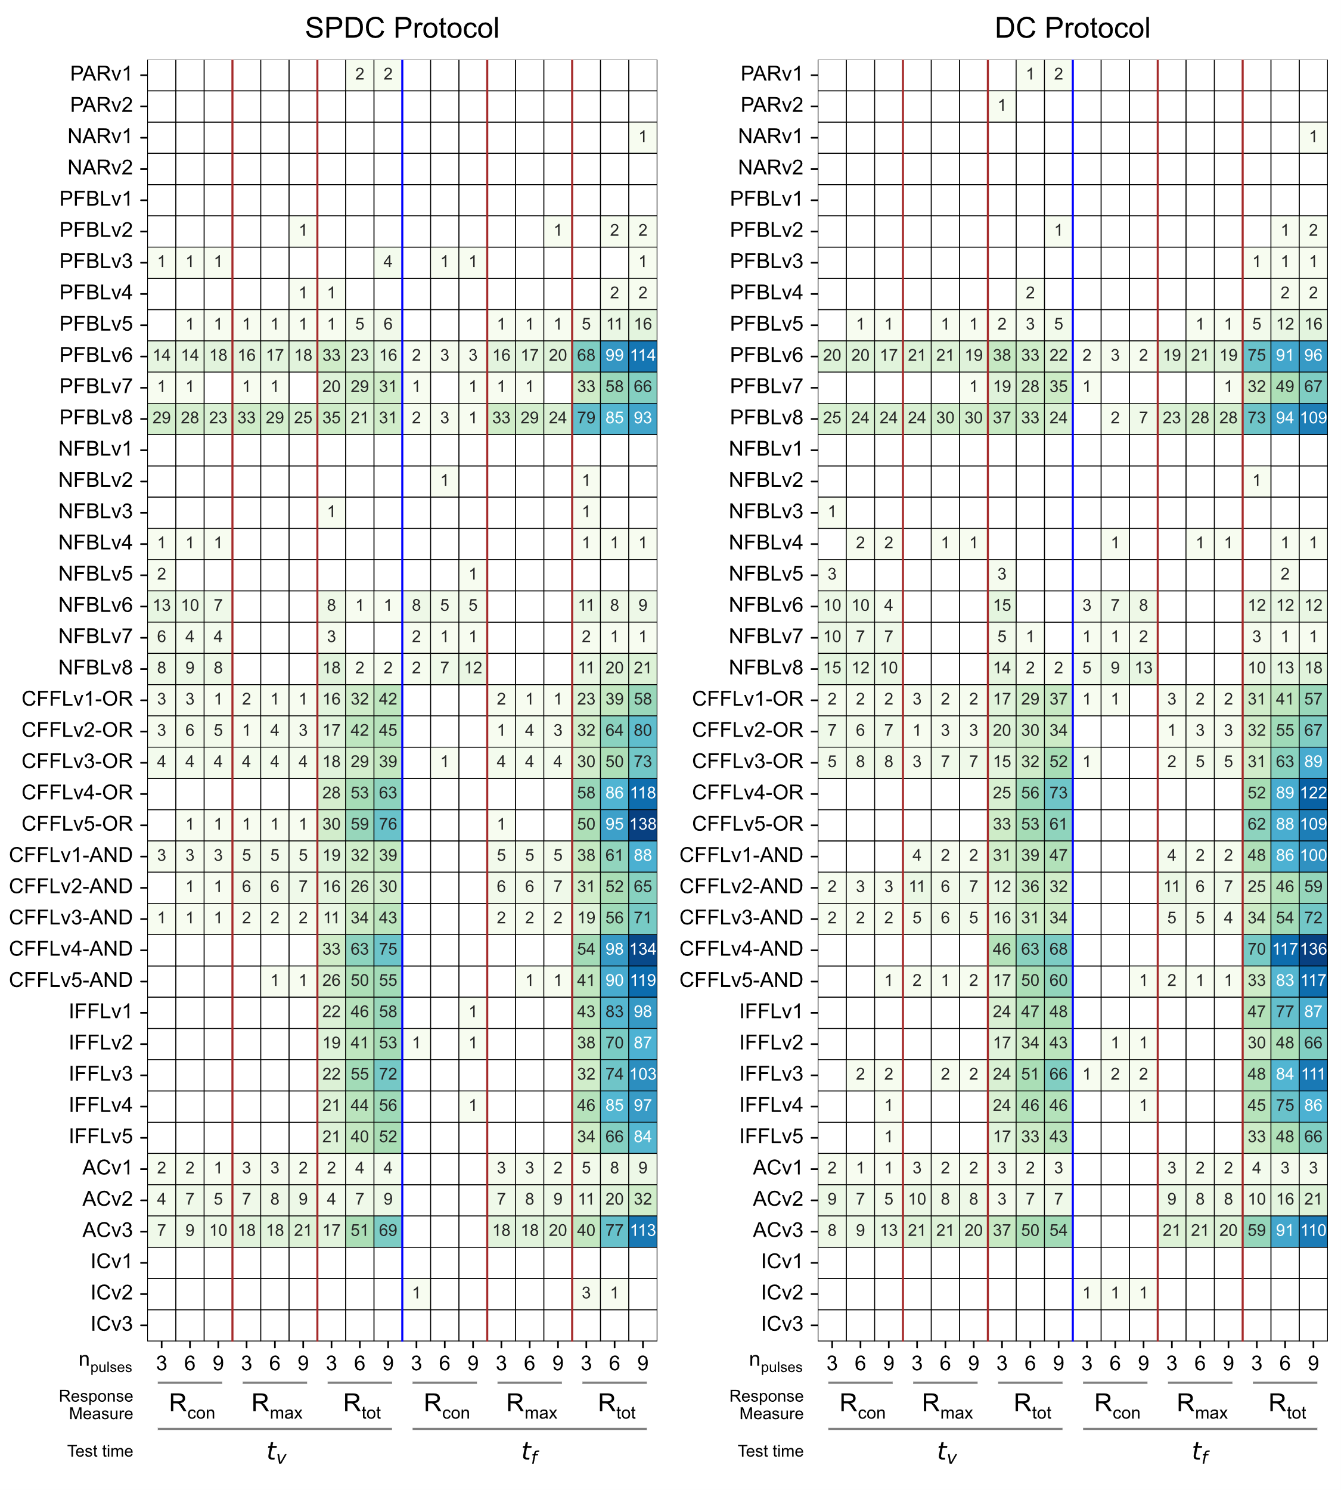
Figure S16. Summary of simulation results for a minimum massed response threshold of 1 d.u. Each cell describes the number of parameter sets that replicate the spacing effect with a minimum RER of 10%.
Figure S16 demonstrates that variations in the response threshold have no significant impact on the results presented in this study. This outcome is anticipated as the ODE models are rescaled using the formation rate constant of the response element. However, even when this cutoff was increased to 10 d.u., no qualitative changes in the results were observed. Similarly, modifying the other constraints did not lead to any qualitative deviations from the patterns observed in Figure 3.

References
Ajay SM, Bhalla US. 2004. A role for ERKII in synaptic pattern selectivity on the time-scale of minutes. Eur J Neurosci 20: 2671–2680.
Farah CA, Naqib F, Weatherill DB, Pack CC, Sossin WS. 2015. Synapse formation changes the rules for desensitization of PKC translocation in Aplysia. Eur J Neurosci 41: 328–340.
Farah CA, Weatherill D, Dunn TW, Sossin WS. 2009. PKC differentially translocates during spaced and massed training in Aplysia. J Neurosci 29: 10281–10286.
Fuhrmann G, Segev I, Markram H, Tsodyks M. 2002. Coding of temporal information by activity-dependent synapses. Journal of Neurophysiology 87: 140–148.
Kim M, Huang T, Abel T, Blackwell KT. 2010. Temporal sensitivity of protein kinase A activation in late-phase long term potentiation ed. T. Nowotny. PLoS Comput Biol 6: e1000691.
Kogan JH, Frankland PW, Blendy JA, Coblentz J, Marowitz Z, Schütz G, Silva AJ. 1997. Spaced training induces normal long-term memory in CREB mutant mice. Current Biology 7: 1–11.
Liu R-Y, Zhang Y, Baxter DA, Smolen P, Cleary LJ, Byrne JH. 2013. Deficit in long-term synaptic plasticity is rescued by a computationally predicted stimulus protocol. J Neurosci 33: 6944–6949.
Mauelshagen J, Sherff CM, Carew TJ. 1998. Differential induction of long-term synaptic facilitation by spaced and massed applications of serotonin at sensory neuron synapses of Aplysia californica. Learn Mem 5: 246–256.
Naqib F, Farah CA, Pack CC, Sossin WS. 2011. The rates of protein synthesis and degradation account for the differential response of neurons to spaced and massed training protocols ed. J.M. Haugh. PLoS Comput Biol 7: e1002324.
Philips GT, Ye X, Kopec AM, Carew TJ. 2013. MAPK establishes a molecular context that defines effective training patterns for long-term memory formation. J Neurosci 33: 7565–7573.
Scharf MT, Woo NH, Lattal KM, Young JZ, Nguyen PV, Abel T. 2002. Protein synthesis is required for the enhancement of long-term potentiation and long-term memory by spaced training. Journal of Neurophysiology 87: 2770–2777.
Woo NH, Duffy SN, Abel T, Nguyen PV. 2003. Temporal spacing of synaptic stimulation critically modulates the dependence of LTP on cyclic AMP-dependent protein kinase. Hippocampus 13: 293–300.
Zhang Y, Liu R-Y, Heberton GA, Smolen P, Baxter DA, Cleary LJ, Byrne JH. 2012. Computational design of enhanced learning protocols. Nat Neurosci 15: 294–297.

