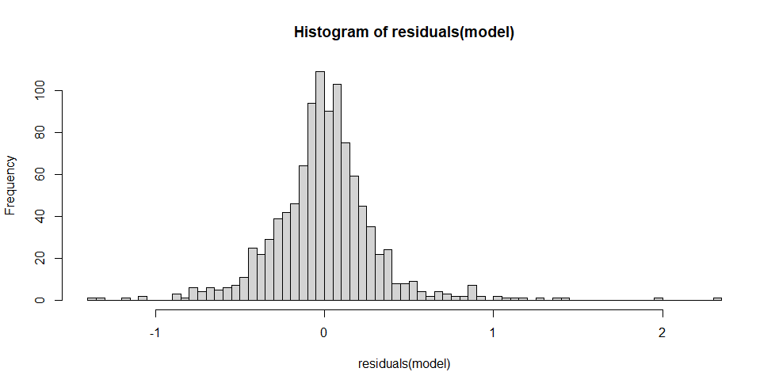
Supplemental Figure 1. Distribution of the residuals in the 4-way analysis of variance performed on the connections from the S1 neurons to B3. The normal distribution of the residuals justifies the use of a parametric test on these data. We thank Dr. Jennifer Benichou Israel Cohen for the analysis and the plot.

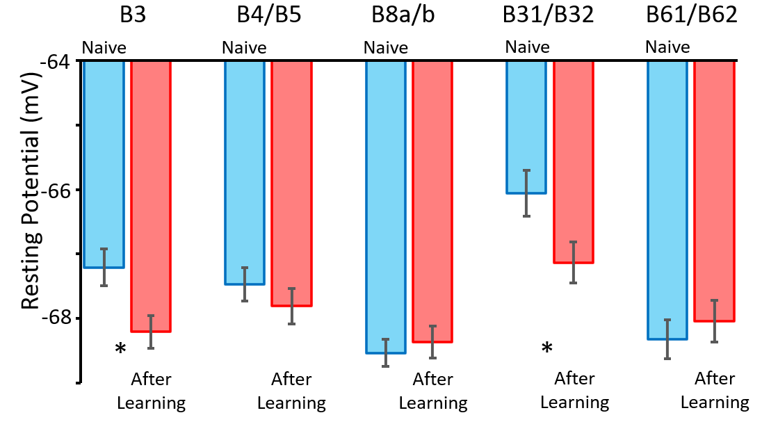
Supplemental Figure 2. Resting potentials of followers in ganglia from naïve animals (blue) and animals after learning (red). Means and standard errors are shown. Significant changes are marked by asterisks. There were significant increases in the resting potential after learning in B3 (p = 0.009) and in B31/B32 (p = 0.019), but not in B4/B5 (p = 0.373), B8a/b (p = 0.597) or B61/B62 (p = 0.532; two-tailed t-tests).
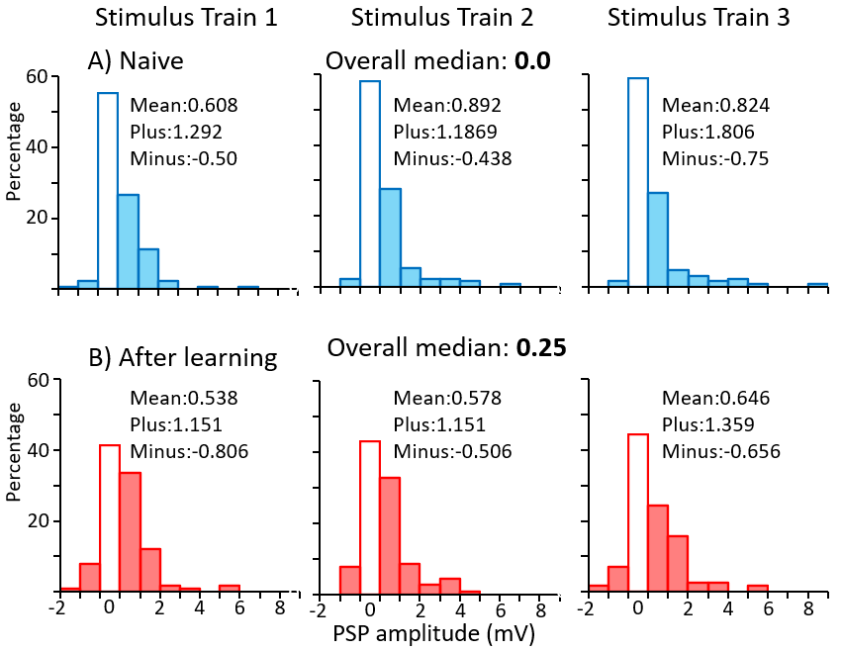
Supplemental Figure 3. Slow PSPs in B3. Distribution of the amplitudes of the slow PSPs in ganglia from: (A) Naive animals (blue) and from (B) animals that had learned (red). The lack of a connection (PSP amplitude of zero) is indicated by an unshaded bar. Within each histogram are shown the mean value of all measured PSPs, and also mean values of the EPSPs (Plus) and of the IPSP (Minus).
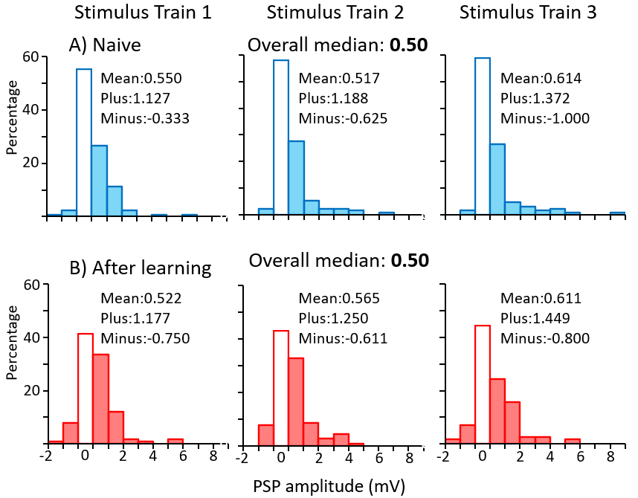
Supplemental Figure 4. Slow PSPs in B4/B5. Distribution of the amplitudes of the slow PSPs in ganglia from: A) Naive animals (blue) and from B) animals that had learned (red). The lack of a connection (PSP amplitude of zero) is indicated by an unshaded bar. Within each histogram are shown the mean value of all measured PSPs, and also mean values of the EPSPs (Plus) and of the IPSPs (Minus).
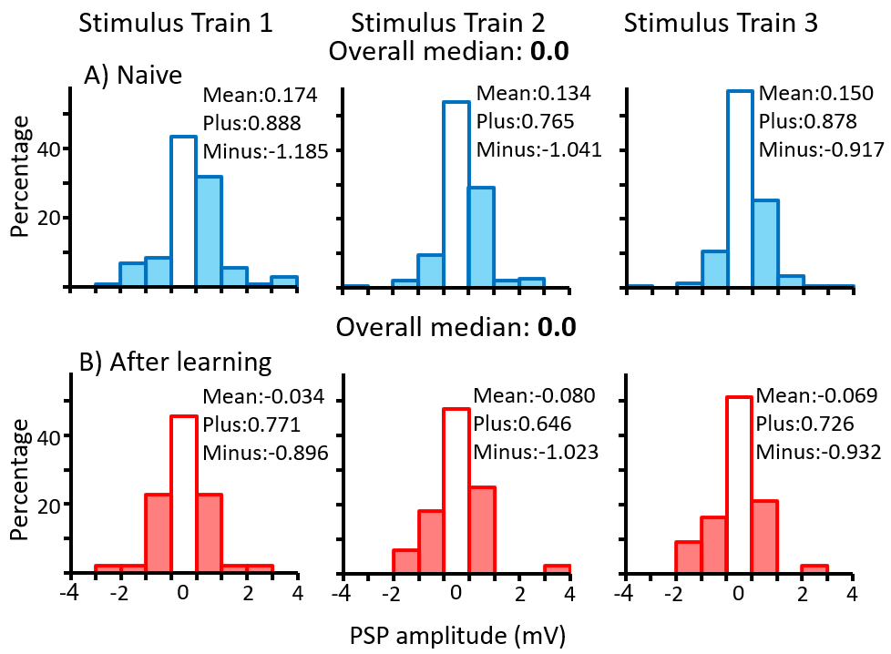
Supplemental Figure 5. Slow PSPs in B8a/b. Distribution of the amplitudes of the slow PSPs in ganglia from: A) Naive animals (blue) and from B) animals that had learned (red). The lack of a connection (PSP amplitude of zero) is indicated by an unshaded bar. Within each histogram are shown the mean value of all measured PSPs, and also mean values of the EPSPs (Plus) and of the IPSP (Minus).
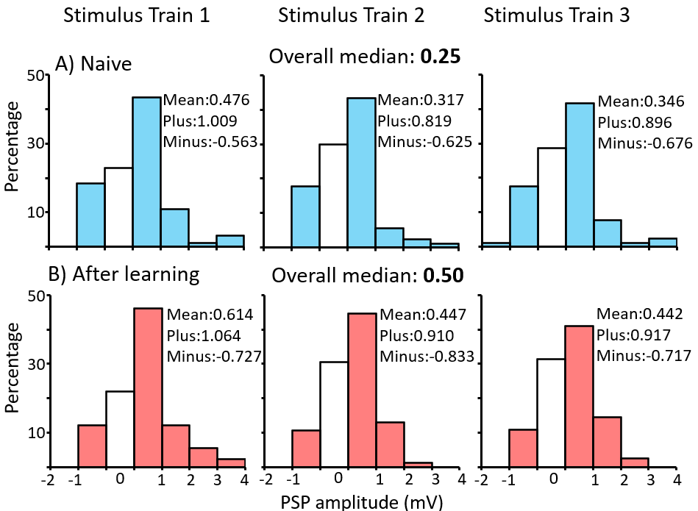
Supplemental Figure 6. Slow PSPs in B31/B32. Distribution of the amplitudes of the slow PSPs in ganglia from: A) Naive animals (blue) and from B) animals that had learned (red). Unconnected neurons (zero amplitude) are shown unfilled. The lack of a connection (PSP amplitude of zero) is indicated by an unshaded bar. In the upper lefthand corner of each histogram are shown the mean value of all measured PSPs, and also mean values of the EPSPs (Plus) and of the IPSP (Minus).
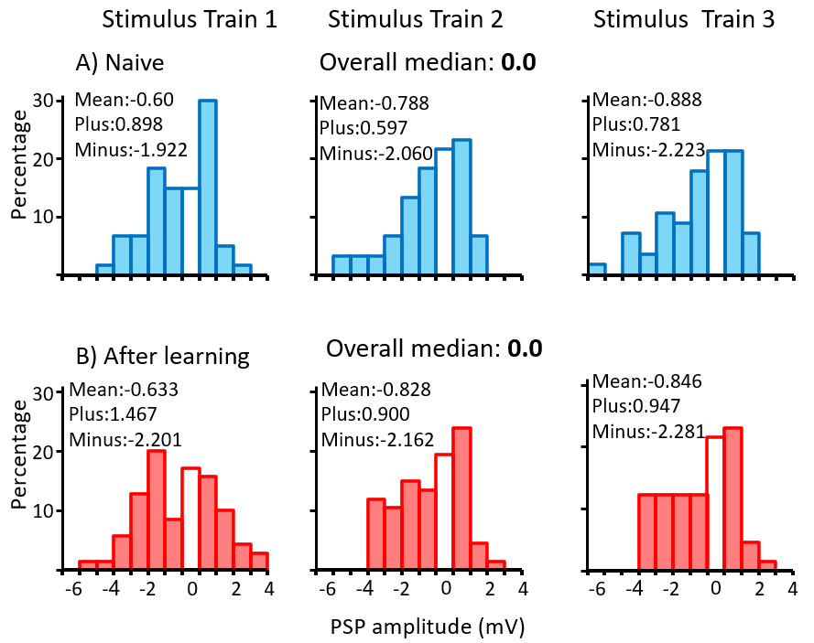
Supplemental Figure 7. Slow PSPs in B61/B62. Distribution of the amplitudes of the slow PSPs in ganglia from: A) Naive animals (blue) and from B) animals that had learned (red). Unconnected neurons (zero amplitude) are shown unfilled. The lack of a connection (PSP amplitude of zero) is indicated by an unshaded bar. In the upper left-hand corner of each histogram are shown the mean value of all measured PSPs, and also mean values of the EPSPs (Plus) and of the IPSP (Minus).

