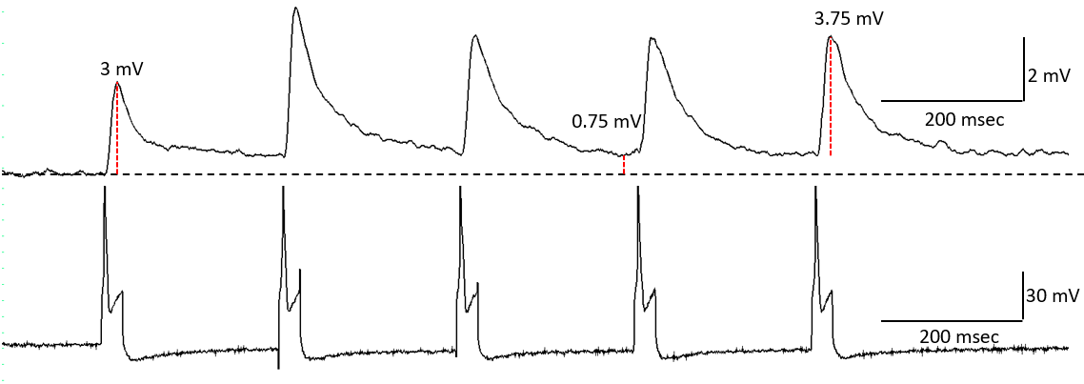
Supplemental Figure 1. An example of a single stimulus train, and of the measurements of fast and slow PSP amplitude made in the follower (vertical red dashed lines). The example is from a neuron in S1-2 to neuron B4/B5. The recording was made in a high-divalent cation solution. Note that in this example, the amplitude of the fast EPSP increased from the first through the fifth stimulus. Generally, the amplitude decreased.

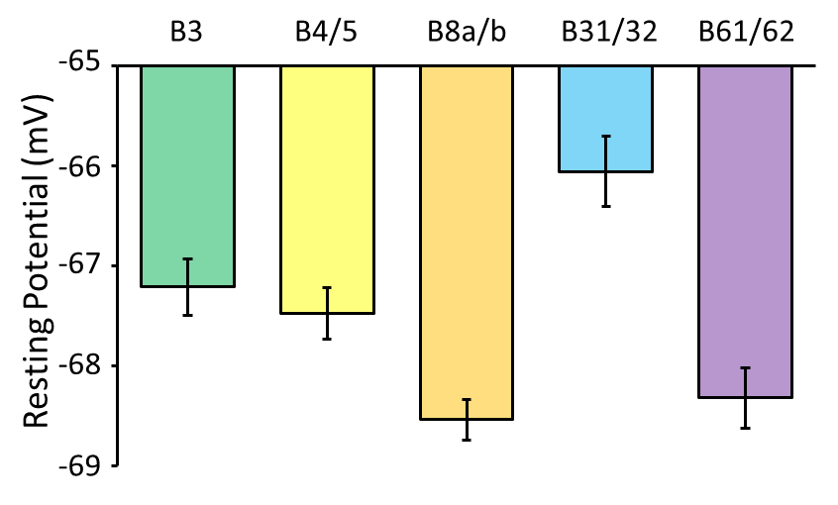
Supplemental Figure 2. Resting potentials of the 5 post-synaptic neurons. Means and standard errors are shown. There were significant differences in the resting potential (p < 0.0001, F = 4,490, One-way analysis of Variance). Post-hoc tests showed significant differences between: 1) B3 and B8a/b, B31/B32 and B61/B62; 2) B4/B5 and B31/B32; 3) B8a/b and B31/B32; 4) B31/B32 and B61/B62; Tukey HSD tests.

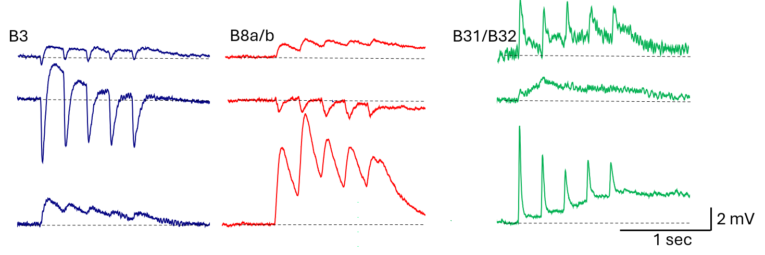
Supplemental Figure 3. Additional examples of recordings in 3 followers in response to a train of 5 stimuli to S1 neurons. Note the heterogeneity of the responses.

Supplemental Text 1
Plasticity of fast PSPs between-stimulus trains was examined separately for each follower cell, and separately for EPSPs (Supplementary Figs. 3A, B) and IPSPs (Supplementary Fig. 2C). Because there are large differences in amplitude between the first and fifth fast PSP, changes among stimulus trains were examined separately for the first (Supplementary Fig. 3A1a, 3A2a, 3B1a, 3B2a) and the fifth (Supplementary Fig. 3A1b, 3A2b, 3B1b, 3B2b) fast EPSP within a stimulus train. Because there might be different changes from the first to the second stimulus train and from the second to the third stimulus train, they were also analyzed separately. For each comparison, the distribution of increases and decreases in PSP amplitude from stimulus train to stimulus train were tested against the null hypothesis of an expectation that increases and decreases should be equally likely, using χ² tests (Supplementary Fig. 3A). In addition, changes in the net amplitude from the different stimulus trains were measured (Supplementary Fig. 3B).
For two followers (B4/B5 and B61/B62), the first EPSP in the train increased in amplitude from the first to the second stimulus train (for B4/B5: p = 0.003, n = 102; for B61/B62: p = 0.002, n = 28) (Supplementary Fig. 3A1a), but not from the second to the third stimulus train (for both: p > 0.47) (Supplementary Fig. 3A2a). Two followers (B8a/b and B31/B32) showed no changes in the amplitude of the first EPSP from the first to the second train (for both B8a/b and B31/B32: p = 0.83) (Fig. 5A1a), or from the second to the third train (for both: p > 0.96) (Supplementary Fig. 3A2a). However, all 4 followers showed significant decreases in EPSP amplitude for the fifth EPSP in a stimulus train from the first to the second train (for B4/B5 and B8a/b: p < 0.004; for B31/B32 p = 0.014; for B61/B62: p = 0.041) (Supplementary Fig. 3A1b), and two followers (B4/B5 and B8a/b) showed additional decreases in EPSP amplitude from the second to the third stimulus train (for both: p < 0.004; χ² tests) (Supplementary Fig. 3A2b). There were too few EPSPs in B3 to test for significant changes between stimulus trains.
We also examined whether there were significant differences in the amplitudes of the changes in EPSP amplitude among the 5 follower neurons examined (Supplementary Fig. 2B). For the difference in amplitude of the first EPSP between the first and second stimulus trains (Supplementary Fig. 3B1a), there was a significant difference (p = 0.0006). there were no significant differences among the follower neurons for the other amplitude differences measured (0.37 > p < 0.79; Kruskal-Wallis tests) (Supplementary Fig. 3B1b, 3B2a, 2B2b).
There were enough IPSPs to test for between-train changes only in B3 (Supplementary Fig. 3C). In this cell, there were significant increases in IPSP amplitude for the first (p = 0.004) but not for the fifth (p = 0.49) IPSP from the first to the second stimulus train. There was no further increase in the amplitude of the first IPSP from the second to the third stimulus train (p = 0.953), but there was a significant decrease in amplitude for the fifth IPSP (p = 0.016, χ² tests, 3 degrees of freedom) from the second to the third stimulus train.

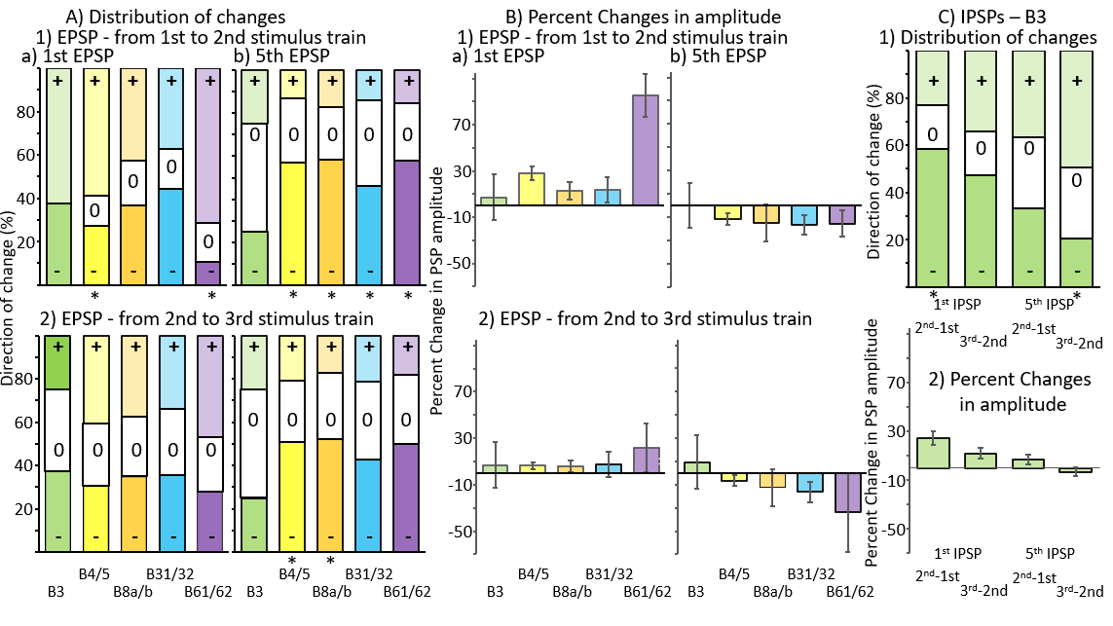
Supplemental Figure 4. Between-stimulus train plasticity of the fast EPSPs in naïve animals. A) For EPSPs measured in the follower cells, changes in the distribution between increases (+), decreases (-), or lack of change (0) from one stimulus train to another. 1) Changes in EPSP amplitude from the first to the second stimulus train. 2) Changes in EPSP amplitude from the second to the third stimulus train. Data are shown separately for: a) changes in the first EPSP in a stimulus train. b) Changes in the 5th EPSP in a stimulus train. Significant changes in the distribution are marked by an asterisk. Note that this panel is identical to Fig. 5 in the main text and is shown again here for comparison. B) Percent changes in the net amplitude of the PSPs measured in the different stimulus trains. Mean and standard errors are shown. C) Changes in the IPSPs measured in neuron B3. 1) Distribution of the changes (increase or decrease of amplitude) 2) Net change in amplitude of the changes. Note that a larger IPSP is an increase in amplitude. Means and standard errors are shown.

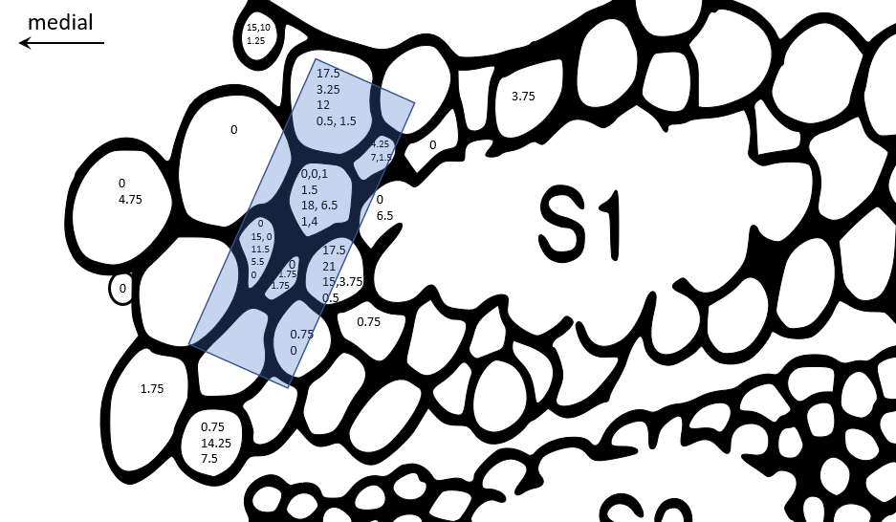
Supplemental Figure 5. A map of the medial areas of the S1 cluster used during experiments to localize the S1 neurons that were penetrated. Amplitudes in millivolts of fast EPSPs to B4/B5 recorded from each location are shown (each number represents a fast EPSP from one pair of recording). The area in which large EPSPs were recorded is shaded.

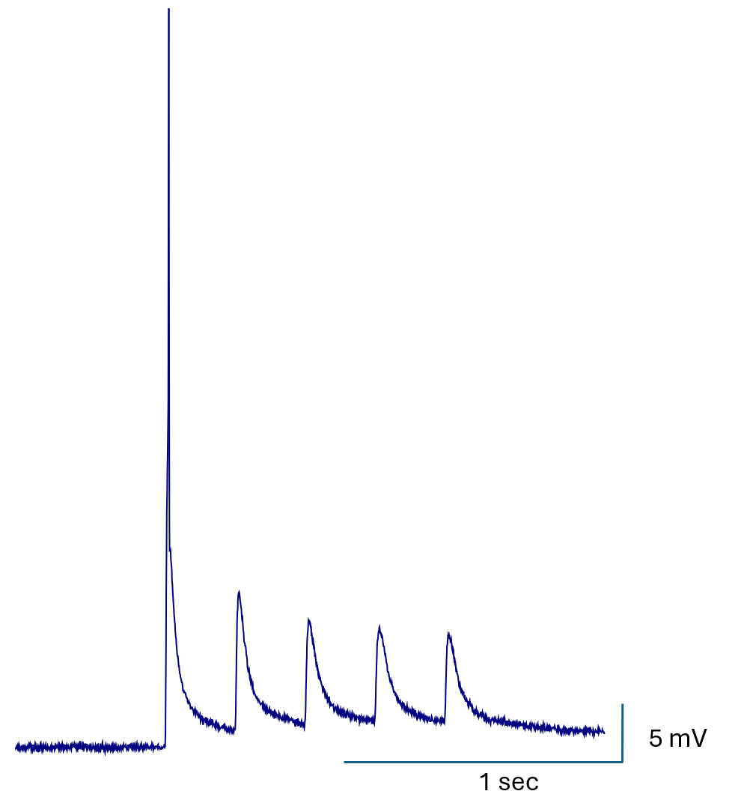
Supplemental Figure 6. Recording of a train of 5 large amplitude EPSPs from area S1-1 to B4/B5. Note that the first EPSP elicited a spike. This is one of only 2 or 3 examples of spikes elicited in response to stimulation of the S1 mechanoafferents.

