Supplemental Materials for:
Adolescents flexibly adapt action selection based on controllability inferences

Participant demographics

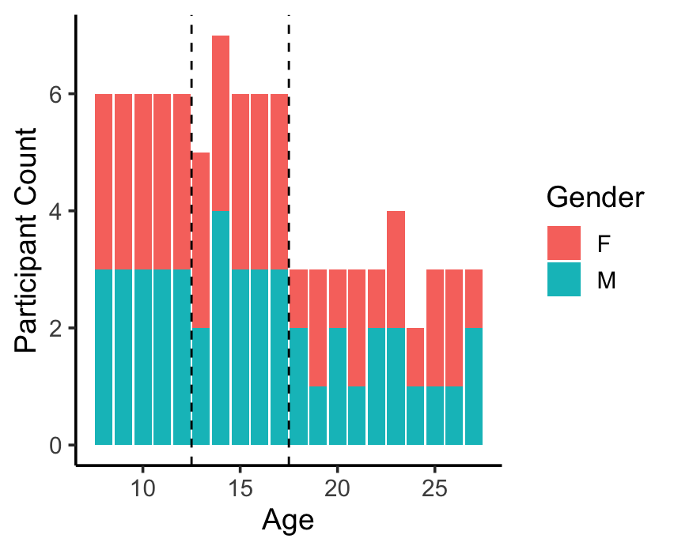
Supplemental Figure S1. Participant age and sex distribution. 90 participants between the ages of 8 and 27 years were included in the analyses.

Modeling methods and results

Model-fitting procedure
For each participant, we identified the fitted parameter values that maximized the likelihood of their choices using the fmincon function in the optimization toolbox in Matlab 2021a (The Mathworks Inc, 2021). We applied the following bounds and to each parameter: inverse temperature [0, 50]; initial stimulus and action values [−1, 1]; initial learning rate: [0, 100]; w2 [0,1]. We randomly initialized each parameter, drawing uniformly from within their bounds. We initialized and ran fmincon 5 times per participant, and took the parameter estimates that maximized the log likelihood across runs.

Model comparison
We compared three versions of the computational models. The first model, which was previously introduced by Dorfman and Gershman 2019, included five free parameters: inverse temperature, initial stimulus and action value (one for each task condition; controllable or uncontrollable), and initial learning rate for each task condition. The second model was more concise and only had three parameters: inverse temperature, one initial stimulus and action value, and one initial learning rate. The third model was identical to the second model but included an additional free parameter: a second-stage initial Pavlovian weight (w2). This parameter was added to capture the possibility that controllability expectations might be biased by exposure to the first block of the task.

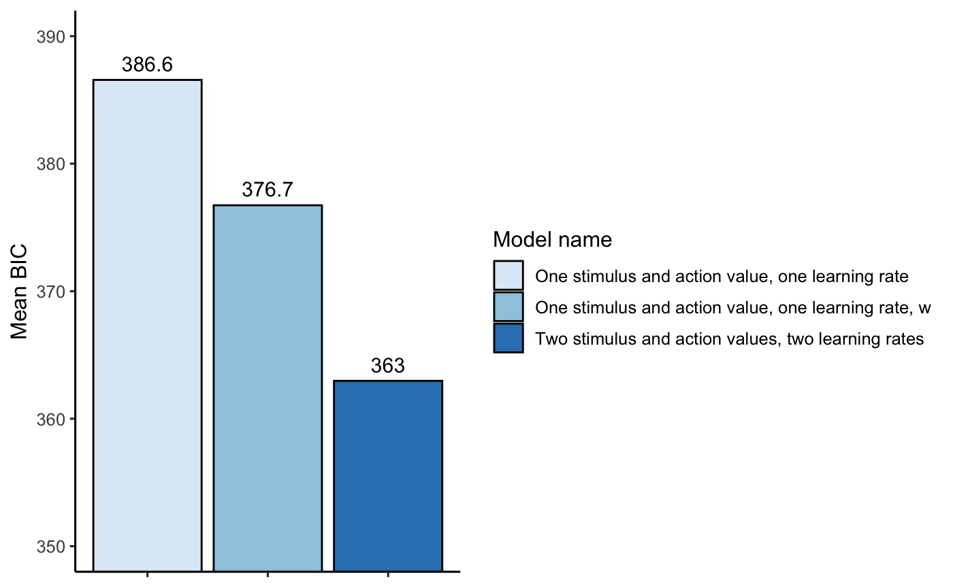

Supplemental Figure S2. Mean BIC values. Lower values indicate improved model fit. BIC: Bayesian information criterion.

Parameter recovery
In order to evaluate the reliability of the models, we conducted a parameter recovery analysis in which we simulated data for 1000 agents from each of the three models, using parameter values that were sampled from the empirical range of fitted parameters for each respective model. We then fit the models to the simulated data. The model that demonstrated the best fit to the empirical data (see Supplemental Figure S2 above), which included two learning rates and two initial stimulus and action values (one for each condition), had poor parameter recoverability (with a range of r values from .29 to .76). In contrast, the two simpler models, which only had one learning rate and one initial stimulus and action value, had similar and higher recoverability (with a range of r values from .67 or .69 to .89 or .90). Of these two models, the one that included an additional second-stage initial Pavlovian weight (w2) parameter provided a better fit to the participant's data (see supplemental Figure S2). As a result, we used this model for our analysis.

Posterior predictive checks
We tested whether simulated data for the selected model, which included as free parameters an inverse temperature, one initial stimulus and action value, one initial learning rate, and a second-stage initial Pavlovian weight (w2) parameter accurately captured qualitative features of participants' actual choices. We generated 100 sets of simulated choices using each of the 90 participant's unique parameter combinations (i.e., 9000 simulated participants). Simulated choice behavior from the model reproduced the qualitative features of participants' actual choices (Supplemental Figure 3).

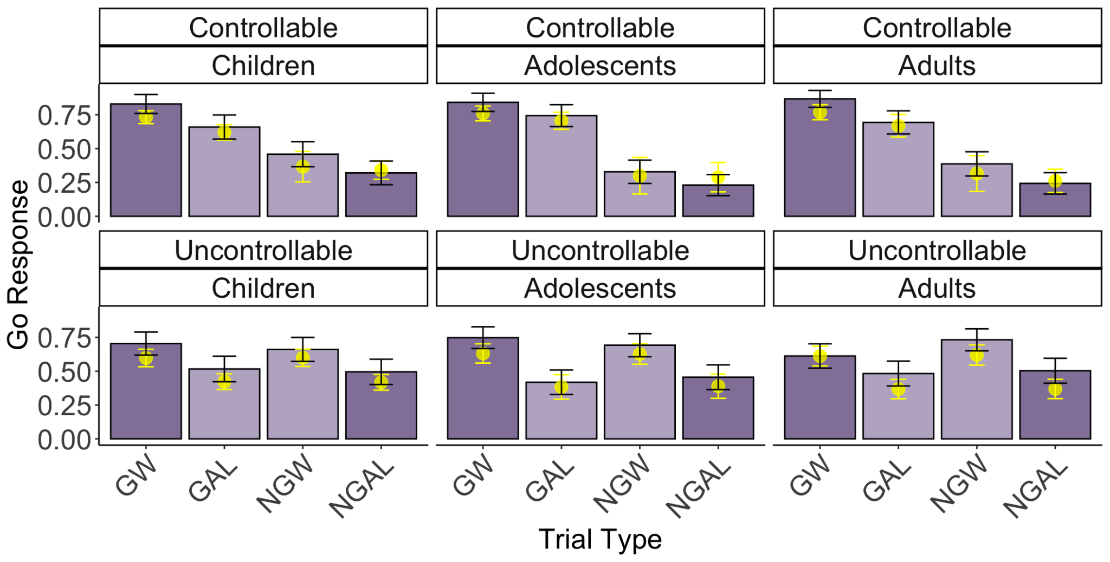
Supplemental Figure S3. Posterior predictive checks. The figure displays the simulated and actual mean accuracy for each trial type, separated by age group. Bars are shaded to indicate different trial conditions: darker shading represents trials where Pavlovian tendencies align with the instrumental contingency, while lighter shading represents trials where Pavlovian tendencies conflict with the optimal instrumental response. Mean accuracy values, calculated from simulated data using participant-specific parameter estimates from the selected model, are represented by yellow points. GW (Go to Win), GAL (Go to Avoid Losing), NGW (No-Go to Win), and NGAL (No-Go to Avoid Losing). Error bars represent ± 1 SEM.
.

Effect | df | F | p-value
Age group | 2, 84.00 | 0.08 | .920
Trial number | 1, 84.00 | 0.06 | .801
Order | 1, 84.00 | 17.24 *** | <.001
Condition | 1, 84.00 | 23.64 *** | <.001
Age group X Trial number | 1, 84.00 | 1.07 | .346
Age group X Condition | 2, 84.00 | 3.43 * | .037
Trial number X Order | 1, 84.00 | 6.26 * | .014
Trial number X Condition | 1, 83.96 | 23.5 *** | <.001
Order X Condition | 1, 84.00 | 20.78 *** | <.001
Age group X Trial number X Order | 2, 84.00 | 2.25 | .111
Age group X Trial number X Order | 2, 83.96 | 0.11 | .892
Age group X Trial number X Condition | 2, 84.00 | 0.42 | .659
Age group X Order X Condition | 2,83.96 | 0.5 | .610
Condition X Trial number X Order | 1, 83.96 | 7.19 ** | .009
Age group X Trial number X Order X Condition | 2, 83.96 | 0.11 | .895

Supplemental Table S1: Full model output for Figure 4:
w ~ Age Group * Order * Trial Number * Condition + (Trial Number * Condition + 1 | subjID).

Contrast | Estimate | SE | df | t.ratio | p.value
Con Controllable first - Uncon Controllable first | -0.00865 | 0.0412 | 84 | -0.21 | 0.8342
Con Controllable first - Con Uncontrollable first | -0.10872 | 0.0649 | 84 | -1.675 | 0.0976
Con Controllable first - Uncon Uncontrollable first | -0.37717 | 0.0642 | 123 | -5.877 | <.0001
Uncon Controllable first - Con Uncontrollable first | -0.10008 | 0.0641 | 123 | -1.561 | 0.1211
Uncon Controllable first - Uncon Uncontrollable first | -0.36853 | 0.0634 | 84 | -5.814 | <.0001
Con Uncontrollable first - Uncon Uncontrollable first | -0.26845 | 0.0394 | 84 | -6.815 | <.0001

Supplemental Table S2: Post-Hoc tests for condition*order interaction from Table S1.

contrast | estimate | SE | df | t.ratio | p.value
Con Children - Uncon Children | -0.1139 | 0.0494 | 84 | -2.307 | 0.0235
Con Children - Con Adolescents | 0.0404 | 0.0795 | 84 | 0.508 | 0.6128
Con Children - Uncon Adolescents | -0.1993 | 0.0786 | 123 | -2.535 | 0.0125
Con Children - Con Adults | -0.0214 | 0.0795 | 84 | -0.269 | 0.7883
Con Children - Uncon Adults | -0.0834 | 0.0785 | 123 | -1.062 | 0.2905
Uncon Children - Con Adolescents | 0.1543 | 0.0786 | 123 | 1.963 | 0.0519
Uncon Children - Uncon Adolescents | -0.0854 | 0.0777 | 84 | -1.099 | 0.275
Uncon Children - Con Adults | 0.0925 | 0.0785 | 123 | 1.178 | 0.2409
Uncon Children - Uncon Adults | 0.0306 | 0.0776 | 84 | 0.394 | 0.6947
Con Adolescents - Uncon Adolescents | -0.2397 | 0.0494 | 84 | -4.854 | <.0001
Con Adolescents - Con Adults | -0.0618 | 0.0795 | 84 | -0.778 | 0.4388
Con Adolescents - Uncon Adults | -0.1238 | 0.0785 | 123 | -1.576 | 0.1176
Uncon Adolescents - Con Adults | 0.1779 | 0.0785 | 123 | 2.265 | 0.0252
Uncon Adolescents - Uncon Adults | 0.1159 | 0.0776 | 84 | 1.494 | 0.139
Con Adults - Uncon Adults | -0.062 | 0.0493 | 84 | -1.258 | 0.212
Supplemental Table S3: Post-Hoc tests for condition*age group interaction from Table S1.

Relations between model-derived parameters and age
We evaluated the relations between the fitted parameters of the selected model and age, comparing models including only a linear effect of age and models including both linear and quadratic age-squared terms. Inclusion of the quadratic age-squared term did not improve the fit of any of the linear models (all p’s>.15). Linear age was not a meaningful predictor for any of the individual parameter values (all p’s>.1).

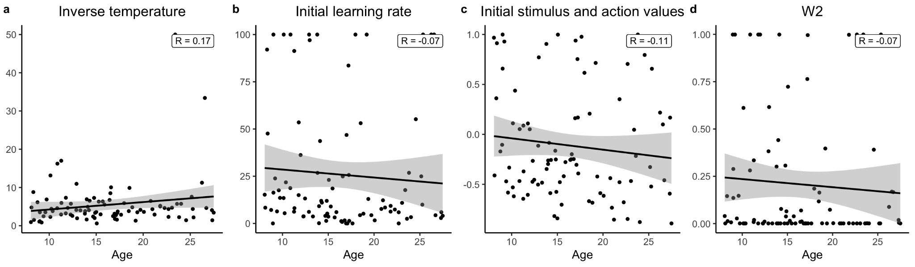

Supplemental Figure S4. Relation between age and model parameters. (a) inverse temperature. (b) Initial learning rate. (c) Initial stimulus and action values. (d) second-stage initial Pavlovian weight. Model-derived parameter estimates showed no evidence of age-related change. The relationship between age and each of the four-parameter estimates was best characterized by a linear function. Shaded error bars represent a .95 confidence interval.

Dorfman HM, Gershman SJ. 2019. Controllability governs the balance between Pavlovian and instrumental action selection. Nat Commun 10: 5826.

