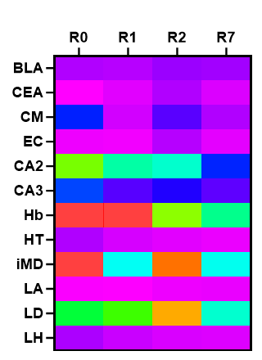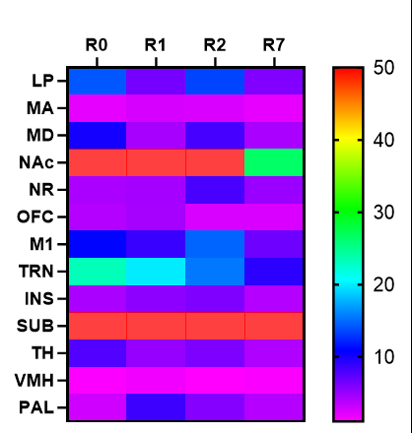
Supplementary Figure 1: cFos counts across cue discrimination learning for brain structures with nonsignificant differences across learning. cFos counts (cells/mm^2), normalized by area, for 25 additional key brain areas selected from literature pertaining to some aspect of learning and memory that did not significantly differ between R1, R2, and R7. Color-coded scale represents fold increases in the cFos density compared to Ctx.

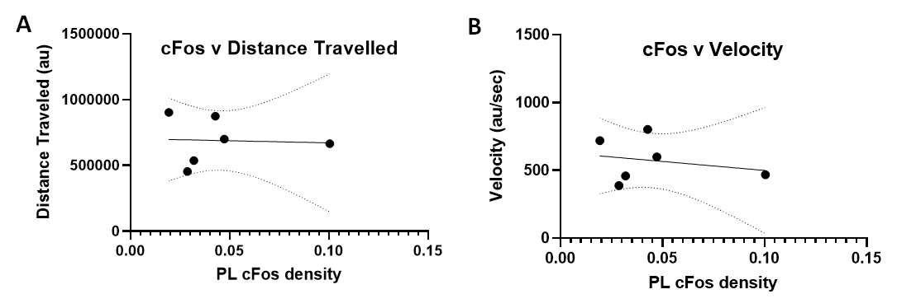
Supplementary Figure 2: cFos is unaffected by velocity or distance traveled. A random sample of videos was taken from the whole brain experiments and the distance traveled and velocity was assessed using a model trained by Deep Lab Cut (Mathis 2018). Both the distance traveled (A, R^2 = 0.002679 and p = 0.92) and velocity (B, R^2 = 0.05549, p = 0.65) seem to have no correlation with cFos density, suggesting that these metrics are not the ones driving cFos expression.

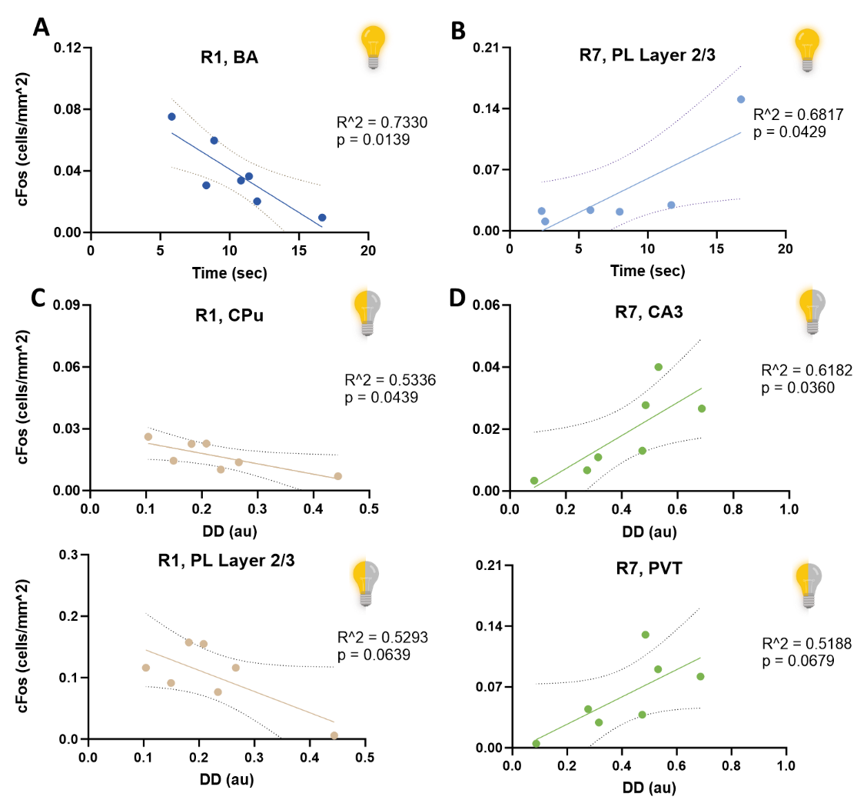
Supplementary Figure 3: Simple linear regressions were performed, analyzing the associations between the cFos activity in certain brain areas with either poking behavior during the light-on condition or discrimination difference scores. 3A: The activity of the BA has a strong negative association with reward seeking behavior during the cue (p=0.0139). 3B: For light-on behavior during R7, layer 2/3 of the PL exhibits a strong positive correlation with poking behavior (p = 0.0429). 3C: The activity of two areas, the CPu and PL layer 2/3, exhibited a moderate negative correlation with the discrimination difference during R1 (p= 0.0439 and 0.0639 respectively). 3D: cFos levels in CA3 and PVT had a positive correlation with discrimination difference in R7 (p=0.0360 and 0.0679 respectively). Linear regressions plotted with a 95% CI.
References:
Mathis A., Mamidanna P., Cury K.M., Abe T., Murthy V.N., Mathis M.W., & Bethge M. (2018). DeepLabCut: markerless pose estimation of user-defined body parts with deep learning. Nat Neurosci.

