Hippocampal motor memory network reorganization depends on familiarity, not time

D. Gregory Sullens¹, Phuoc Nguyen^{1,3}, Kayla Gilley^{1,4}, Madison B. Wiffler ^{2,5}, Melanie J. Sekeres*^{1,6}
¹Department of Psychology and Neuroscience; ²Department of Biology, Baylor University, Waco, Texas, 76798, USA; ³Program in Neuroscience, University of Maryland, Baltimore, Maryland, 21201,⁴Department of Biology & Chemistry, Liberty University, Lynchburg, Virginia, 24515, ⁵Department of Neurobiology, University of Utah, Salt Lake City, Utah, 84112; ⁶ School of Psychology, University of Ottawa, Ottawa, Ontario, K1N 6N5, Canada

*Corresponding author email (msekeres@uottawa.ca)
Address: School of Psychology, University of Ottawa, Vanier Hall, 136 Jean-Jacques Lussier, Ottawa, Ontario, Canada, K1N 6N5. Phone: 1-613-562-5800, x:4687

Supplemental Materials and Methods
Subjects
Male F1 hybrid C57BL/6J (Jackson Labs) x 129S6/SvEvTac (Taconic) served as subjects. Mice were bred in the mouse vivarium at Baylor University. Post-weaning, mice were group-housed (3-5 per cage) in standard shoebox cages with bedding and nesting materials, located in ventilated racks in the rodent vivarium. Throughout the study, mice had ad libitum access to food and water, and were maintained on a standard 12hr light-dark cycle (lights on 600hr – 1800hr). All behavioural tests were conducted between 900hr – 1700hr. At 2 months of age, home cages of mice were randomly divided into one of four conditions: recent (1d train, n=17), remote (1d train/2d-19d rest/20d test, n=16), remote continuous training (1-19d train/20d test, n=16, or home cage control (HC, n=8) conditions. See Figure 1A for a schematic of the study design. All procedures were approved by Baylor University’s Institutional Care and Use Committee and conducted in accordance with the Guide for the Care and Use of Laboratory Animals from the National Institutes of Health.

Behavioral Apparatus – Straight Alley Maze Task (SAM)
The white Plexiglas SAM apparatus, constructed in the Baylor University machine shop, consisted of a single lane (52 cm long × 10 cm wide × 30 cm high). The SAM was placed in a black circular plastic pool (68 cm diameter), filled to a depth of 25 cm with water (~26º C) made opaque by the addition of nontoxic white acrylic paint. The testing apparatus was surrounded by a black curtain to obscure spatial cues. A circular escape platform (10 cm diameter) was placed at one end of the SAM, submerged 0.5cm beneath the surface of the water.

Behavioral Training/Testing
Mice were handled individually by an experimenter for 5 min/day for 5 days prior to beginning behavioural training. Each day, mice were transferred to the behavioral testing room and given 30 min to acclimate prior to beginning training on the motor task. All behavioural training/testing was conducted by a single experimenter (DGS). Mice in all conditions (except the HC control condition) performed 5 non-consecutive SAM trials per training day, with an inter-trial interval of 5 min. For each trial, mice were individually placed in the water at the vacant end of the SAM, opposite the submerged platform. The mouse was given up to 60 sec to swim towards the cued escape platform. The trial ended when the mouse successfully mounted the escape platform with all four paws. The mouse was given 30 sec to rest atop the platform prior to being gently dried with a towel, then placed in a heated holding cage to await the next trial. If the mouse did not mount the escape platform within 60 sec, it was guided to the platform by the experimenter, and given 30 sec to rest atop the platform prior to being returned to the holding cage. Mice were returned to their home cage after completing the 5th daily training trial. One the final training/test day, mice were individually placed in a holding cage immediately following the final trial, and placed in a dark, quiet room for 90 min, followed by sacrifice and perfusion. Escape latencies during the SAM task were manually recorded using a digital stopwatch. Motor activity was recorded by an overhead digital video camera, and activity levels (distance travelled, cm; speed, cm/sec) were analyzed using the Noldus Ethovision (V4.0) software (Noldus (RRID:SCR_004074). For the remote and continuous groups, a learning index (LI) was calculated for each behavioural measure, where day 1 values were subtracted from the day 20 values to generate a measure of behavioural change over time (Badreddine et al., 2022).

Sacrifice and Perfusion
Immediately following the final training trial, mice were placed in individual holding cages in a dark room. Ninety minutes following the last training trial mice were anaesthetize using a mixture of oxygen and 5% isoflurane. When non-responsive to tail pinch, toe pinch, and eye blink, the mouse was transcardially perfused using a peristaltic pump with a 1 x PBS solution followed by a 4% paraformaldehyde-PBS solution (PFA) to fix the tissue. The brain was then extracted from the skull and left in the 4% PFA solution at 4°C for 48 hr, then was switched to a 0.02% sodium azide-PBS solution (NaN₃) until tissue was sliced. Tissue was sliced to coronally at 30µm with a vibratome (Leica, VT1000 S), and stored with five serial sections per well.

Immunohistochemistry
Ten sections per brain ranging between 2.22 mm anterior to -3.52 mm posterior (A/P) from bregma were selected using a systematic random sampling procedure (Sekeres et al., 2018, 2020). For each brain, one section per well was randomly sampled across the A/P range. Sections were incubated for 2hr at room temperature (RT) in 10% normal goat serum and blocking solution (PBS and 0.3% Triton X-100), then incubated with rabbit anti-c-Fos polyclonal primary antibody (1:1000, PBS and 0.3% Triton X-100, Abcam, ab190289) at 4°C for 48hr. Sections were washed 4 x 10 min in PBS, then incubated with goat-anti-rabbit Alexa 488 secondary antibody (1:200, Invitrogen, A-11034) for 2hr at RT. Sections were then washed with PBS and then mounted with PermaFluor mounting medium (Thermo Scientific, Fremont, CA) on glass slides, and cover slipped.

Cell Quantification
Stained sections were imaged and analyzed using a Nikon Eclipse-NI-E fluorescent microscope at 10x magnification with an exposure of 800ms with a standardized contrast parameter applied to all images. A series of large scan images were acquired and digitally stitched together for using NIS-Elements software (Nikon, version 4.1.3) to reconstruct each region of interest (ROI) (hippocampus, aCC, striatum, motor cortex). Regions were defined based on the stereotaxic mouse brain atlas (Paxinos & Franklin, 2019) Within each section, ROIs were digitally outlined and measured to determine the area. c-Fos positive nuclei within each ROI were manually counted using Image J (RRID: SCR_003070) by a single researcher blind to the subject’s experimental condition. The total number of c-Fos positive cells per ROI was divided by the outlined area to generate a normalized cells/area value. At least 4 sections per ROI were used to generate the mean value for each ROI per brain, and group means were then calculated for each condition. One brain from the HC control condition was omitted due to poor staining cause by poor tissue fixation. Two brains from the recent group continuous group did not include hippocampal sections due to poor integrity of the mounted sections.

Statistical Analyses
Univariate ANOVAs were conducted for SAM behaviour (mean escape latency, LI, speed, distance travelled, speed), and c-Fos cell quantification analyses in each ROI (CA1, DG, aCC, M1, M2, striatum), and effect size (partial eta²) are reported. Independent-samples t-tests (2-tailed) were used when only two experimental conditions were available (i.e., remote vs. continuous behavioural analyses on day 20). All histological and behavioral statistical analyses were conducted using SPSS 26 (RRID: SCR_002865) by an experimenter blind to experimental condition. Effects were considered significant at p<.05. Figures depicting ± standard error of the mean (SEM), as well as all individual subject’s data points.

Supplemental Results

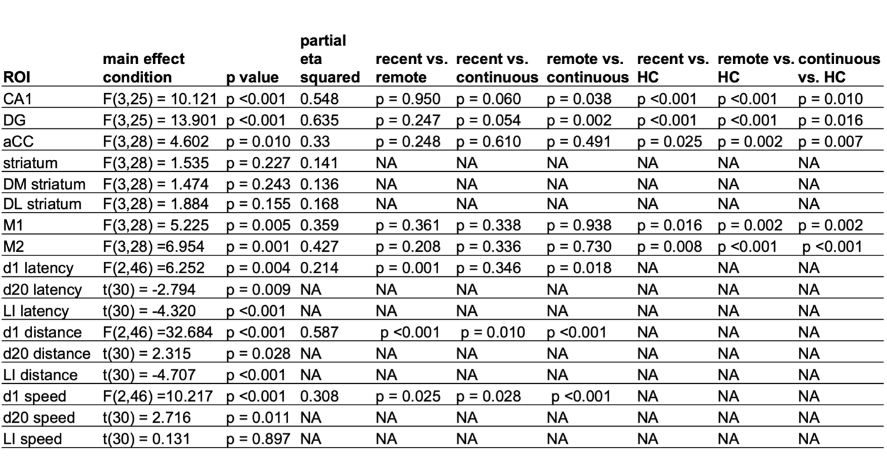

Table S1. Complete ANOVA and LSD post-hoc and t-test results
Univariate ANOVA and LSD post-hoc and t-test results for distance travelled (cm) and speed (cm/sec) in the SAM during the first training day (d1) and the last training/test day (d20). Complete ANOVA and t-test results, including non-significant effects, reported in the main manuscript are reported here. Post-hoc analyses were not conducted for the striatum due to a non-significant main effect of training condition. Abbreviations: DG: dentate gyrus; aCC: anterior cingulate cortex; DM: dorso-medial; DL: dorso-lateral; M1: motor cortex 1; M2: motor cortex 2; d1: training day 1; d20: training day 20; LI: Learning Index; HC: home cage control.

A
B
C

Figure S1. (A) Mean distance travelled (cm) (left) and learning index (LI) (right) between the first training day (d1) and the last training/test day (d20) in the SAM. (B) Mean speed (cm/sec) (left) and LI (right) between the d1 and d20 in the SAM. The LI was calculated by subtracting day 1 values from day 20 values to generate a measure of motor learning over time. Bars represent the group mean and error bars represent the standard error of the mean (SEM). (C) Mean escape latency (sec) for the complete 20d training for mice in the continuous training condition.

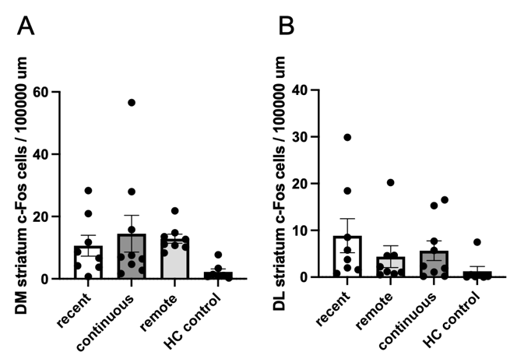
Figure S2. No differences in c-Fos expression were observed between training conditions in the (A) dorsomedial (DM) or (B) dorsolateral (DL) striatum. Bars represent the group mean and error bars represent the standard error of the mean (SEM). Individual data points are presented for each subject within each condition. Bars represent the group mean and error bars represent the standard error of the mean (SEM).

References
Badreddine, N., Zalcman, G., Appaix, F., Becq, G., Tremblay, N., Saudou, F., ... & Fino, E. (2022). Spatiotemporal reorganization of corticostriatal networks encodes motor skill learning. Cell Reports, 39(1), 110623.

Paxinos, G., & Franklin, K. B. (2019). Paxinos and Franklin's the mouse brain in stereotaxic coordinates. Academic press.

Sekeres, M.J., Moscovitch, M., Grady, C.A., Sullens, D.G., Winocur, G. (2020). Reminders reinstate context-specificity to generalized remote memories in rats: Relation to activity in the hippocampus and aCC. Learning & Memory 27(1), 1-5.

Sekeres, M.J., Winocur, G., Moscovitch, M. (2018). The hippocampus and related neocortical structures in memory transformation. Neuroscience Letters, 680, 39-53.

