Parsing Memory and Non-Memory Contributions to Age-Related Declines in Mnemonic Discrimination Performance: A Hierarchical Bayesian Diffusion Decision Modeling Approach
Chwiesko et al.

SUPPLEMENTARY MATERIALS

Model | Model structure | DIC
Model 0 | ⍺ (g), β (g), 𝜏 (g), 𝛿 (g, c) | 10688.25
Model 1 | ⍺ (g), β (g), 𝜏 (g), 𝛿 (g, c, s) | 9567.33
Model 2 | ⍺ (g), β (g), 𝜏 (g, s), 𝛿 (g, c, s) | 6573.04
Model 3 | ⍺ (g), β (g, s), 𝜏 (g, s), 𝛿 (g, c, s) | 6496.65
Model 4 | ⍺ (g, s), β (g, s), 𝜏 (g, s), 𝛿 (g, c, s) | 6390.63
Model 5 | ⍺ (g, s), β (g, s), 𝜏 (g, s, t), 𝛿 (g, c, s) | 2553.64
Model 6 | ⍺ (g, s), β (g, s, t), 𝜏 (g, s, t), 𝛿 (g, c, s) | 2344.74
Model 7 (Full model) | ⍺ (g, s), β (g, s, t), 𝜏 (g, s, t), 𝛿 (g, c, s, t) | 438.61

Supplementary Table S1. Models of different complexity (number of hierarchical levels (g: Group, c: Condition, s: Subject, t: Trial) and permitted variation of model parameters (⍺: Boundary separation, β: Response Bias, 𝜏: Non-decision time, 𝛿: drift-rate) across these levels) that were fitted to the data and their Deviance Information Criterions (DICs). Based on the lowest DIC, Model 7 was chosen for analysis.

Supplementary Table S2. Estimated group means for Diffusion Decision Model Parameters based on our Hierarchical Bayesian model (Full model) using Markov-chain Monte Carlo (MCMC), and two standard fitting methods -the publicly available fast-dm package (outliers removed) and the two chi-square fitting method. Group differences in Model parameters are evaluated based on the Bayes factor (Savage-Dickey Density ratio) for our Full Model, and t-test for independent groups for the latter two fitting methods. The last two columns list the p-values for the t-tests. The group differences in the non-decision time (τ), and the drift rate parameter for the two lure conditions (δ (HighSim) and (δ (LowSim)) that we found evidence for in our Hierarchical Bayesian model, were also found using the fast-dm and the two chi-square fitting methods. However, note that the exact values of the group mean estimates differ across the three fitting methods. For a discussion and analysis of the two standard fitting methods mentioned here, and others, including a Hierarchical Bayesian method, and how they compare in their performance of recovering model parameters see Ratcliff and Childers (2015). This work showed that for a small number of 40 observations per condition, the Hierarchical Bayesian method provided superior parameter recovery in contrast to the standard two chi-square method. The authors concluded that a Hierarchical Bayesian model approach is the method of choice when the number of observations is small.

a. b.
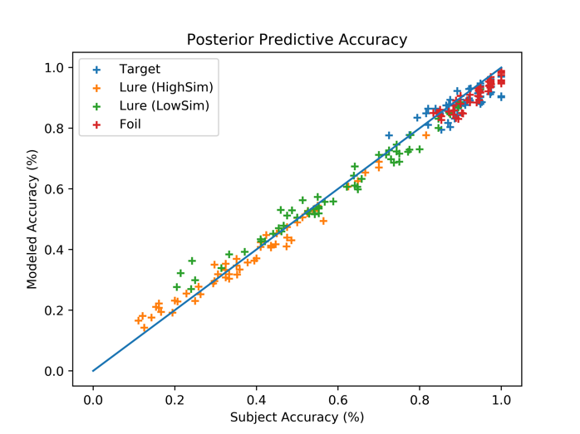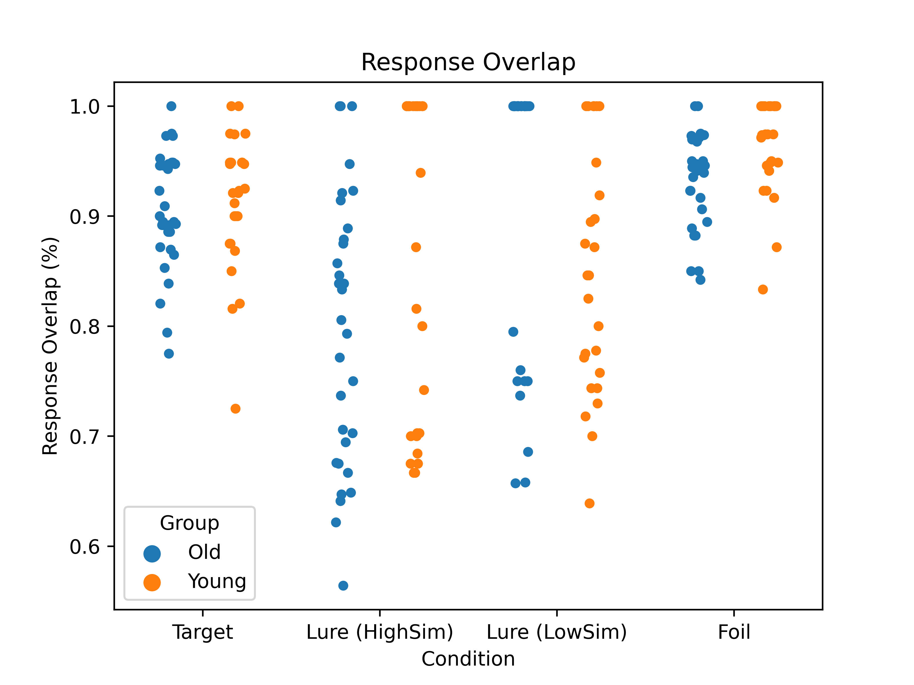

Supplementary Figure S1. Quality check of model performance. (a) The modeled and observed accuracy for the Reduced Model. The modeled accuracy data fit the observed accuracy data well. Each cross represents the accuracy of one participant averaged across all trials within each condition. (b) Overlap between the modeled and observed response type (“Old”/ “New”). Individual data points represent the percentage of agreement in response type between the observed and modeled dataset for each participant and condition.

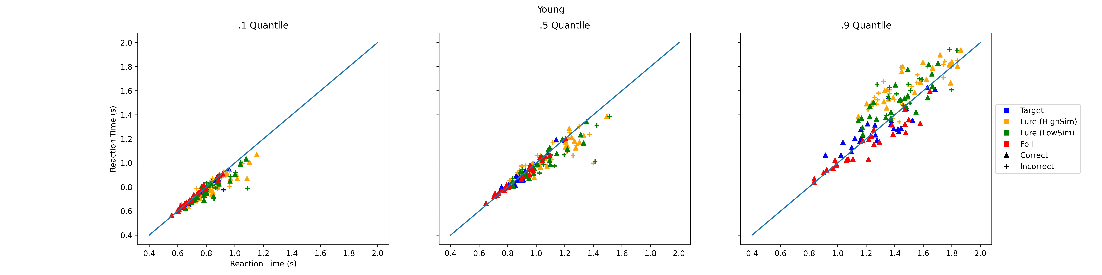

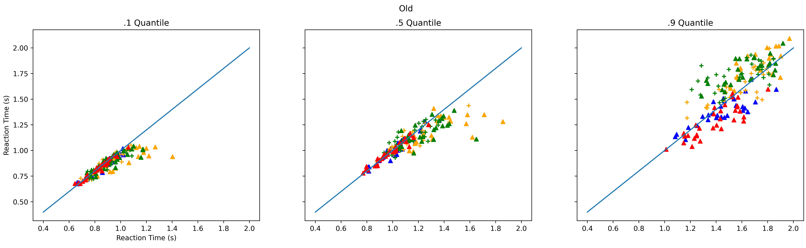

Supplementary Figure S2. Quality check of model performance. Overlap between the modeled and observed 0.1, 0.5, and 0.9 quantiles of the modeled and observed reaction time distributions for the Reduced Model. Each data point represents the RT of one participant per condition and response type (“Old”/ ”New”).

- b.
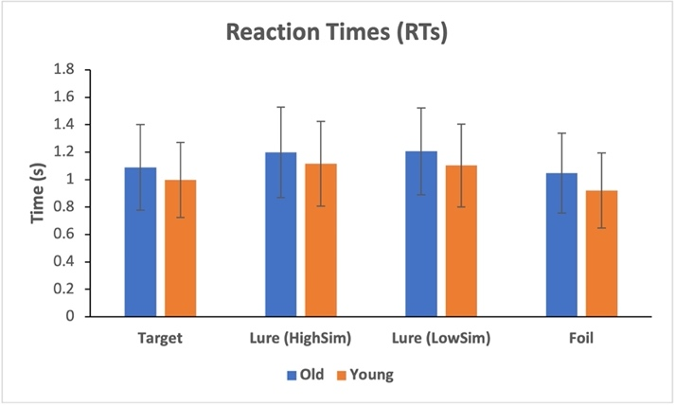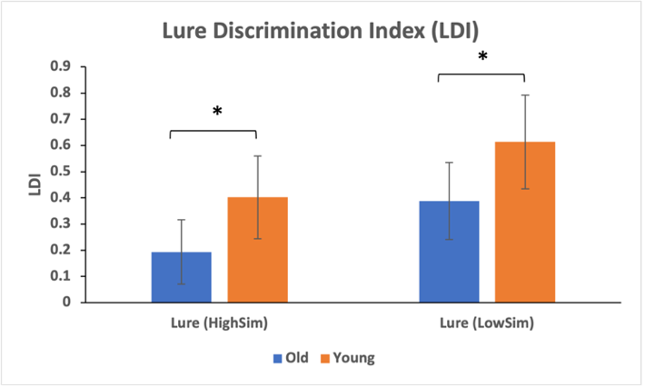

Supplementary Figure S3. (a) Reaction Times for the younger and older adults group and each task condition. Error bars show the standard deviation. (b). Lure Discrimination Index for younger and older adults for the two lure conditions. The LDI assesses lure discrimination performance by calculating the difference between the probability of giving a “similar” response to the lure items minus the probability of giving a “similar” response to the foils. Groups were compared using an independent t-test. * p<0.0001

