Table S1. Sample demographics and questionnaire assessments
 | Sleep |  | Wake |  | stat | sig
 | M / % | SD | M / % | SD
Age (years) | 19 | 1.2 | 19 | 1.02 | 1.08 | .28
Sex
Female | 65 |  | 69 |  | 0.02 | .88
Male | 35 |  | 31 |  | 0.02 | .88
Ethnicity
Hispanic or Latino | 22 |  | 13 |  | 0.37 | .54
Not Hispanic or Latino | 78 |  | 87 |  | 0.37 | .54
Race
American Indian or Alaska Native | 0 |  | 0 |  | 3.74 | .44
Asian | 13 |  | 6 |  | 3.74 | .44
Black or African American | 3 |  | 10 |  | 3.74 | .44
Native Hawaiian or Pacific Islander | 3 |  | 0 |  | 3.74 | .44
White | 78 |  | 74 |  | 3.74 | .44
Not listed | 3 |  | 10 |  | 3.74 | .44
Diurnal preference¹ | 2.85 | 0.87 | 2.58 | 0.92 | 1.19 | .24
Evening preference | 67% |  | 61% |  | 0.04 | .85
Preference preference | 33% |  | 39% |  | 0.04 | .85
Session 1 subjective alertness² | 2.60 | 1.04 | 2.60 | 0.99 | 0.002 | .99
Session 2 subjective alertness | 2.85 | 1.12 | 2.37 | 1.43 | 1.75 | .084
Vividness of visual imagery³ | 56.74 | 12.03 | 59.55 | 8.95 | 1.15 | .25
Baseline nights⁴
Bed time | 00:42 | 01:02 | 00:30 | 01:08 | 0.64 | .53
Rise time | 08:46 | 01:07 | 08:38 | 01:05 | 0.23 | .82
Total sleep time (mins) | 483.13 | 44.91 | 487.74 | 60.00 | 0.50 | .62
Consolidation night⁵
Bed time | 00:45 | 01:24
Rise time | 08:37 | 11:05
Total sleep time (mins) | 471.91 | 74.79
Note. Sex, Ethnicity, and Race expressed as percentage of the sample and group differences were assessed by chi-square. All other variables shown as the mean and standard deviation, with group differences assessed by t-tests. ¹ A larger number indicates a greater evening preference (theoretical range 1 - 4). Evening preference = % of participants responding 3 or 4 to diurnal preference question. Morning preference = % of participants responding 1 or 2 to diurnal preference question. ² Subjective alertness assessed by the Stanford sleepiness scale. A larger number indicates feeling more sleepy/less alert (theoretical range 1 - 7). ³ A larger number indicates more vivid visual imagery (theoretical range 16 - 80). ⁴ Baseline nights refer to the average of the three nights prior to starting the experiment. ⁵ Consolidation night refers to the night between session 1 and session 2 in the sleep group.

Table S2. Memory scores including all participants
 | Sleep |  | Wake
 | M | SD | M | SD
Immediate recall
Integrative | .58 | .24 | .59 | .24
Non-integrative | .22 | .18 | .22 | .20
Delayed recall
Integrative | .53 | .23 | .44 | .21
Non-integrative | .20 | .18 | .17 | .18
Change in recall
Integrative | -.05 | .12 | -.16 | .13
Non-integrative | -.01 | 10 | -.04 | -.06
Note. M = Mean, SD = Standard deviation. Immediate and delayed recall expressed as proportion of correctly recalled trials. Change in recall calculated as delayed - immediate recall.

Table S3. Memory scores for low imageability trials
 | Sleep |  | Wake
 | M | SD | M | SD
Immediate recall
Integrative | .45 | .24 | .46 | .24
Non-integrative | .06 | .13 | .09 | .15
Delayed recall
Integrative | .41 | .23 | .31 | .20
Non-integrative | .05 | .13 | .07 | .15
Change in recall
Integrative | -.04 | .15 | -.15 | .16
Non-integrative | -.01 | .06 | -.02 | .08
Note. M = Mean, SD = Standard deviation. Immediate and delayed recall expressed as proportion of correctly recalled trials. Change in recall calculated as delayed - immediate recall.

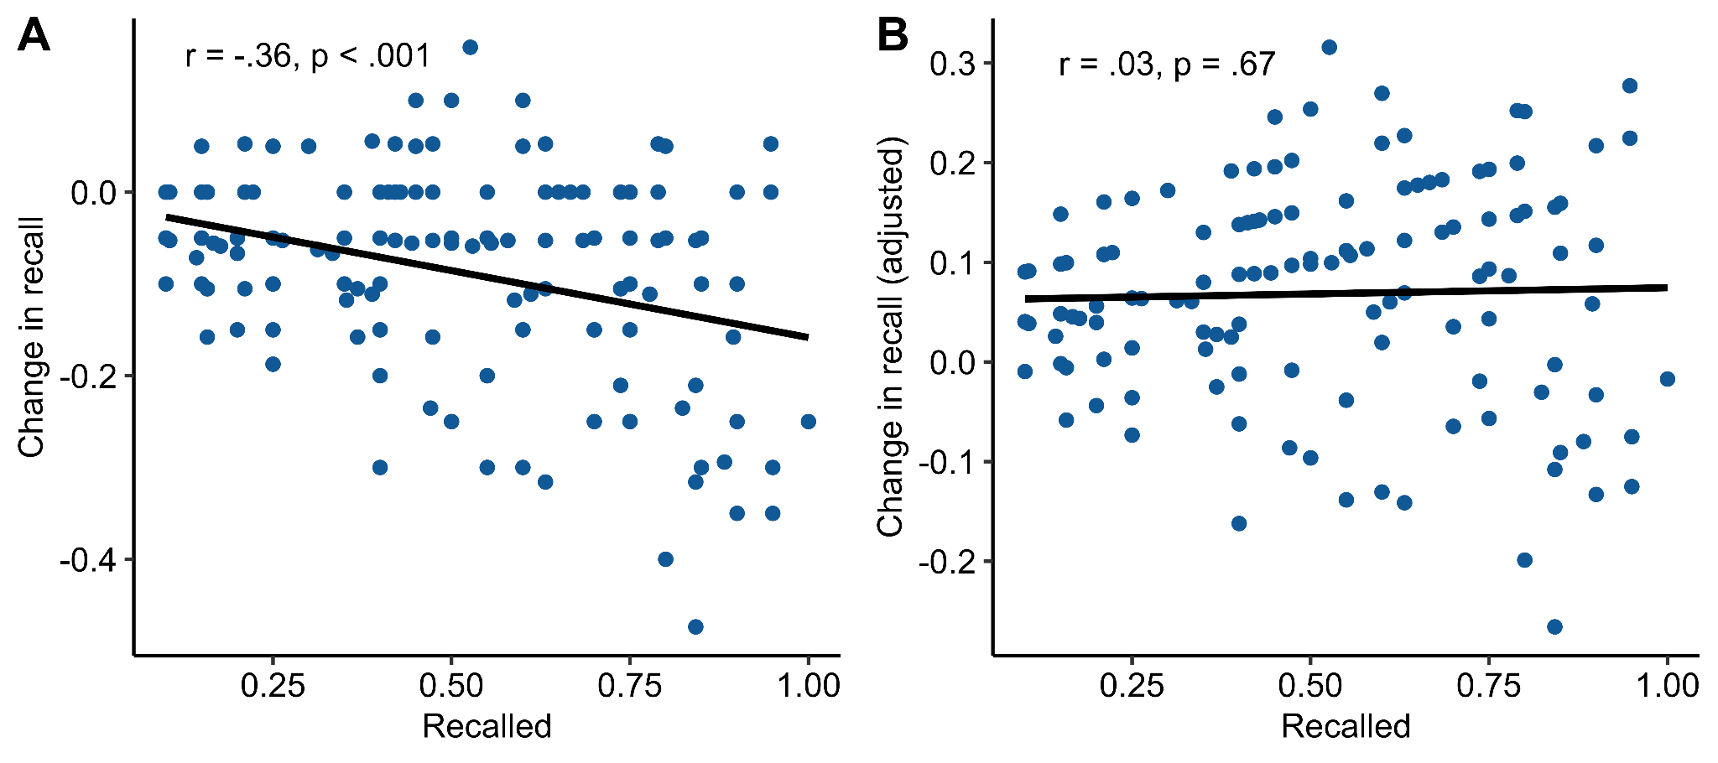
Figure S1. Adjusted change in recall score. A - Immediate recall accuracy significantly predicts the unadjusted change in recall score. B - Adjusted change in recall after regressing out immediate recall accuracy. This adjusted score is no longer associated with immediate performance.

