Supplementary Material
Sensitivity and power analyses were conducted in R using the packages simr v.1.0.5 (Green & MacLeod, 2016) and lme4 v.1.1.27.1 (Bates et al., 2015). For the sensitivity analyses, mixed effects models fit in lme4 were passed to the simr function powerSim, with the effect size for the fixed effect of interest iteratively adjusted downward until power dropped to, without falling below, the desired level of 80%. For the post-hoc power curves, mixed effects models with the observed effect sizes were passed to the simr function powerCurve, with power evaluated for 5 different sample sizes (evenly spaced from 15-75 for Experiments 1 and 2, and from 20 to 68 for Experiment 3). Alpha was set to 0.05 and simulations to 500 for each result. The figures of the power curves are displayed for each experiment below.
Figure S1
Power Curve for Experiment 1
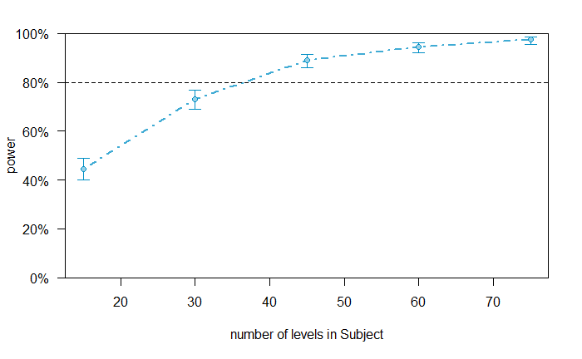
Note. Power to detect a difference in final List 1 recall depending on List 2 recall for items recalled in the interpolated phase in the A-B, A-C condition including testing without feedback, with an effect size of odds ratio (OR) = 3.43. Sample sizes evaluated for N = 15-75. Power = 80% at approximately N = 40.

Figure S2
Power Curve for Experiment 2
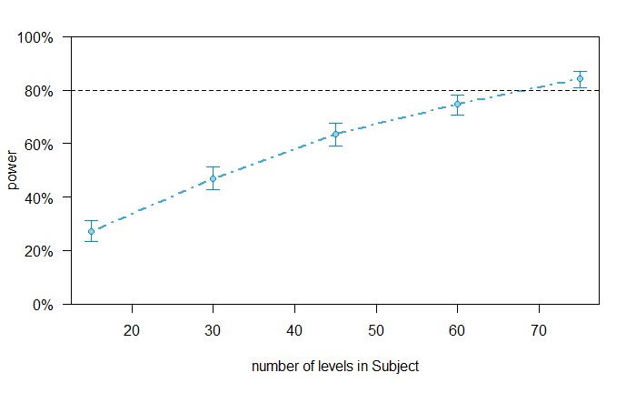
Note. Power to detect a difference in final List 1 recall depending on List 2 recall for items recalled in the interpolated phase in the A-B, A-C condition including testing without feedback, with an effect size of odds ratio (OR) = 4.45. Sample sizes evaluated for N = 15-75. Power = 80% at approximately N = 70.

Figure S3
Power Curve for Experiment 3
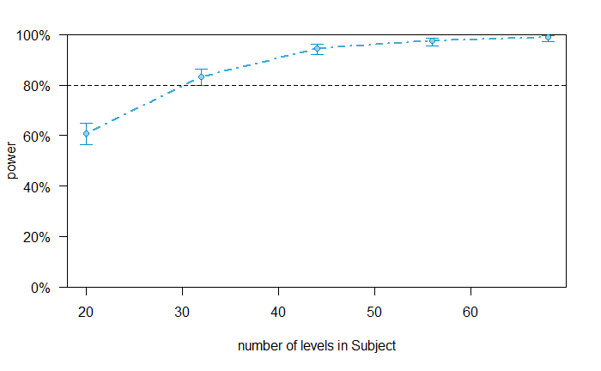
Note. Power to detect a difference in final List 1 recall depending on List 2 recall for items recalled in the interpolated phase in the A-B, A-C condition including testing without feedback, with an effect size of odds ratio (OR) = 5.51. Sample sizes evaluated for N = 12-68. Power = 80% at approximately N = 32.
References
Bates, D., Mächler, M., Bolker, B., & Walker, S. (2015). Fitting linear mixed-effects models using lme4. Journal of Statistical Software, 67, 1-48.
Green, P., & MacLeod, C. J. simr: an R package for power analysis of generalized linear mixed models by simulation. Methods in Ecology and Evolution, 7(4), 493-498.

