- Experiment 1
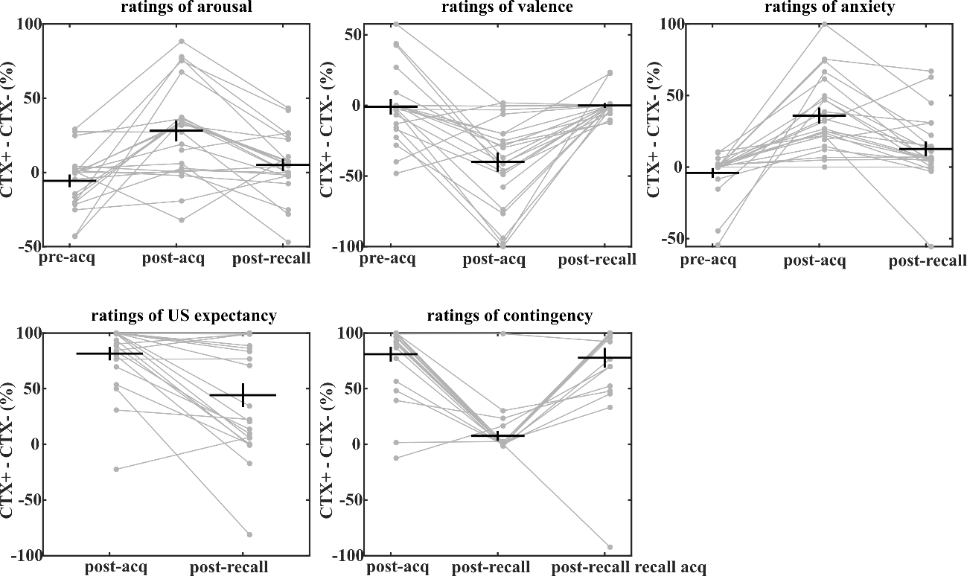

- Experiment 2
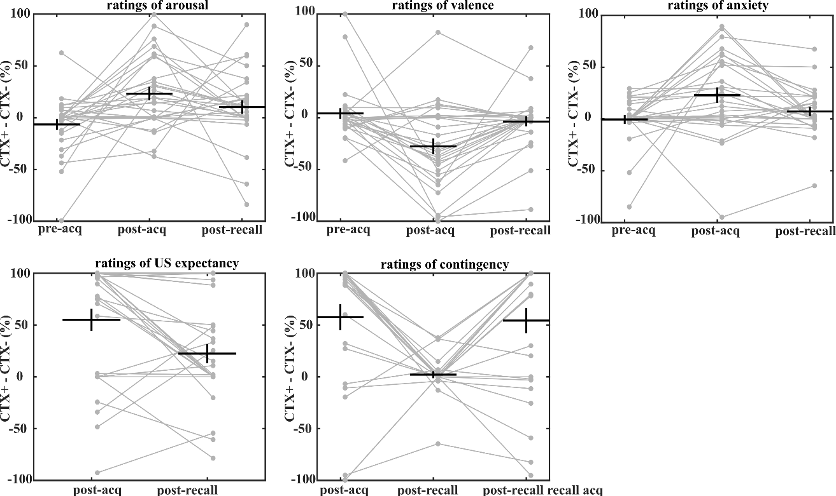

Figure S1. Subjective ratings in experiment 1 (A) and 2 (B). Individual data is plotted in grey and group data is plotted in black as group mean ± SEM.

- Experiment 3 acquisition training
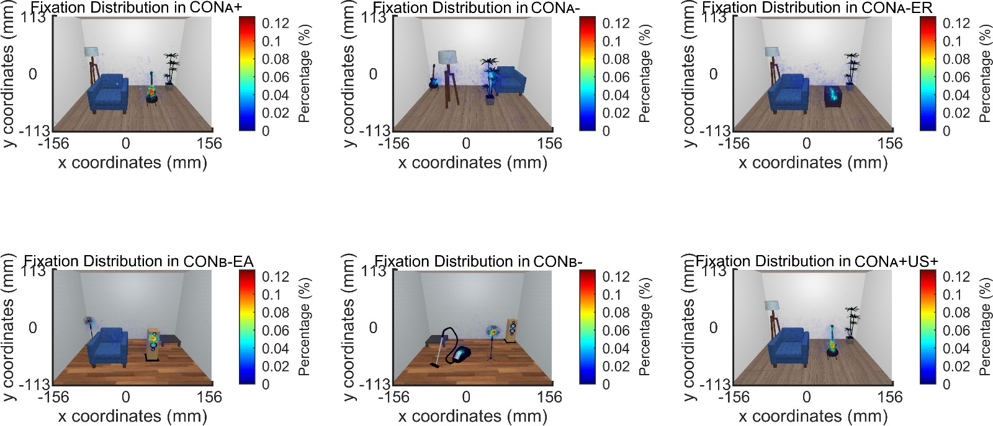

- Experiment 3 recall test
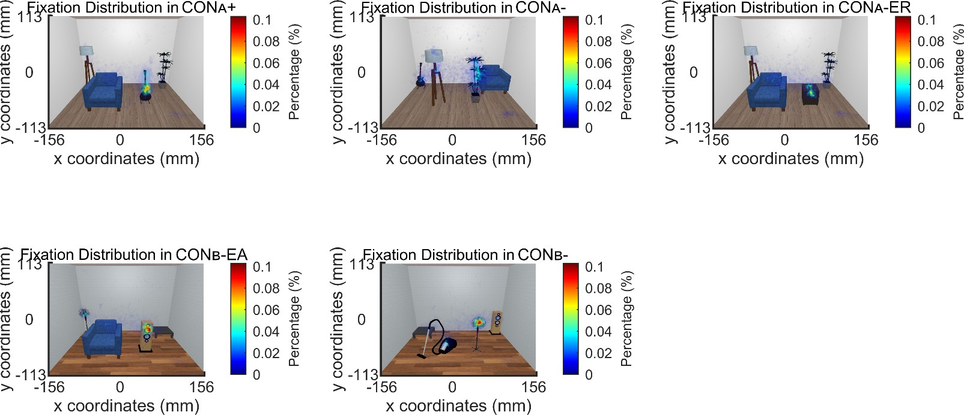

Figure S2. Fixation distribution in experiment 3. (A) During memory acquisition. (B) During memory recall. Gaze coordinates are plotted in a scale of the presentation screen.

- Experiment 4 acquisition training
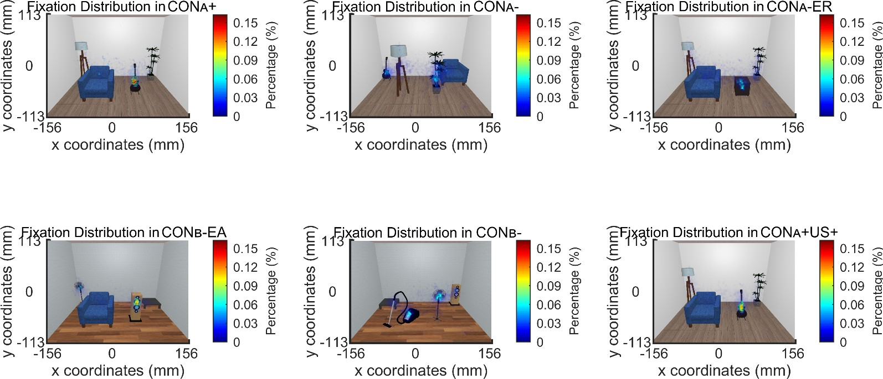

- Experiment 4 recall test
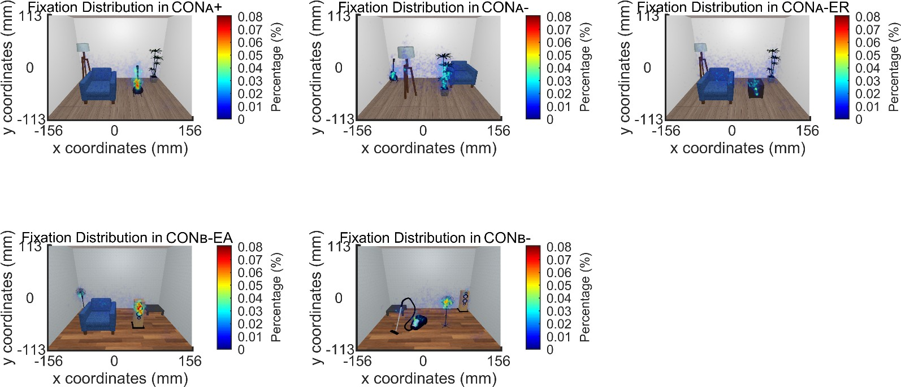

Figure S3. Fixation distribution in experiment 4. (A) During memory acquisition. (B) During memory recall. Gaze coordinates are plotted in a scale of the presentation screen.

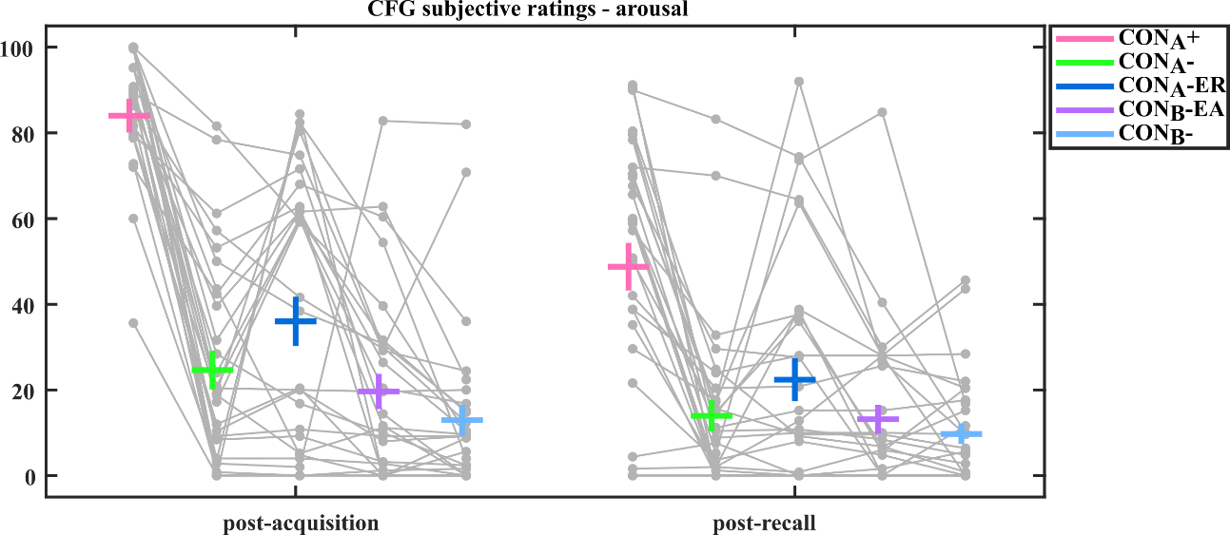

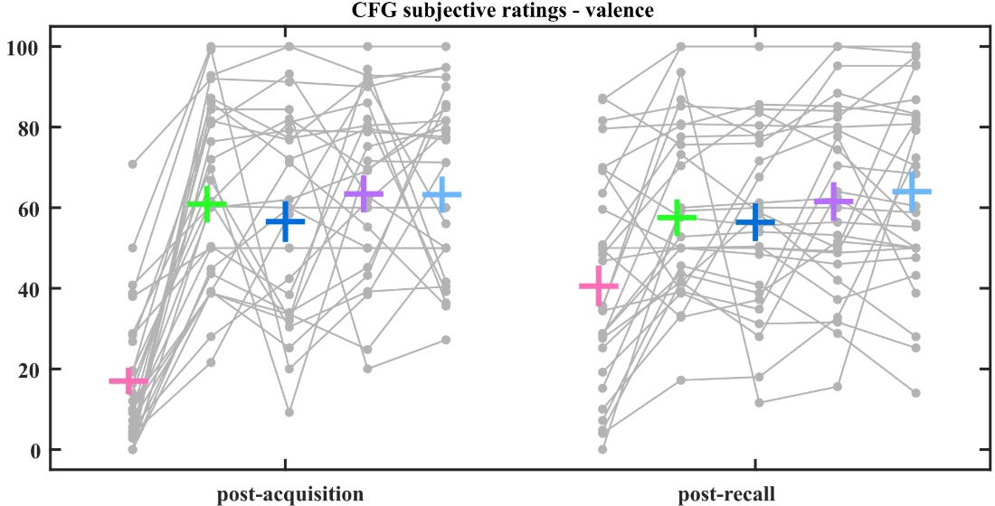

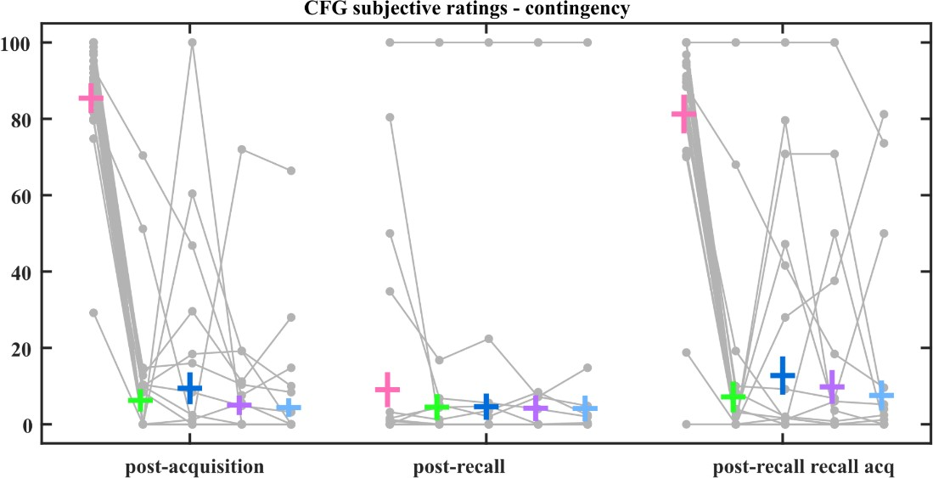

Figure S4. Subjective ratings in experiment 3. Individual data is plotted in grey and group data is plotted in corresponding colors as group mean ± SEM.

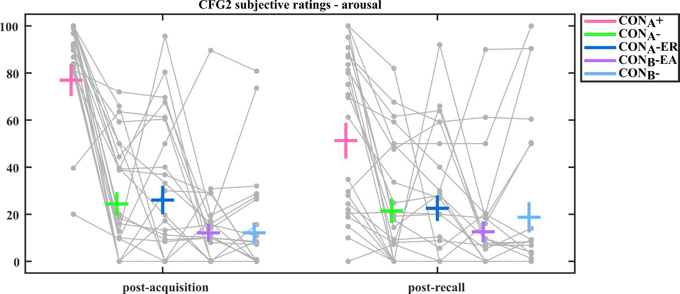

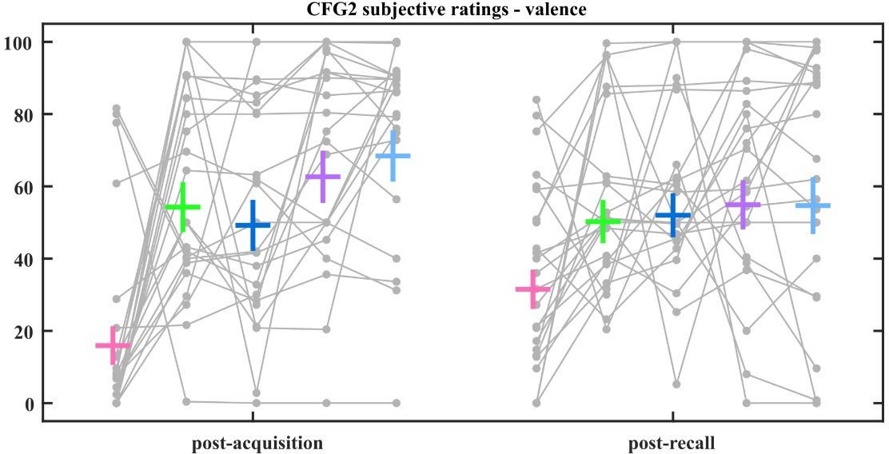

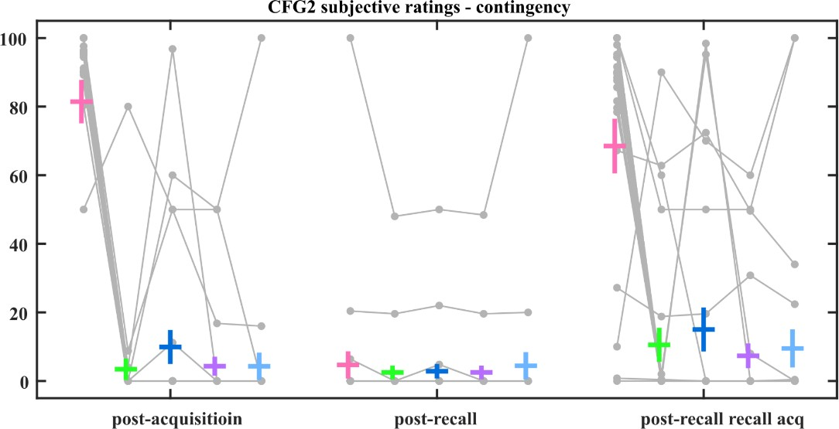

Figure S5. Subjective ratings in experiment 4. Individual data is plotted in grey and group data is plotted in corresponding colors as group mean ± SEM.

- Experiment 3
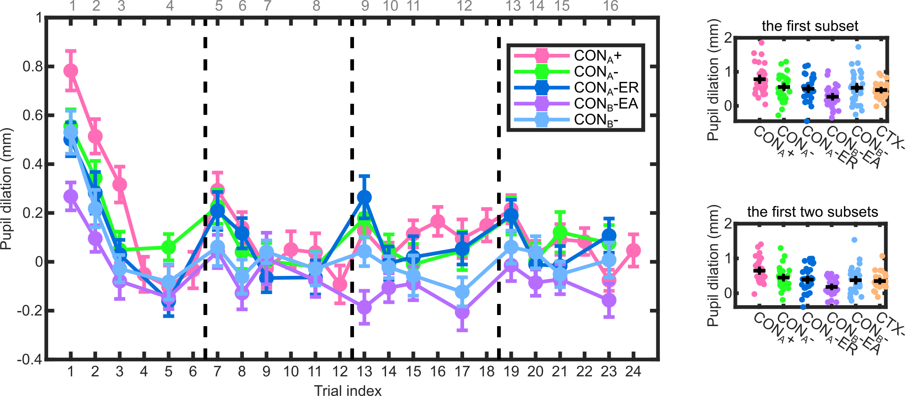

- Experiment 4
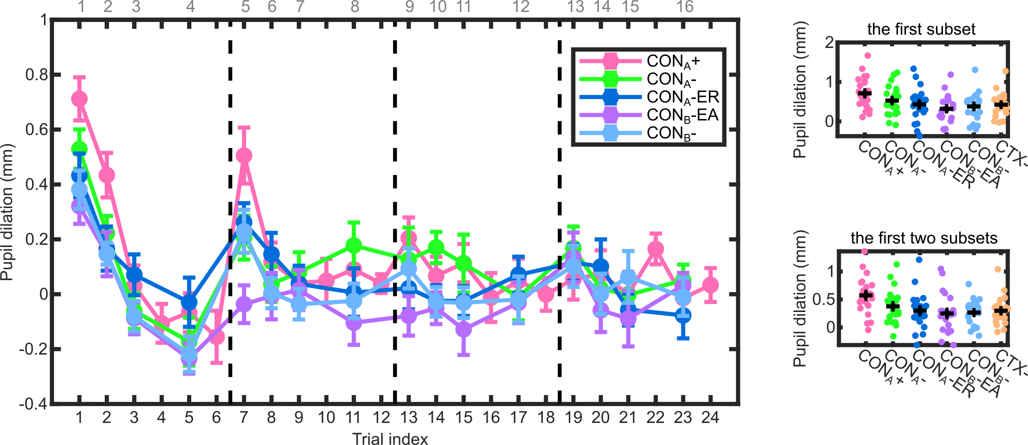
Figure S6. Pupil dilation during memory recall in experiment 3 (A) and 4 (B). Trial-wise pupil dilation is plotted on left with dashed black lines separating blocks. X axis on the top represents trial index of CTX- conditions. The average over the first one and the first two subsets are plotted on right. LME analysis suggests a trial effect on pupil dilation, and larger pupil dilation in CONA+ than in CONB- and in CONB-EA in both experiments; explorative paired t-test on average of the first N subsets supports LME results. Paired t-test also shows notable difference between CONA+ and CONA- and between CONA+ and CONA-ER in the first and the second subsets. Group data is plotted in corresponding colors as group mean ± SEM. Individual data is plotted in colored dots. “CTX-” represents data averaged over all four CTX- conditions.

  - Experiment 3
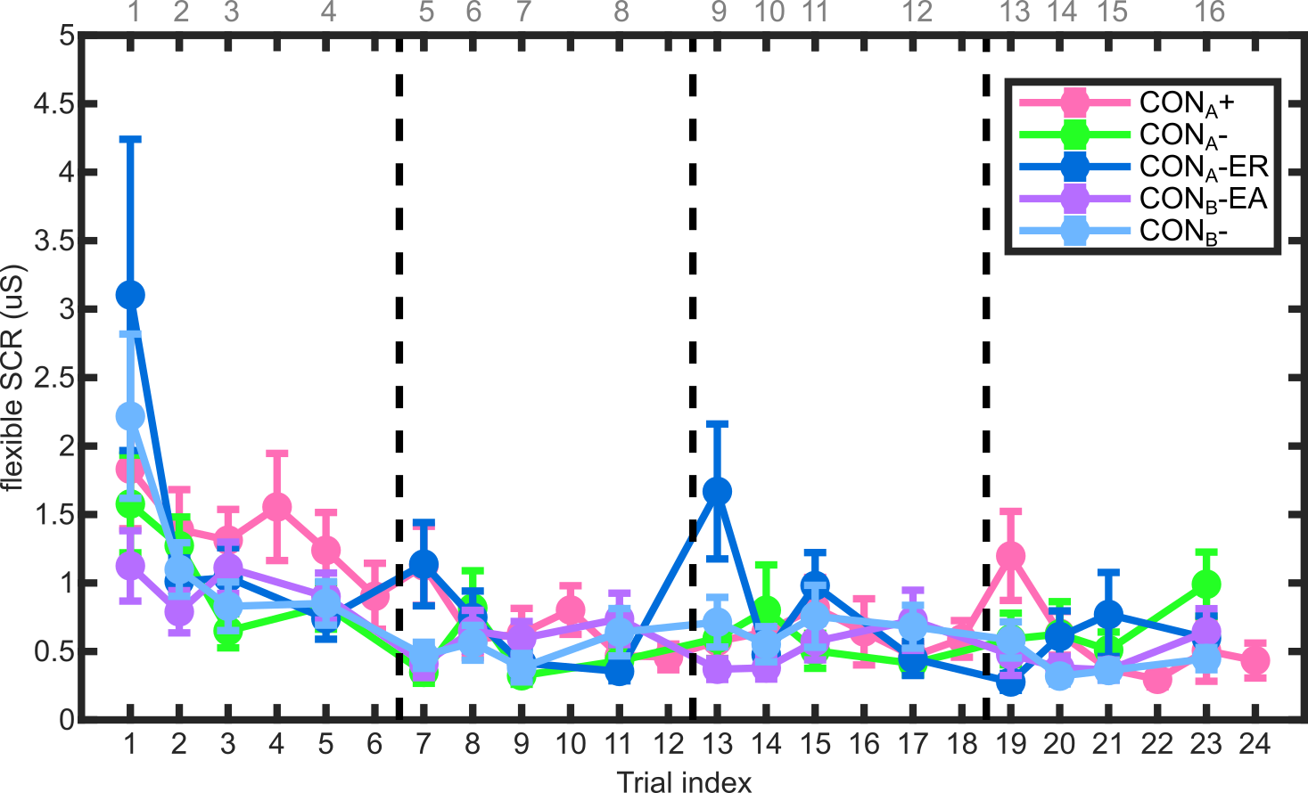

  - Experiment 4
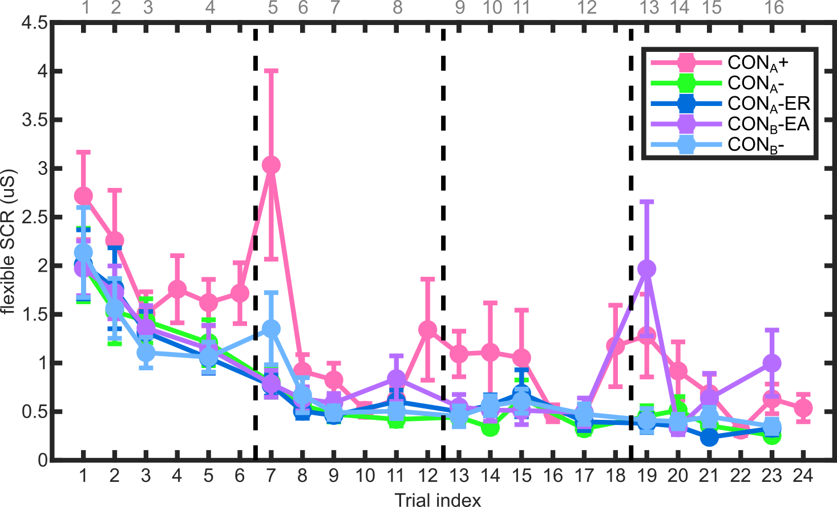

Figure S7. Normalised SCR estimates flexible during CTX presentation during memory recall in experiment 3 (A) and 4 (B). Trial-wise SCR is plotted with dashed black lines separating blocks. X axis on the top represents trial index of CTX- conditions. Although LME and paired t-test results support each other in each experiment, they does not show consistency between experiments. Data is plotted in corresponding colors as group mean ± SEM.

A.

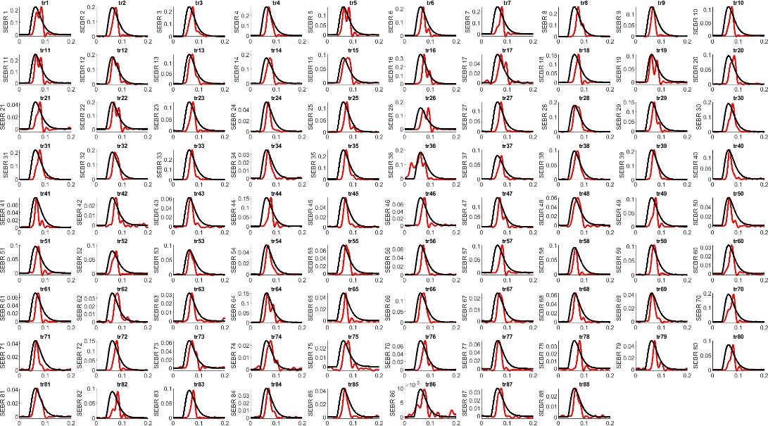

B.
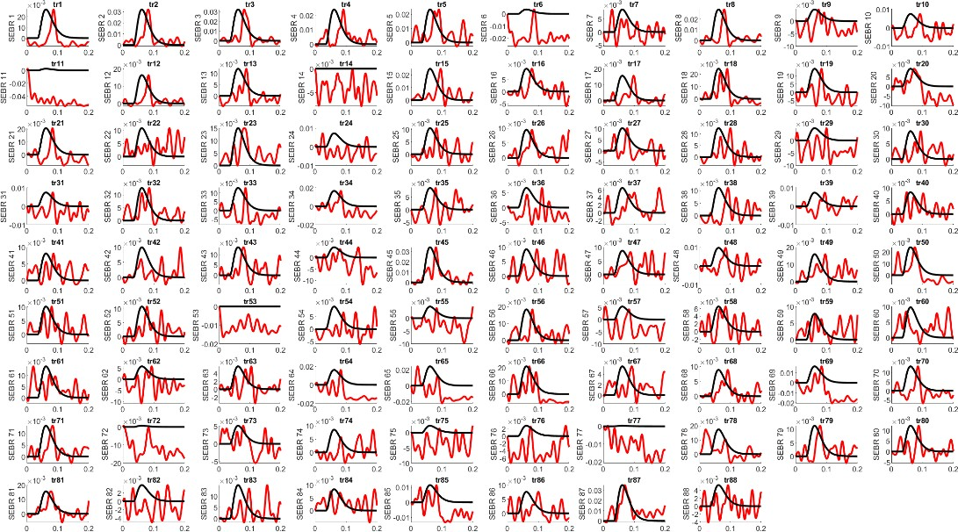

Figure S8. Examples of visual inspectation for SEBR quality control. (A) An example of a participant with discernible SEBR in most trials. (B) An example of a participant without discernible SEBR in most trials. Red curves were raw EMG data within a 0- 200 ms interval after startle probe delivery; black curves were the scaled standard canonical response function implemented in PsPM. Two participants in experiment 3 had no discernible SEBR in most of the trials and were excluded from SEBR analysis.

Table S1 CTX paradigm acquisition design 1
case | rooms | n. of probes | n. of shocks | CTX | duration (/s) | block_number
1 | Hallway | 0 | 0 | ITI | 13 | 1
2 | Vase | 0 | 2 | + | 32 | 1
3 | Hallway | 0 | 0 | ITI | 13 | 1
4 | Chairs | 0 | 0 | - | 32 | 1
5 | Hallway | 0 | 0 | ITI | 13 | 1
6 | Vase | 0 | 1 | + | 32 | 1
7 | Hallway | 0 | 0 | ITI | 13 | 1
8 | Chairs | 0 | 0 | - | 32 | 1
9 | Hallway | 0 | 0 | ITI | 13 | 1
10 | Chairs | 0 | 0 | - | 32 | 1
11 | Hallway | 0 | 0 | ITI | 13 | 1
12 | Vase | 0 | 2 | + | 32 | 1
13 | Hallway | 0 | 0 | ITI | 13 | 1
14 | Chairs | 0 | 0 | - | 32 | 1
15 | Hallway | 0 | 0 | ITI | 13 | 1
16 | Vase | 0 | 1 | + | 32 | 1
17 | Hallway | 0 | 0 | ITI | 13 | 1
18 | Vase | 0 | 2 | + | 32 | 1
19 | Hallway | 0 | 0 | ITI | 13 | 1
20 | Chairs | 0 | 0 | - | 32 | 1
21 | Hallway | 0 | 0 | ITI | 13 | 1
22 | Chairs | 0 | 0 | - | 32 | 1
23 | Hallway | 0 | 0 | ITI | 13 | 1
24 | Vase | 0 | 2 | + | 32 | 1
25 | Hallway | 0 | 0 | ITI | 13 | 1
26 | Chairs | 0 | 0 | - | 32 | 1
27 | Hallway | 0 | 0 | ITI | 13 | 1
28 | Vase | 0 | 2 | + | 32 | 1
29 | Hallway | 0 | 0 | ITI | 13 | 1
30 | Chairs | 0 | 0 | - | 32 | 1
31 | Hallway | 0 | 0 | ITI | 13 | 1
32 | Vase | 0 | 1 | + | 32 | 1
33 | Hallway | 0 | 0 | ITI | 13 | 1
34 | Vase | 0 | 2 | + | 32 | 1
35 | Hallway | 0 | 0 | ITI | 13 | 1
36 | Chairs | 0 | 0 | - | 32 | 1
37 | Hallway | 0 | 0 | ITI | 13 | 1
38 | Vase | 0 | 1 | + | 32 | 1
39 | Hallway | 0 | 0 | ITI | 13 | 1
40 | Chairs | 0 | 0 | - | 32 | 1
41 | End | 0 | 0 | ITI |  | 1

Table S2 CTX paradigm acquisition design 2
case | rooms | n. of probes | n. of shocks | CTX | duration (/s) | block_number
1 | Hallway | 0 | 0 | ITI | 13 | 1
2 | Vase | 0 | 0 | - | 32 | 1
3 | Hallway | 0 | 0 | ITI | 13 | 1
4 | Chairs | 0 | 2 | + | 32 | 1
5 | Hallway | 0 | 0 | ITI | 13 | 1
6 | Vase | 0 | 0 | - | 32 | 1
7 | Hallway | 0 | 0 | ITI | 13 | 1
8 | Chairs | 0 | 1 | + | 32 | 1
9 | Hallway | 0 | 0 | ITI | 13 | 1
10 | Chairs | 0 | 2 | + | 32 | 1
11 | Hallway | 0 | 0 | ITI | 13 | 1
12 | Vase | 0 | 0 | - | 32 | 1
13 | Hallway | 0 | 0 | ITI | 13 | 1
14 | Chairs | 0 | 1 | + | 32 | 1
15 | Hallway | 0 | 0 | ITI | 13 | 1
16 | Vase | 0 | 0 | - | 32 | 1
17 | Hallway | 0 | 0 | ITI | 13 | 1
18 | Vase | 0 | 0 | - | 32 | 1
19 | Hallway | 0 | 0 | ITI | 13 | 1
20 | Chairs | 0 | 2 | + | 32 | 1
21 | Hallway | 0 | 0 | ITI | 13 | 1
22 | Chairs | 0 | 2 | + | 32 | 1
23 | Hallway | 0 | 0 | ITI | 13 | 1
24 | Vase | 0 | 0 | - | 32 | 1
25 | Hallway | 0 | 0 | ITI | 13 | 1
26 | Chairs | 0 | 2 | + | 32 | 1
27 | Hallway | 0 | 0 | ITI | 13 | 1
28 | Vase | 0 | 0 | - | 32 | 1
29 | Hallway | 0 | 0 | ITI | 13 | 1
30 | Chairs | 0 | 1 | + | 32 | 1
31 | Hallway | 0 | 0 | ITI | 13 | 1
32 | Vase | 0 | 0 | - | 32 | 1
33 | Hallway | 0 | 0 | ITI | 13 | 1
34 | Vase | 0 | 0 | - | 32 | 1
35 | Hallway | 0 | 0 | ITI | 13 | 1
36 | Chairs | 0 | 2 | + | 32 | 1
37 | Hallway | 0 | 0 | ITI | 13 | 1
38 | Vase | 0 | 0 | - | 32 | 1
39 | Hallway | 0 | 0 | ITI | 13 | 1
40 | Chairs | 0 | 1 | + | 32 | 1
41 | End | 0 | 0 | ITI |  | 1

Table S3 CTX paradigm extinction design
case | rooms | n. of probes | n. of shocks | CTX | duration (/s) | block_number
1 | Hallway | 1 | 0 | ITI | 13 | 1
2 | Vase | 2 | 0 | - | 32 | 1
3 | Hallway | 1 | 0 | ITI | 13 | 1
4 | Chairs | 2 | 0 | - | 32 | 1
5 | Hallway | 1 | 0 | ITI | 13 | 1
6 | Vase | 2 | 0 | - | 32 | 1
7 | Hallway | 1 | 0 | ITI | 13 | 1
8 | Chairs | 2 | 0 | - | 32 | 1
9 | Hallway | 1 | 0 | ITI | 13 | 1
10 | Chairs | 2 | 0 | - | 32 | 1
11 | Hallway | 1 | 0 | ITI | 13 | 1
12 | Vase | 2 | 0 | - | 32 | 1
13 | Hallway | 1 | 0 | ITI | 13 | 1
14 | Chairs | 2 | 0 | - | 32 | 1
15 | Hallway | 1 | 0 | ITI | 13 | 1
16 | Vase | 2 | 0 | - | 32 | 1
17 | Hallway | 1 | 0 | ITI | 13 | 1
18 | Vase | 2 | 0 | - | 32 | 1
19 | Hallway | 1 | 0 | ITI | 13 | 1
20 | Chairs | 2 | 0 | - | 32 | 1
21 | Hallway | 1 | 0 | ITI | 13 | 1
22 | Chairs | 2 | 0 | - | 32 | 1
23 | Hallway | 1 | 0 | ITI | 13 | 1
24 | Vase | 2 | 0 | - | 32 | 1
25 | Hallway | 1 | 0 | ITI | 13 | 1
26 | Chairs | 1 | 0 | - | 32 | 1
27 | Hallway | 1 | 0 | ITI | 13 | 1
28 | Vase | 2 | 0 | - | 32 | 1
29 | Hallway | 1 | 0 | ITI | 13 | 1
30 | Chairs | 2 | 0 | - | 32 | 1
31 | Hallway | 1 | 0 | ITI | 13 | 1
32 | Vase | 2 | 0 | - | 32 | 1
33 | Hallway | 1 | 0 | ITI | 13 | 1
34 | Vase | 1 | 0 | - | 32 | 1
35 | Hallway | 1 | 0 | ITI | 13 | 1
36 | Chairs | 2 | 0 | - | 32 | 1
37 | Hallway | 1 | 0 | ITI | 13 | 1
38 | Vase | 2 | 0 | - | 32 | 1
39 | Hallway | 1 | 0 | ITI | 13 | 1
40 | Chairs | 2 | 0 | - | 32 | 1
41 | End | 0 | 0 | ITI |  | 1

Table S4
Experiment 1 and 2 SSQ
time | Nausea | Oculomotor | Disorientation | SSQ total
Exp 1, acq | 40.6 ± 38.4 ** | 30.3 ± 26.8 ** | 44.8 ± 44.4 ** | 42.9 ± 36.9 **
Exp 1, recall | 16.2 ± 17.8 * | 19.1 ± 15.8 * | 16.3 ± 24.7 * | 20.2 ± 17.4 *
Exp 2, acq | 40.9 ± 39.8 ** | 31.9 ± 23.1 ** | 55.7 ± 47.5 ** | 46.8 ± 36.5 **
Exp 2, recall | 37.8 ± 30.6 ** | 34.4 ± 22.2 ** | 44.2 ± 40.3 ** | 43.7 ± 31.5 **

a. data shown in mean +/- sd
b. * higher than calibration sample, p < .05; ** higher than calibration sample, p < .01

Table S5 | Experiment 1 subjective ratings rmANOVA
Experiment 1
Effect | DFn | DFd | F | p[GG] | partial η²
valence
time | 2 | 42 | 4.488 | 0.021 | 0.176
condition | 1 | 21 | 18.297 | < .001 | 0.466
time x condition | 2 | 42 | 20.077 | < .001 | 0.489
arousal
time | 2 | 40 | 0.57 | 0.552 | 0.028
condition | 1 | 20 | 4.633 | 0.044 | 0.188
time x condition | 2 | 40 | 11.764 | < .001 | 0.37
anxiety
time | 2 | 42 | 10.355 | < .001 | 0.33
condition | 1 | 21 | 23.063 | < .001 | 0.523
time x condition | 2 | 42 | 20.764 | < .001 | 0.497
US expectancy
time | 1 | 22 | 8.313 | 0.009 | 0.274
condition | 1 | 22 | 74.143 | < .001 | 0.771
time x condition | 1 | 22 | 15.825 | < .001 | 0.418
CS-US contingency
time | 2 | 44 | 52.046 | < .001 | 0.703
condition | 1 | 22 | 131.989 | < .001 | 0.857
time x condition | 2 | 44 | 45.051 | < .001 | 0.672

* condition contains CTX+, CTX-, ITI

Table S6 | post-hoc t-test CTX+ v.s. CTX-
Experiment 1
rating time | df | t | p | hedge's g
valence
pre-acq | 21 | -0.19 | 0.85 | -0.04
post-acq | 22 | -6.12 | < .001 | -1.23
post-recall | 22 | -0.05 | 0.96 | -0.01
arousal
pre-acq | 20 | -1.33 | 0.20 | -0.28
post-acq | 22 | 4.17 | < .001 | 0.84
post-recall | 22 | 1.15 | .26 | 0.23
anxiety
pre-acq | 21 | -1.21 | 0.24 | -0.25
post-acq | 22 | 6.74 | < .001 | 1.36
post-recall | 22 | 2.49 | 0.021 | 0.50
US expectancy
post-acq | 22 | 13.21 | < .001 | 2.66
post-recall | 22 | 4.16 | < .001 | 0.84
CS-US contingency
post-acq | 22 | 11.96 | < .001 | 2.41
post-recall | 22 | 1.68 | 0.11 | 0.34
post-recall recall acq | 22 | 8.69 | < .001 | 1.75

Table S7 | Experiment 2 subjective ratings rmANOVA
Experiment 2
Effect | DFn | DFd | F | p[GG] | partial η²
valence
time | 2 | 54 | 5.893 | 0.005 | 0.179
condition | 1 | 27 | 6.584 | 0.016 | 0.196
time x condition | 2 | 54 | 7.792 | 0.002 | 0.224
arousal
time | 2 | 54 | 0.473 | 0.609 | 0.017
condition | 1 | 27 | 8.176 | 0.008 | 0.232
time x condition | 2 | 54 | 5.224 | 0.009 | 0.162
anxiety
time | 2 | 54 | 7.408 | 0.003 | 0.215
condition | 1 | 27 | 7.497 | 0.011 | 0.217
time x condition | 2 | 54 | 5.335 | 0.015 | 0.165
US expectancy
time | 1 | 27 | 16.556 | < .001 | 0.38
condition | 1 | 27 | 20.215 | < .001 | 0.428
time x condition | 1 | 27 | 9.655 | 0.004 | 0.263
CS-US contingency
time | 2 | 54 | 73.237 | < .001 | 0.731
condition | 1 | 27 | 23.029 | < .001 | 0.46
time x condition | 2 | 54 | 15.592 | < .001 | 0.366

* condition contains CTX+, CTX-, ITI

Table S8 | post-hoc t-test CTX+ v.s. CTX-
Experiment 2
rating time | df | t | p | hedge's g
valence
pre-acq | 27 | 0.82 | 0.42 | 0.15
post-acq | 27 | -3.61 | 0.001 | -0.66
post-recall | 27 | -0.75 | 0.46 | -0.14
arousal
pre-acq | 27 | -1.22 | 0.23 | -0.22
post-acq | 27 | 3.51 | 0.002 | 0.64
post-recall | 27 | 1.56 | 0.13 | 0.29
anxiety
pre-acq | 27 | -0.10 | 0.92 | -0.02
post-acq | 27 | 3.06 | 0.005 | 0.56
post-recall | 27 | 1.67 | 0.11 | 0.31
US expectancy
post-acq | 27 | 5.05 | < .001 | 0.93
post-recall | 27 | 2.43 | 0.022 | 0.45
CS-US contingency
post-acq | 27 | 4.61 | < .001 | 0.85
post-recall | 27 | 0.61 | 0.55 | 0.11
post-recall recall acq | 27 | 4.50 | < .001 | 0.83

Table S9
Experiment 1 SEBR LME omnibus effects
Predictors | df | F | p
condition | 2, 1227.2 | 7.92 | <0.001
probe_index | 1, 1227.3 | 40.51 | <0.001
probe_index_trial | 1, 1227.2 | 3.97 | 0.047
condition x probe_index | 2, 1227.2 | 3.78 | 0.023

Experiment 2 SEBR LME omnibus effects
Predictors | df | F | p
condition | 2, 1514.6 | 3.11 | 0.045
probe_index | 1, 1514.5 | 46.3 | <0.001
probe_index_trial | 1, 1514.4 | 3.29 | 0.070
condition x probe_index | 2, 1514.5 | 0.38 | 0.683

Experiment 1 SEBR LME summary table
Predictors | df | t | p
CTX- | 1246 | -0.12 | 0.904
ITI | 1246 | -3.47 | 0.001
probe_index | 1246 | -4.31 | <0.001
ITI x probe_index | 1246 | 2.23 | 0.026

Experiment 2 SEBR LME summary table
Predictors | df | t | p
CTX- | 1539 | -0.02 | 0.984
ITI | 1539 | -2.14 | 0.032
probe_index | 1539 | -4.66 | <0.001
ITI x probe_index | 1539 | 0.77 | 0.443

* condition contains CTX+, CTX-, ITI; probe_index represents probe number over time (i.e., 1 to 58); probe_index_trial represents the order of probes delivered in each trial (i.e., the first or the second probe)

Table S10 | rmANOVA of Experiment 3 and 4 verval reports
 |  |  | Experiment 3 |  |  |  |  |  | Experiment 4
Effect | DFn | DFd | F | p[GG] | partial η² | Effect | DFn | DFd | F | p[GG] | partial η²
valence |  |  |  |  |  | valence
trial | 1 | 28 | 1.510 | 0.229 | 0.051 | trial | 1 | 23 | 0.252 | 0.621 | 0.011
CON | 4 | 112 | 33.340 | <0.001 | 0.544 | CON | 4 | 92 | 12.932 | <0.001 | 0.360
trial x CON | 4 | 112 | 10.201 | <0.001 | 0.267 | trial x CON | 4 | 92 | 5.029 | 0.004 | 0.179
arousal |  |  |  |  |  | arousal
trial | 1 | 28 | 26.441 | <0.001 | 0.486 | trial | 1 | 23 | 2.883 | 0.103 | 0.111
CON | 4 | 112 | 76.252 | <0.001 | 0.731 | CON | 4 | 92 | 33.250 | <0.001 | 0.591
trial x CON | 4 | 112 | 8.457 | <0.001 | 0.232 | trial x CON | 4 | 92 | 7.930 | <0.001 | 0.256
CS-US contingency |  |  |  |  |  | CS-US contingency
trial | 2 | 56 | 24.539 | <0.001 | 0.467 | trial | 2 | 46 | 25.302 | <0.001 | 0.524
CON | 4 | 112 | 141.890 | <0.001 | 0.835 | CON | 4 | 92 | 82.764 | <0.001 | 0.783
trial x CON | 8 | 224 | 68.117 | <0.001 | 0.709 | trial x CON | 8 | 184 | 38.479 | <0.001 | 0.626

* condition contains CON_{A}+, CON_{A}-, CON_{A}-ER, CON_{B}-, CON_{B}-EA; linear trial index represents time

Table S11 | Experiment 3 and 4 acquisition fixed SCR and pupil dilation paired t-test effect sizes
Experiment 3 Experiment 4
 | df | t | p | d | g df t p d g
fixed-latency SCR to CTX onset
CON_{A}+/CON_{A}- | 27 | 3.027 | 0.005 | 0.572 | 0.556 | 22 | 3.692 | 0.001 | 0.770 | 0.743
CON_{A}+/CON_{A}-ER | 27 | 2.800 | 0.009 | 0.529 | 0.514 | 22 | 3.814 | <0.001 | 0.795 | 0.768
CON_{A}+/CON_{B}-EA | 27 | 2.909 | 0.007 | 0.550 | 0.534 | 22 | 3.150 | 0.005 | 0.657 | 0.634
CON_{A}+/CON_{B}- | 27 | 3.764 | <0.001 | 0.711 | 0.691 | 22 | 3.527 | 0.002 | 0.735 | 0.710
CON_{A}+/CTX- | 27 | 3.270 | 0.003 | 0.618 | 0.601 | 22 | 3.626 | 0.001 | 0.756 | 0.730
pupil dilation
CON_{A}+/CON_{A}- | 28 | 2.913 | 0.007 | 0.541 | 0.526 | 23 | 4.611 | <0.001 | 0.941 | 0.910
CON_{A}+/CON_{A}-ER | 28 | 3.285 | 0.003 | 0.610 | 0.593 | 23 | 5.033 | <0.001 | 1.027 | 0.993
CON_{A}+/CON_{B}-EA | 28 | 5.586 | <0.001 | 1.037 | 1.009 | 23 | 5.167 | <0.001 | 1.055 | 1.020
CON_{A}+/CON_{B}- | 28 | 4.804 | <0.001 | 0.892 | 0.868 | 23 | 4.721 | <0.001 | 0.964 | 0.932
CON_{A}+/CTX- | 28 | 4.395 | <0.001 | 0.816 | 0.794 | 23 | 5.331 | <0.001 | 1.088 | 1.052
* only non-reinforced trials were included in analysis
p-values were not Holm-Bonferroni corrected

Table S12 | Experiment 3 and 4 extinction SEBR LME summary table
Experiment 3 Experiment 4
Predictors | df | t | p | df | t | p
trial | 2319 | -14.01 | <0.001 | 2064 | -13.98 | <0.001
CON_{A}- | 2319 | -3.78 | <0.001 | 2064 | -3.78 | <0.001
CON_{A}-ER | 2319 | -3.39 | 0.001 | 2064 | -5.23 | <0.001
CON_{B}- | 2319 | -2.67 | 0.008 | 2064 | -4.11 | <0.001
CON_{B}-EA | 2319 | -3.11 | 0.002 | 2064 | -4.01 | <0.001
trial x CON_{A}- | 2319 | 2.14 | 0.032 | 2064 | 1.85 | 0.064
trial x CON_{A}-ER | 2319 | 1.35 | 0.18 | 2064 | 2.71 | 0.007
trial x CON_{B}- | 2319 | 0.8 | 0.42 | 2064 | 2.15 | 0.031
trial x CON_{B}-EA | 2319 | 1.44 | 0.15 | 2064 | 2.18 | 0.029

Table S13 | Experiment 3 extinction SEBR paired t-test effect sizes
CON_{A}+ vs. CON_{A}- |  |  |  |  |  | CON_{A}+ vs. CON_{A}-ER
 | df | t | p | d | g | df | t | p | d | g
first 1 | 25 | 2.889 | 0.008 | 0.556 | 0.540 | 24 | 2.264 | 0.033 | 0.436 | 0.423
first 2 | 26 | 3.118 | 0.004 | 0.600 | 0.583 | 26 | 2.406 | 0.024 | 0.463 | 0.449
first 3 | 26 | 2.700 | 0.012 | 0.520 | 0.504 | 26 | 1.898 | 0.069 | 0.365 | 0.355
first 4 | 26 | 1.610 | 0.120 | 0.310 | 0.301 | 26 | 1.356 | 0.187 | 0.261 | 0.253
first 5 | 26 | 2.058 | 0.050 | 0.396 | 0.385 | 26 | 1.602 | 0.121 | 0.308 | 0.299
first 6 | 26 | 2.207 | 0.036 | 0.425 | 0.412 | 26 | 1.743 | 0.093 | 0.335 | 0.326
first 7 | 26 | 1.965 | 0.060 | 0.378 | 0.367 | 26 | 1.556 | 0.132 | 0.299 | 0.291
first 8 | 26 | 1.650 | 0.111 | 0.318 | 0.308 | 26 | 1.435 | 0.163 | 0.276 | 0.268
first 9 | 26 | 1.659 | 0.109 | 0.319 | 0.310 | 26 | 1.582 | 0.126 | 0.305 | 0.296
first 10 | 26 | 1.716 | 0.098 | 0.330 | 0.321 | 26 | 1.689 | 0.103 | 0.325 | 0.316
first 11 | 26 | 1.783 | 0.086 | 0.343 | 0.333 | 26 | 1.756 | 0.091 | 0.338 | 0.328
first 12 | 26 | 1.861 | 0.074 | 0.358 | 0.348 | 26 | 1.845 | 0.076 | 0.355 | 0.345
first 13 | 26 | 2.019 | 0.054 | 0.389 | 0.377 | 26 | 1.919 | 0.066 | 0.369 | 0.358
first 14 | 26 | 2.205 | 0.037 | 0.424 | 0.412 | 26 | 2.069 | 0.049 | 0.398 | 0.387
first 15 | 26 | 2.239 | 0.034 | 0.431 | 0.418 | 26 | 2.108 | 0.045 | 0.406 | 0.394
first 16 | 26 | 2.053 | 0.050 | 0.395 | 0.383 | 26 | 2.139 | 0.042 | 0.412 | 0.400

CON_{A}+ vs. CON_{B}-EA CON_{A}+ vs. CON_{B}- CON_{A}+ vs. CTX-
df |  | t | p | d | g | df | t | p | d | g | df | t | p | d | g
first 1 | 24 | 1.640 | 0.114 | 0.316 | 0.306 | 25 | 2.869 | 0.008 | 0.552 | 0.536 | 25 | 3.004 | 0.006 | 0.578 | 0.561
first 2 | 26 | 2.172 | 0.039 | 0.418 | 0.406 | 26 | 2.034 | 0.052 | 0.391 | 0.380 | 26 | 2.791 | 0.010 | 0.537 | 0.521
first 3 | 26 | 1.388 | 0.177 | 0.267 | 0.259 | 26 | 1.405 | 0.172 | 0.270 | 0.263 | 26 | 1.984 | 0.058 | 0.382 | 0.371
first 4 | 26 | 1.051 | 0.303 | 0.202 | 0.196 | 26 | 0.888 | 0.383 | 0.171 | 0.166 | 26 | 1.292 | 0.208 | 0.249 | 0.241
first 5 | 26 | 1.639 | 0.113 | 0.315 | 0.306 | 26 | 1.325 | 0.197 | 0.255 | 0.248 | 26 | 1.704 | 0.100 | 0.328 | 0.318
first 6 | 26 | 1.849 | 0.076 | 0.356 | 0.346 | 26 | 1.495 | 0.147 | 0.288 | 0.279 | 26 | 1.855 | 0.075 | 0.357 | 0.347
first 7 | 26 | 1.704 | 0.100 | 0.328 | 0.318 | 26 | 1.417 | 0.168 | 0.273 | 0.265 | 26 | 1.689 | 0.103 | 0.325 | 0.316
first 8 | 26 | 1.512 | 0.142 | 0.291 | 0.283 | 26 | 1.240 | 0.226 | 0.239 | 0.232 | 26 | 1.489 | 0.148 | 0.287 | 0.278
first 9 | 26 | 1.518 | 0.141 | 0.292 | 0.284 | 26 | 1.401 | 0.173 | 0.270 | 0.262 | 26 | 1.576 | 0.127 | 0.303 | 0.295
first 10 | 26 | 1.603 | 0.121 | 0.309 | 0.300 | 26 | 1.434 | 0.163 | 0.276 | 0.268 | 26 | 1.649 | 0.111 | 0.317 | 0.308
first 11 | 26 | 1.468 | 0.154 | 0.282 | 0.274 | 26 | 1.492 | 0.148 | 0.287 | 0.279 | 26 | 1.671 | 0.107 | 0.322 | 0.312
first 12 | 26 | 1.454 | 0.158 | 0.280 | 0.272 | 26 | 1.535 | 0.137 | 0.295 | 0.287 | 26 | 1.729 | 0.096 | 0.333 | 0.323
first 13 | 26 | 1.540 | 0.136 | 0.296 | 0.288 | 26 | 1.744 | 0.093 | 0.336 | 0.326 | 26 | 1.865 | 0.073 | 0.359 | 0.349
first 14 | 26 | 1.680 | 0.105 | 0.323 | 0.314 | 26 | 1.864 | 0.074 | 0.359 | 0.348 | 26 | 2.022 | 0.054 | 0.389 | 0.378
first 15 | 26 | 1.775 | 0.088 | 0.342 | 0.332 | 26 | 1.926 | 0.065 | 0.371 | 0.360 | 26 | 2.094 | 0.046 | 0.403 | 0.391
first 16 | 26 | 1.688 | 0.103 | 0.325 | 0.315 | 26 | 1.824 | 0.080 | 0.351 | 0.341 | 26 | 2.016 | 0.054 | 0.388 | 0.377

* first N means average over the first N subsets; d: cohen's d; g: hedge's g
p-values were not Holm-Bonferroni corrected (5 comparisons for each summarisation over subsets)

Table S14 |  | Experiment 4 extinction SEBR paired t-test effect sizes
 | CON_{A}+ vs. CON_{A}- |  |  |  |  | CON_{A}+ vs. CON_{A}-ER
 | df | t | p | d | g | df | t | p | d | g
first 1 | 22 | 2.777 | 0.011 | 0.567 | 0.548 | 22 | 3.064 | 0.006 | 0.625 | 0.605
first 2 | 23 | 2.485 | 0.021 | 0.507 | 0.491 | 23 | 3.719 | 0.001 | 0.759 | 0.734
first 3 | 23 | 2.200 | 0.038 | 0.449 | 0.434 | 23 | 3.430 | 0.002 | 0.700 | 0.677
first 4 | 23 | 2.183 | 0.039 | 0.446 | 0.431 | 23 | 3.002 | 0.006 | 0.613 | 0.593
first 5 | 23 | 2.969 | 0.007 | 0.606 | 0.586 | 23 | 3.602 | 0.002 | 0.735 | 0.711
first 6 | 23 | 3.726 | 0.001 | 0.760 | 0.735 | 23 | 4.135 | <0.001 | 0.844 | 0.816
first 7 | 23 | 4.055 | <0.001 | 0.828 | 0.800 | 23 | 3.915 | <0.001 | 0.799 | 0.773
first 8 | 23 | 3.561 | 0.002 | 0.727 | 0.703 | 23 | 3.865 | <0.001 | 0.789 | 0.763
first 9 | 23 | 3.614 | 0.001 | 0.738 | 0.713 | 23 | 4.462 | <0.001 | 0.911 | 0.881
first 10 | 23 | 3.871 | <0.001 | 0.790 | 0.764 | 23 | 4.591 | <0.001 | 0.937 | 0.906
first 11 | 23 | 3.932 | <0.001 | 0.803 | 0.776 | 23 | 4.603 | <0.001 | 0.939 | 0.908
first 12 | 23 | 3.978 | <0.001 | 0.812 | 0.785 | 23 | 4.385 | <0.001 | 0.895 | 0.865
first 13 | 23 | 4.067 | <0.001 | 0.830 | 0.803 | 23 | 4.595 | <0.001 | 0.938 | 0.907
first 14 | 23 | 4.461 | <0.001 | 0.911 | 0.880 | 23 | 5.156 | <0.001 | 1.052 | 1.018
first 15 | 23 | 4.277 | <0.001 | 0.873 | 0.844 | 23 | 5.148 | <0.001 | 1.051 | 1.016
first 16 | 23 | 3.911 | <0.001 | 0.798 | 0.772 | 23 | 5.167 | <0.001 | 1.055 | 1.020

CON_{A}+ vs. CON_{B}-EA CON_{A}+ vs. CON_{B}- CON_{A}+ vs. CTX-
 | df | t | p | d | g | df | t | p | d | g | df | t | p | d | g
first 1 | 23 | 2.998 | 0.006 | 0.612 | 0.592 | 22 | 2.620 | 0.016 | 0.535 | 0.517 | 23 | 3.478 | 0.002 | 0.710 | 0.687
first 2 | 23 | 2.061 | 0.051 | 0.421 | 0.407 | 23 | 2.467 | 0.022 | 0.504 | 0.487 | 23 | 2.878 | 0.008 | 0.588 | 0.568
first 3 | 23 | 1.652 | 0.112 | 0.337 | 0.326 | 23 | 1.858 | 0.076 | 0.379 | 0.367 | 23 | 2.814 | 0.010 | 0.574 | 0.555
first 4 | 23 | 1.403 | 0.174 | 0.286 | 0.277 | 23 | 1.949 | 0.064 | 0.398 | 0.385 | 23 | 2.417 | 0.024 | 0.493 | 0.477
first 5 | 23 | 2.233 | 0.036 | 0.456 | 0.441 | 23 | 2.468 | 0.021 | 0.504 | 0.487 | 23 | 3.339 | 0.003 | 0.682 | 0.659
first 6 | 23 | 2.441 | 0.023 | 0.498 | 0.482 | 23 | 3.121 | 0.005 | 0.637 | 0.616 | 23 | 4.011 | <0.001 | 0.819 | 0.792
first 7 | 23 | 2.571 | 0.017 | 0.525 | 0.507 | 23 | 2.903 | 0.008 | 0.593 | 0.573 | 23 | 4.092 | <0.001 | 0.835 | 0.808
first 8 | 23 | 2.440 | 0.023 | 0.498 | 0.482 | 23 | 2.721 | 0.012 | 0.555 | 0.537 | 23 | 3.801 | <0.001 | 0.776 | 0.750
first 9 | 23 | 2.994 | 0.006 | 0.611 | 0.591 | 23 | 3.280 | 0.003 | 0.670 | 0.647 | 23 | 4.396 | <0.001 | 0.897 | 0.868
first 10 | 23 | 3.326 | 0.003 | 0.679 | 0.657 | 23 | 3.641 | 0.001 | 0.743 | 0.719 | 23 | 4.727 | <0.001 | 0.965 | 0.933
first 11 | 23 | 3.292 | 0.003 | 0.672 | 0.650 | 23 | 3.199 | 0.004 | 0.653 | 0.631 | 23 | 4.563 | <0.001 | 0.931 | 0.901
first 12 | 23 | 3.121 | 0.005 | 0.637 | 0.616 | 23 | 3.051 | 0.006 | 0.623 | 0.602 | 23 | 4.448 | <0.001 | 0.908 | 0.878
first 13 | 23 | 2.954 | 0.007 | 0.603 | 0.583 | 23 | 3.216 | 0.004 | 0.657 | 0.635 | 23 | 4.520 | <0.001 | 0.923 | 0.892
first 14 | 23 | 3.336 | 0.003 | 0.681 | 0.658 | 23 | 3.481 | 0.002 | 0.711 | 0.687 | 23 | 4.939 | <0.001 | 1.008 | 0.975
first 15 | 23 | 2.811 | 0.010 | 0.574 | 0.555 | 23 | 3.265 | 0.003 | 0.666 | 0.644 | 23 | 4.567 | <0.001 | 0.932 | 0.901
first 16 | 23 | 2.748 | 0.011 | 0.561 | 0.542 23 3.222 0.004 0.658 0.636 23 4.441 <0.001 0.906 0.877

* first N means average over the first N subsets; d: cohen's d; g: hedge's g
p-values were not Holm-Bonferroni corrected (5 comparisons for each summarisation over subsets)

Table S15
Experiment 3 and 4 extinction, LME omnibus effect of pupil dilation
 | Experiment 3 |  |  | Experiment 4
Predictors | df | F | p | df | F | p
trial | 1, 2491.0 | 85.25 | < 0.001 | 1, 2070.0 | 42.46 | < 0.001
condition | 4, 2490.3 | 5.88 | < 0.001 | 4, 2070.2 | 4.55 | 0.001
trial x condition | 4, 2490.5 | 0.32 | 0.84 | 4, 2070.3 | 1.15 | 0.33

Experiment 3 and 4 extinction, LME summary table of pupil dilation
 | Experiment 3 |  |  | Experiment 4
Predictors | df | t | p | df | t | p
trial | 2516 | -5.69 | < 0.001 | 2091 | -4.50 | < 0.001
CON_{A}- | 2516 | -0.57 | 0.57 | 2091 | -0.78 | 0.43
CON_{A}-ER | 2516 | -1.72 | 0.085 | 2091 | -0.34 | 0.73
CON_{B}- | 2516 | -2.29 | 0.022 | 2091 | -2.66 | 0.008
CON_{B}-EA | 2516 | -4.53 | < 0.001 | 2091 | -3.59 | < 0.001

Table S16 |  | Experiment 3 extinction pupil dilation paired t-test effect sizes
CON_{A}+ vs. CON_{A}- |  |  |  |  |  | CON_{A}+ vs. CON_{A}-ER
df |  | t | p | d | g | df | t | p | d | g
first 1 | 28 | 3.079 | 0.005 | 0.572 | 0.556 | 28 | 2.839 | 0.008 | 0.527 | 0.513
first 2 | 28 | 3.464 | 0.002 | 0.643 | 0.626 | 28 | 2.906 | 0.007 | 0.540 | 0.525
first 3 | 28 | 1.123 | 0.271 | 0.209 | 0.203 | 28 | 1.808 | 0.081 | 0.336 | 0.327
first 4 | 28 | -0.130 | 0.897 | -0.024 | -0.024 | 28 | 1.267 | 0.216 | 0.235 | 0.229
first 5 | 28 | 0.078 | 0.939 | 0.014 | 0.014 | 28 | 1.247 | 0.223 | 0.232 | 0.225
first 6 | 28 | 0.510 | 0.614 | 0.095 | 0.092 | 28 | 1.369 | 0.182 | 0.254 | 0.247
first 7 | 28 | 0.231 | 0.819 | 0.043 | 0.042 | 28 | 1.208 | 0.237 | 0.224 | 0.218
first 8 | 28 | -0.088 | 0.931 | -0.016 | -0.016 | 28 | 1.068 | 0.295 | 0.198 | 0.193
first 9 | 28 | -0.223 | 0.825 | -0.041 | -0.040 | 28 | 0.739 | 0.466 | 0.137 | 0.133
first 10 | 28 | -0.167 | 0.868 | -0.031 | -0.030 | 28 | 0.811 | 0.424 | 0.151 | 0.147
first 11 | 28 | 0.218 | 0.829 | 0.041 | 0.039 | 28 | 1.324 | 0.196 | 0.246 | 0.239
first 12 | 28 | 0.330 | 0.744 | 0.061 | 0.060 | 28 | 1.513 | 0.141 | 0.281 | 0.273
first 13 | 28 | 0.340 | 0.736 | 0.063 | 0.061 | 28 | 1.437 | 0.162 | 0.267 | 0.260
first 14 | 28 | 0.454 | 0.653 | 0.084 | 0.082 | 28 | 1.614 | 0.118 | 0.300 | 0.292
first 15 | 28 | 0.362 | 0.720 | 0.067 | 0.065 | 28 | 2.032 | 0.052 | 0.377 | 0.367
first 16 | 28 | 0.081 | 0.936 | 0.015 | 0.015 | 28 | 1.467 | 0.154 | 0.272 | 0.265

CON_{A}+ vs. CON_{B}-EA CON_{A}+ vs. CON_{B}- CON_{A}+ vs. CTX-
df |  | t | p | d | g | df | t | p | d | g | df | t | p | d | g
first 1 | 28 | 5.784 | < 0.001 | 1.074 | 1.045 | 28 | 2.993 | 0.006 | 0.556 | 0.541 | 28 | 4.943 | < 0.001 | 0.918 | 0.893
first 2 | 28 | 6.367 | < 0.001 | 1.182 | 1.150 | 28 | 4.756 | < 0.001 | 0.883 | 0.859 | 28 | 5.498 | < 0.001 | 1.021 | 0.993
first 3 | 28 | 4.718 | < 0.001 | 0.876 | 0.852 | 28 | 2.564 | 0.016 | 0.476 | 0.463 | 28 | 2.969 | 0.006 | 0.551 | 0.536
first 4 | 28 | 3.718 | < 0.001 | 0.690 | 0.672 | 28 | 1.364 | 0.184 | 0.253 | 0.246 | 28 | 1.751 | 0.091 | 0.325 | 0.316
first 5 | 28 | 4.729 | < 0.001 | 0.878 | 0.854 | 28 | 1.900 | 0.068 | 0.353 | 0.343 | 28 | 2.147 | 0.041 | 0.399 | 0.388
first 6 | 28 | 5.208 | < 0.001 | 0.967 | 0.941 | 28 | 2.611 | 0.014 | 0.485 | 0.472 | 28 | 2.679 | 0.012 | 0.497 | 0.484
first 7 | 28 | 4.817 | < 0.001 | 0.894 | 0.870 | 28 | 1.961 | 0.060 | 0.364 | 0.354 | 28 | 2.271 | 0.031 | 0.422 | 0.410
first 8 | 28 | 4.092 | < 0.001 | 0.760 | 0.739 | 28 | 1.652 | 0.110 | 0.307 | 0.298 | 28 | 1.972 | 0.059 | 0.366 | 0.356
first 9 | 28 | 4.999 | < 0.001 | 0.928 | 0.903 | 28 | 1.782 | 0.086 | 0.331 | 0.322 | 28 | 2.135 | 0.042 | 0.396 | 0.386
first 10 | 28 | 5.386 | < 0.001 | 1.000 | 0.973 | 28 | 1.875 | 0.071 | 0.348 | 0.339 | 28 | 2.266 | 0.031 | 0.421 | 0.409
first 11 | 28 | 5.770 | < 0.001 | 1.071 | 1.042 | 28 | 2.187 | 0.037 | 0.406 | 0.395 | 28 | 2.820 | 0.009 | 0.524 | 0.510
first 12 | 28 | 6.979 | < 0.001 | 1.296 | 1.261 | 28 | 2.686 | 0.012 | 0.499 | 0.485 | 28 | 3.398 | 0.002 | 0.631 | 0.614
first 13 | 28 | 7.136 | < 0.001 | 1.325 | 1.289 | 28 | 2.876 | 0.008 | 0.534 | 0.520 | 28 | 3.609 | 0.001 | 0.670 | 0.652
first 14 | 28 | 6.778 | < 0.001 | 1.259 | 1.225 | 28 | 2.873 | 0.008 | 0.533 | 0.519 | 28 | 3.694 | < 0.001 | 0.686 | 0.667
first 15 | 28 | 7.176 | < 0.001 | 1.333 | 1.297 | 28 | 2.985 | 0.006 | 0.554 | 0.539 | 28 | 3.872 | < 0.001 | 0.719 | 0.700
first 16 28 |  | 7.283 | < 0.001 | 1.352 | 1.316 28 3.063 0.005 0.569 0.553 28 3.736 < 0.001 0.694 0.675

* first N means average over the first N subsets; d: cohen's d; g: hedge's g
p-values were not Holm-Bonferroni corrected (5 comparisons for each summarisation over subsets)

Table S17 | Experiment 4 extinction pupil dilation paired t-test effect sizes

CON_{A}+ vs. CON_{A}- CON_{A}+ vs. CON_{A}-ER
 | df | t | p | d | g | df | t | p | d | g
first 1 | 23 | 2.432 | 0.023 | 0.496 | 0.480 | 23 | 3.357 | 0.003 | 0.685 | 0.663
first 2 | 23 | 2.767 | 0.011 | 0.565 | 0.546 | 23 | 3.866 | 0.001 | 0.789 | 0.763
first 3 | 23 | 0.544 | 0.591 | 0.111 | 0.107 | 23 | 0.669 | 0.510 | 0.137 | 0.132
first 4 | 23 | 0.200 | 0.844 | 0.041 | 0.039 | 23 | -0.277 | 0.784 | -0.057 | -0.055
first 5 | 23 | 0.837 | 0.411 | 0.171 | 0.165 | 23 | 0.194 | 0.848 | 0.040 | 0.038
first 6 | 23 | 1.039 | 0.309 | 0.212 | 0.205 | 23 | 0.142 | 0.888 | 0.029 | 0.028
first 7 | 23 | 0.737 | 0.469 | 0.150 | 0.145 | 23 | 0.016 | 0.988 | 0.003 | 0.003
first 8 | 23 | 0.304 | 0.764 | 0.062 | 0.060 | 23 | 0.081 | 0.936 | 0.016 | 0.016
first 9 | 23 | 0.390 | 0.700 | 0.080 | 0.077 | 23 | 0.447 | 0.659 | 0.091 | 0.088
first 10 | 23 | 0.188 | 0.852 | 0.038 | 0.037 | 23 | 0.666 | 0.512 | 0.136 | 0.132
first 11 | 23 | -0.016 | 0.987 | -0.003 | -0.003 | 23 | 0.731 | 0.472 | 0.149 | 0.144
first 12 | 23 | -0.021 | 0.983 | -0.004 | -0.004 | 23 | 0.565 | 0.578 | 0.115 | 0.111
first 13 | 23 | -0.199 | 0.844 | -0.041 | -0.039 | 23 | 0.452 | 0.656 | 0.092 | 0.089
first 14 | 23 | -0.073 | 0.942 | -0.015 | -0.014 | 23 | 0.429 | 0.672 | 0.088 | 0.085
first 15 | 23 | 0.073 | 0.943 | 0.015 | 0.014 | 23 | 0.692 | 0.496 | 0.141 | 0.137
first 16 | 23 | -0.076 | 0.940 | -0.016 | -0.015 | 23 | 0.801 | 0.431 | 0.164 | 0.158

CON_{A}+ vs. CON_{B}-EA CON_{A}+ vs. CON_{B}- CON_{A}+ vs. CTX-
df |  | t | p | d | g | df | t | p | d | g | df | t | p | d | g
first 1 | 22 | 3.855 | < 0.001 | 0.787 | 0.761 | 23 | 4.029 | < 0.001 | 0.822 | 0.795 | 23 | 3.889 | < 0.001 | 0.794 | 0.768
first 2 | 23 | 3.892 | < 0.001 | 0.795 | 0.768 | 23 | 5.380 | < 0.001 | 1.098 | 1.062 | 23 | 4.461 | < 0.001 | 0.911 | 0.880
first 3 | 23 | 2.173 | 0.040 | 0.443 | 0.429 | 23 | 2.353 | 0.028 | 0.480 | 0.464 | 23 | 1.590 | 0.125 | 0.325 | 0.314
first 4 | 23 | 1.880 | 0.073 | 0.384 | 0.371 | 23 | 1.731 | 0.097 | 0.353 | 0.342 | 23 | 0.899 | 0.378 | 0.184 | 0.177
first 5 | 23 | 3.145 | 0.005 | 0.642 | 0.621 | 23 | 2.090 | 0.048 | 0.427 | 0.412 | 23 | 1.639 | 0.115 | 0.335 | 0.324
first 6 | 23 | 3.166 | 0.004 | 0.646 | 0.625 | 23 | 2.279 | 0.032 | 0.465 | 0.450 | 23 | 1.767 | 0.091 | 0.361 | 0.349
first 7 | 23 | 2.681 | 0.013 | 0.547 | 0.529 | 23 | 2.099 | 0.047 | 0.428 | 0.414 | 23 | 1.529 | 0.140 | 0.312 | 0.302
first 8 | 23 | 3.040 | 0.006 | 0.621 | 0.600 | 23 | 2.181 | 0.040 | 0.445 | 0.431 | 23 | 1.590 | 0.125 | 0.325 | 0.314
first 9 | 23 | 3.626 | 0.001 | 0.740 | 0.716 | 23 | 2.380 | 0.026 | 0.486 | 0.470 | 23 | 1.891 | 0.071 | 0.386 | 0.373
first 10 | 23 | 3.734 | 0.001 | 0.762 | 0.737 | 23 | 2.508 | 0.020 | 0.512 | 0.495 | 23 | 1.969 | 0.061 | 0.402 | 0.389
first 11 | 23 | 3.839 | < 0.001 | 0.784 | 0.758 | 23 | 2.737 | 0.012 | 0.559 | 0.540 | 23 | 2.075 | 0.049 | 0.424 | 0.410
first 12 | 23 | 3.765 | 0.001 | 0.768 | 0.743 | 23 | 2.527 | 0.019 | 0.516 | 0.499 | 23 | 1.947 | 0.064 | 0.397 | 0.384
first 13 | 23 | 3.133 | 0.005 | 0.640 | 0.618 | 23 | 2.195 | 0.039 | 0.448 | 0.433 | 23 | 1.651 | 0.112 | 0.337 | 0.326
first 14 | 23 | 3.255 | 0.003 | 0.664 | 0.642 | 23 | 2.271 | 0.033 | 0.464 | 0.448 | 23 | 1.819 | 0.082 | 0.371 | 0.359
first 15 | 23 | 3.315 | 0.003 | 0.677 | 0.654 | 23 | 2.244 | 0.035 | 0.458 | 0.443 | 23 | 2.028 | 0.054 | 0.414 | 0.400
first 16 | 23 | 3.180 | 0.004 | 0.649 | 0.628 | 23 | 2.103 | 0.047 | 0.429 | 0.415 | 23 | 1.979 | 0.060 | 0.404 | 0.391

* first N means average over the first N subsets; d: cohen's d; g: hedge's g
p-values were not Holm-Bonferroni corrected (5 comparisons for each summarisation over subsets)

Table S18
Experiment 3 and 4 extinction, LME omnibus effect of flexible SCR during CTX
 | Experiment 3 |  |  | Experiment 4
Predictors | df | F | p | df | F | p
trial | 1, 2433.3 | 87.11 | <0.001 | 1, 2007.7 | 196.55 | <0.001
condition | 4, 2433.0 | 4.26 | 0.002 | 4, 2007.7 | 6.41 | <0.001
trial x condition | 4, 2433.2 | 2.06 | 0.084 | 4, 2007.8 | 2.25 | 0.062

Experiment 3 and 4 extinction, LME summary table of flexible SCR during CTX
 | Experiment 3 |  |  | Experiment 4
Predictors | df | t | p | df | t | p
trial | 2458 | -6.06 | <0.001 | 2028 | -9.31 | <0.001
CON_{A}- | 2458 | -2.54 | 0.011 | 2028 | -3.68 | <0.001
CON_{A}-ER | 2458 | 0.77 | 0.442 | 2028 | -3.56 | <0.001
CON_{B}- | 2458 | -1.11 | 0.266 | 2028 | -3.57 | <0.001
CON_{B}-EA | 2458 | -2.74 | 0.006 | 2028 | -4.25 | <0.001
trial x CON_{A}- | 2458 | 1.97 | 0.049 | 2028 | 0.97 | 0.33
trial x CON_{B}-EA | 2458 | 1.71 | 0.087 | 2028 | 2.97 | 0.003

Table S19 |  | Experiment 3 extinction flexible SCR during CTX paired t-test effect sizes
CON_{A}+ vs. CON_{A}- CON_{A}+ vs. CON_{A}-ER
df |  | t | p | d | g df t p d g
first 1 | 25 | -0.382 | 0.706 | -0.071 | -0.069 25 -0.819 0.420 -0.152 -0.148
first 2 | 28 | 0.531 | 0.600 | 0.099 | 0.096 28 -0.719 0.478 -0.133 -0.130
first 3 | 28 | 1.440 | 0.161 | 0.267 | 0.260 28 -0.288 0.775 -0.054 -0.052
first 4 | 28 | 1.598 | 0.121 | 0.297 | 0.289 28 -0.007 0.994 -0.001 -0.001
first 5 | 28 | 2.194 | 0.037 | 0.407 | 0.396 28 0.060 0.953 0.011 0.011
first 6 | 28 | 1.959 | 0.060 | 0.364 | 0.354 28 0.058 0.954 0.011 0.010
first 7 | 28 | 2.254 | 0.032 | 0.419 | 0.407 28 0.032 0.975 0.006 0.006
first 8 | 28 | 2.184 | 0.037 | 0.406 | 0.395 28 -0.088 0.931 -0.016 -0.016
first 9 | 28 | 2.208 | 0.036 | 0.410 | 0.399 28 -0.714 0.481 -0.133 -0.129
first 10 | 28 | 1.938 | 0.063 | 0.360 | 0.350 28 -0.537 0.595 -0.100 -0.097
first 11 | 28 | 1.994 | 0.056 | 0.370 | 0.360 28 -0.690 0.496 -0.128 -0.125
first 12 | 28 | 1.964 | 0.060 | 0.365 | 0.355 28 -0.755 0.457 -0.140 -0.136
first 13 | 28 | 2.229 | 0.034 | 0.414 | 0.403 28 -0.221 0.827 -0.041 -0.040
first 14 | 28 | 2.061 | 0.049 | 0.383 | 0.372 28 -0.151 0.881 -0.028 -0.027
first 15 | 28 | 1.817 | 0.080 | 0.337 | 0.328 28 -0.509 0.615 -0.094 -0.092
first 16 | 28 | 1.301 | 0.204 | 0.242 | 0.235 28 -0.627 0.536 -0.116 -0.113

CON_{A}+ vs. CON_{B}-EA CON_{A}+ vs. CON_{B}- CON_{A}+ vs. CTX-
df |  | t | p | d | g | df | t | p | d | g | df | t | p | d | g
first 1 | 26 | 1.421 | 0.167 | 0.264 | 0.257 | 25 | -1.121 | 0.273 | -0.208 | -0.203 | 26 | -0.172 | 0.865 | -0.032 | -0.031
first 2 | 28 | 2.223 | 0.034 | 0.413 | 0.402 | 28 | -0.223 | 0.825 | -0.041 | -0.040 | 28 | 0.401 | 0.692 | 0.074 | 0.072
first 3 | 28 | 2.739 | 0.011 | 0.509 | 0.495 | 28 | 0.797 | 0.432 | 0.148 | 0.144 | 28 | 1.190 | 0.244 | 0.221 | 0.215
first 4 | 28 | 2.686 | 0.012 | 0.499 | 0.485 | 28 | 0.953 | 0.349 | 0.177 | 0.172 | 28 | 1.349 | 0.188 | 0.250 | 0.244
first 5 | 28 | 3.031 | 0.005 | 0.563 | 0.548 | 28 | 1.617 | 0.117 | 0.300 | 0.292 | 28 | 1.770 | 0.088 | 0.329 | 0.320
first 6 | 28 | 2.885 | 0.007 | 0.536 | 0.521 | 28 | 1.815 | 0.080 | 0.337 | 0.328 | 28 | 1.765 | 0.088 | 0.328 | 0.319
first 7 | 28 | 3.217 | 0.003 | 0.597 | 0.581 | 28 | 1.986 | 0.057 | 0.369 | 0.359 | 28 | 1.936 | 0.063 | 0.359 | 0.350
first 8 | 28 | 2.875 | 0.008 | 0.534 | 0.519 | 28 | 1.652 | 0.110 | 0.307 | 0.298 | 28 | 1.691 | 0.102 | 0.314 | 0.305
first 9 | 28 | 3.362 | 0.002 | 0.624 | 0.607 | 28 | 1.526 | 0.138 | 0.283 | 0.276 | 28 | 1.444 | 0.160 | 0.268 | 0.261
first 10 | 28 | 3.662 | 0.001 | 0.680 | 0.662 | 28 | 1.608 | 0.119 | 0.299 | 0.291 | 28 | 1.554 | 0.131 | 0.289 | 0.281
first 11 | 28 | 3.514 | 0.002 | 0.652 | 0.635 | 28 | 1.428 | 0.164 | 0.265 | 0.258 | 28 | 1.462 | 0.155 | 0.272 | 0.264
first 12 | 28 | 2.961 | 0.006 | 0.550 | 0.535 | 28 | 1.132 | 0.267 | 0.210 | 0.205 | 28 | 1.256 | 0.220 | 0.233 | 0.227
first 13 | 28 | 3.467 | 0.002 | 0.644 | 0.626 | 28 | 1.560 | 0.130 | 0.290 | 0.282 | 28 | 1.734 | 0.094 | 0.322 | 0.313
first 14 | 28 | 3.532 | 0.001 | 0.656 | 0.638 | 28 | 1.796 | 0.083 | 0.333 | 0.324 | 28 | 1.798 | 0.083 | 0.334 | 0.325
first 15 | 28 | 3.391 | 0.002 | 0.630 | 0.613 | 28 | 1.583 | 0.125 | 0.294 | 0.286 | 28 | 1.492 | 0.147 | 0.277 | 0.270
first 16 | 28 | 2.865 | 0.008 | 0.532 | 0.518 | 28 | 1.486 | 0.148 | 0.276 | 0.269 | 28 | 1.170 | 0.252 | 0.217 | 0.211

* first N means average over the first N subsets; d: cohen's d; g: hedge's g
p-values were not Holm-Bonferroni corrected (5 comparisons for each summarisation over subsets)

Table S20 | Experiment 4 extinction flexible SCR during CTX paired t-test effect sizes
CON_{A}+ vs. CON_{A}- CON_{A}+ vs. CON_{A}-ER
df |  | t | p | d | g df t p d g
first 1 | 22 | 1.449 | 0.161 | 0.296 | 0.286 22 1.720 0.100 0.351 0.339
first 2 | 22 | 2.247 | 0.035 | 0.459 | 0.444 22 1.568 0.131 0.320 0.309
first 3 | 22 | 2.075 | 0.050 | 0.424 | 0.410 22 1.610 0.122 0.329 0.318
first 4 | 23 | 2.265 | 0.033 | 0.462 | 0.447 23 1.728 0.097 0.353 0.341
first 5 | 23 | 2.916 | 0.008 | 0.595 | 0.576 23 2.537 0.018 0.518 0.501
first 6 | 23 | 3.540 | 0.002 | 0.723 | 0.699 23 3.032 0.006 0.619 0.599
first 7 | 23 | 3.609 | 0.001 | 0.737 | 0.712 23 3.055 0.006 0.624 0.603
first 8 | 23 | 3.601 | 0.002 | 0.735 | 0.711 23 3.143 0.005 0.642 0.620
first 9 | 23 | 3.810 | <0.001 | 0.778 | 0.752 23 3.325 0.003 0.679 0.656
first 10 | 23 | 3.713 | 0.001 | 0.758 | 0.733 23 3.252 0.004 0.664 0.642
first 11 | 23 | 3.626 | 0.001 | 0.740 | 0.716 23 3.195 0.004 0.652 0.631
first 12 | 23 | 3.574 | 0.002 | 0.729 | 0.705 23 3.112 0.005 0.635 0.614
first 13 | 23 | 3.477 | 0.002 | 0.710 | 0.686 23 3.156 0.004 0.644 0.623
first 14 | 23 | 3.621 | 0.001 | 0.739 | 0.715 23 3.433 0.002 0.701 0.678
first 15 | 23 | 3.500 | 0.002 | 0.714 | 0.691 23 3.352 0.003 0.684 0.662
first 16 | 23 | 3.505 | 0.002 | 0.715 | 0.692 23 3.318 0.003 0.677 0.655

CON_{A}+ vs. CON_{B}-EA CON_{A}+ vs. CON_{B}- CON_{A}+ vs. CTX-
df |  | t | p | d | g | df | t | p | d | g | df | t | p | d | g
first 1 | 21 | 0.867 | 0.396 | 0.177 | 0.171 | 22 | 1.752 | 0.094 | 0.358 | 0.346 | 22 | 1.805 | 0.085 | 0.369 | 0.356
first 2 | 22 | 1.434 | 0.166 | 0.293 | 0.283 | 22 | 1.956 | 0.063 | 0.399 | 0.386 | 22 | 2.052 | 0.052 | 0.419 | 0.405
first 3 | 22 | 1.619 | 0.120 | 0.330 | 0.320 | 22 | 2.210 | 0.038 | 0.451 | 0.436 | 22 | 2.230 | 0.036 | 0.455 | 0.440
first 4 | 23 | 1.777 | 0.089 | 0.363 | 0.351 | 23 | 2.884 | 0.008 | 0.589 | 0.569 | 23 | 2.461 | 0.022 | 0.502 | 0.486
first 5 | 23 | 2.646 | 0.014 | 0.540 | 0.522 | 23 | 2.444 | 0.023 | 0.499 | 0.482 | 23 | 2.735 | 0.012 | 0.558 | 0.540
first 6 | 23 | 3.018 | 0.006 | 0.616 | 0.596 | 23 | 2.808 | 0.010 | 0.573 | 0.554 | 23 | 3.238 | 0.004 | 0.661 | 0.639
first 7 | 23 | 2.984 | 0.007 | 0.609 | 0.589 | 23 | 2.866 | 0.009 | 0.585 | 0.566 | 23 | 3.303 | 0.003 | 0.674 | 0.652
first 8 | 23 | 2.635 | 0.015 | 0.538 | 0.520 | 23 | 2.943 | 0.007 | 0.601 | 0.581 | 23 | 3.248 | 0.004 | 0.663 | 0.641
first 9 | 23 | 2.764 | 0.011 | 0.564 | 0.546 | 23 | 3.140 | 0.005 | 0.641 | 0.620 | 23 | 3.397 | 0.002 | 0.693 | 0.671
first 10 | 23 | 2.668 | 0.014 | 0.545 | 0.527 | 23 | 3.098 | 0.005 | 0.632 | 0.611 | 23 | 3.269 | 0.003 | 0.667 | 0.645
first 11 | 23 | 2.734 | 0.012 | 0.558 | 0.540 | 23 | 3.141 | 0.005 | 0.641 | 0.620 | 23 | 3.284 | 0.003 | 0.670 | 0.648
first 12 | 23 | 2.671 | 0.014 | 0.545 | 0.527 | 23 | 3.054 | 0.006 | 0.623 | 0.603 | 23 | 3.201 | 0.004 | 0.653 | 0.632
first 13 | 23 | 1.947 | 0.064 | 0.398 | 0.384 | 23 | 3.149 | 0.004 | 0.643 | 0.622 | 23 | 3.004 | 0.006 | 0.613 | 0.593
first 14 | 23 | 2.212 | 0.037 | 0.451 | 0.437 | 23 | 3.469 | 0.002 | 0.708 | 0.685 | 23 | 3.267 | 0.003 | 0.667 | 0.645
first 15 | 23 | 1.948 | 0.064 | 0.398 | 0.385 | 23 | 3.305 | 0.003 | 0.675 | 0.652 | 23 | 3.097 | 0.005 | 0.632 | 0.611
first 16 | 23 | 1.632 | 0.116 | 0.333 | 0.322 | 23 | 3.207 | 0.004 | 0.655 | 0.633 | 23 | 2.957 | 0.007 | 0.604 | 0.584

* first N means average over the first N subsets; d: cohen's d; g: hedge's g
p-values were not Holm-Bonferroni corrected (5 comparisons for each summarisation over subsets)

