Supplemental Materials
SM 1. Study Phase Instructions
While you are completing this task, you may notice that your ability to focus on the object and imaging it in an indoor or outdoor context waxes and wanes throughout this period. It is normal for people to experience various levels of engagement with a task. We are interested in the extent to which you experience these variations in task engagement. Every now and then, we will ask you to indicate your task engagement during the upcoming study phase. To measure this, we will randomly present a screen that asks you to indicate whether you were on task or off task. If you were thinking about the object in an indoor or outdoor context just before the screen appears, then indicate that you were ON task. In contrast, if your attention was on something else other than imagining the object in this specific context, then indicate that you were OFF task. You will indicate this by clicking on the appropriately labeled button on the screen.
SM 2. Analysis of Lure False Alarms Conditioned on Lure Similarity
We examined whether the higher lure false alarm rate associated with on-task reports (Figure 3A) was independent of the similarity between lures and studied objects by conditioning attention-related false alarm differences on lure similarity. We operationalized lure similarity using the lure “bin” classifications assigned to the stimuli by their creators (Stark et al., 2013). The stimulus set included objects from bins 2, 3, and 4. Lower bin numbers were assigned to objects with higher normative lure false alarm rates. A model including fixed effects of task report and lure bin indicated a significant effect of task report, χ²(1) = 11.22, p < .001, a significant effect of lure bin, χ²(2) = 7.22, p = .03, and no significant interaction, χ²(2) = 2.53, p = .28. The lure bin effect indicated non-significant decreases in false alarms across bins 2-4: bin 2 (.32), bin 3 (.24), bin 4 (.21), largest z ratio = 2.20, OR = 1.78, p = .07.
Figure S1
Individual Differences in Test Responses
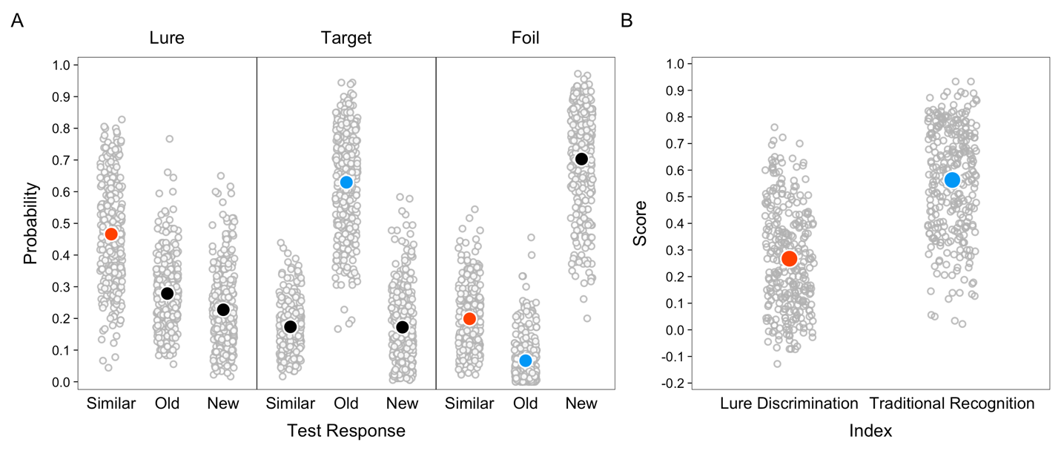
Note. Filled points are probabilities estimated from mixed-effect models. Open points are individual participant probabilities. Orange points are values comprising the lure discrimination index, and blue points are values comprising the traditional recognition index.

