Awareness and differential eyeblink conditioning: Effects of
manipulating auditory CS frequencies
Materials and Methods
Participants: A total of 60 (54 female) participants were recruited for the study. Participants were students (mean = 19.2 years old, standard deviation = 1.58) at Auburn University and were recruited through a research participation portal for which they received extra credit in their psychology courses. Participants were pre-screened for possible neurological or psychological disorders before participating in the study (see Appendix A). All procedures were approved by the Institutional Review Board at Auburn University.
Apparatus: The timing and delivery of the stimuli was controlled by custom built software based on LabView (v.7.1) which was connected to a desktop PC. Auditory CSs were presented through two computer speakers located approximately two feet away. A silent movie (‘The Gold Rush’) was played on a monitor approximately two feet away. The airpuff US was delivered through tubing connected to a solenoid valve and attached to custom modified swimming goggles. An infrared sensor attached to a fiber optic cable which continuously monitors the movement of the eyelids during the experiment was also attached to the modified goggles (Miller, Li, Weiss, Disterhoft, & Wyrwicz, 2005). These procedures and instruments have been successfully utilized in previous behavioral and fMRI experiments (Cheng, Disterhoft, Power, Ellis, & Desmond, 2008; Cheng, Faulkner, Disterhoft, & Desmond, 2010; Cheng et al., 2014; Cheng et al., 2017). To provide a quiet environment, conditioning took place in a sound attenuated booth (ETS-Lindgren Acoustic Systems).
Procedure: Audiometric testing was administered to participants prior to conditioning to ensure normal hearing thresholds. The participants were instructed to pay attention to a silent movie and that they would be given a short quiz following the movie. They were also informed that the goal of the experiment was to examine the effects distracting tones and airpuffs have on their ability to remember details related to the movie. After answering any questions, experimenters positioned participants in the sound attenuated booth and fitted them with the conditioning goggles.
Conditioned and Unconditioned Stimuli
Two hundred trials of two conditioned stimuli were presented (100 CS+ and 100 CS-). Each CS lasted 850 ms and each trial lasted 2000 ms with a variable intertrial interval (ITI) of 5-7 secs (Carrillo, Thompson, Gabrieli, & Disterhoft, 1997). Participants were randomly assigned to one of three groups. In Group I, CSs were 1000 Hz and a white noise, counterbalanced and presented in a pseudorandom order such that no more than two trials of the same CS were consecutively presented. In Group II, CSs were 1000 Hz and 1400 Hz and in Group III, CSs were 1000 Hz and 1150 Hz. CS+ trials always coterminated with US presentations and CS- trials were always presented alone. The US was a 100 ms 5 psi (measured at the delivery site) left corneal airpuff.
Awareness
Immediately following conditioning, participants were asked to indicate how many different tones they heard during the experiment. Next, the two tones were replayed and participants were asked to identify the high pitch and low pitch tones. If they answered correctly, the awareness questionnaire was administered. If they answered incorrectly, they were informed that there was a high pitch tone and a low pitch tone and that the next set of questions were related to these two tones. A 14-item questionnaire consisting of True or False statements was administered to assess participants’ awareness of the CS-US contingency (see Appendix B). This questionnaire was the same one used in a previous study (Manns, Clark, & Squire, 2000) but given twice to assess both CS+ and CS- (order counterbalanced). In addition to the True/False statements, a schematic of a trial structure (Supplemental Figure 1) was presented to further probe the participant’s understanding of the temporal sequence of events. The participants were asked to report at which time point (as indicated by letters in the schematic) the US occurred for CS+ and CS-. Lastly, a True or False movie questionnaire was presented to the participant.
Analysis: An eyeblink was considered a CR (Figure 1) if the response amplitude within a 500 ms time window before US onset was greater than four times the standard deviation of the baseline period (500 ms before CS presentation). These criteria were used to minimize the inclusion of spontaneous eyeblinks, orienting, and voluntary responses (Spence & Ross, 1959). Participants were categorized as aware if they scored at least 12 on the questionnaire and correctly identified when/if the US was presented on the schematic (Supplemental Figure 1). This threshold is based on the probability of obtaining 12 correct responses out of 14 from a binomial distribution which is set to p = 0.05. Performance was expressed as % CR (number of CRs divided by the number of trials). Trials were grouped into five blocks with 20 trials/block to assess learning-related changes.

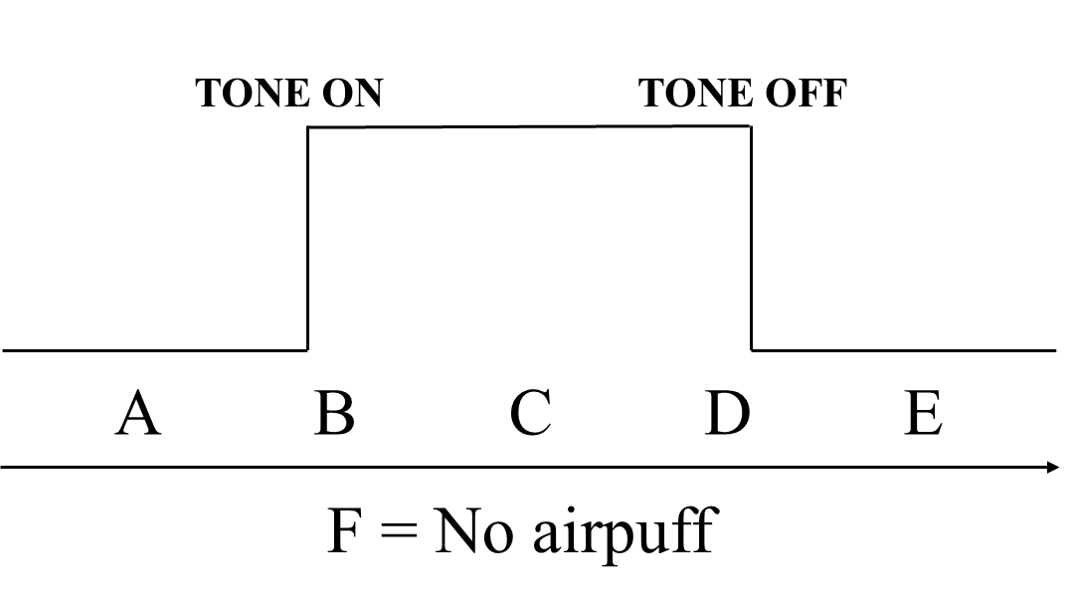
Supplemental Figure 1

Supplemental Figure 1. A schematic of a CS trial used to assess awareness. Participants were asked to indicate which letter (A-F) represented the time at which the airpuff occurred with respect to the CS. A response “D” for the CS+ was considered a correct response and “F” was considered a correct response to CS-.

Supplemental Figure 2
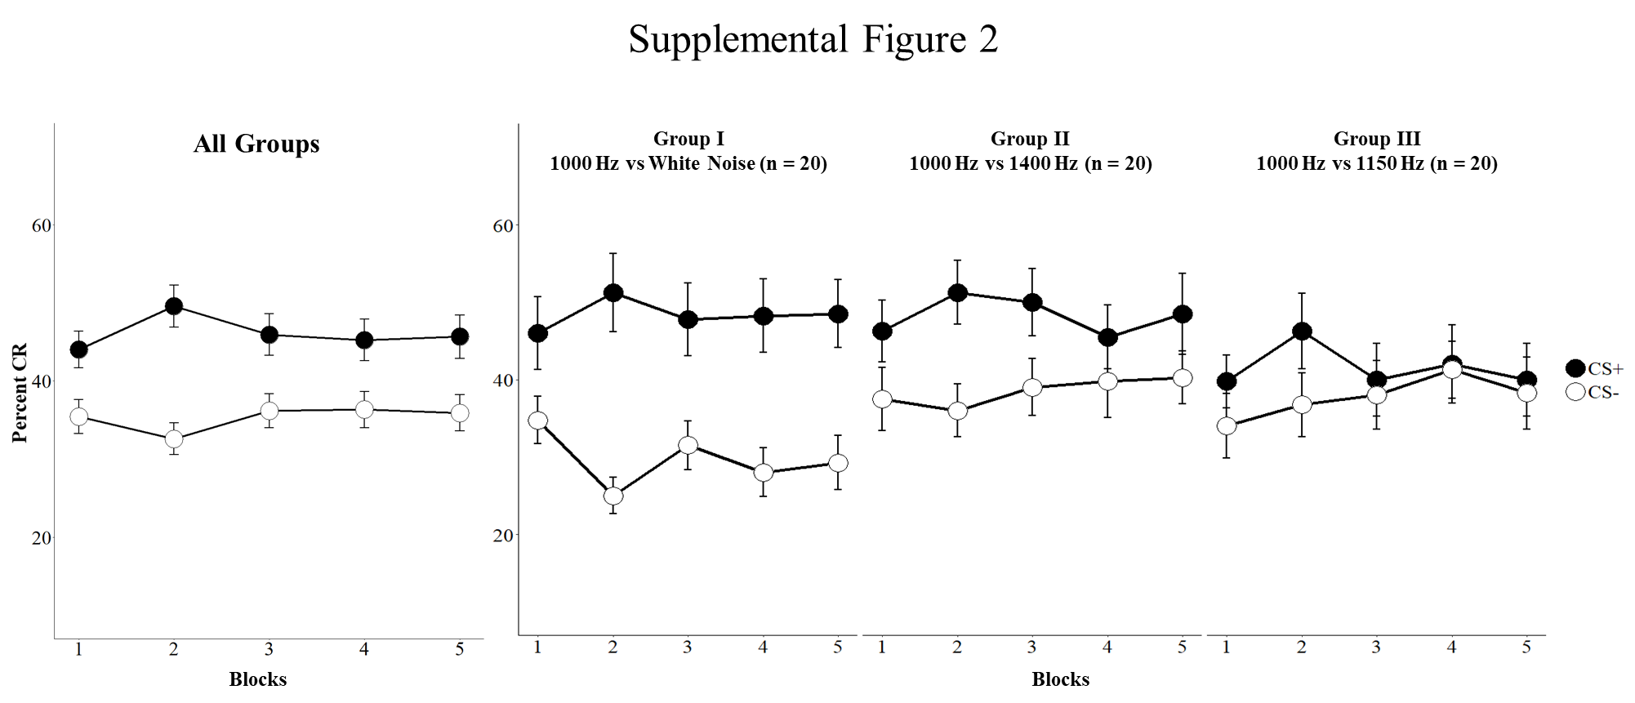

Supplemental Figure 2. Overall % CRs to CS+ and CS- trials for Groups I-III over time. In order to assess training effects, a Group (Group I, Group II, Group III) x CS Type (CS+, CS-) x Blocks (1-5) repeated measures ANOVA on % CR was performed. The main effect of Block was not significant (F(4,228) = 0.23, p = 0.924) but a significant interaction between CS Type and Block was observed (F(4,228) = 3.05, p = 0.018).

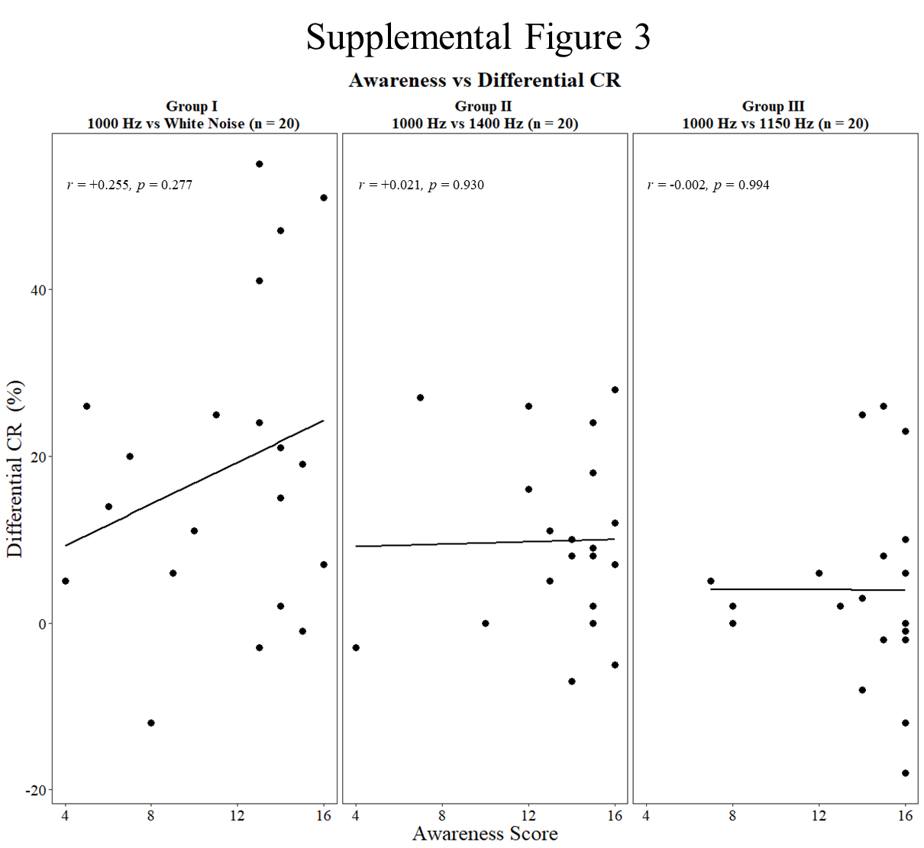
Supplemental Figure 3

Supplemental Figure 3. Relationship between awareness score and % differential CR (CS+ minus CS-) across groups. Participants were categorized as aware if they scored at least 14 out of the 16 questions used to assess awareness (a 14 item awareness questionnaire and two correct responses to the schematic). Correlation analyses indicated no significant relationship between awareness and conditioning.

Supplemental Figure 4
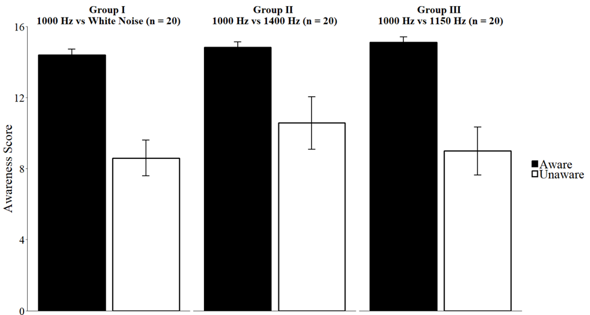

Supplemental Figure 4. Average awareness scores of participants across groups. A 3 (Groups) x 2 (Awareness) ANOVA was conducted to examine the effect of CS similarity on contingency awareness. The main effect of Awareness was significant (F (1,54) = 36.33, p < 0.05) but the main effect of Group and Group x Awareness interaction were not significant (all p’s > 0.05). Error bars represent standard error of mean.
Appendix A
Screening Form

- Are you right-handed, left-handed, or ambidextrous? R L A
- What is your age? _______________
- Do you have normal vision, or vision that is corrected to normal?
Normal
Corrected to Normal
Corrected not normal
- What is the first language that you learned? English non-English
- How many years of education have you had? __________
- Have you ever had a head injury with loss of consciousness? Y N
- Have you ever had a stroke? Y N
- Have you ever had seizures, fainting spells, or migraines? Y N
- Have you ever been evaluated for a neurological disorder or possible neurological
disorder? Y N
- Do you have a family history of epilepsy? Y N
- Do you have a history of vertigo or inner ear issues? Y N
- Do you have hearing loss sufficient to wear a hearing aid? Y N
- (If Female) Are you or could you possibly be pregnant? Y N
- Are you currently taking any medications? Y N
If yes:
Please list, including prescription or over-the-counter

________________________________________________________________
________________________________________________________________

Appendix B
Awareness Questionnaire
Can you tell me how many different tones you heard during the experiment?
__________________________________________________________________
- I believe the airpuff usually came immediately before the White Noise T F
- I believe the airpuff usually came immediately before the Tone T F
- I believe the airpuff usually came immediately after the White Noise T F
- I believe the airpuff usually came immediately after the Tone T F
- I believe the White Noise usually came immediately before the airpuff T F
- I believe the White Noise usually came immediately after the airpuff T F
- I believe the Tone usually came immediately before the airpuff T F
- I believe the Tone usually came immediately after the airpuff T F
- I believe the Tone and airpuff were always closely related in time T F
- I believe the White Noise tone and airpuff were always closely related in time T F
- I believe the Tone and airpuff were only sometimes related in time T F
- I believe the White Noise and airpuff were only sometimes related in time T F
- I believe the Tone predicted when the airpuff would come T F
- I believe the White Noise predicted when the airpuff would come T F

References
Carrillo, M. C., Thompson, L. T., Gabrieli, J. D. E., & Disterhoft, J. F. (1997). Variation of the intertrial interval in human classical conditioning. Psychobiology, 25(2), 152-157. doi:10.3758/bf03331921
Cheng, D. T., Disterhoft, J. F., Power, J. M., Ellis, D. A., & Desmond, J. E. (2008). Neural substrates underlying human delay and trace eyeblink conditioning. Proc Natl Acad Sci U S A, 105(23), 8108-8113. Retrieved from http://www.ncbi.nlm.nih.gov/entrez/query.fcgi?cmd=Retrieve&db=PubMed&dopt=Citation&list_uids=18523017
Cheng, D. T., Faulkner, M. L., Disterhoft, J. F., & Desmond, J. E. (2010). The effects of aging in delay and trace human eyeblink conditioning. Psychol Aging, 25(3), 684-690. Retrieved from http://www.ncbi.nlm.nih.gov/entrez/query.fcgi?cmd=Retrieve&db=PubMed&dopt=Citation&list_uids=20677885
Cheng, D. T., Meintjes, E. M., Stanton, M. E., Desmond, J. E., Pienaar, M., Dodge, N. C., . . . Jacobson, S. W. (2014). Functional MRI of cerebellar activity during eyeblink classical conditioning in children and adults. Hum Brain Mapp, 35(4), 1390-1403. doi:10.1002/hbm.22261
Cheng, D. T., Meintjes, E. M., Stanton, M. E., Dodge, N. C., Pienaar, M., Warton, C. M. R., . . . Jacobson, S. W. (2017). Functional MRI of Human Eyeblink Classical Conditioning in Children with Fetal Alcohol Spectrum Disorders. Cereb Cortex, 27(7), 3752-3767. doi:10.1093/cercor/bhw273
Manns, J. R., Clark, R. E., & Squire, L. R. (2000). Awareness predicts the magnitude of single-cue trace eyeblink conditioning. Hippocampus, 10(2), 181-186. doi:10.1002/(SICI)1098-1063(2000)10:2<181::AID-HIPO7>3.0.CO;2-V
Miller, M. J., Li, L., Weiss, C., Disterhoft, J. F., & Wyrwicz, A. M. (2005). A fiber optic-based system for behavioral eyeblink measurement in a MRI environment. Journal of Neuroscience Methods, 141(1), 83-87. doi:https://doi.org/10.1016/j.jneumeth.2004.05.015
Spence, K. W., & Ross, L. E. (1959). A methodological study of the form and latency of eyelid responses in conditioning. J Exp Psychol, 58, 376-381. Retrieved from http://www.ncbi.nlm.nih.gov/entrez/query.fcgi?cmd=Retrieve&db=PubMed&dopt=Citation&list_uids=13833233

