Supplementary Materials
Method
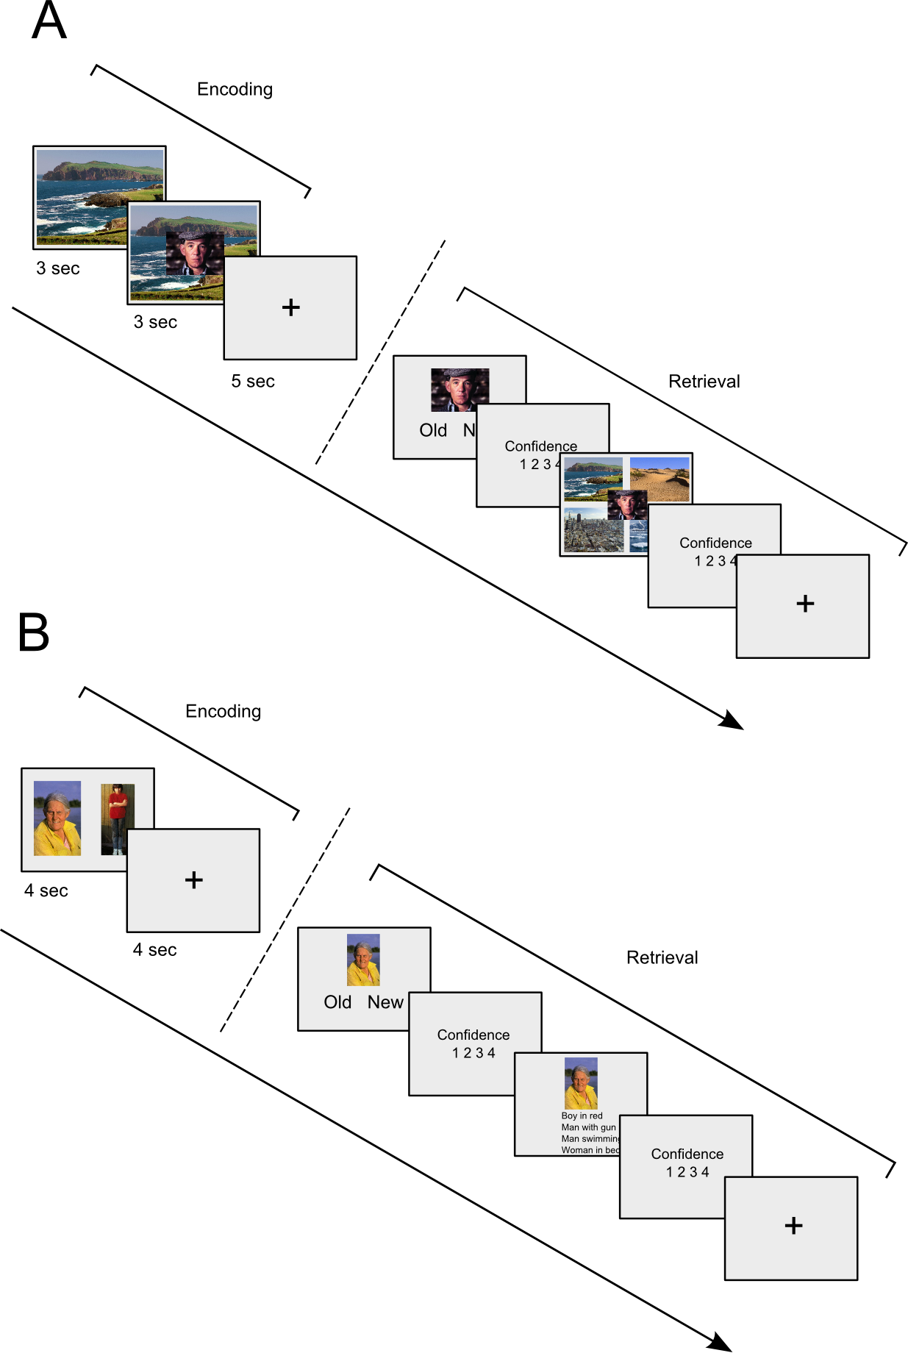
Figure S1. General procedure and example stimuli for (A) Experiments 1 and 2, and (B) Experiment 3.

Results

Experiment 1

Analysis of participants’ confidence ratings for correctly recognized item images and their associated context (Fig.S2) showed a significant memory type x valence interaction (F(1,17)=29.22, p<0.001, η_{P}²=0.63) and significant main effects of memory type (F(1,17)=280.89, p<0.001, η_{P}²=0.94) and valence (F(1,17)=13.33, p=0.002, η_{P}²=0.44). Further analysis of the interaction showed no significant difference (t(17)=0.54, p=0.60) between confidence ratings for correctly recognized and negative items. Confidence ratings for the correctly judged context were significantly higher (t(17)=5.47, p<0.001, d=1.32) for contexts associated with neutral item images than contexts associated with negative item images. Analysis of item recognition split by participants’ plausibility ratings and item valence showed a significant plausibility x valence interaction (F(1,17)=21.91, p<0.001, η_{P}²=0.56) and main effect of plausibility (F(1,17)=11.31, p<0.01, η_{P}²=0.40) but not of valence (F(1,17)=2.09, p=0.17, η_{P}²=0.11). Further examination of this interaction showed slightly worse item recognition for neutral items when classified as part of a plausible pairing (0.70 ± 0.12) compared to all other conditions (p’s<0.001; plausible-negative items, 0.81 ± 0.12; implausible-neutral items, 0.83 ± 0.11; implausible-negative items, 0.80 ± 0.13). All other comparisons were not significant (p’s>0.40).

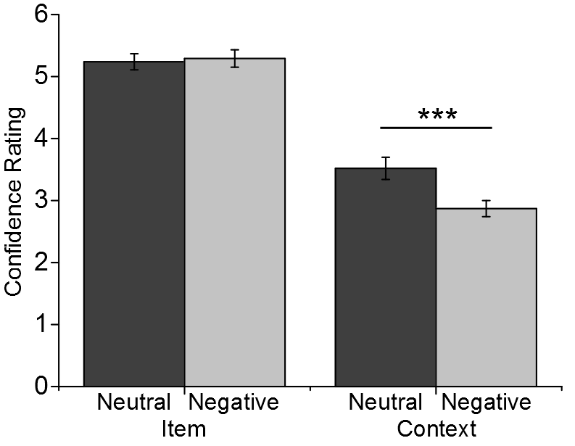
Figure S2. Mean confidence ratings for correctly recognized neutral and negative items and contexts associated with neutral and negative items from Experiment 1. Bars represent standard error. (***) p<0.001.

Experiment 2

We re-analyzed recognition memory without correcting for false alarm rates using a 2x2 repeated measures ANOVA with condition (safety, threat) and valence (neutral, negative) as within participant factors. Analysis showed a significant main effect of valence (F(1,17)=5.72, p=0.03, η_{P}²=0.41) with greater recognition memory accuracy for negative (0.77 ± 0.14 compared to neutral items (0.70 ± 0.15). No main effect was found for condition (F(1,17)=3.65, p=0.07, η_{P}²=0.39) or condition x valence interaction (F(1,17)=0.16, p=0.70, η_{P}²=0.33).

Confidence ratings (Fig.S3) given by participants on correctly recognized neutral and negative items and associated background were analyzed using a 2x2x2 repeated measures ANOVA with memory type (item, context), condition (safety, threat) and valence (neutral, negative) included as within participants factors. We found a significant memory type x valence interaction (F(1,17)=17.84, p<0.001, η_{P}²=0.51) and main effects of memory type (F(1,17)=75.60, p<0.001, η_{P}²=0.81) and condition (F(1,17)=4.53, p=0.048, η_{P}²=0.21; all other p’s > 0.22). Further analysis of the memory type x valence interaction showed greater confidence ratings (t(17)=2.52, p=0.02, d=0.58) for correctly recognized negative items compared to neutral items. The opposite pattern was observed for source memory ratings (t(17)=2.73, p=0.01, d=0.65) with lower confidence ratings for contexts associated with negative images compared to neutral images.

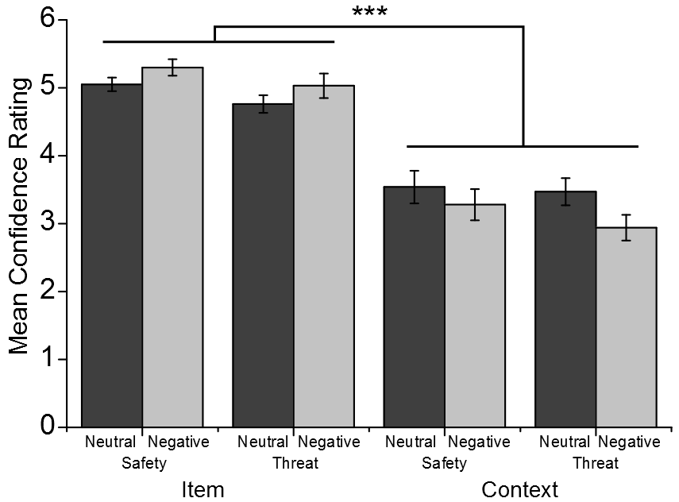

Figure S3. Mean confidence ratings for correctly recognized neutral and negative items and contexts associated with neutral and negative items across safety and threat conditions from Experiment 2. Lines represent significant memory type x valence interaction and bars represent standard error. (***) p=0.001.

Analysis of mean skin conductance responses for each condition using a 2x2 repeated measures ANOVA showed a significant main effect of condition (safety, threat; F(1,16)=48.16, p<0.001, η_{P}²=0.75) with greater responses during threat trials (Fig.S4). The condition x valence interaction (F(1,16)=3.57, p=0.08, η_{P}²=0.18) and main effect of valence (F(1,16)=3.51), p=0.08, η_{P}²=0.18) approached significance. Further examination of the interaction showed significantly higher skin conductance responses for all conditions compared to safety-neutral trials (p’s<0.005). Threat-neutral and threat-negative conditions did not differ (t(16)=0.54, p=0.60).
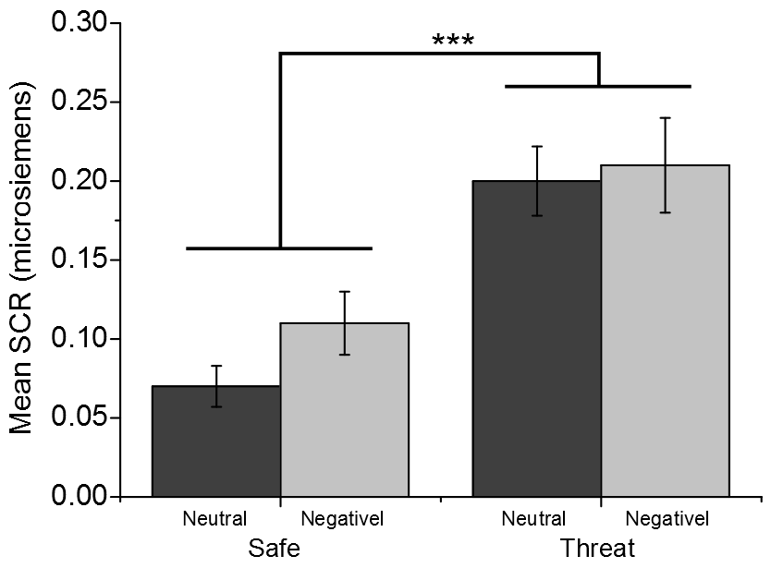

Figure S4. Mean skin conductance responses during encoding across each condition for Experiment 2. Line represents significant main effect of condition and bars represent standard error. (***) p=0.001.

Experiment 3

Participants’ confidence ratings for Experiment 3 (Fig.S5) were analyzed using a 2x2x2 repeated measures ANOVA with memory type (cue, target), cue valence (neutral, negative) and target valence (neutral, negative) entered as within participant factors. A significant memory type x cue valence interaction was found (F(1,14)=43.44, p<.001, η_{P}²=0.76) demonstrating lower confidence for the target associate when the cue item was negative compared to neutral (t(14)=8.24, p<0.001, d=2.19). Analysis also showed significant main effects of memory type (F(1,14)=41.85, p<0.001, η_{P}²=0.75), cue valence (F(1,14)=45.77, p<0.001, η_{P}²=0.77) and target valence (F(1,14)=6.07, p=0.048, η_{P}²=0.30).
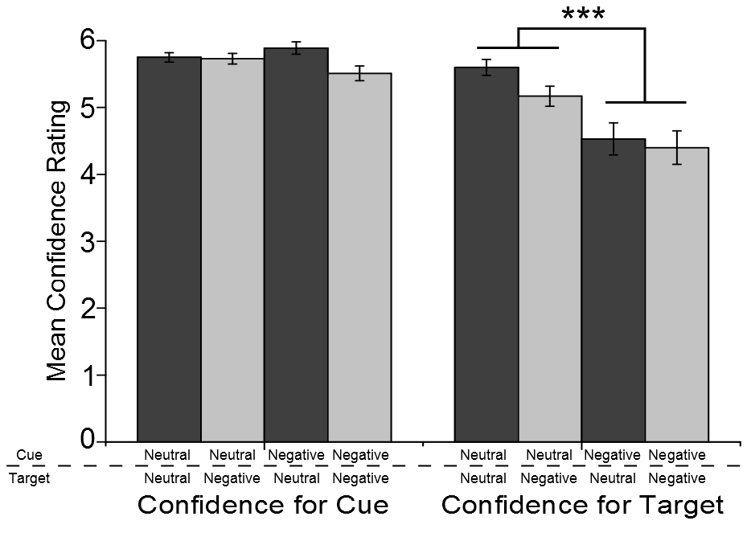

Figure S5. Mean confidence ratings for the (left) item cue and (right) target associate. Bars represent standard error. (***) p<0.001.

